

A detailed report on industrial exports
and imports of industrial machinery and equipment in August 2017

Prepared by:
Ministry of Industry
Industrial Information Department

www.industry.gov.lb
Index

I. Introduction 3
II. Industrial exports in August 2017 4
1. Main exported products 4
2. Products with increased exports value 4
2.1. Base metals and articles of base metal 4
2.2. Plastics and rubber and articles thereof 4
3. Products with decreased exports value 5
3.1. Products of the chemical industries 5
3.2. Pearls, precious or semi-precious stones, precious metals and articles thereof (Excluding unworked diamonds, silver and gold Ingots) 5
4. Main export markets 5
4.1. Main export markets by groups of countries 5
4.2. Main export markets by country 5
III. Imports of industrial machinery and equipment 6
1. Imported industrial machinery and equipment by country of origin 6
2. Imported industrial machinery and equipment by country of origin and industrial activity 6
IV. Appendix tables 7
V. Appendix charts 20

Introduction
The Industrial Information Department of the Ministry of Industry has prepared a detailed report on industrial exports and imports of industrial machinery and equipment for the month of August 2017.
It should be noted that the total value of industrial exports during the first eight months of the year 2017 amounted about 1 billion and 655 million US dollars compared to 1 billion and 713 million US dollars during the same period of the year 2016, and 2 billion and 7 million US dollars during the same period of the year 2015. Therefore we notice a decline of 3.4% compared to the year 2016, and a decline of 17.6% compared to the year 2015. (Tables 1 and 11(
It should also be noted that the monthly average of the Lebanese industrial exports during the first eight months of the year 2017 amounted about 206.8 million US dollars compared to 214.1 million US dollars during the year 2016, and 250.9 million US dollars during the year 2015.
On the other hand, the total value of imports of industrial machinery and equipment during the first eight months of the year 2017 amounted about 164 million US dollars compared to 166.9 million US dollars during the same period of the year 2016, and 175.5 million US dollars during the same period of the year 2015. Therefore, we notice a decline of 1.7% compared to the year 2016, and a decline of 6.5% compared to the year 2015. (Table 17)

Industrial exports in August 2017
The total value of industrial exports in August 2017 amounted to nearly 227 million US dollars, compared to 232.9 million US dollars in August 2016, and 233.4 million US dollars in August 2015, which is equivalent to a decline of 5.9 million US dollars, with the rate of 2.5% compared to year 2016, and a decline of 6.4 million US dollars with the rate of 2.8%, compared to year 2015. (Table 1, Chart 1)

Main exported products
Exports of machinery and electrical equipment came first in August 2017, with a total value of 44.4 million US dollars; Iraq was on top of importers list of this product, with an import value of 6.5 million US dollars. Followed by exports of products of the chemical industries, with a total value of 43.3 million US dollars, Bangladesh was the largest importer of this product, with an import value of 19.5 million US dollars. Then prepared foodstuffs and tobacco, with a total value of 35.9 million US dollars, Syria topped the importers list of this product, with an import value of 6.1 million US dollars, followed by base metals and articles of base metal, with a total value of 34.2 million US dollars. (For more details tables 2, 4, 6, 8, 10, 15, and 16)

Products with increased exports value
Statistics showed a significant increase in exports of the following products:

Base metals and articles of base metal
Exports of this product increased from 21.3 million US dollars in August 2016 to 34.2 million US dollars in August 2017 (Table 2 and Chart 2). The exports of this product mainly increased to Turkey, Spain and Greece which led to an increase in the total value of about 12.9 million US dollars. (Tables 3 and 4)

Plastics and rubber and articles thereof
Exports of this product increased from 13.5 million US dollars in August 2016 to 17.4 million US dollars in August 2017 (Table 2 and Chart 2). The exports of this product mainly increased to Syria which led to an increase of the total value of about 3.9 million US dollars. (Tables 5 and 6)

Products with decreased exports value
Statistics showed a significant decrease in exports of the following products:

Products of the chemical industries
Exports of this product decreased from 54.9 million US dollars in August 2016 to 43.3 million US dollars in August 2017 (Table 2 and Chart 2). The exports of this product increased to Bangladesh, Saudi Arabia and United Arab Emirates whereas it mainly decreased to Spain, Italy, Argentina, Iraq and France which led to a fall of the total value of about 11.6 million US dollars. (Tables 7 and 8)

Pearls, precious or semi-precious stones, precious metals and articles thereof (Excluding unworked diamonds, silver and gold Ingots)
Exports of this product decreased from 15.2 million US dollars in August 2016 to 8.9 million US dollars in August 2017 (Table 2 and Chart 2). The exports of this product increased to Belgium whereas it mainly decreased to United Arab Emirates and Hong Kong which led to a fall of the total value of about 6.3 million US dollars. (Tables 9 and 10)

Main export markets

Main export markets by groups of countries
Arab countries were the main market for Lebanese industrial exports in August 2017, with a total export value of 114.4 million US dollars, with a rate of 50.4% of the total export value. Non-arab Asian countries were the second largest export markets with a rate of 19.1% of the total export value. Followed by, European countries with a rate of 13.3% of the total export value, and, the Non-arab African countries with a rate of 10.8% of the total export value. The main products exported to Arab countries are: machinery and electrical equipment with the total value of 25.2 million US dollars, prepared foodstuffs and tobacco with the total value of 24.5 million US dollars, and the products of the chemical industries with the total value of 18.8 million US dollars. (Table 12)

Main export markets by country
Among countries importing Lebanese industrial products, Syria ranked first with a total value of 22.6 million US dollars, with a rate of 9.9% of the total export value. Bangladesh came second with a total value of 19.6 million US dollars with a rate of 8.6% of the total export value. Followed by, Saudi Arabia with a total value of 19.4 million US dollars with a rate of 8.6% of the total exports value. (Table 13)
During this month, Lebanese products were exported to 44 European countries, 40 Non-arab African countries, 27 Non-arab Asian countries, 26 American countries, 19 Arab countries, and 6 Oceanic countries. Countries that imported Lebanese goods by over 1 million US dollars are as following: 11 Arab countries, 10 European countries, 8 Non-arab African countries, 5 Non-arab Asian countries, 2 American countries, and 1 Oceanic country. (Table 14, Charts 3 and 4)

Imports of industrial machinery and equipment
The total import value of industrial machinery and equipment in August 2017 reached about 27 million US dollars compared to 19 million US dollars during the same period in 2016, and 21.3 million US dollars during the same period in 2015, an increase by 42.1 % compared to year 2016, and an increase of 26.9% compared to year 2015. (Tables 17 and 18 and Chart 5)

Imported industrial machinery and equipment by country of origin
China ranked first on the list of countries exporting industrial machinery and equipment to Lebanon, with a total value amounting to about 8.9 million US dollars, followed by Germany, with a total value of 3.7 million US dollars, and Italy, with a total value of 3.4 million US dollars. (Table 18)

Imported industrial machinery and equipment by country of origin and industrial activity
In August 2017, imports of machines for food industry, ranked first, with a total value of 5.9 million US dollars, and China topped the list of countries exporting of this product to Lebanon with exports value of 2.8 million US dollars, followed by machines for rubber and plastics industry, with a total value of 1.4 million US dollars. China was the leading exporter of this product with an export value of 0.9 million US dollars. Followed by machines for printing and binding, with a total value of 1 million US dollars. (Table 19, Chart 6)

Appendix tables

Table 1: Industrial exports during Years 2015 – 2016 – 2017
Month | Year  2015 | Year  2016 | Year  2017 | Variation in %  2015/2017 | Variation in %  2016/2017
January | 243.2 | 199.5 | 175.9 | -27.7% | -11.8%
February | 237.5 | 222.8 | 196.8 | -17.1% | -11.7%
March | 246.5 | 211.6 | 223.9 | -9.2% | 5.8%
April | 240.2 | 231.1 | 210.4 | -12.4% | -8.9%
May | 280.6 | 210.6 | 205.9 | -26.6% | -2.3%
June | 292.1 | 225.3 | 199.0 | -31.9% | -11.7%
July | 233.5 | 178.8 | 215.7 | -7.6% | 20.7%
August | 233.4 | 232.9 | 227.0 | -2.8% | -2.5%
September | 242.5 | 184.3
October | 255.3 | 220.0
November | 219.9 | 193.7
December | 231.1 | 216.3
Total | 2,955.8 | 2,526.9 | 1,654.6
All above figures are in Millions of USD

Table 2: Comparison of industrial exports during August 2017 and August 2016
Section | Goods | August 2016 | August 2017 | Variation 2016/2017 | Variation in % 2016/2017
1 | Animal products | 0.4 | 0.5 | 0.0 | 1.5%
2 | Vegetable products | 3.5 | 3.6 | 0.1 | 3.6%
3 | Fats and edible fats and oils | 3.0 | 2.9 | -0.2 | -5.1%
4 | Prepared foodstuffs and tobacco | 36.9 | 35.9 | -1.0 | -2.7%
5 | Mineral products | 0.6 | 1.3 | 0.7 | 127.0%
6 | Products of the chemical industries | 54.9 | 43.3 | -11.6 | -21.2%
7 | Plastics and rubber and articles thereof | 13.5 | 17.4 | 3.9 | 28.5%
8 | Raw hides and skins, leather, furskins and articles thereof | 0.8 | 1.2 | 0.3 | 42.2%
9 | Wood and articles of wood | 1.4 | 1.2 | -0.1 | -8.8%
10 | Paper and paperboard and articles thereof | 14.4 | 15.0 | 0.6 | 4.1%
11 | Textiles and textile articles | 7.9 | 5.1 | -2.8 | -35.7%
12 | Footwear, headgear, prepared feather | 1.1 | 0.6 | -0.4 | -40.7%
13 | Articles of stone, plaster, cement; glass and glassware | 1.8 | 1.6 | -0.2 | -12.9%
14 | Pearls, precious or semi-precious stones, precious metals and articles thereof (Excluding unworked diamonds, silver and gold Ingots) | 15.2 | 8.9 | -6.3 | -41.7%
15 | Base metals and articles of base metal | 21.3 | 34.2 | 12.9 | 60.7%
16 | Machinery and electrical equipment | 45.6 | 44.4 | -1.1 | -2.5%
17 | Transport equipment | 1.5 | 2.5 | 1.0 | 67.3%
18 | Optical, measuring, medical, and musical instruments; clocks and watches | 1.4 | 1.4 | -0.1 | -4.1%
19 | Arms and ammunition | 0.1 | 0.0 | -0.1 | -100.0%
20 | Miscellaneous manufactured articles | 7.6 | 6.1 | -1.5 | -20.1%
 | Total | 232.9 | 227.0 | -5.9 | -2.5%
All above figures are in Millions of USD
Table 3: Exports of base metals and articles of base metal according to the main importing countries during August 2016
Export destination Country | Republic of Korea | Turkey | Japan | Italy | Nigeria | India | United Arab Emirates | China
Value in thousands of USD | 3,875 | 3,864 | 1,276 | 1,267 | 1,093 | 832 | 637 | 614

Table 4: Exports of base metals and articles of base metal according to the main importing countries during August 2017
Export destination Country | Turkey | Republic of Korea | Spain | Greece | India | Qatar | Ivory Coast | Syria
Value in thousands of USD | 14,438 | 4,315 | 2,883 | 1,832 | 764 | 728 | 706 | 655

Table 5: Exports of plastics and rubber and articles thereof according to the main importing countries during August 2016
Export destination Country | Syria | Iraq | Saudi Arabia | Egypt | Spain | Jordan | Kuwait | Burkina Faso
Value in thousands of USD | 3,570 | 1,502 | 1,362 | 1,116 | 507 | 411 | 393 | 312

Table 6: Exports of plastics and rubber and articles thereof according to the main importing countries during August 2017
Export destination Country | Syria | Iraq | Saudi Arabia | Spain | Egypt | Qatar | Algeria | Ivory Coast
Value in thousands of USD | 6,598 | 1,641 | 1,564 | 723 | 590 | 563 | 370 | 357

Table 7: Exports of products of the chemical industries according to the main importing countries during August 2016
Export destination Country | Bangladesh | Spain | Iraq | Italy | Argentina | France | United Arab Emirates | Saudi Arabia
Value in thousands of USD | 13,850 | 5,459 | 5,218 | 5,108 | 4,373 | 3,649 | 3,507 | 2,788

Table 8: Exports of products of the chemical industries according to the main importing countries during August 2017
Export destination Country | Bangladesh | Saudi Arabia | United Arab Emirates | Iraq | France | Jordan | Syria | Kuwait
Value in thousands of USD | 19,499 | 5,248 | 5,009 | 2,583 | 2,085 | 1,574 | 1,560 | 741

Table 9: Exports of pearls, precious or semi-precious stones, precious metals and articles thereof (Excluding unworked diamonds, silver and gold Ingots) according to the main importing countries during August 2016
Export destination Country | United Arab Emirates | Hong Kong | Saudi Arabia | Switzerland | Jordan | United Kingdom | France | Upper Volta
Value in thousands of USD | 8,166 | 4,158 | 1,020 | 311 | 305 | 217 | 207 | 207

Table 10: Exports of pearls, precious or semi-precious stones, precious metals and articles thereof (Excluding unworked diamonds, silver and gold Ingots) according to the main importing countries during August 2017
Export destination Country | United Arab Emirates | Belgium | United States Of America | Jordan | Saudi Arabia | Switzerland | Qatar | France
Value in thousands of USD | 3,098 | 2,292 | 914 | 864 | 844 | 348 | 163 | 127

Table 11: Industrial exports according to exported goods during year 2017

Table 12: Industrial exports according to exported goods and countries groups during August 2017
Goods | Arab Countries | European Countries | Oceanic Countries | Non-Arab Asian countries | American Countries | Non-Arab African countries | Other* | Total
Animal products | 390 | 5 | 4 |  |  | 53 |  | 453
Vegetable products | 1,304 | 1,239 | 42 | 328 | 222 | 503 |  | 3,637
Fats and edible fats and oils | 1,289 | 782 | 112 | 9 | 563 | 123 |  | 2,878
Prepared foodstuffs and tobacco | 24,526 | 4,120 | 637 | 343 | 3,626 | 2,309 | 361 | 35,922
Mineral products | 430 | 647 |  | 2 |  | 132 | 78 | 1,290
Products of the chemical industries | 18,757 | 3,277 | 75 | 19,705 | 500 | 914 | 38 | 43,266
Plastics and rubber and articles thereof | 12,497 | 1,887 | 132 | 428 | 437 | 1,772 | 230 | 17,383
Raw hides and skins, leather, furskins and articles thereof | 465 | 524 |  | 94 |  | 75 |  | 1,158
Wood and articles of wood | 985 | 16 |  |  | 39 | 194 |  | 1,233
Paper and paperboard and articles thereof | 11,169 | 1,261 | 14 | 439 | 35 | 2,051 | 8 | 14,977
Textiles and textile articles | 2,990 | 1,348 | 2 | 31 | 91 | 508 | 92 | 5,063
Footwear, headgear, prepared feather | 551 | 43 |  | 6 |  | 49 |  | 649
Articles of stone, plaster, cement; glass and glassware | 1,063 | 70 | 6 | 12 | 115 | 300 |  | 1,566
Pearls, precious or semi-precious stones, precious metals and articles thereof (Excluding unworked diamonds, silver and gold Ingots) | 4,969 | 2,783 | 5 | 72 | 947 | 102 | 4 | 8,882
Base metals and articles of base metal | 3,583 | 7,365 | 70 | 20,176 | 157 | 2,687 | 192 | 34,231
Machinery and electrical equipment | 25,160 | 3,611 | 83 | 1,366 | 2,896 | 9,542 | 1,779 | 44,437
Transport equipment | 504 | 519 |  | 155 | 19 | 696 | 619 | 2,513
Optical, measuring, medical, and musical instruments; clocks and watches | 663 | 325 |  | 117 | 139 | 116 | 15 | 1,376
Arms and ammunition |  |  |  |  |  |  |  | 0
Miscellaneous manufactured articles | 3,109 | 353 | 38 | 65 | 50 | 2,456 |  | 6,071
Total | 114,404 | 30,175 | 1,221 | 43,350 | 9,836 | 24,582 | 3,417 | 226,985
All the above figures are in thousands of US dollars.
* "other" Includes exported goods to the duty free market and those that are supplied to ships and aircraft.
Table 13: Distribution of the industrial exports according to the main importing countries during August 2017
Export destination Country | Syria | Bangladesh | Saudi Arabia | Iraq | United Arab Emirates | Turkey | Qatar | Jordan
Value in thousands of USD | 22,575 | 19,563 | 19,441 | 16,925 | 16,715 | 15,654 | 10,911 | 7,454

Export destination Country | United States Of America | Kuwait | France | Egypt | Republic of Korea | Spain | Germany | Ivory Coast
Value in thousands of USD | 6,975 | 5,731 | 5,465 | 4,523 | 4,316 | 3,864 | 3,648 | 3,586

Export destination Country | Congo | Nigeria | Algeria | Belgium | Ghana | United Kingdom | Greece | Canada
Value in thousands of USD | 3,547 | 3,540 | 3,532 | 3,038 | 2,662 | 2,525 | 2,160 | 1,955

Table 14: Distribution of importing countries according to countries groups and the value of exports during August 2017
Exports Value  (in million USD) | Arab Countries | European Countries | Oceania Countries | Non-Arab Asian countries | American Countries | Non-Arab African countries | Total
]0-1[ | 8 | 34 | 5 | 22 | 24 | 32 | 125
[1-5[ | 4 | 9 | 1 | 3 | 1 | 8 | 26
[5-10[ | 2 | 1 |  |  | 1 |  | 4
[10-15[ | 1 |  |  |  |  |  | 1
More than 15 million USD | 4 |  |  | 2 |  |  | 6
Total | 19 | 44 | 6 | 27 | 26 | 40 | 162

Table 15: Distribution of the industrial exports according to product and to the main importing countries during August 2017

Animal products | Qatar | Iraq | United Arab Emirates | Gabon | Senegal | Kuwait | Zambia | Guinea
Value in 1000 of USD | 263 | 84 | 31 | 14 | 13 | 12 | 8 | 6

Vegetable products | Saudi Arabia | Sweden | Turkey | Germany | Netherlands | United Kingdom | Tunisia | Canada
Value in 1000 of USD | 389 | 385 | 327 | 245 | 240 | 234 | 176 | 174

Fats and edible fats and oils | Portugal | United States Of America | United Arab Emirates | Kuwait | United Kingdom | Sudan | Saudi Arabia | Qatar
Value in 1000 of USD | 399 | 391 | 280 | 265 | 208 | 202 | 148 | 142

Prepared foodstuffs and tobacco | Syria | Saudi Arabia | Qatar | Iraq | United States Of America | United Arab Emirates | Jordan | Canada
Value in 1000 of USD | 6,087 | 5,866 | 3,156 | 2,099 | 2,056 | 1,778 | 1,527 | 1,425

Mineral products | Cyprus | Syria | Sierra Leone | Qatar | Other | Ivory Coast | Gambia | Ghana
Value in 1000 of USD | 642 | 340 | 82 | 81 | 78 | 20 | 11 | 7

Raw hides and skins, leather, furskins and articles thereof | Germany | United Arab Emirates | Jordan | Egypt | Qatar | Italy | Turkey | Kuwait
Value in 1000 of USD | 283 | 121 | 100 | 80 | 69 | 68 | 65 | 49

Wood and articles of wood | Syria | Saudi Arabia | Jordan | Nigeria | United Arab Emirates | Iraq | Qatar | Ethiopia
Value in 1000 of USD | 272 | 263 | 184 | 148 | 115 | 61 | 46 | 27

Paper and paperboard and articles thereof | Iraq | Egypt | Saudi Arabia | Syria | Qatar | Jordan | Morocco | Ivory Coast
Value in 1000 of USD | 3,215 | 1,343 | 1,321 | 1,103 | 854 | 789 | 630 | 528

Textiles and textile articles | United Arab Emirates | Syria | France | Qatar | Kuwait | Jordan | Saudi Arabia | Switzerland
Value in 1000 of USD | 930 | 619 | 408 | 315 | 248 | 244 | 238 | 222

Table 15: (continued) Distribution of the industrial exports according to product and the main importing countries during August 2017
Footwear, headgear, prepared feather | Saudi Arabia | United Arab Emirates | Kuwait | Jordan | Egypt | Qatar | United Kingdom | Upper Volta
Value in 1000 of USD | 271 | 101 | 67 | 41 | 34 | 30 | 28 | 27

Articles of stone, plaster, cement; glass and glassware | Qatar | Kuwait | United Arab Emirates | Ivory Coast | Bahrain | United States Of America | Syria | Iraq
Value in 1000 of USD | 535 | 203 | 77 | 71 | 64 | 64 | 61 | 54

Machinery and electrical equipment | Iraq | Syria | United Arab Emirates | United States Of America | Qatar | Kuwait | Saudi Arabia | Algeria
Value in 1000 of USD | 6,490 | 4,306 | 3,319 | 2,818 | 2,333 | 2,322 | 2,278 | 1,956

Transport equipment | Other | Ivory Coast | Guinea | United Kingdom | Syria | Iraq | Iran | France
Value in 1000 of USD | 619 | 278 | 252 | 216 | 204 | 124 | 119 | 116

Optical, measuring, medical, and musical instruments; clocks and watches | Syria | United Arab Emirates | France | United States Of America | Germany | Turkey | Upper Volta | Iraq
Value in 1000 of USD | 323 | 181 | 175 | 139 | 125 | 117 | 89 | 47

Miscellaneous manufactured articles | Qatar | Ivory Coast | Saudi Arabia | Sierra Leone | Syria | Jordan | Iraq | United Arab Emirates
Value in 1000 of USD | 1,004 | 723 | 678 | 590 | 361 | 358 | 245 | 198

Table 16: Distribution of industrial exports, according to the main exported goods and main importing countries during August 2017

Table 17: Imports of industrial machinery and equipment during years 2015-2016-2017
Month | Year  2015 | Year  2016 | Year  2017 | Variation in %  2015/2017 | Variation in %  2016/2017
January | 20.5 | 25.3 | 21.0 | 2.4% | -17.1%
February | 22.3 | 17.3 | 10.7 | -52.1% | -38.3%
March | 20.5 | 25.1 | 20.2 | -1.3% | -19.4%
April | 19.1 | 22.8 | 18.0 | -5.8% | -20.9%
May | 28.0 | 20.5 | 23.1 | -17.5% | 12.3%
June | 23.7 | 20.0 | 22.2 | -6.2% | 10.9%
July | 20.1 | 16.8 | 21.8 | 8.5% | 29.9%
August | 21.3 | 19.0 | 27.0 | 26.9% | 42.1%
September | 13.8 | 16.2
October | 16.5 | 14.5
November | 18.9 | 20.0
December | 18.7 | 17.9
Total | 243.4 | 235.5 | 164.0
All above figures are in Millions of USD

Table 18: Imports of industrial equipment and machinery according to exporting country for the year 2017
Table 19: Imports of industrial equipment and machinery according to industrial activity and country during August 2017

Appendix charts
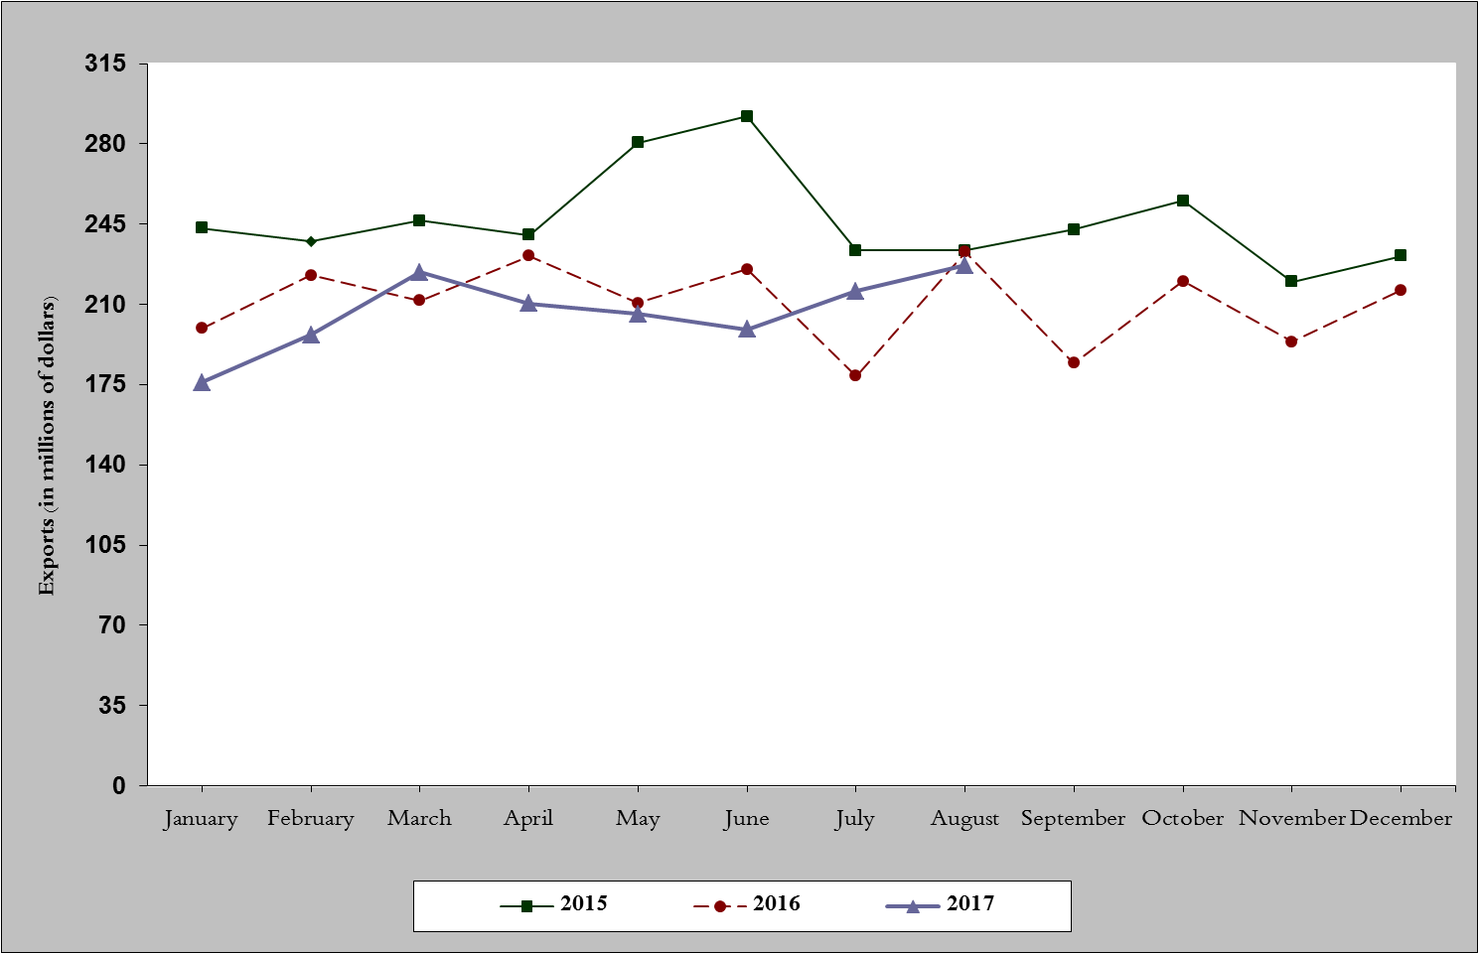
Chart 1: Industrial exports during years 2015-2016-2017

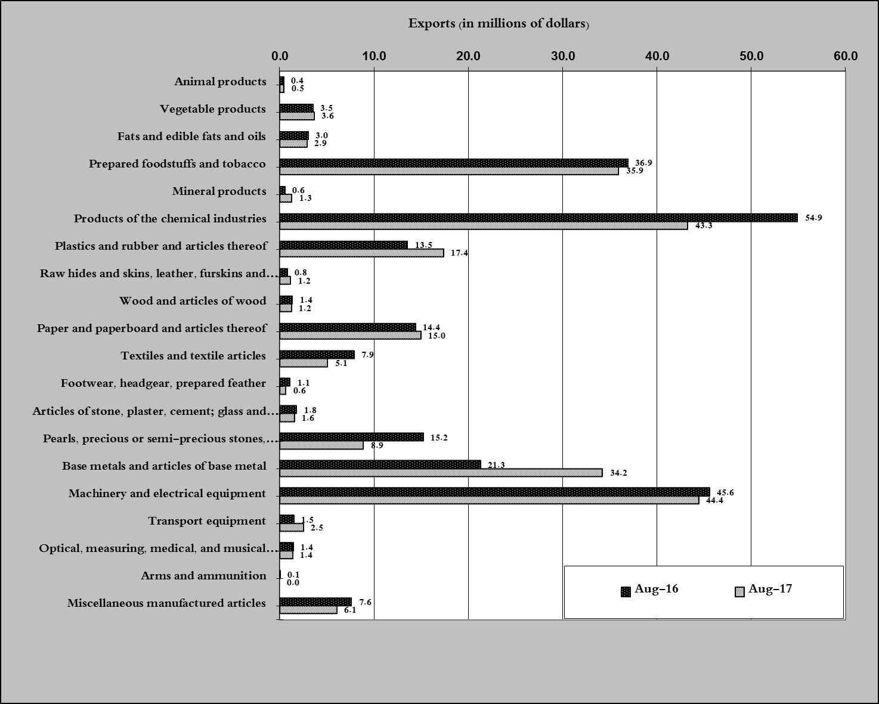
Chart 2: Comparison of industrial exports during August 2017 and August 2016

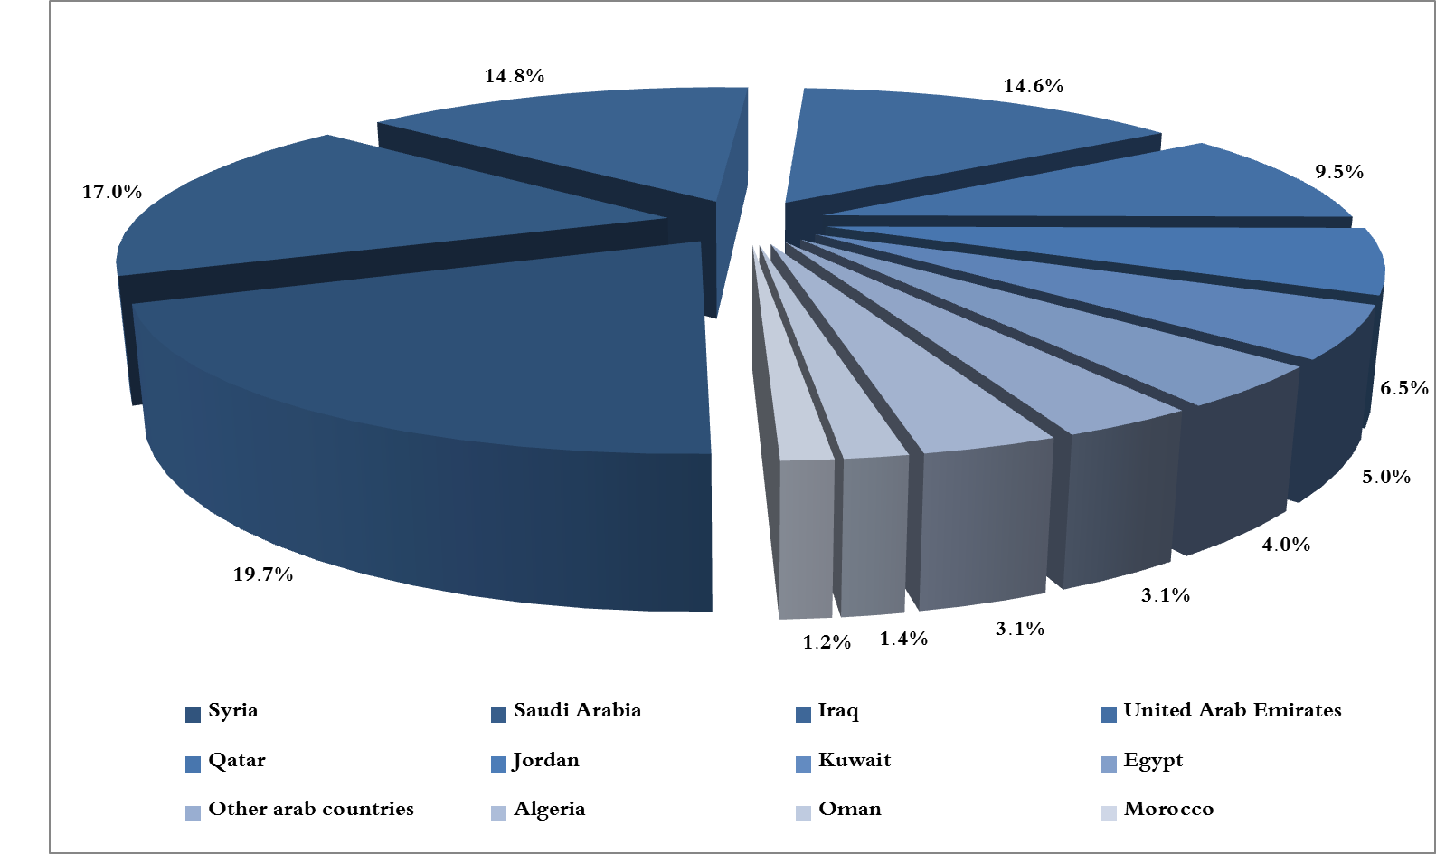
Chart 3: Distribution of industrial exports to Arab countries during August 2017

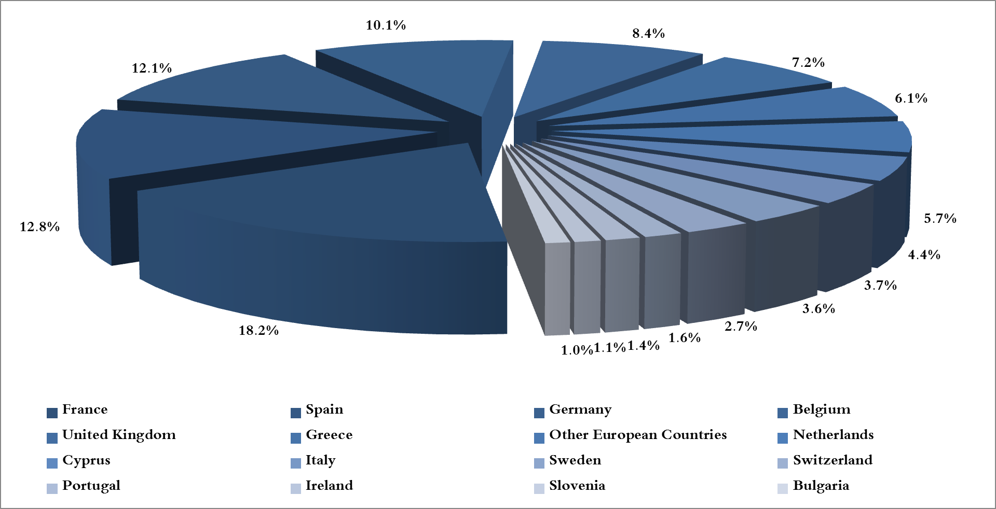
Chart 4: Distribution of industrial exports to European countries during August 2017
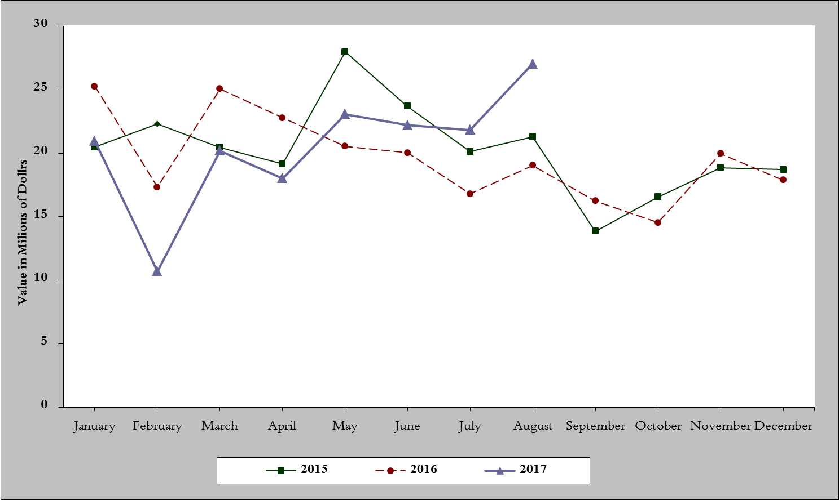
Chart 5: Imports of industrial machinery and equipment during years 2015-2016-2017
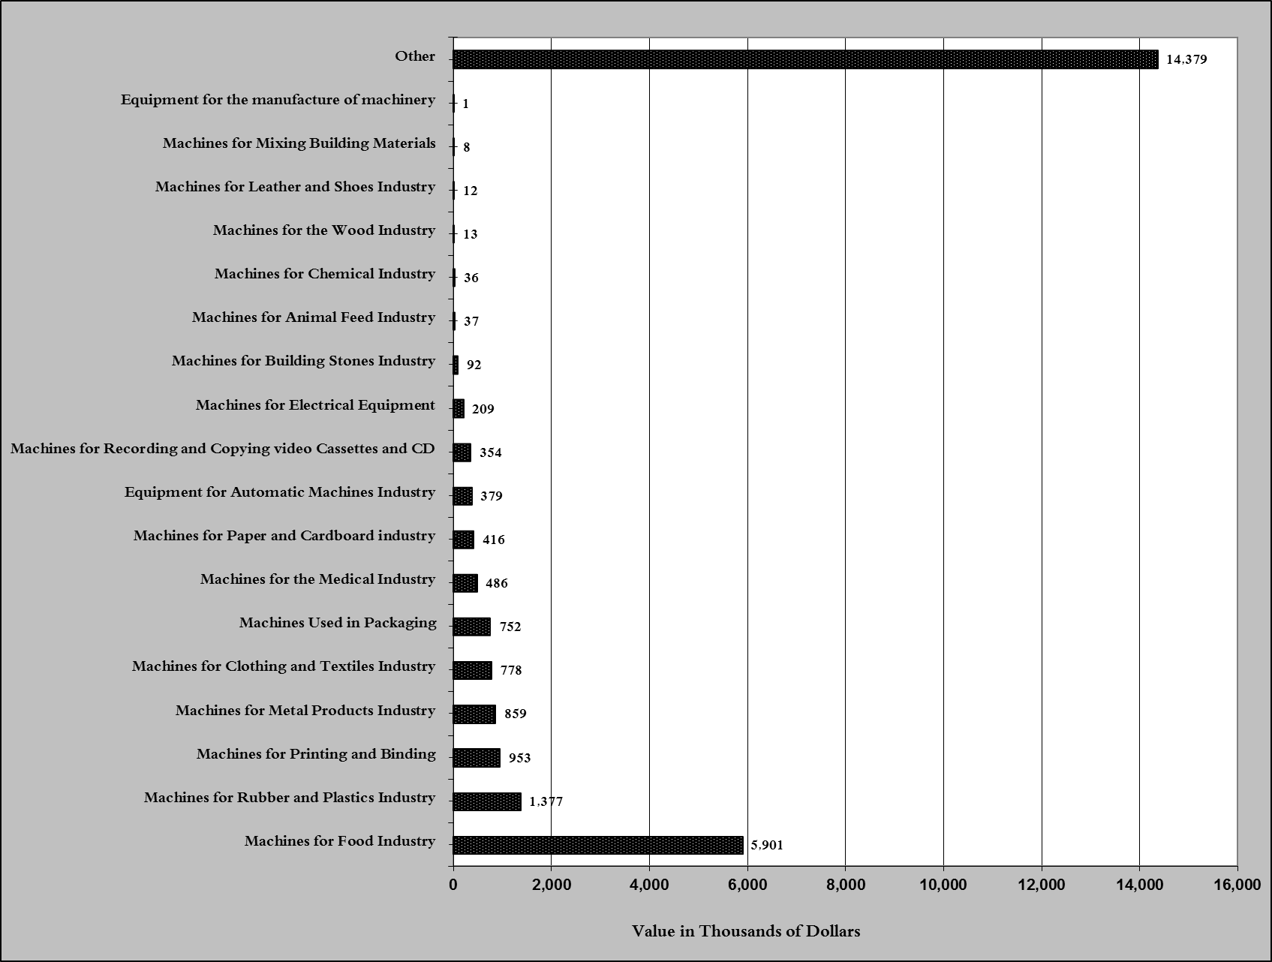
Chart 6: Imports of industrial equipment and machinery according to industrial activity during August 2017

Exports of unworked Diamonds, Silver and Gold Ingots reached this month a value of 31.2 million USD
The machineries and equipment are classified in this table according to the industrial sectors that are used in, while heading "other" includes machineries and equipment that can be used in various sectors.

