

A detailed report on industrial exports
and imports of industrial machinery and equipment in December 2017

Prepared by:
Ministry of Industry
Industrial Information Department

www.industry.gov.lb
Index

I. Introduction 3
II. Industrial exports in December 2017 4
1. Main exported products 4
2. Products with increased exports value 4
2.1. Base metals and articles of base metal 4
2.2. Plastics and rubber and articles thereof 5
3. Products with decreased exports value 5
3.1. Products of the chemical industries 5
3.2. Machinery and electrical equipment 5
4. Main export markets 5
4.1. Main export markets by groups of countries 5
4.2. Main export markets by country 6
III. Imports of industrial machinery and equipment 6
1. Imported industrial machinery and equipment by country of origin 6
2. Imported industrial machinery and equipment by country of origin and industrial activity 6
IV. Appendix tables 8
V. Appendix charts 21

Introduction
The Industrial Information Department of the Ministry of Industry has prepared a detailed report on industrial exports and imports of industrial machinery and equipment for the month of December 2017.
It should be noted that the total value of industrial exports during the year 2017 amounted about 2 billion and 474 million US dollars compared to 2 billion and 527 million US dollars during the same period of the year 2016, and 2 billion and 956 million US dollars during the same period of the year 2015. Therefore we notice a decline of 2.1% compared to the year 2016, and a decline of 16.3% compared to the year 2015. (Tables 1 and 11(
It should also be noted that the monthly average of the Lebanese industrial exports during the the year 2017 amounted about 206.1 million US dollars compared to 210.6 million US dollars during the year 2016, and 246.3 million US dollars during the year 2015.
On the other hand, the total value of imports of industrial machinery and equipment during the the year 2017 amounted about 257.4 million US dollars compared to 235.5 million US dollars during the same period of the year 2016, and 243.4 million US dollars during the same period of the year 2015. Therefore, we notice an increase of 9.3% compared to the year 2016, and an increase of 5.7% compared to the year 2015. (Table 17)

Industrial exports in December 2017
The total value of industrial exports in December 2017 amounted to nearly 219.6 million US dollars, compared to 216.3 million US dollars in December 2016, and 231.1 million US dollars in December 2015, which is equivalent to an increase of 3.3 million US dollars, with the rate of 1.5% compared to year 2016, and a decline of 11.5 million US dollars with the rate of 5%, compared to year 2015. (Table 1, Chart 1)

Main exported products
Exports of machinery and electrical equipment came first in December 2017, with a total value of 42.5 million US dollars; Libya was on top of importers list of this product, with an import value of 6 million US dollars. Followed by exports of prepared foodstuffs and tobacco, with a total value of 41.6 million US dollars, Saudi Arabia was the largest importer of this product, with an import value of 5.6 million US dollars. Then base metals and articles of base metal, with a total value of 35.7 million US dollars, Turkey topped the importers list of this product, with an import value of 12.1 million US dollars, followed by products of the chemical industries, with a total value of 30.1 million US dollars. (For more details tables 2, 4, 6, 8, 10, 15, and 16)

Products with increased exports value
Statistics showed a significant increase in exports of the following products:

Base metals and articles of base metal
Exports of this product increased from 28.9 million US dollars in December 2016 to 35.7 million US dollars in December 2017 (Table 2 and Chart 2). The exports of this product mainly decreased to Greece and Italy whereas it mainly increased to Turkey, Spain, and Saudi Arabia which led to an increase in the total value of about 6.8 million US dollars. (Tables 3 and 4)

Plastics and rubber and articles thereof
Exports of this product increased from 11 million US dollars in December 2016 to 14.9 million US dollars in December 2017 (Table 2 and Chart 2). The exports of this product mainly increased to Syria which led to an increase of the total value of about 3.8 million US dollars. (Tables 5 and 6).

Products with decreased exports value
Statistics showed a significant decrease in exports of the following products:

Products of the chemical industries
Exports of this product decreased from 33.7 million US dollars in December 2016 to 30.1 million US dollars in December 2017 (Table 2 and Chart 2). The exports of this product mainly increased to Saudi Arabia and United Arab Emirates whereas it mainly decreased to France, Italy, and Greece which led to a fall of the total value of about 3.6 million US dollars. (Tables 7 and 8)

Machinery and electrical equipment
Exports of this product decreased from 45.2 million US dollars in December 2016 to 42.5 million US dollars in December 2017 (Table 2 and Chart 2). The exports of this product mainly increased to Libya and Iraq whereas it mainly decreased to Saudi Arabia, United Arab Emirates, Algeria, and Syria which led to a fall of the total value of about 2.7 million US dollars. (Tables 9 and 10)

Main export markets

Main export markets by groups of countries
Arab countries were the main market for Lebanese industrial exports in December 2017, with a total export value of 134.4 million US dollars, with a rate of 61.2% of the total export value. Non-arab Asian countries were the second largest export markets with a rate of 12.9% of the total export value. Followed by, European countries with a rate of 11% of the total export value, and, the Non-arab African countries with a rate of 10.3% of the total export value. The main products exported to Arab countries are: machinery and electrical equipment with the total value of 28.7 million US dollars, prepared foodstuffs and tobacco with the total value of 28 million US dollars, and the products of the chemical industries with the total value of 22.4 million US dollars. (Table 12)

Main export markets by country
Among countries importing Lebanese industrial products, Saudi Arabia ranked first with a total value of 26.5 million US dollars, with a rate of 12.1% of the total export value. United Arab Emirates came second with a total value of 24.4 million US dollars with a rate of 11.1% of the total export value. Followed by, Syria with a total value of 18 million US dollars with a rate of 8.2% of the total exports value. (Table 13)
During this month, Lebanese products were exported to 45 European countries, 41 Non-arab African countries, 28 American countries, 27 Non-arab Asian countries, 19 Arab countries, and 8 Oceanic countries. Countries that imported Lebanese goods by over 1 million US dollars are as following: 14 Arab countries, 7 European countries, 7 Non-arab African countries, 4 Non-arab Asian countries, and 2 American countries, and 1 Oceanic country. (Table 14, Charts 3 and 4)

Imports of industrial machinery and equipment
The total import value of industrial machinery and equipment in December 2017 reached about 23.2 million US dollars compared to 17.9 million US dollars during the same period in 2016, and 18.7 million US dollars during the same period in 2015, an increase by 29.6% compared to year 2016, and an increase of 23.9% compared to year 2015. (Tables 17 and 18 and Chart 5)

Imported industrial machinery and equipment by country of origin
Italy ranked first on the list of countries exporting industrial machinery and equipment to Lebanon, with a total value amounting to about 7.5 million US dollars, followed by Germany, with a total value of 3.4 million US dollars, and China, with a total value of 3.1 million US dollars. (Table 18)

Imported industrial machinery and equipment by country of origin and industrial activity
In December 2017, imports of machines for food industry, ranked first, with a total value of 4.5 million US dollars, and Germany topped the list of countries exporting of this product to Lebanon with exports value of 1.1 million US dollars, followed by machines used in packaging, with a total value of 3.4 million US dollars. Italy was the leading exporter of this product with an export value of 2.5 million US dollars. Followed by machines for rubber and plastics industry, with a total value of 1.4 million US dollars. (Table 19, Chart 6)

Appendix tables

Table 1: Industrial exports during Years 2015 – 2016 – 2017
Month | Year  2015 | Year  2016 | Year  2017 | Variation in %  2015/2017 | Variation in %  2016/2017
January | 243.2 | 199.5 | 175.9 | -27.7% | -11.8%
February | 237.5 | 222.8 | 196.8 | -17.1% | -11.7%
March | 246.5 | 211.6 | 223.9 | -9.2% | 5.8%
April | 240.2 | 231.1 | 210.4 | -12.4% | -8.9%
May | 280.6 | 210.6 | 205.9 | -26.6% | -2.3%
June | 292.1 | 225.3 | 199.0 | -31.9% | -11.7%
July | 233.5 | 178.8 | 215.7 | -7.6% | 20.7%
August | 233.4 | 232.9 | 227.0 | -2.8% | -2.5%
September | 242.5 | 184.3 | 167.6 | -30.9% | -9.0%
October | 255.3 | 220.0 | 226.7 | -11.2% | 3.0%
November | 219.9 | 193.7 | 205.1 | -6.8% | 5.9%
December | 231.1 | 216.3 | 219.6 | -5.0% | 1.5%
Total | 2,955.8 | 2,526.9 | 2,473.5 | -16.3% | -2.1%
All above figures are in Millions of USD

Table 2: Comparison of industrial exports during December 2017 and December 2016
Section | Goods | December 2016 | December 2017 | Variation 2016/2017 | Variation in % 2016/2017
1 | Animal products | 0.49 | 0.51 | 0.02 | 3.9%
2 | Vegetable products | 4.44 | 5.78 | 1.34 | 30.1%
3 | Fats and edible fats and oils | 4.50 | 4.32 | -0.17 | -3.9%
4 | Prepared foodstuffs and tobacco | 41.56 | 41.61 | 0.06 | 0.1%
5 | Mineral products | 0.45 | 0.68 | 0.23 | 51.7%
6 | Products of the chemical industries | 33.71 | 30.14 | -3.57 | -10.6%
7 | Plastics and rubber and articles thereof | 11.02 | 14.86 | 3.84 | 34.8%
8 | Raw hides and skins, leather, furskins and articles thereof | 0.83 | 0.95 | 0.12 | 13.9%
9 | Wood and articles of wood | 1.50 | 0.76 | -0.74 | -49.1%
10 | Paper and paperboard and articles thereof | 13.38 | 10.88 | -2.50 | -18.7%
11 | Textiles and textile articles | 7.59 | 5.38 | -2.21 | -29.1%
12 | Footwear, headgear, prepared feather | 1.26 | 0.65 | -0.61 | -48.3%
13 | Articles of stone, plaster, cement; glass and glassware | 1.73 | 1.91 | 0.18 | 10.3%
14 | Pearls, precious or semi-precious stones, precious metals and articles thereof (Excluding unworked diamonds, silver and gold Ingots) | 10.11 | 12.18 | 2.08 | 20.5%
15 | Base metals and articles of base metal | 28.88 | 35.67 | 6.78 | 23.5%
16 | Machinery and electrical equipment | 45.23 | 42.50 | -2.73 | -6.0%
17 | Transport equipment | 1.61 | 1.22 | -0.39 | -24.2%
18 | Optical, measuring, medical, and musical instruments; clocks and watches | 1.02 | 1.36 | 0.34 | 33.7%
19 | Arms and ammunition | 0.01 | 0.00 | -0.01 | -100.0%
20 | Miscellaneous manufactured articles | 6.96 | 8.19 | 1.23 | 17.6%
 | Total | 216.28 | 219.56 | 3.28 | 1.5%
All above figures are in Millions of USD
Table 3: Exports of base metals and articles of base metal according to the main importing countries during December 2016
Export destination Country | Turkey | Republic of Korea | Greece | Italy | Japan | Saudi Arabia | China | Congo
Value in thousands of USD | 5,687 | 4,470 | 2,624 | 1,833 | 1,318 | 963 | 927 | 794

Table 4: Exports of base metals and articles of base metal according to the main importing countries during December 2017
Export destination Country | Turkey | Spain | Republic of Korea | Saudi Arabia | China | Algeria | Qatar | Greece
Value in thousands of USD | 12,056 | 4,970 | 4,932 | 2,388 | 1,504 | 833 | 811 | 688

Table 5: Exports of plastics and rubber and articles thereof according to the main importing countries during December 2016
Export destination Country | Syria | Saudi Arabia | Iraq | Egypt | Spain | Ivory Coast | Jordan | Qatar
Value in thousands of USD | 2,153 | 1,750 | 664 | 601 | 443 | 369 | 356 | 270

Table 6: Exports of plastics and rubber and articles thereof according to the main importing countries during December 2017
Export destination Country | Syria | Saudi Arabia | Qatar | Iraq | United Arab Emirates | Jordan | Ivory Coast | Egypt
Value in thousands of USD | 5,143 | 1,101 | 959 | 696 | 600 | 541 | 524 | 481

Table 7: Exports of products of the chemical industries according to the main importing countries during December 2016
Export destination Country | Turkey | Iraq | United Arab Emirates | France | Saudi Arabia | Italy | Greece | Syria
Value in thousands of USD | 4,608 | 4,267 | 3,917 | 3,897 | 3,359 | 2,569 | 1,537 | 1,417

Table 8: Exports of products of the chemical industries according to the main importing countries during December 2017
Export destination Country | Saudi Arabia | United Arab Emirates | Turkey | Iraq | Qatar | Jordan | Syria | Kuwait
Value in thousands of USD | 6,630 | 4,959 | 4,550 | 3,973 | 1,595 | 1,490 | 1,264 | 1,119

Table 9: Exports of machinery and electrical equipment according to the main importing countries during December 2016
Export destination Country | Saudi Arabia | Syria | Iraq | United Arab Emirates | Libya | Algeria | Kuwait | Ghana
Value in thousands of USD | 5,430 | 4,172 | 4,007 | 2,609 | 2,346 | 2,336 | 1,948 | 1,721

Table 10: Exports of machinery and electrical equipment according to the main importing countries during December 2017
Export destination Country | Libya | Iraq | Saudi Arabia | Syria | Qatar | Ivory Coast | Kuwait | Egypt
Value in thousands of USD | 6,015 | 5,366 | 3,729 | 3,514 | 2,302 | 2,220 | 2,117 | 1,483

Table 11: Industrial exports according to exported goods during year 2017

Table 12: Industrial exports according to exported goods and countries groups during December 2017
Goods | Arab Countries | European Countries | Oceanic Countries | Non-Arab Asian countries | American Countries | Non-Arab African countries | Other* | Total
Animal products | 452 | 1 |  | 1 | 25 | 34 |  | 514
Vegetable products | 3,343 | 1,404 | 18 | 358 | 188 | 470 |  | 5,781
Fats and edible fats and oils | 1,634 | 756 | 368 | 116 | 1,289 | 160 |  | 4,323
Prepared foodstuffs and tobacco | 28,025 | 5,252 | 690 | 609 | 4,103 | 2,592 | 343 | 41,614
Mineral products | 391 | 55 |  |  |  | 93 | 138 | 678
Products of the chemical industries | 22,447 | 949 | 115 | 4,746 | 417 | 1,233 | 236 | 30,143
Plastics and rubber and articles thereof | 10,524 | 985 | 51 | 694 | 275 | 2,332 | 1 | 14,862
Raw hides and skins, leather, furskins and articles thereof | 515 | 377 |  | 15 | 1 | 39 | 3 | 949
Wood and articles of wood | 578 | 10 | 1 |  |  | 173 |  | 763
Paper and paperboard and articles thereof | 8,153 | 918 | 1 | 569 | 60 | 995 | 184 | 10,881
Textiles and textile articles | 2,615 | 2,108 | 3 | 44 | 164 | 395 | 50 | 5,380
Footwear, headgear, prepared feather | 534 | 27 |  | 6 |  | 73 | 12 | 650
Articles of stone, plaster, cement; glass and glassware | 1,219 | 146 | 1 | 4 | 63 | 478 |  | 1,912
Pearls, precious or semi-precious stones, precious metals and articles thereof (Excluding unworked diamonds, silver and gold Ingots) | 10,573 | 760 |  | 231 | 419 | 198 |  | 12,183
Base metals and articles of base metal | 6,408 | 6,818 | 70 | 19,928 | 62 | 2,320 | 60 | 35,666
Machinery and electrical equipment | 28,737 | 2,456 | 208 | 789 | 235 | 10,033 | 47 | 42,504
Transport equipment | 591 | 427 |  |  | 117 | 82 |  | 1,217
Optical, measuring, medical, and musical instruments; clocks and watches | 832 | 94 |  | 196 | 143 | 74 | 18 | 1,358
Arms and ammunition |  |  |  |  |  |  |  | 0
Miscellaneous manufactured articles | 6,781 | 549 | 50 | 14 | 25 | 764 | 2 | 8,185
Total | 134,353 | 24,095 | 1,577 | 28,320 | 7,586 | 22,539 | 1,094 | 219,564
All the above figures are in thousands of US dollars.
* "other" Includes exported goods to the duty free market and those that are supplied to ships and aircraft.
Table 13: Distribution of the industrial exports according to the main importing countries during December 2017
Export destination Country | Saudi Arabia | United Arab Emirates | Syria | Turkey | Iraq | Qatar | Egypt | Libya
Value in thousands of USD | 26,467 | 24,370 | 18,006 | 17,679 | 15,823 | 12,128 | 8,625 | 6,395

Export destination Country | Kuwait | Jordan | Spain | Republic of Korea | Ivory Coast | United States Of America | France | United Kingdom
Value in thousands of USD | 6,368 | 6,137 | 5,568 | 4,968 | 4,769 | 4,728 | 3,316 | 2,584

Export destination Country | Netherlands | Germany | Ghana | Algeria | Congo | Canada | Sudan | Oman
Value in thousands of USD | 2,551 | 2,514 | 2,219 | 2,155 | 2,115 | 2,028 | 1,829 | 1,762

Table 14: Distribution of importing countries according to countries groups and the value of exports during December 2017
Exports Value  (in million USD) | Arab Countries | European Countries | Oceania Countries | Non-Arab Asian countries | American Countries | Non-Arab African countries | Total
]0-1[ | 5 | 38 | 7 | 23 | 26 | 34 | 133
[1-5[ | 5 | 6 | 1 | 3 | 2 | 7 | 24
[5-10[ | 4 | 1 |  |  |  |  | 5
[10-15[ | 1 |  |  |  |  |  | 1
More than 15 million USD | 4 |  |  | 1 |  |  | 5
Total | 19 | 45 | 8 | 27 | 28 | 41 | 168

Table 15: Distribution of the industrial exports according to product and to the main importing countries during December 2017

Animal products | Qatar | Iraq | Saudi Arabia | Kuwait | United States Of America | Ivory Coast | Jordan | Gabon
Value in 1000 of USD | 305 | 57 | 44 | 31 | 22 | 11 | 9 | 6

Vegetable products | United Arab Emirates | Saudi Arabia | Algeria | Turkey | Netherlands | United Kingdom | Germany | Sweden
Value in 1000 of USD | 959 | 930 | 390 | 353 | 352 | 301 | 290 | 287

Fats and edible fats and oils | Canada | United States Of America | Saudi Arabia | Iraq | Australia | Netherlands | Kuwait | United Kingdom
Value in 1000 of USD | 663 | 564 | 491 | 370 | 366 | 284 | 263 | 259

Prepared foodstuffs and tobacco | Saudi Arabia | Syria | Egypt | Iraq | Qatar | United States Of America | United Arab Emirates | Kuwait
Value in 1000 of USD | 5,614 | 5,163 | 4,382 | 3,423 | 2,944 | 2,689 | 2,397 | 1,504

Mineral products | Syria | Other | Italy | Angola | United Arab Emirates | Kuwait | Ivory Coast | Benin
Value in 1000 of USD | 351 | 139 | 55 | 45 | 16 | 15 | 15 | 13

Raw hides and skins, leather, furskins and articles thereof | United Arab Emirates | Egypt | Portugal | France | Qatar | Syria | Switzerland | Spain
Value in 1000 of USD | 222 | 165 | 139 | 103 | 52 | 40 | 30 | 22

Wood and articles of wood | Qatar | Syria | Jordan | Saudi Arabia | Seychelles | United Arab Emirates | Mali | Ivory Coast
Value in 1000 of USD | 148 | 147 | 124 | 100 | 92 | 33 | 24 | 22

Paper and paperboard and articles thereof | Saudi Arabia | Egypt | Syria | Morocco | Bahrain | Jordan | United Arab Emirates | Qatar
Value in 1000 of USD | 1,531 | 1,365 | 825 | 717 | 676 | 648 | 636 | 598

Textiles and textile articles | Switzerland | Saudi Arabia | Syria | United Arab Emirates | France | United Kingdom | Jordan | Kuwait
Value in 1000 of USD | 1,010 | 588 | 484 | 462 | 395 | 340 | 307 | 292

Table 15: (continued) Distribution of the industrial exports according to product and the main importing countries during December 2017
Footwear, headgear, prepared feather | Saudi Arabia | United Arab Emirates | Benin | Kuwait | Switzerland | Qatar | Other | Ivory Coast
Value in 1000 of USD | 420 | 64 | 55 | 26 | 20 | 16 | 12 | 8

Articles of stone, plaster, cement; glass and glassware | Qatar | United Arab Emirates | Saudi Arabia | Ivory Coast | Iraq | Belgium | Kuwait | Syria
Value in 1000 of USD | 459 | 223 | 216 | 180 | 159 | 104 | 102 | 47

Pearls, precious or semi-precious stones, precious metals and articles thereof (Excluding unworked diamonds, silver and gold Ingots) | United Arab Emirates | Saudi Arabia | United States Of America | Jordan | Hong Kong | United Kingdom | Upper Volta | France
Value in 1000 of USD | 9,749 | 426 | 344 | 297 | 221 | 195 | 191 | 189

Transport equipment | France | Syria | United States Of America | Libya | Netherlands | Iraq | United Arab Emirates | Egypt
Value in 1000 of USD | 186 | 143 | 117 | 109 | 109 | 103 | 93 | 88

Optical, measuring, medical, and musical instruments; clocks and watches | United Arab Emirates | Hong Kong | United States Of America | Libya | Iraq | France | Syria | Upper Volta
Value in 1000 of USD | 629 | 192 | 143 | 67 | 66 | 52 | 49 | 37

Miscellaneous manufactured articles | Saudi Arabia | Qatar | United Arab Emirates | Iraq | Kuwait | Ivory Coast | Germany | Jordan
Value in 1000 of USD | 2,252 | 1,276 | 1,261 | 906 | 288 | 263 | 257 | 194

Table 16: Distribution of industrial exports, according to the main exported goods and main importing countries during December 2017

Table 17: Imports of industrial machinery and equipment during years 2015-2016-2017
Month | Year  2015 | Year  2016 | Year  2017 | Variation in %  2015/2017 | Variation in %  2016/2017
January | 20.5 | 25.3 | 21.0 | 2.4% | -17.1%
February | 22.3 | 17.3 | 10.7 | -52.1% | -38.3%
March | 20.5 | 25.1 | 20.2 | -1.3% | -19.4%
April | 19.1 | 22.8 | 18.0 | -5.8% | -20.9%
May | 28.0 | 20.5 | 23.1 | -17.5% | 12.3%
June | 23.7 | 20.0 | 22.2 | -6.2% | 10.9%
July | 20.1 | 16.8 | 21.8 | 8.5% | 29.9%
August | 21.3 | 19.0 | 27.0 | 26.9% | 42.1%
September | 13.8 | 16.2 | 30.1 | 117.5% | 85.4%
October | 16.5 | 14.5 | 22.4 | 35.5% | 54.2%
November | 18.9 | 20.0 | 17.6 | -6.5% | -11.6%
December | 18.7 | 17.9 | 23.2 | 23.9% | 29.6%
Total | 243.4 | 235.5 | 257.4 | 5.7% | 9.3%
All above figures are in Millions of USD

Table 18: Imports of industrial equipment and machinery according to exporting country for the year 2017
Table 19: Imports of industrial equipment and machinery according to industrial activity and country during December 2017

Appendix charts
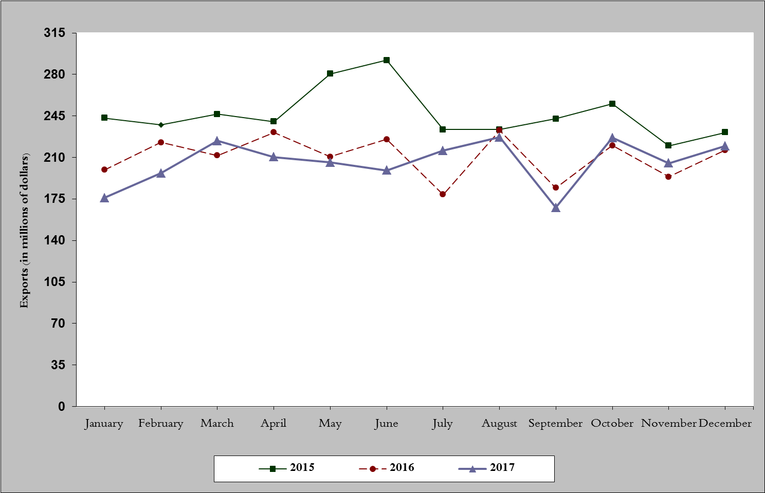
Chart 1: Industrial exports during years 2015-2016-2017
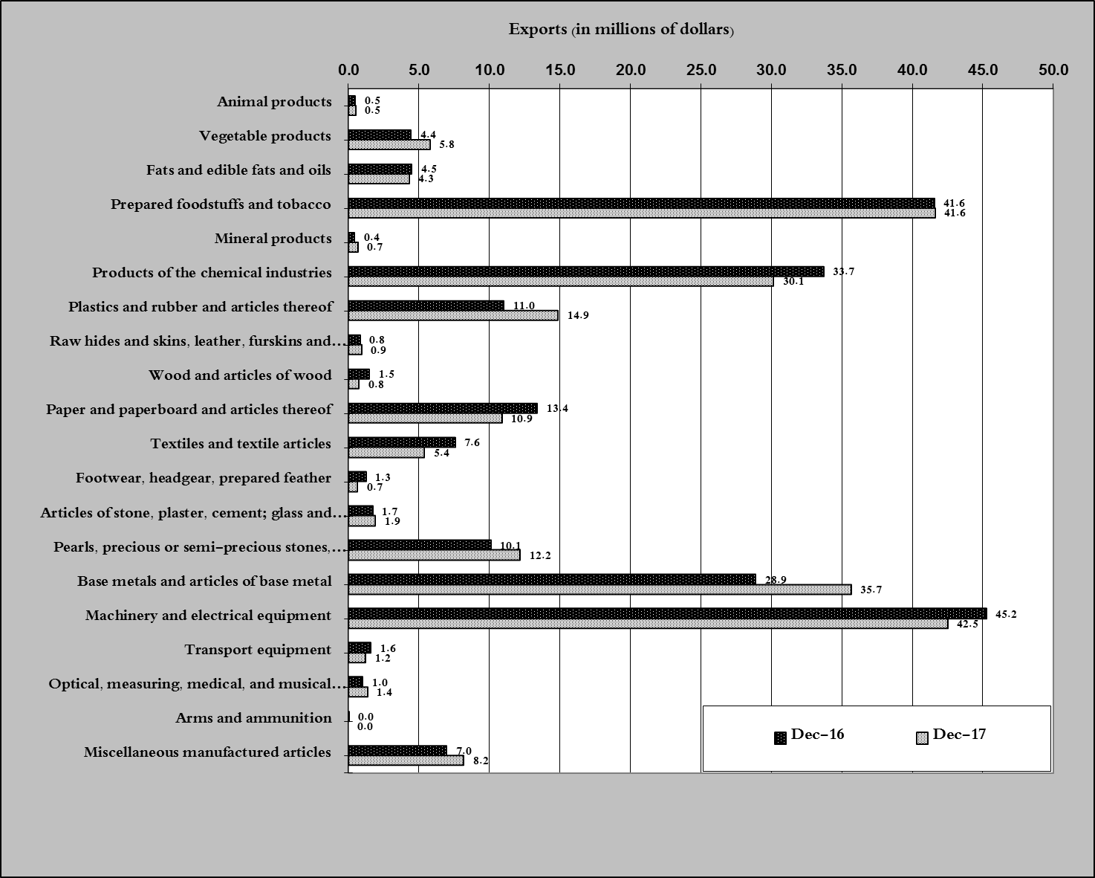
Chart 2: Comparison of industrial exports during December 2017 and December 2016

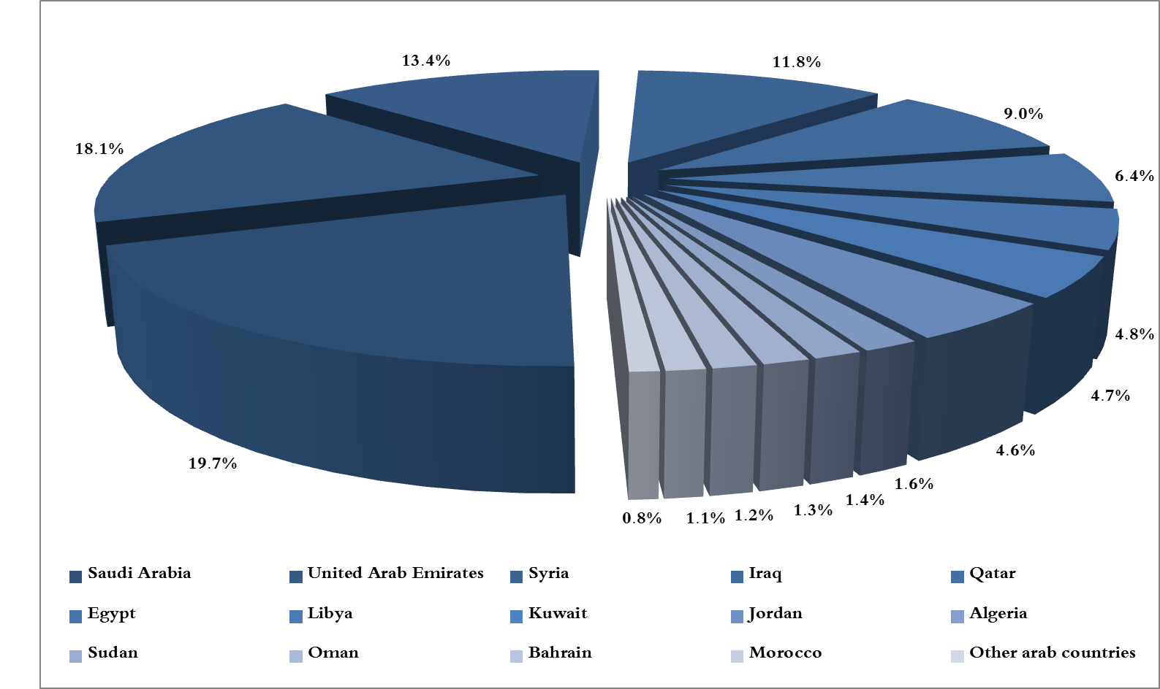
Chart 3: Distribution of industrial exports to Arab countries during December 2017
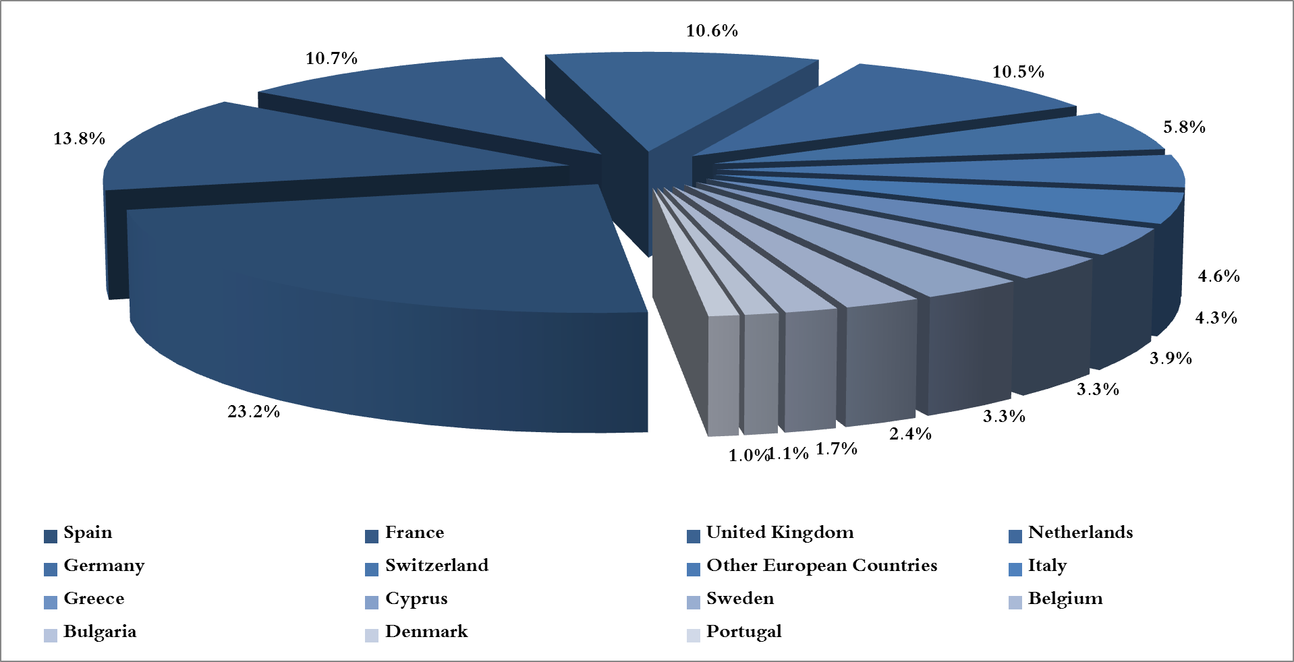
Chart 4: Distribution of industrial exports to European countries during December 2017

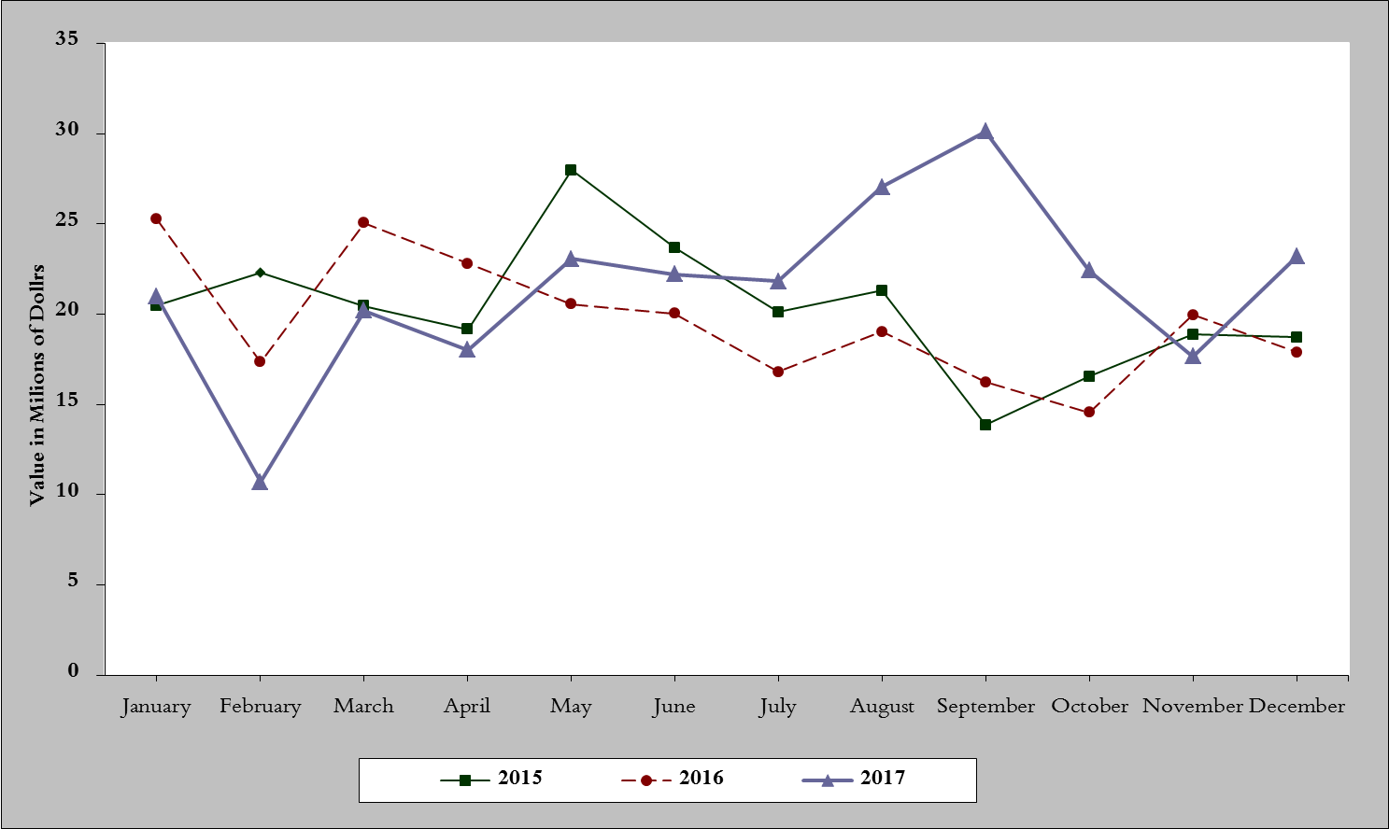
Chart 5: Imports of industrial machinery and equipment during years 2015-2016-2017
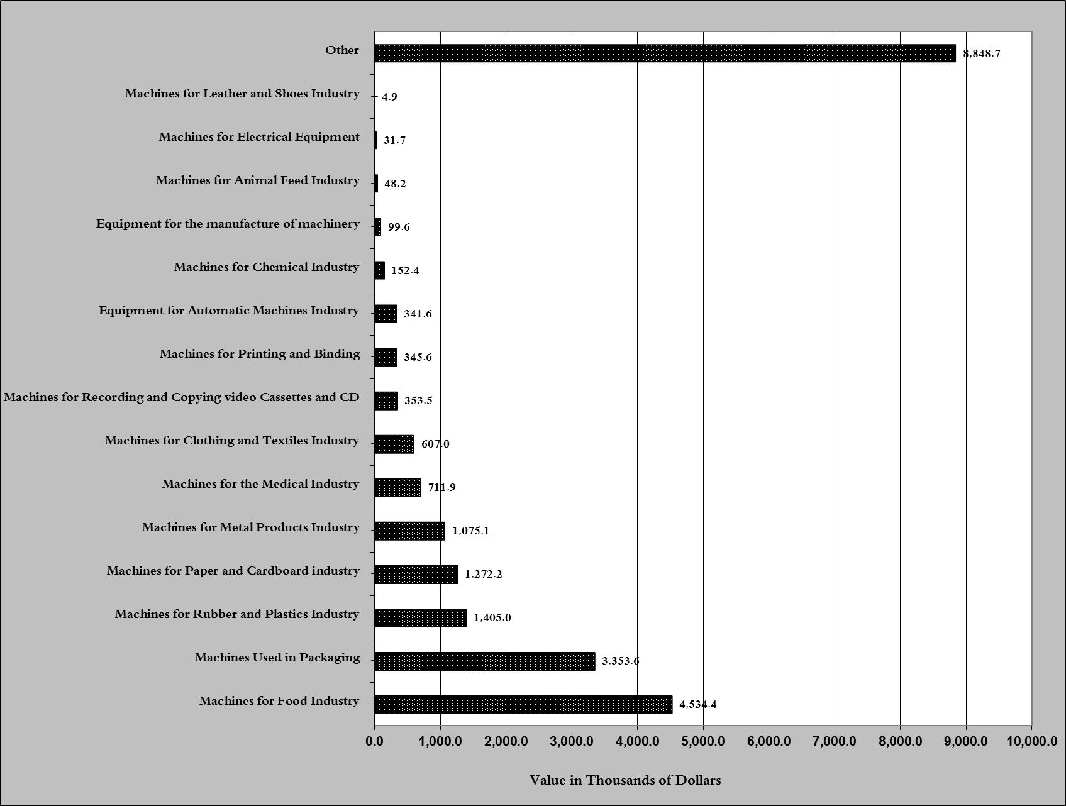
Chart 6: Imports of industrial equipment and machinery according to industrial activity during December 2017

Exports of unworked Diamonds, Silver and Gold Ingots reached this month a value of 39.2 million USD
The machineries and equipment are classified in this table according to the industrial sectors that are used in, while heading "other" includes machineries and equipment that can be used in various sectors.

