

**A detailed report on industrial exports  
and imports of industrial machinery and equipment in February 2017**

**Prepared by:**

**Ministry of Industry**

**Department of Industrial Information**

[**www.industry.gov.lb**](http://www.industry.gov.lb)

Index

I. Introduction ……………………………………………………………………………………….3

II. Industrial exports in February 2017 4

1. Main exported products 4

2. Products with increased exports value 4

2.1. Base metals and articles of base metals 4

2.2. Prepared Foodstuffs and Tobacco 4

3. Products with decreased exports value 5

3.1. Machinery and electrical equipment 5

3.2. Pearls, Precious or semi-precious stones, precious Metals and Articles thereof (Excluding unworked diamonds, silver and gold Ingots) …………………………………………………………………………………………………………5

4. Main export markets 5

4.1. Main export markets by groups of countries 5

4.2. Main export markets by country 5

III. Imports of industrial machinery and equipment 6

1. Imported industrial machinery and equipment by country of origin and industrial activity ………………………………………………………………………….6

IV. Appendix tables………………………… 7

V. Appendix charts ………………………… 20

# Introduction

The Industrial Information Department of the Ministry of Industry has prepared a detailed report on industrial exports and imports of industrial machinery and equipment for the month of February 2017.

It should be noted that the total value of industrial exports during the first two months of the year 2017 amounted about 372.6 million US dollars compared to 422.3 million US dollars during the same period of the year 2016, and 480.6 million US dollars during the same period of the year 2015. Therefore we notice a decline of 11.7% compared to the year 2016, and a decline of 22.5% compared to the year 2015. (Tables 1 and 11(

It should also be noted that the monthly average of the Lebanese industrial exports during the first two months of the year 2017 amounted about 186.3 million US dollars compared to 211.1 million US dollars during the year 2016, and 240.3 million US dollars during the year 2015.

On the other hand, the total value of imports of industrial machinery and equipment during the first two months of the year 2017 amounted about 31.7 million US dollars compared to 42.6 million US dollars during the same period of the year 2016, and 42.8 million US dollars during the same period of the year 2015. Therefore we notice a decline of 25.7% compared to the year 2016, and a decline of 26% compared to the year 2015. (Table 17)

# Industrial exports in February 2017

The total value of industrial exports in February 2017 amounted to nearly 196.8 million US dollars, compared to 222.8 million US dollars in February 2016, and 237.5 million US dollars in February 2015, which is equivalent to a decline of 26 million US dollars, with the rate of 11.7% compared to year 2016, and a decline of 40.7 million US dollars with the rate of 17.1%, compared to year 2015. (Table 1, Chart1)

## Main exported products

Exports of prepared foodstuffs and Tobacco came first in February 2017, with a total value of 39.5 million US dollars; Syria was on top of importers list of this product, with an import value of 9.1 million US dollars. Followed by exports of machinery and electrical equipment, with a total value of 37.5 million US dollars, Iraq was the largest importer of this product, with an import value of 6.2 million US dollars. Then products of the chemical industries, with a total value of 37.3 million US dollars, Brazil topped the importers list of this product, with an import value of 14.8 million US dollars, followed by base metals and articles ofbase metals, with a total value of 25.1 million US dollars. (Tables 2, 4, 6, 8, 10, 15, and 16)

## Products with increased exports value

Statistics showed a significant increase in exports of the following products:

### Base metals and articles of base metals

Exports of this product increased from 20.3 million US dollars in February 2016 to 25.1 million US dollars in February 2017 (Table 2 and Chart 2). The exports of this product increased to Turkey and Portugal which led to an increase in the total value of about 4.8 million US dollars. (Tables 3 and 4)

### Prepared Foodstuffs and Tobacco

Exports of this product increased from 35 million US dollars in February 2016 to 39.5 million US dollars in February 2017 (Table 2 and Chart 2). The exports of this product decreased to Saudi Arabia whereas it increased to Syria, Iraq, and Kuwait which led to an increase of the total value of about 4.6 million US dollars. (Tables 5 and 6)

## Products with decreased exports value

Statistics showed a significant decrease in exports of the following products:

### Machinery and electrical equipment

Exports of this product decreased from 59.9 million US dollars in February 2016 to 37.5 million US dollars in February 2017 (Table 2 and Chart 2). The exports of this product increased to Iraq and Kuwait whereas it decreased to Germany, Saudi Arabia, Algeria, Angola, Ghana, United Arab Emirates, and Egypt which led to a fall of the total value of about 22.3 million US dollars. (Tables 7 and 8)

### Pearls, Precious or semi-precious stones, precious Metals and Articles thereof (Excluding unworked diamonds, silver and gold Ingots)

Exports of this product decreased from 14 million US dollars in February 2016 to 7.2 million US dollars in February 2017 (Table 2 and Chart 2). The exports of this product increased to the United Arab Emirates whereas it decreased to Hong Kong, Belgium, and Switzerland which led to a fall of the total value of about 6.8 million US dollars. (Tables 9 and 10)

## Main export markets

### Main export markets by groups of countries

Arab countries were the main market for Lebanese industrial exports in February 2017, with a total export value of 107.6 million US dollars, with a rate of 54.7% of the total export value. European countries were the second largest export market with a rate of 12.2% of the total export value. Followed by, non-Arab African countries with a rate of 11.1% of the total export value, and, the American countries with a rate of 10.7% of the total export value. The main products exported to Arab countries are: prepared foodstuffs and tobacco with the total value of 26.6 million US dollars, Machinery and electrical equipment with the total value of 24.1 million US dollars, and the products of the chemical with the total value of 16.2 million US dollars. (Table 12)

### Main export markets by country

Among countries importing Lebanese industrial products, Saudi Arabia ranked first with a total value of 19.8 million US dollars, with a rate of 10.1% of the total export value. United Arab Emirates came second with a total value of 19.6 million US dollars with a rate of 10% of the total export value. Followed by, Syria with a total value of 17.3 million US dollars with a rate of 8.8% of the total export value. (Table 13)

During this month, Lebanese products were exported to 37 European countries, 33 non-Arab African countries, 25 non-Arab Asian countries, 19 Arab countries, 16 American countries, and 2 Oceanic countries. Countries that imported Lebanese goods by over 1 million US dollars are as following: 13 Arab countries, 9 European countries, 8 non-Arab African countries, 4 non-Arab Asian countries, 3 American countries, and 1 Oceanic country. (Table 14, Charts 3 and 4)

# Imports of industrial machinery and equipment

The total import value of industrial machinery and equipment in February 2017 reached about 10.7 million US dollars compared to 17.3 million US dollars during the same period in 2016, and 22.3 million US dollars during the same period in 2015, a decline by 38.3% compared to year 2016, and a decline of 52.1% compared to year 2015. (Tables 17 and 18 and Chart 5)

China ranked first on the list of countries exporting industrial machinery and equipment to Lebanon, with a total value amounting to about 3 million US dollars, followed by Germany, with a total value of 1.6 million US dollars, and Italy, with a total value of 1.4 million US dollars. (Table 18)

## Imported industrial machinery and equipment by country of origin and industrial activity

In February 2017, imports of machines for food industry, ranked first, with a total value of 1.7 million US dollars, and China topped the list of countries exporting of this product to Lebanon with exports value of 0.4 million US dollars, followed by machinery for themanufacture of paper and paperboard, with a total value of 0.7 million US dollars. China was the leading exporter of this product with an export value of 0.4 million US dollars. Followed by machinery for medical industry, with a total value of 0.6 million US dollars. (Table 19, Chart 6)

# Appendix tables

**Table 1: Industrial exports during Years 2015 – 2016 – 2017**

|  |  |  |  |  |  |
| --- | --- | --- | --- | --- | --- |
| **Month** | **Year**  **2015** | **Year**  **2016** | **Year**  **2017** | **Variation**  **2015/2017** | **Variation**  **2016/2017** |
| **January** | 243.2 | 199.5 | 175.9 | *-27.7%* | *-11.8%* |
| **February** | 237.5 | 222.8 | 196.8 | *-17.1%* | *-11.7%* |
| **March** | 246.5 | 211.6 |  |  |  |
| **April** | 240.2 | 231.1 |  |  |  |
| **May** | 280.6 | 210.6 |  |  |  |
| **June** | 292.1 | 225.3 |  |  |  |
| **July** | 233.5 | 178.8 |  |  |  |
| **August** | 233.4 | 232.9 |  |  |  |
| **September** | 242.5 | 184.3 |  |  |  |
| **October** | 255.3 | 220.0 |  |  |  |
| **November** | 219.9 | 193.7 |  |  |  |
| **December** | 231.1 | 216.3 |  |  |  |
| **Total** | **2,955.8** | **2,526.9** | **372.6** |  |  |

***All above figures are in Millions of USD***

**Table 2: Comparison of industrial exports during February 2017 and February 2016**

|  |  |  |  |  |  |
| --- | --- | --- | --- | --- | --- |
| **Section** | **Goods** | **February 2016** | **February 2017** | **Variation 2016/2017** | **Variation in % 2016/2017** |
| **1** | **Animal products** | 0.9 | 0.5 | -0.4 | *-44.3%* |
| **2** | **Vegetable products** | 5.5 | 3.0 | -2.5 | *-45.8%* |
| **3** | **Fats and edible fats and oils** | 3.1 | 2.2 | -0.8 | *-26.9%* |
| **4** | **Prepared foodstuffs and tobacco** | 35.0 | 39.5 | 4.6 | *13.1%* |
| **5** | **Mineral products** | 0.5 | 0.6 | 0.1 | *31.3%* |
| **6** | **Products of the chemical industries** | 35.5 | 37.3 | 1.8 | *5.1%* |
| **7** | **Plastics and rubber and articles thereof** | 11.4 | 11.8 | 0.4 | *3.4%* |
| **8** | **Raw hides and skins, leather, furskins and articles thereof** | 1.0 | 0.9 | -0.1 | *-13.0%* |
| **9** | **Wood and articles of wood** | 0.9 | 0.6 | -0.3 | *-31.0%* |
| **10** | **Paper and paperboard and articles thereof** | 12.9 | 12.4 | -0.5 | *-4.0%* |
| **11** | **Textiles and textile articles** | 6.4 | 6.3 | -0.1 | *-1.9%* |
| **12** | **Footwear, headgear, prepared feather** | 1.2 | 1.3 | 0.1 | *10.5%* |
| **13** | **Articles of stone, plaster, cement; glass and glassware** | 2.3 | 1.5 | -0.8 | *-33.6%* |
| **14** | **Pearls, precious or semi-precious stones, precious metals and articles thereof (Excluding unworked diamonds, silver and gold Ingots)** | 14.0 | 7.2 | -6.8 | *-48.7%* |
| **15** | **Base metals and articles of base metal** | 20.3 | 25.1 | 4.8 | *23.5%* |
| **16** | **Machinery and electrical equipment** | 59.9 | 37.5 | -22.3 | *-37.3%* |
| **17** | **Transport equipment** | 2.2 | 1.3 | -0.8 | *-37.9%* |
| **18** | **Optical, measuring, medical, and musical instruments; clocks and watches** | 1.6 | 1.4 | -0.3 | *-15.9%* |
| **19** | **Arms and ammunition** | 0.0 | 0.1 | 0.1 | *3565.1%* |
| **20** | **Miscellaneous manufactured articles** | 8.2 | 6.2 | -2.1 | *-25.1%* |
|  | **Total** | **222.8** | **196.8** | **-26.0** | ***-11.7%*** |

***All above figures are in Millions of USD***

**Table 3: Exports of base metals and articles of base metal according to the main importing countries during February 2016**

|  |  |  |  |  |  |  |  |  |
| --- | --- | --- | --- | --- | --- | --- | --- | --- |
| **Export destination Country** | Turkey | Republic of Korea | Greece | India | Brazil | United Arab Emirates | Saudi Arabia | Japan |
| **Value in thousands of USD** | 2,649 | 2,385 | 1,476 | 1,111 | 928 | 907 | 902 | 899 |

**Table 4: Exports of base metals and articles of base metal according to the main importing countries during February 2017**

|  |  |  |  |  |  |  |  |  |
| --- | --- | --- | --- | --- | --- | --- | --- | --- |
| **Export destination Country** | Turkey | Republic of Korea | Portugal | Italy | Greece | Ivory Coast | China | Saudi Arabia |
| **Value in thousands of USD** | 8,109 | 2,157 | 1,440 | 1,294 | 1,119 | 912 | 752 | 751 |

**Table 5: Exports of prepared foodstuffs and tobacco according to the main importing countries during February 2016**

|  |  |  |  |  |  |  |  |  |
| --- | --- | --- | --- | --- | --- | --- | --- | --- |
| **Export destination Country** | Saudi Arabia | Syria | Iraq | United Arab Emirates | Qatar | Germany | United States Of America | Jordan |
| **Value in thousands of USD** | 5,336 | 4,126 | 2,438 | 2,318 | 1,959 | 1,907 | 1,787 | 1,495 |

**Table 6: Exports of prepared foodstuffs and tobacco according to the main importing countries during February 2017**

|  |  |  |  |  |  |  |  |  |
| --- | --- | --- | --- | --- | --- | --- | --- | --- |
| **Export destination Country** | Syria | Saudi Arabia | Iraq | United Arab Emirates | Kuwait | United States Of America | Jordan | Qatar |
| **Value in thousands of USD** | 9,147 | 4,244 | 3,236 | 2,289 | 2,179 | 2,145 | 1,908 | 1,759 |

**Table 7: Exports of machinery and electrical equipment according to the main importing countries during February 2016**

|  |  |  |  |  |  |  |  |  |
| --- | --- | --- | --- | --- | --- | --- | --- | --- |
| **Export destination Country** | Germany | Saudi Arabia | Iraq | United Arab Emirates | Algeria | Angola | Ghana | Egypt |
| **Value in thousands of USD** | 10,530 | 6,744 | 5,539 | 5,042 | 3,327 | 3,254 | 3,090 | 2,618 |

**Table 8: Exports of machinery and electrical equipment according to the main importing countries during February 2017**

|  |  |  |  |  |  |  |  |  |
| --- | --- | --- | --- | --- | --- | --- | --- | --- |
| **Export destination Country** | Iraq | Saudi Arabia | United Arab Emirates | Kuwait | Syria | Free Zone | Egypt | Ghana |
| **Value in thousands of USD** | 6,213 | 4,409 | 3,492 | 3,291 | 2,560 | 1,879 | 1,385 | 1,137 |

**Table 9: Exports of pearls, precious or semi-precious stones, precious metals and articles thereof[1] according to the main importing countries during February 2016**

|  |  |  |  |  |  |  |  |  |
| --- | --- | --- | --- | --- | --- | --- | --- | --- |
| **Export destination Country** | Hong Kong | United Arab Emirates | Belgium | Jordan | Switzerland | United States Of America | Other | Saudi Arabia |
| **Value in thousands of USD** | 5,627 | 2,910 | 1,363 | 723 | 717 | 624 | 608 | 445 |

**Table 10: Exports of pearls, precious or semi-precious stones, precious metals and articles thereof1 according to the main importing countries during February 2017**

|  |  |  |  |  |  |  |  |  |
| --- | --- | --- | --- | --- | --- | --- | --- | --- |
| **Export destination Country** | United Arab Emirates | Qatar | Jordan | Saudi Arabia | United States Of America | Thailand | Hong Kong | Kuwait |
| **Value in thousands of USD** | 4,230 | 666 | 427 | 375 | 374 | 318 | 314 | 169 |

**Table 11: Industrial exports according to exported goods during year 2017**



**Table 12: Industrial exports according to exported goods and countries groups during February 2017**

|  |  |  |  |  |  |  |  |  |
| --- | --- | --- | --- | --- | --- | --- | --- | --- |
| **Goods** | **Arab Countries** | **European Countries** | **Oceania Countries** | **Non-Arab Asian countries** | **American Countries** | **Non-Arab African countries** | **Other\*** | **Total** |
| **Animal products** | 378 |  | 13 |  | 36 | 64 |  | **491** |
| **Vegetable products** | 1,326 | 669 | 11 | 224 | 418 | 347 |  | **2,996** |
| **Fats and edible fats and oils** | 1,057 | 454 | 56 | 3 | 425 | 247 | 1 | **2,243** |
| **Prepared foodstuffs and tobacco** | 26,609 | 5,175 | 750 | 736 | 3,457 | 2,222 | 601 | **39,549** |
| **Mineral products** | 345 | 95 |  | 34 | 2 | 62 | 91 | **628** |
| **Products of the chemical industries** | 16,167 | 4,063 | 80 | 588 | 15,114 | 1,154 | 145 | **37,312** |
| **Plastics and rubber and articles thereof** | 8,141 | 772 | 28 | 400 | 17 | 2,278 | 145 | **11,780** |
| **Raw hides and skins, leather, furskins and articles thereof** | 598 | 208 |  | 47 | 6 | 33 |  | **892** |
| **Wood and articles of wood** | 510 | 1 |  | 2 | 10 | 111 |  | **633** |
| **Paper and paperboard and articles thereof** | 9,248 | 1,087 | 2 | 649 | 63 | 1,209 | 96 | **12,356** |
| **Textiles and textile articles** | 3,357 | 2,121 | 6 | 203 | 236 | 246 | 106 | **6,275** |
| **Footwear, headgear, prepared feather** | 1,136 | 42 |  | 71 |  | 25 |  | **1,274** |
| **Articles of stone, plaster, cement; glass and glassware** | 884 | 62 | 12 | 5 | 163 | 416 | 3 | **1,545** |
| **Pearls, precious or semi-precious stones, precious metals and articles thereof (Excluding unworked diamonds, silver and gold Ingots)** | 5,867 | 205 |  | 679 | 374 | 71 |  | **7,196** |
| **Base metals and articles of base metal** | 3,360 | 6,133 | 88 | 12,260 | 156 | 2,802 | 291 | **25,090** |
| **Machinery and electrical equipment** | 24,121 | 2,219 | 40 | 876 | 169 | 8,072 | 2,037 | **37,534** |
| **Transport equipment** | 310 | 146 |  | 246 | 10 | 632 |  | **1,345** |
| **Optical, measuring, medical, and musical instruments; clocks and watches** | 416 | 265 |  | 517 | 19 | 157 |  | **1,374** |
| **Arms and ammunition** | 9 |  |  | 96 |  |  |  | **105** |
| **Miscellaneous manufactured articles** | 3,763 | 243 | 5 | 15 | 367 | 1,781 |  | **6,174** |
| **Total** | **107,599** | **23,961** | **1,092** | **17,651** | **21,041** | **21,929** | **3,517** | **196,789** |

**All the above figures are in thousands of US dollars.**

**\* "other" Includes exported goods to the duty free market and those that are supplied to ships and aircraft.**

**Table 13: Distribution of the industrial exports according to the main importing countries during February 2017**

|  |  |  |  |  |  |  |  |  |
| --- | --- | --- | --- | --- | --- | --- | --- | --- |
| **Export destination Country** | Saudi Arabia | United Arab Emirates | Syria | Iraq | Brazil | Turkey | Kuwait | Jordan |
| **Value in thousands of USD** | 19,829 | 19,647 | 17,339 | 15,760 | 14,915 | 9,022 | 8,278 | 8,065 |

|  |  |  |  |  |  |  |  |  |
| --- | --- | --- | --- | --- | --- | --- | --- | --- |
| **Export destination Country** | Qatar | United States Of America | Ivory Coast | Egypt | Italy | Germany | Ghana | Congo |
| **Value in thousands of USD** | 5,517 | 4,224 | 4,165 | 4,078 | 3,547 | 2,723 | 2,641 | 2,638 |

|  |  |  |  |  |  |  |  |  |
| --- | --- | --- | --- | --- | --- | --- | --- | --- |
| **Export destination Country** | Greece | France | United Kingdom | Republic of Korea | Portugal | Oman | Sierra Leone | Netherlands |
| **Value in thousands of USD** | 2,586 | 2,476 | 2,227 | 2,171 | 1,899 | 1,855 | 1,823 | 1,741 |

**Table 14: Distribution of importing countries according to countries groups and the value of exports during February 2017**

|  |  |  |  |  |  |  |  |
| --- | --- | --- | --- | --- | --- | --- | --- |
| **Exports Value**  **(in million USD)** | **Arab Countries** | **European Countries** | **Oceania Countries** | **Non-Arab Asian countries** | **American Countries** | **Non-Arab African countries** | **Total** |
| **]0-1[** | 6 | 28 | 1 | 21 | 13 | 25 | **94** |
| **[1-5[** | 6 | 9 | 1 | 3 | 2 | 8 | **29** |
| **[5-10[** | 3 |  |  | 1 |  |  | **4** |
| **[10-15[** |  |  |  |  | 1 |  | **1** |
| **More than 15 million USD** | 4 |  |  |  |  |  | **4** |
| **Total** | **19** | **37** | **2** | **25** | **16** | **33** | **132** |

**Table 15: Distribution of the industrial exports according to product and to the main importing countries during February 2017**

|  |  |  |  |  |  |  |  |  |
| --- | --- | --- | --- | --- | --- | --- | --- | --- |
| **Animal products** | United Arab Emirates | Saudi Arabia | Iraq | Qatar | United States Of America | Liberia | Kuwait | Australia |
| **Value in 1000 of USD** | 128 | 101 | 63 | 61 | 25 | 20 | 19 | 13 |

|  |  |  |  |  |  |  |  |  |
| --- | --- | --- | --- | --- | --- | --- | --- | --- |
| **Vegetable products** | Qatar | United States Of America | Germany | Jordan | Turkey | Sweden | Saudi Arabia | Sudan |
| **Value in 1000 of USD** | 314 | 264 | 258 | 206 | 206 | 176 | 171 | 140 |

|  |  |  |  |  |  |  |  |  |
| --- | --- | --- | --- | --- | --- | --- | --- | --- |
| **Fats and edible fats and oils** | Portugal | United Arab Emirates | Iraq | United States Of America | Kuwait | Canada | Saudi Arabia | Syria |
| **Value in 1000 of USD** | 334 | 248 | 232 | 210 | 208 | 185 | 180 | 129 |

|  |  |  |  |  |  |  |  |  |
| --- | --- | --- | --- | --- | --- | --- | --- | --- |
| **Mineral Products** | Syria | Jordan | Other | Bulgaria | Qatar | Italy | Sierra Leone | China |
| **Value in 1000 of USD** | 196 | 102 | 75 | 67 | 27 | 26 | 20 | 19 |

|  |  |  |  |  |  |  |  |  |
| --- | --- | --- | --- | --- | --- | --- | --- | --- |
| **Products of the chemical industries** | Brazil | United Arab Emirates | Iraq | Saudi Arabia | Jordan | Italy | Kuwait | Greece |
| **Value in 1000 of USD** | 14,844 | 4,771 | 3,563 | 1,919 | 1,725 | 1,648 | 1,451 | 1,171 |

|  |  |  |  |  |  |  |  |  |
| --- | --- | --- | --- | --- | --- | --- | --- | --- |
| **Plastics and rubber and articles thereof** | Syria | Saudi Arabia | Iraq | Jordan | Egypt | Congo | Ghana | Sudan |
| **Value in 1000 of USD** | 2,908 | 2,319 | 832 | 427 | 391 | 390 | 346 | 313 |

|  |  |  |  |  |  |  |  |  |
| --- | --- | --- | --- | --- | --- | --- | --- | --- |
| **Raw hides and skins, leather, furskins and articles thereof** | United Arab Emirates | Qatar | Portugal | Saudi Arabia | Egypt | France | Nigeria | Switzerland |
| **Value in 1000 of USD** | 273 | 139 | 88 | 84 | 76 | 35 | 31 | 24 |

|  |  |  |  |  |  |  |  |  |
| --- | --- | --- | --- | --- | --- | --- | --- | --- |
| **Wood & Articles of Wood** | Syria | Saudi Arabia | United Arab Emirates | Qatar | Congo | Ivory Coast | Nigeria | Iraq |
| **Value in 1000 of USD** | 257 | 98 | 70 | 53 | 26 | 21 | 20 | 12 |

|  |  |  |  |  |  |  |  |  |
| --- | --- | --- | --- | --- | --- | --- | --- | --- |
| **Paper and Paperboard & Articles Thereof** | Saudi Arabia | Jordan | United Arab Emirates | Egypt | Iraq | Tunisia | Morocco | Syria |
| **Value in 1000 of USD** | 1,974 | 1,224 | 977 | 925 | 745 | 654 | 528 | 499 |

**Table 15: (continued) Distribution of the industrial exports according to product and the main importing countries during February 2017**

|  |  |  |  |  |  |  |  |  |
| --- | --- | --- | --- | --- | --- | --- | --- | --- |
| **Textiles & textile articles** | United Arab Emirates | Germany | Syria | Switzerland | Egypt | Saudi Arabia | Jordan | Qatar |
| **Value in 1000 of USD** | 1,198 | 744 | 481 | 459 | 377 | 367 | 352 | 317 |

|  |  |  |  |  |  |  |  |  |
| --- | --- | --- | --- | --- | --- | --- | --- | --- |
| **Footwear, Headgear, Prepared Feather** | Saudi Arabia | Egypt | United Arab Emirates | Sri Lanka | France | Ukraine | Qatar | Senegal |
| **Value in 1000 of USD** | 874 | 141 | 105 | 67 | 23 | 10 | 9 | 8 |

|  |  |  |  |  |  |  |  |  |
| --- | --- | --- | --- | --- | --- | --- | --- | --- |
| **Articles of stone, plaster, cement; glass and glassware** | Qatar | Saudi Arabia | United States Of America | Ivory Coast | Iraq | United Arab Emirates | Kuwait | Nigeria |
| **Value in 1000 of USD** | 298 | 175 | 156 | 115 | 104 | 102 | 92 | 64 |

|  |  |  |  |  |  |  |  |  |
| --- | --- | --- | --- | --- | --- | --- | --- | --- |
| **Transport Equipment** | Ivory Coast | Iran | United Arab Emirates | Libya | Guinea | Germany | France | Tanzania |
| **Value in 1000 of USD** | 412 | 244 | 108 | 96 | 90 | 86 | 52 | 35 |

|  |  |  |  |  |  |  |  |  |
| --- | --- | --- | --- | --- | --- | --- | --- | --- |
| **Optical, measuring, medical, and musical instruments; clocks and watches** | Hong Kong | United Arab Emirates | Switzerland | Upper Volta | United Kingdom | Nigeria | Germany | Jordan |
| **Value in 1000 of USD** | 517 | 359 | 133 | 76 | 70 | 56 | 39 | 32 |

|  |  |  |  |  |  |  |  |  |
| --- | --- | --- | --- | --- | --- | --- | --- | --- |
| **Arms and Ammunition** | Afghanistan | Jordan |  |  |  |  |  |  |
| **Value in 1000 of USD** | 96 | 9 |  |  |  |  |  |  |

|  |  |  |  |  |  |  |  |  |
| --- | --- | --- | --- | --- | --- | --- | --- | --- |
| **Miscellaneous Manufactured Articles** | Saudi Arabia | Ivory Coast | Qatar | United Arab Emirates | Sierra Leone | United States Of America | Iraq | Jordan |
| **Value in 1000 of USD** | 1,790 | 680 | 657 | 414 | 336 | 332 | 315 | 216 |

**Table 16: Distribution of industrial exports, according to the main exported goods and main importing countries during February 2017**



**Table 17: Imports of industrial machinery and equipment during years 2015-2016-2017**

|  |  |  |  |  |  |
| --- | --- | --- | --- | --- | --- |
| **Month** | **Year**  **2015** | **Year**  **2016** | **Year**  **2017** | **Variation**  **2015/2017** | **Variation**  **2016/2017** |
| **January** | 20.5 | 25.3 | 21.0 | *2.4%* | *-17.1%* |
| **February** | 22.3 | 17.3 | 10.7 | *-52.1%* | *-38.3%* |
| **March** | 20.5 | 25.1 |  |  |  |
| **April** | 19.1 | 22.8 |  |  |  |
| **May** | 28.0 | 20.5 |  |  |  |
| **June** | 23.7 | 20.0 |  |  |  |
| **July** | 20.1 | 16.8 |  |  |  |
| **August** | 21.3 | 19.0 |  |  |  |
| **September** | 13.8 | 16.2 |  |  |  |
| **October** | 16.5 | 14.5 |  |  |  |
| **November** | 18.9 | 20.0 |  |  |  |
| **December** | 18.7 | 17.9 |  |  |  |
| **Total** | **243.4** | **235.5** | **31.7** |  |  |

***All above figures are in Millions of USD***

**Table 18: Imports of industrial equipment and machinery according to exporting country for the year 2017**



**Table 19: Imports of industrial equipment and machinery according to industrial activity[2] and country during February 2017**



# Appendix charts

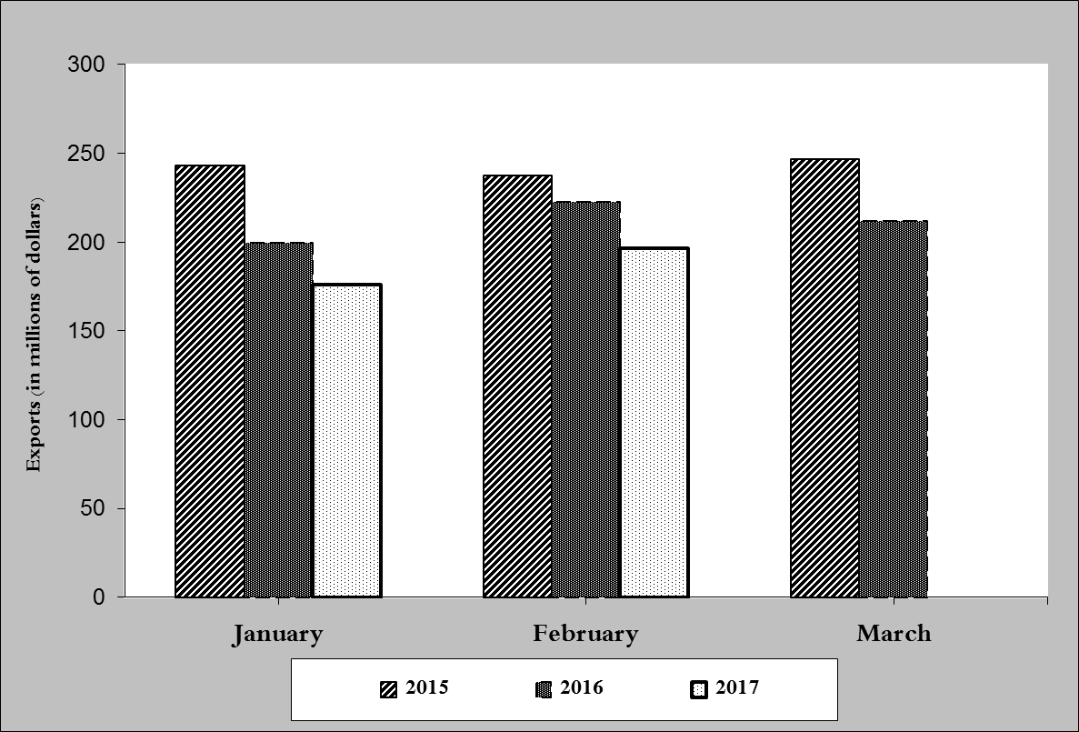

**Chart 1: Industrial exports during years 2015-2016-2017**

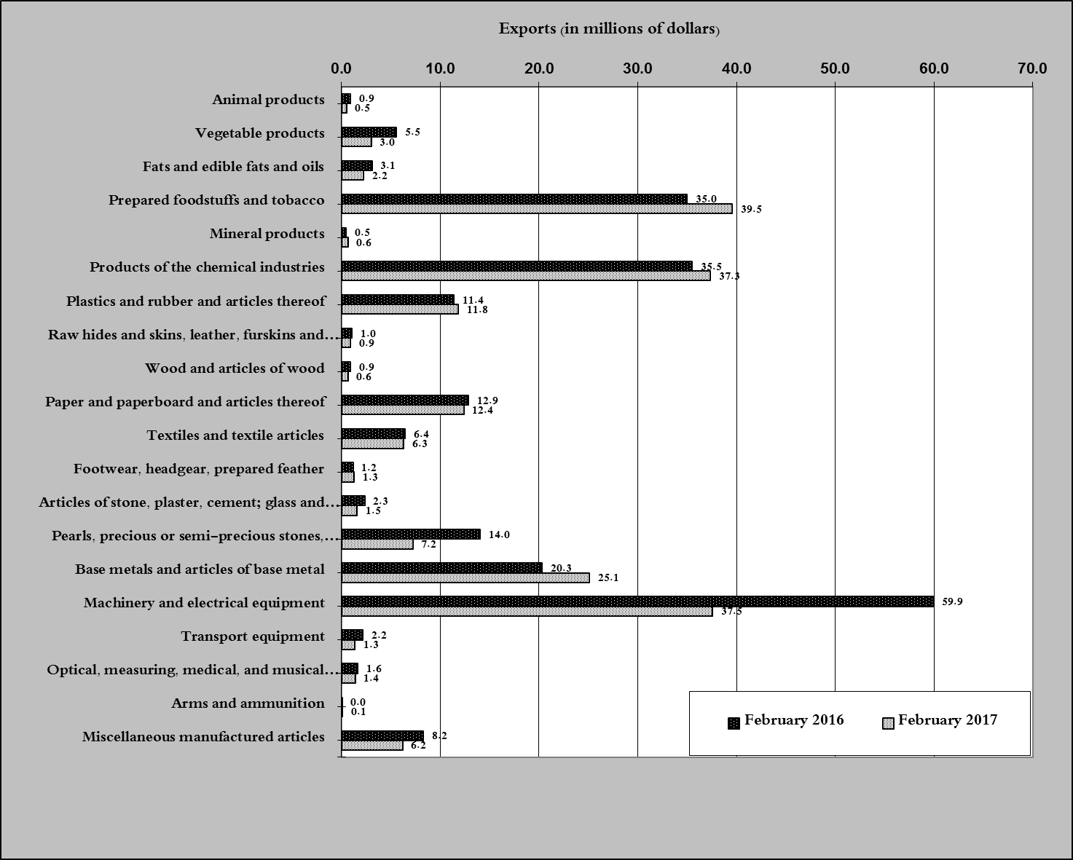

**Chart 2: Comparison of industrial exports during February 2017 and February 2016**

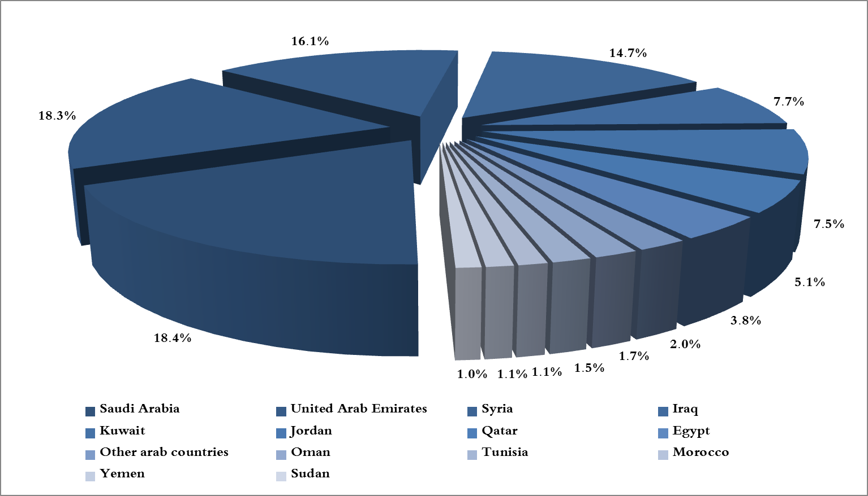

**Chart 3: Distribution of industrial exports to Arab countries during February 2017**

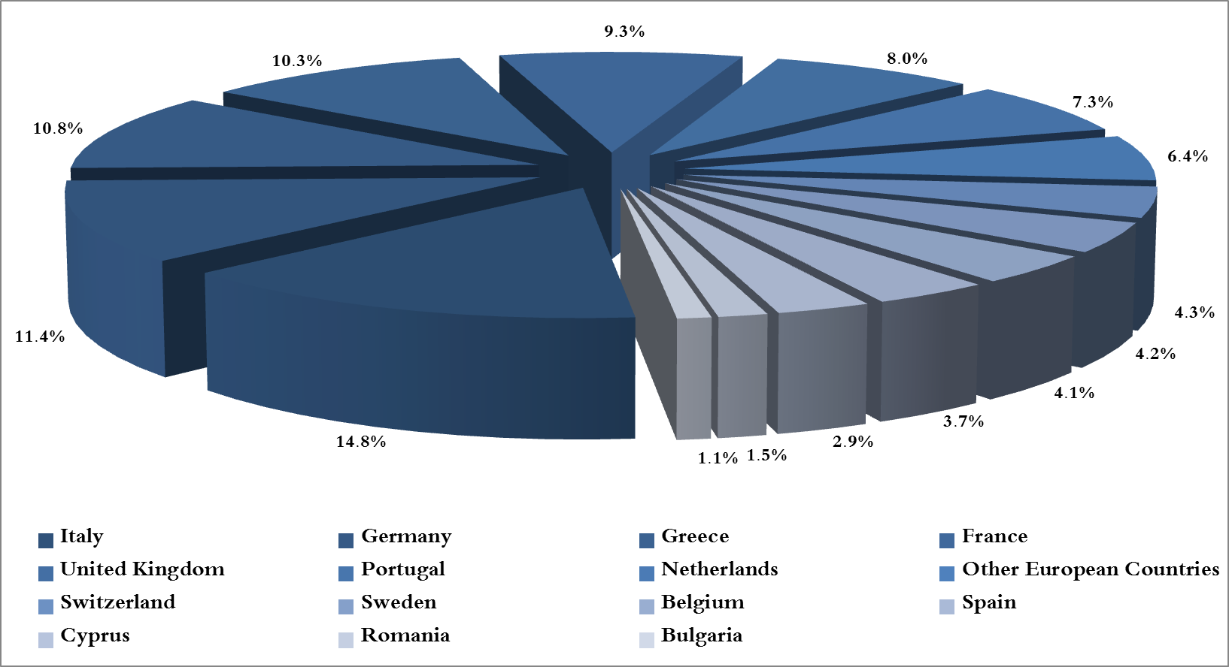

**Chart 4: Distribution of industrial exports to European countries during February 2017**

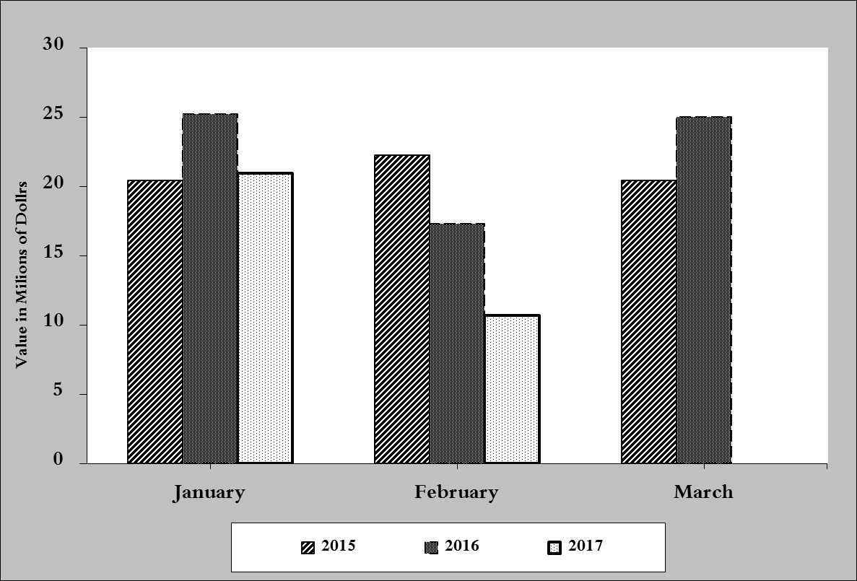

**Chart 5: Imports of industrial machinery and equipment during years 2015-2016-2017**

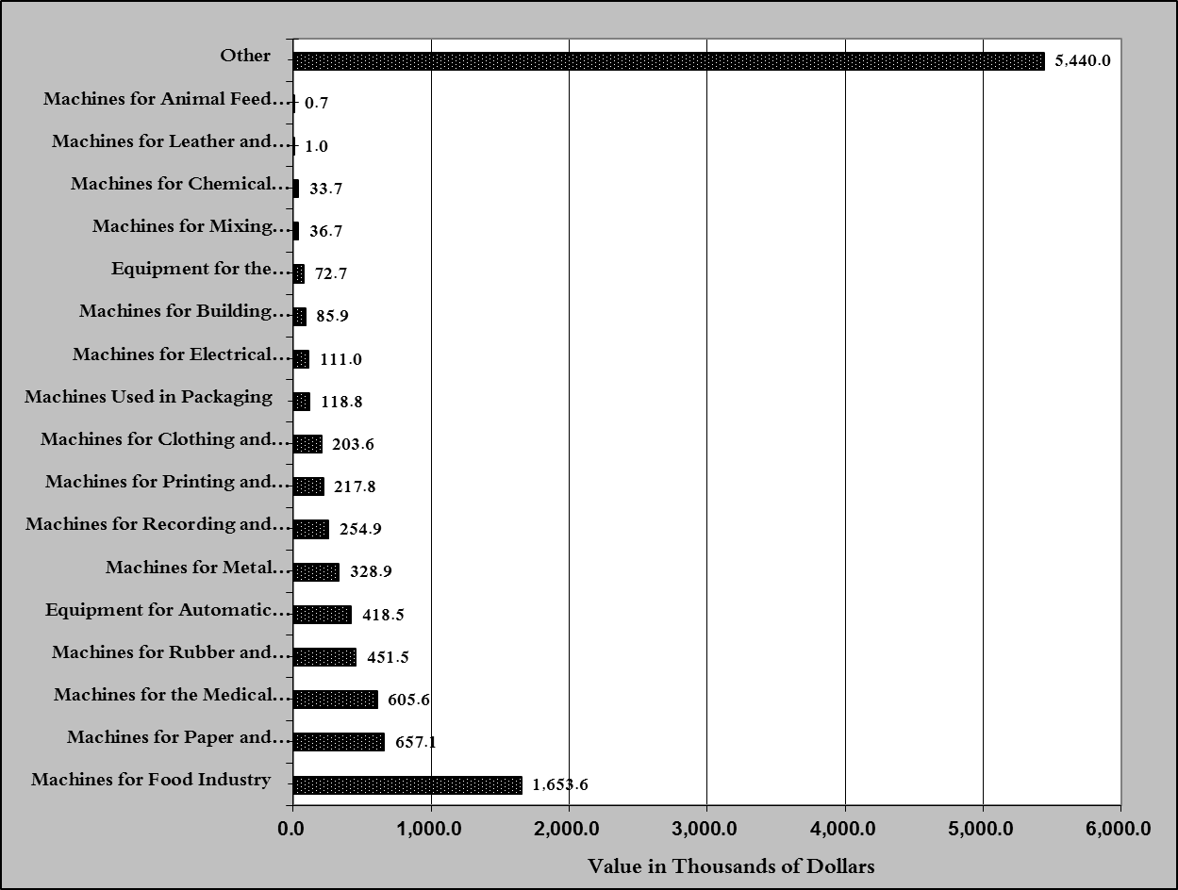

**Chart 6: Imports of industrial equipment and machinery according to industrial activity during February 2017**

1. **Excluding unworked Diamonds, Silver and Gold Ingots which reached this month a value of 30.9 million USD**
2. **The machineries and equipment are classified in this table according to the industrial sectors that are used in, while heading "other" includes machineries and equipment that can be used in various sectors.**