

A detailed report on industrial exports
and imports of industrial machinery and equipment in July 2017

Prepared by:
Ministry of Industry
Industrial Information Department

www.industry.gov.lb
Index

I. Introduction 3
II. Industrial exports in July 2017 4
1. Main exported products 4
2. Products with increased exports value 4
2.1. Base metals and articles of base metal 4
2.2. Paper and paperboard and articles thereof 4
3. Products with decreased exports value 5
3.1. Fats and edible fats and oils 5
3.2. Wood and articles of wood 5
4. Main export markets 5
4.1. Main export markets by groups of countries 5
4.2. Main export markets by country 5
III. Imports of industrial machinery and equipment 6
1. Imported industrial machinery and equipment by country of origin 6
2. Imported industrial machinery and equipment by country of origin and industrial activity 6
IV. Appendix tables 7
V. Appendix charts 20

Introduction
The Industrial Information Department of the Ministry of Industry has prepared a detailed report on industrial exports and imports of industrial machinery and equipment for the month of July 2017.
It should be noted that the total value of industrial exports during the first seven months of the year 2017 amounted about 1 billion and 428 million US dollars compared to 1 billion and 480 million US dollars during the same period of the year 2016, and 1 billion and 774 million US dollars during the same period of the year 2015. Therefore we notice a decline of 3.5% compared to the year 2016, and a decline of 19.5% compared to the year 2015. (Tables 1 and 11(
It should also be noted that the monthly average of the Lebanese industrial exports during the first seven months of the year 2017 amounted about 203.9 million US dollars compared to 211.4 million US dollars during the year 2016, and 253.4 million US dollars during the year 2015.
On the other hand, the total value of imports of industrial machinery and equipment during the first seven months of the year 2017 amounted about 137 million US dollars compared to 147.8 million US dollars during the same period of the year 2016, and 154.2 million US dollars during the same period of the year 2015. Therefore, we notice a decline of 7.3% compared to the year 2016, and a decline of 11.1% compared to the year 2015. (Table 17)

Industrial exports in July 2017
The total value of industrial exports in July 2017 amounted to nearly 215.7 million US dollars, compared to 178.8 million US dollars in July 2016, and 233.5 million US dollars in July 2015, which is equivalent to an increase of 37 million US dollars, with the rate of 20.7% compared to year 2016, and a decline of 17.8 million US dollars with the rate of 7.6%, compared to year 2015. (Table 1, Chart 1)

Main exported products
Exports of products of the chemical industries came first in July 2017, with a total value of 50.1 million US dollars; Bangladesh was on top of importers list of this product, with an import value of 21.2 million US dollars. Followed by exports of machinery and electrical equipment, with a total value of 38.5 million US dollars, Iraq was the largest importer of this product, with an import value of 7.8 million US dollars. Then prepared foodstuffs and tobacco, with a total value of 33.9 million US dollars, Saudi Arabia topped the importers list of this product, with an import value of 5.7 million US dollars, followed by base metals and articles of base metal, with a total value of 26.9 million US dollars. (For more details tables 2, 4, 6, 8, 10, 15, and 16)

Products with increased exports value
Statistics showed a significant increase in exports of the following products:

Base metals and articles of base metal
Exports of this product increased from 13.8 million US dollars in July 2016 to 26.9 million US dollars in July 2017 (Table 2 and Chart 2). The exports of this product mainly increased to Turkey, Spain and Republic of Korea which led to an increase in the total value of about 13.1 million US dollars. (Tables 3 and 4)

Paper and paperboard and articles thereof
Exports of this product increased from 10.8 million US dollars in July 2016 to 18.9 million US dollars in July 2017 (Table 2 and Chart 2). The exports of this product mainly increased to Iraq which led to an increase of the total value of about 8.1 million US dollars. (Tables 5 and 6)

Products with decreased exports value
Statistics showed a significant decrease in exports of the following products:

Fats and edible fats and oils
Exports of this product decreased from 2.7 million US dollars in July 2016 to 2.2 million US dollars in July 2017 (Table 2 and Chart 2). The exports of this product increased to Portugal whereas it mainly decreased to Holland, Saudi Arabia, and Venezuela which led to a fall of the total value of about 0.5 million US dollars. (Tables 7 and 8)

Wood and articles of wood
Exports of this product decreased from 1.3 million US dollars in July 2016 to 0.7 million US dollars in July 2017 (Table 2 and Chart 2). The exports of this product increased to Syria whereas it mainly decreased to Qatar and Saudi Arabia which led to a fall of the total value of about 0.5 million US dollars. (Tables 9 and 10)

Main export markets

Main export markets by groups of countries
Arab countries were the main market for Lebanese industrial exports in July 2017, with a total export value of 117.9 million US dollars, with a rate of 54.7% of the total export value. Non-arab Asian countries were the second largest export markets with a rate of 18.3% of the total export value. Followed by, European countries with a rate of 13.8% of the total export value, and, the Non-arab African countries with a rate of 9.4% of the total export value. The main products exported to Arab countries are: machinery and electrical equipment with the total value of 26.9 million US dollars, prepared foodstuffs and tobacco with the total value of 22.6 million US dollars, and the products of the chemical industries with the total value of 18.7 million US dollars. (Table 12)

Main export markets by country
Among countries importing Lebanese industrial products, Iraq ranked first with a total value of 25.1 million US dollars, with a rate of 11.6% of the total export value. Saudi Arabia came second with a total value of 22.5 million US dollars with a rate of 10.4% of the total export value. Followed by, Bangladesh with a total value of 21.2 million US dollars with a rate of 9.8% of the total exports value. (Table 13)
During this month, Lebanese products were exported to 44 European countries, 40 Non-arab African countries, 27 Non-arab Asian countries, 25 American countries, 19 Arab countries, and 6 Oceanic countries. Countries that imported Lebanese goods by over 1 million US dollars are as following: 11 Arab countries, 10 European countries, 7 Non-arab African countries, 4 Non-arab Asian countries, 2 American countries. (Table 14, Charts 3 and 4)

Imports of industrial machinery and equipment
The total import value of industrial machinery and equipment in July 2017 reached about 21.8 million US dollars compared to 16.8 million US dollars during the same period in 2016, and 20.1 million US dollars during the same period in 2015, an increase by 29.8% compared to year 2016, and an increase of 8.5% compared to year 2015. (Tables 17 and 18 and Chart 5)

Imported industrial machinery and equipment by country of origin
China ranked first on the list of countries exporting industrial machinery and equipment to Lebanon, with a total value amounting to about 5.8 million US dollars, followed by Italy, with a total value of 5.1 million US dollars, and France, with a total value of 1.9 million US dollars. (Table 18)

Imported industrial machinery and equipment by country of origin and industrial activity
In July 2017, imports of machines for food industry, ranked first, with a total value of 3.3 million US dollars, and Italy topped the list of countries exporting of this product to Lebanon with exports value of 1.2 million US dollars, followed by machines used in packaging, with a total value of 2.7 million US dollars. Italy was the leading exporter of this product with an export value of 1.2 million US dollars. Followed by machines for paper and cardboard industry, with a total value of 2.4 million US dollars. (Table 19, Chart 6)

Appendix tables

Table 1: Industrial exports during Years 2015 – 2016 – 2017
Month | Year  2015 | Year  2016 | Year  2017 | Variation  2015/2017 | Variation  2016/2017
January | 243.2 | 199.5 | 175.9 | -27.7% | -11.8%
February | 237.5 | 222.8 | 196.8 | -17.1% | -11.7%
March | 246.5 | 211.6 | 223.9 | -9.2% | 5.8%
April | 240.2 | 231.1 | 210.4 | -12.4% | -8.9%
May | 280.6 | 210.6 | 205.9 | -26.6% | -2.3%
June | 292.1 | 225.3 | 199.0 | -31.9% | -11.7%
July | 233.5 | 178.8 | 215.7 | -7.6% | 20.7%
August | 233.4 | 232.9
September | 242.5 | 184.3
October | 255.3 | 220.0
November | 219.9 | 193.7
December | 231.1 | 216.3
Total | 2,955.8 | 2,526.9 | 1,427.6
All above figures are in Millions of USD

Table 2: Comparison of industrial exports during July 2017 and July 2016
Section | Goods | July 2016 | July 2017 | Variation 2016/2017 | Variation in % 2016/2017
1 | Animal products | 0.2 | 0.5 | 0.3 | 119.6%
2 | Vegetable products | 3.4 | 3.5 | 0.1 | 2.7%
3 | Fats and edible fats and oils | 2.7 | 2.2 | -0.5 | -17.1%
4 | Prepared foodstuffs and tobacco | 30.6 | 33.9 | 3.3 | 10.9%
5 | Mineral products | 0.7 | 0.5 | -0.2 | -34.4%
6 | Products of the chemical industries | 42.2 | 50.1 | 7.9 | 18.7%
7 | Plastics and rubber and articles thereof | 11.0 | 13.4 | 2.4 | 21.9%
8 | Raw hides and skins, leather, furskins and articles thereof | 1.2 | 0.8 | -0.4 | -35.0%
9 | Wood and articles of wood | 1.3 | 0.7 | -0.5 | -42.7%
10 | Paper and paperboard and articles thereof | 10.8 | 18.9 | 8.1 | 75.5%
11 | Textiles and textile articles | 6.7 | 6.8 | 0.1 | 1.5%
12 | Footwear, headgear, prepared feather | 0.5 | 0.6 | 0.1 | 18.6%
13 | Articles of stone, plaster, cement; glass and glassware | 1.3 | 1.4 | 0.1 | 10.5%
14 | Pearls, precious or semi-precious stones, precious metals and articles thereof (Excluding unworked diamonds, silver and gold Ingots) | 6.7 | 7.3 | 0.6 | 9.5%
15 | Base metals and articles of base metal | 13.8 | 26.9 | 13.1 | 94.7%
16 | Machinery and electrical equipment | 35.8 | 38.5 | 2.7 | 7.5%
17 | Transport equipment | 1.6 | 1.4 | -0.2 | -12.3%
18 | Optical, measuring, medical, and musical instruments; clocks and watches | 1.8 | 1.4 | -0.4 | -23.0%
19 | Arms and ammunition | 0.0 | 0.0 | 0.0 | 0%
20 | Miscellaneous manufactured articles | 6.5 | 6.8 | 0.3 | 5.0%
 | Total | 178.8 | 215.7 | 37.0 | 20.7%
All above figures are in Millions of USD
Table 3: Exports of base metals and articles of base metal according to the main importing countries during July 2016
Export destination Country | Republic of Korea | Spain | Saudi Arabia | Japan | Nigeria | India | Ivory Coast | Netherlands
Value in thousands of USD | 2,483 | 1,070 | 964 | 815 | 642 | 640 | 526 | 480

Table 4: Exports of base metals and articles of base metal according to the main importing countries during July 2017
Export destination Country | Turkey | Republic of Korea | Spain | Greece | Belgium | Saudi Arabia | India | Bulgaria
Value in thousands of USD | 9,029 | 3,807 | 2,702 | 1,311 | 888 | 830 | 668 | 613

Table 5: Exports of paper and paperboard and articles thereof according to the main importing countries during July 2016
Export destination Country | Iraq | Saudi Arabia | Algeria | Syria | Egypt | United Arab Emirates | Morocco | Ivory Coast
Value in thousands of USD | 1,944 | 1,806 | 749 | 638 | 629 | 549 | 521 | 505

Table 6: Exports of paper and paperboard and articles thereof according to the main importing countries during July 2017
Export destination Country | Iraq | Saudi Arabia | Morocco | Egypt | Syria | Algeria | Ivory Coast | Jordan
Value in thousands of USD | 6,857 | 1,517 | 1,304 | 1,303 | 1,249 | 887 | 828 | 659

Table 7: Exports of fats and edible fats and oils according to the main importing countries during July 2016
Export destination Country | Saudi Arabia | Netherlands | Venezuela | United Arab Emirates | Sudan | Kuwait | Canada | Iraq
Value in thousands of USD | 408 | 385 | 277 | 268 | 228 | 207 | 182 | 120

Table 8: Exports of fats and edible fats and oils according to the main importing countries during July 2017
Export destination Country | Portugal | Kuwait | Iraq | United States Of America | Saudi Arabia | United Kingdom | Canada | Netherlands
Value in thousands of USD | 401 | 351 | 331 | 312 | 204 | 113 | 91 | 73

Table 9: Exports of wood and articles of wood according to the main importing countries during July 2016
Export destination Country | Qatar | Saudi Arabia | Iraq | Jordan | Congo | United Arab Emirates | Ghana | Spain
Value in thousands of USD | 663 | 168 | 120 | 119 | 38 | 36 | 27 | 20

Table 10: Exports of wood and articles of wood according to the main importing countries during July 2017
Export destination Country | Syria | Jordan | Qatar | United Arab Emirates | Nigeria | Congo | United Kingdom | Ivory Coast
Value in thousands of USD | 193 | 163 | 137 | 95 | 21 | 20 | 16 | 12

Table 11: Industrial exports according to exported goods during year 2017

Table 12: Industrial exports according to exported goods and countries groups during July 2017
Goods | Arab Countries | European Countries | Oceanic Countries | Non-Arab Asian countries | American Countries | Non-Arab African countries | Other* | Total
Animal products | 407 |  |  | 2 |  | 77 |  | 486
Vegetable products | 1,195 | 804 | 92 | 419 | 660 | 337 |  | 3,507
Fats and edible fats and oils | 1,061 | 603 | 31 | 15 | 408 | 113 |  | 2,231
Prepared foodstuffs and tobacco | 22,629 | 4,780 | 631 | 319 | 3,378 | 1,816 | 397 | 33,949
Mineral products | 307 | 2 |  |  | 10 | 66 | 85 | 470
Products of the chemical industries | 18,657 | 8,289 | 42 | 21,796 | 252 | 1,059 | 45 | 50,140
Plastics and rubber and articles thereof | 10,025 | 1,338 | 18 | 359 | 233 | 1,355 | 106 | 13,435
Raw hides and skins, leather, furskins and articles thereof | 381 | 179 |  | 178 |  | 30 |  | 768
Wood and articles of wood | 612 | 19 |  |  |  | 88 |  | 720
Paper and paperboard and articles thereof | 15,952 | 739 | 2 | 309 | 23 | 1,786 | 93 | 18,905
Textiles and textile articles | 3,106 | 2,908 | 7 | 186 | 63 | 388 | 102 | 6,760
Footwear, headgear, prepared feather | 583 | 5 |  |  | 4 | 46 | 2 | 640
Articles of stone, plaster, cement; glass and glassware | 696 | 60 | 2 | 3 | 225 | 438 |  | 1,425
Pearls, precious or semi-precious stones, precious metals and articles thereof (Excluding unworked diamonds, silver and gold Ingots) | 6,027 | 819 |  | 106 | 205 | 141 | 21 | 7,318
Base metals and articles of base metal | 3,908 | 6,296 | 26 | 14,263 | 10 | 2,441 | 3 | 26,946
Machinery and electrical equipment | 26,909 | 1,793 | 3 | 958 | 275 | 8,196 | 364 | 38,498
Transport equipment | 669 | 302 |  | 138 | 30 | 247 |  | 1,388
Optical, measuring, medical, and musical instruments; clocks and watches | 315 | 372 |  | 462 | 147 | 74 | 12 | 1,382
Arms and ammunition |  |  |  |  |  |  |  | 0
Miscellaneous manufactured articles | 4,465 | 454 |  | 58 | 124 | 1,665 | 8 | 6,774
Total | 117,904 | 29,764 | 854 | 39,572 | 6,049 | 20,361 | 1,238 | 215,741
All the above figures are in thousands of US dollars.
* "other" Includes exported goods to the duty free market and those that are supplied to ships and aircraft.
Table 13: Distribution of the industrial exports according to the main importing countries during July 2017
Export destination Country | Iraq | Saudi Arabia | Bangladesh | Syria | United Arab Emirates | Turkey | Kuwait | Qatar
Value in thousands of USD | 25,074 | 22,520 | 21,234 | 17,532 | 16,458 | 10,321 | 8,146 | 7,392

Export destination Country | Jordan | Spain | Egypt | Italy | United States Of America | Republic of Korea | Nigeria | France
Value in thousands of USD | 6,539 | 6,259 | 5,803 | 4,765 | 3,971 | 3,807 | 3,460 | 3,431

Export destination Country | Ivory Coast | Germany | United Kingdom | Algeria | Congo | Morocco | Canada | Greece
Value in thousands of USD | 3,421 | 2,658 | 2,540 | 2,272 | 2,153 | 1,710 | 1,626 | 1,490

Table 14: Distribution of importing countries according to countries groups and the value of exports during July 2017
Exports Value  (in million USD) | Arab Countries | European Countries | Oceania Countries | Non-Arab Asian countries | American Countries | Non-Arab African countries | Total
]0-1[ | 8 | 34 | 6 | 23 | 23 | 33 | 127
[1-5[ | 3 | 9 |  | 2 | 2 | 7 | 23
[5-10[ | 4 | 1 |  |  |  |  | 5
[10-15[ |  |  |  | 1 |  |  | 1
More than 15 million USD | 4 |  |  | 1 |  |  | 5
Total | 19 | 44 | 6 | 27 | 25 | 40 | 161

Table 15: Distribution of the industrial exports according to product and to the main importing countries during July 2017
Animal products | Qatar | Iraq | Nigeria | Equatorial Guinea | United Arab Emirates | Jordan | Congo | Sierra Leone
Value in 1000 of USD | 235 | 145 | 34 | 26 | 12 | 9 | 4 | 4

Vegetable products | United States Of America | Turkey | Germany | Qatar | Sweden | Algeria | United Arab Emirates | Canada
Value in 1000 of USD | 504 | 394 | 307 | 285 | 214 | 164 | 154 | 152

Prepared foodstuffs and tobacco | Saudi Arabia | Syria | Iraq | Qatar | United Arab Emirates | United States Of America | Egypt | Canada
Value in 1000 of USD | 5,717 | 5,687 | 2,592 | 2,138 | 2,074 | 2,047 | 1,509 | 1,235

Mineral products | Syria | Other | Liberia | Iraq | Congo | Canada | Qatar | Egypt
Value in 1000 of USD | 265 | 84 | 25 | 24 | 17 | 10 | 9 | 9

Products of the chemical industries | Bangladesh | Iraq | Italy | United Arab Emirates | Saudi Arabia | Spain | Jordan | Syria
Value in 1000 of USD | 21,234 | 4,817 | 4,061 | 3,953 | 3,276 | 3,245 | 2,338 | 1,369

Plastics and rubber and articles thereof | Syria | Iraq | Saudi Arabia | Egypt | Jordan | Qatar | United Kingdom | Kuwait
Value in 1000 of USD | 4,982 | 1,456 | 1,374 | 615 | 376 | 359 | 289 | 288

Raw hides and skins, leather, furskins and articles thereof | Turkey | United Arab Emirates | Qatar | Portugal | Egypt | France | Italy | Bahrain
Value in 1000 of USD | 178 | 152 | 113 | 53 | 47 | 43 | 36 | 35

Textiles and textile articles | Germany | France | Syria | Saudi Arabia | United Arab Emirates | United Kingdom | Qatar | Italy
Value in 1000 of USD | 662 | 653 | 649 | 575 | 502 | 495 | 454 | 348

Footwear, headgear, prepared feather | Saudi Arabia | United Arab Emirates | Kuwait | Qatar | Ghana | Senegal | Jordan | Bahrain
Value in 1000 of USD | 393 | 120 | 24 | 22 | 20 | 17 | 9 | 8

Table 15: (continued) Distribution of the industrial exports according to product and the main importing countries during July 2017
Articles of stone, plaster, cement; glass and glassware | Qatar | United States Of America | United Arab Emirates | Guinea | Kuwait | Nigeria | Congo | Ivory Coast
Value in 1000 of USD | 291 | 225 | 153 | 99 | 90 | 67 | 60 | 55

Pearls, precious or semi-precious stones, precious metals and articles thereof (Excluding unworked diamonds, silver and gold Ingots) | United Arab Emirates | Saudi Arabia | Jordan | Belgium | Switzerland | United States Of America | Upper Volta | Thailand
Value in 1000 of USD | 4,159 | 1,216 | 652 | 452 | 305 | 205 | 141 | 96

Machinery and electrical equipment | Iraq | Saudi Arabia | Kuwait | United Arab Emirates | Syria | Nigeria | Egypt | Qatar
Value in 1000 of USD | 7,797 | 5,520 | 4,446 | 2,699 | 2,543 | 2,219 | 1,543 | 998

Transport equipment | Egypt | Syria | Iran | Germany | France | Iraq | Ghana | United Arab Emirates
Value in 1000 of USD | 306 | 181 | 122 | 104 | 91 | 85 | 70 | 67

Optical, measuring, medical, and musical instruments; clocks and watches | Hong Kong | France | United Arab Emirates | United States Of America | Jordan | Netherlands | Italy | Germany
Value in 1000 of USD | 462 | 204 | 157 | 146 | 125 | 38 | 38 | 36

Miscellaneous manufactured articles | Saudi Arabia | Qatar | United Arab Emirates | Ivory Coast | Nigeria | Jordan | Congo | Iraq
Value in 1000 of USD | 1,672 | 1,218 | 909 | 732 | 369 | 292 | 241 | 175

Table 16: Distribution of industrial exports, according to the main exported goods and main importing countries during July 2017

Table 17: Imports of industrial machinery and equipment during years 2015-2016-2017
Month | Year  2015 | Year  2016 | Year  2017 | Variation  2015/2017 | Variation  2016/2017
January | 20.5 | 25.3 | 21.0 | 2.4% | -17.1%
February | 22.3 | 17.3 | 10.7 | -52.1% | -38.3%
March | 20.5 | 25.1 | 20.2 | -1.3% | -19.4%
April | 19.1 | 22.8 | 18.0 | -5.8% | -20.9%
May | 28.0 | 20.5 | 23.1 | -17.5% | 12.3%
June | 23.7 | 20.0 | 22.2 | -6.2% | 10.9%
July | 20.1 | 16.8 | 21.8 | 8.5% | 29.9%
August | 21.3 | 19.0
September | 13.8 | 16.2
October | 16.5 | 14.5
November | 18.9 | 20.0
December | 18.7 | 17.9
Total | 243.4 | 235.5 | 137.0
All above figures are in Millions of USD

Table 18: Imports of industrial equipment and machinery according to exporting country for the year 2017
Table 19: Imports of industrial equipment and machinery according to industrial activity and country during July 2017

Appendix charts
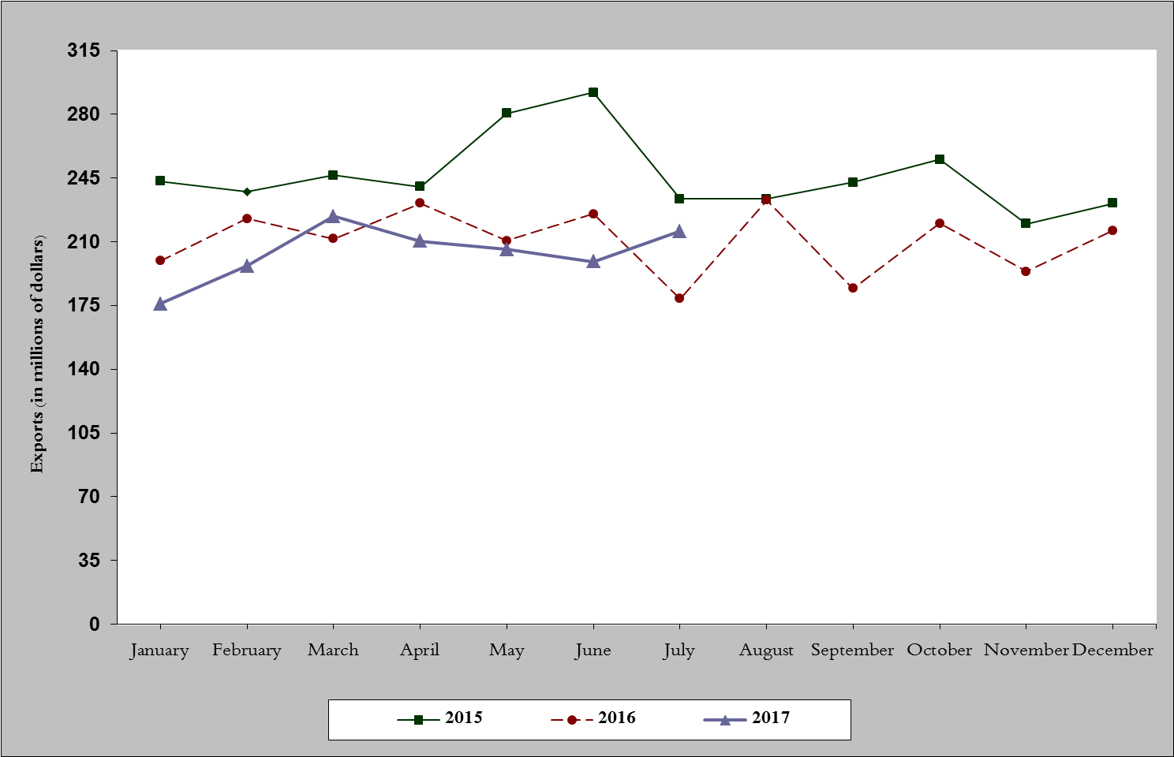
Chart 1: Industrial exports during years 2015-2016-2017

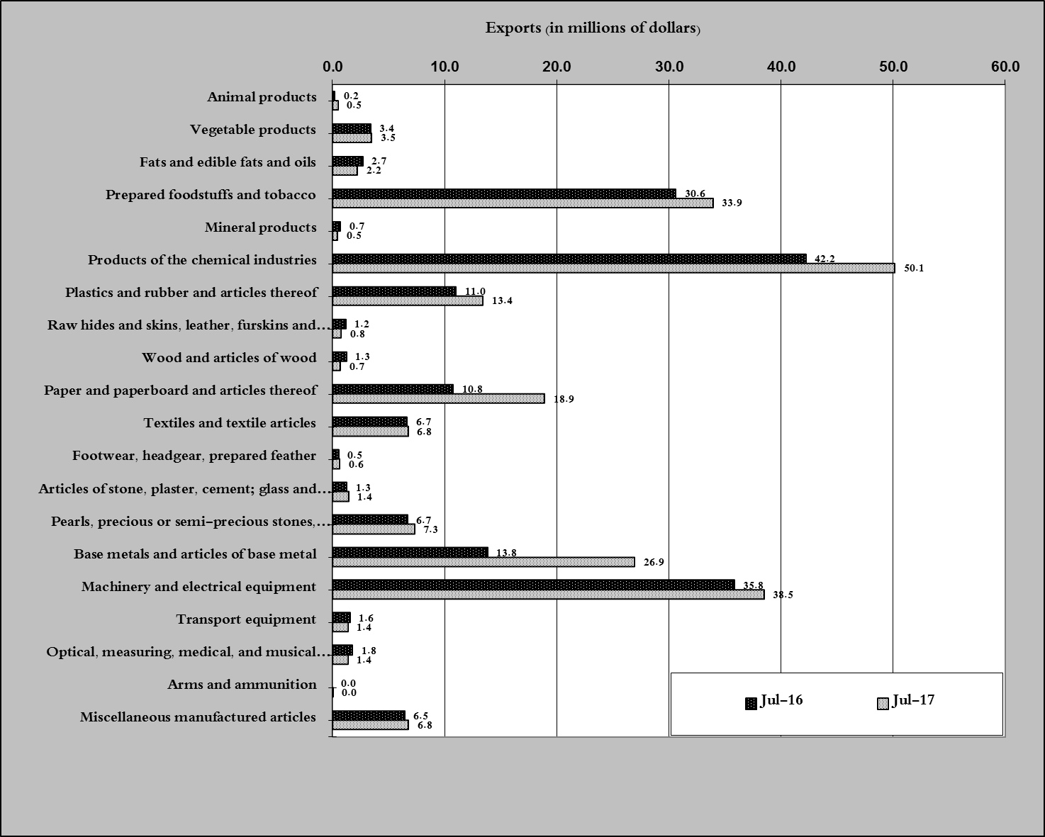
Chart 2: Comparison of industrial exports during July 2017 and July 2016
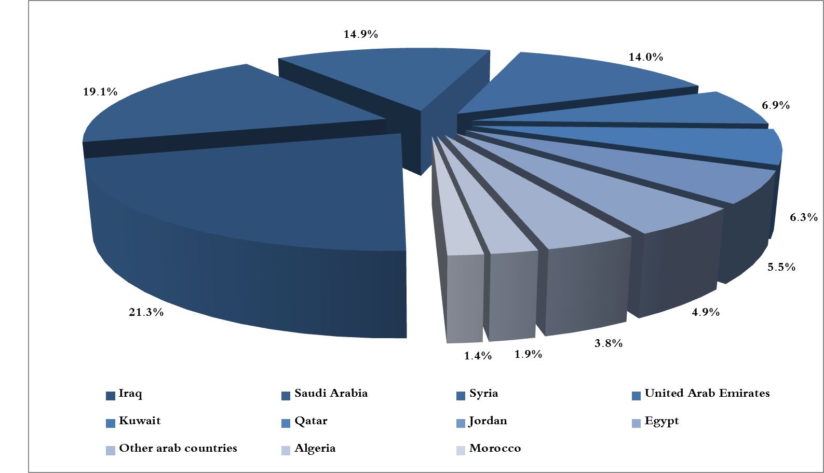
Chart 3: Distribution of industrial exports to Arab countries during July 2017

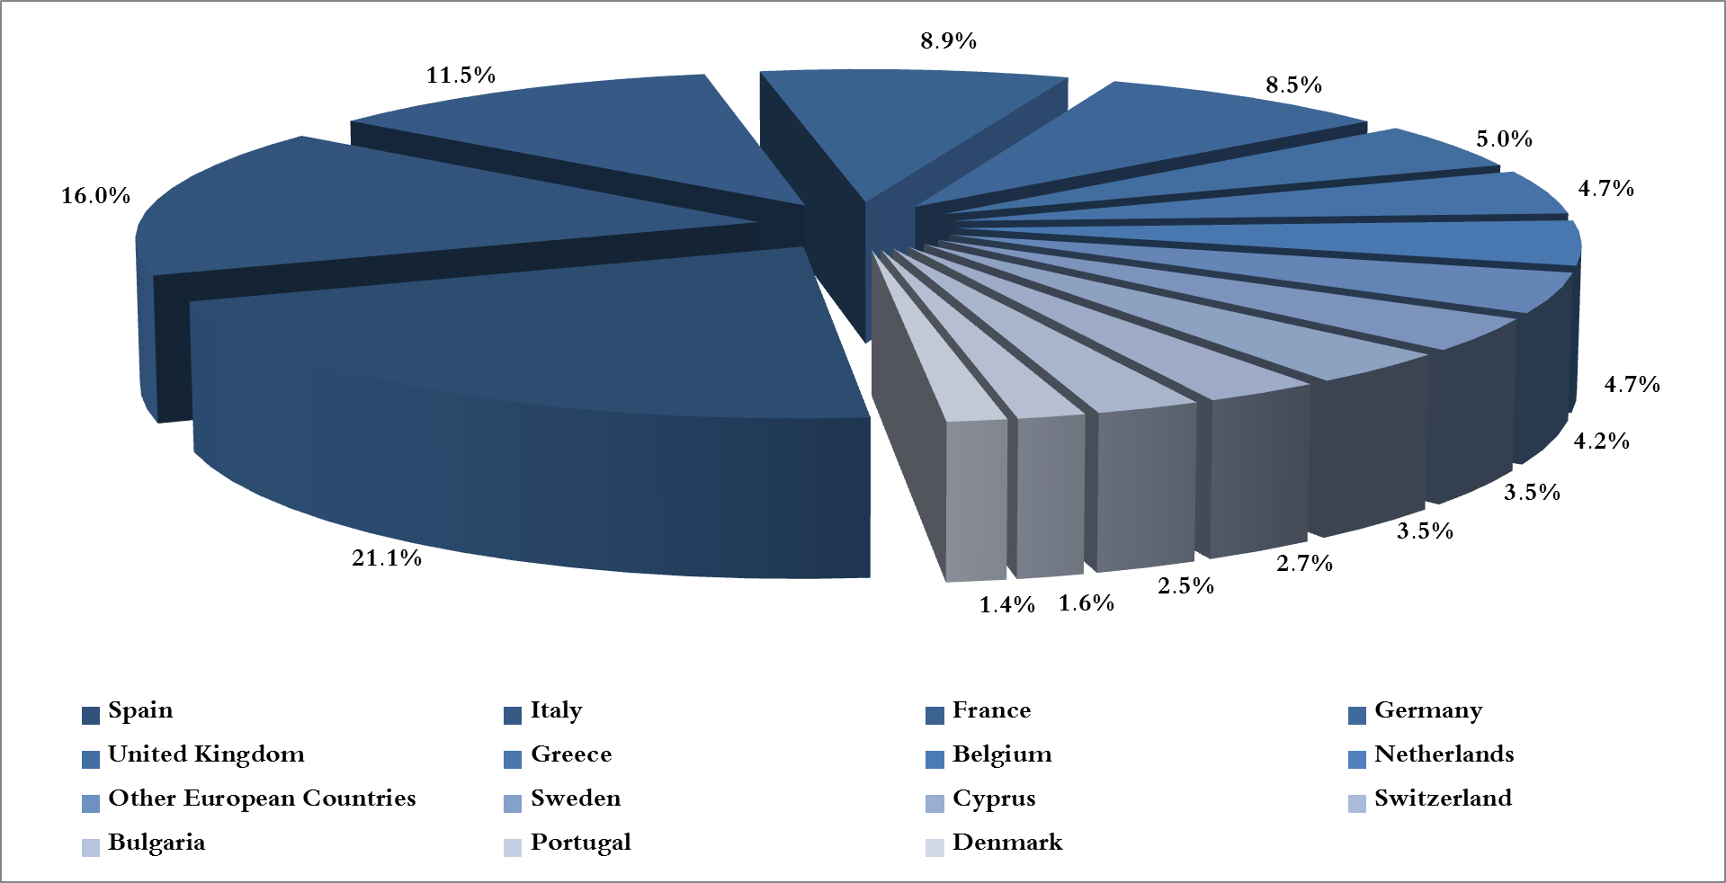
Chart 4: Distribution of industrial exports to European countries during July 2017
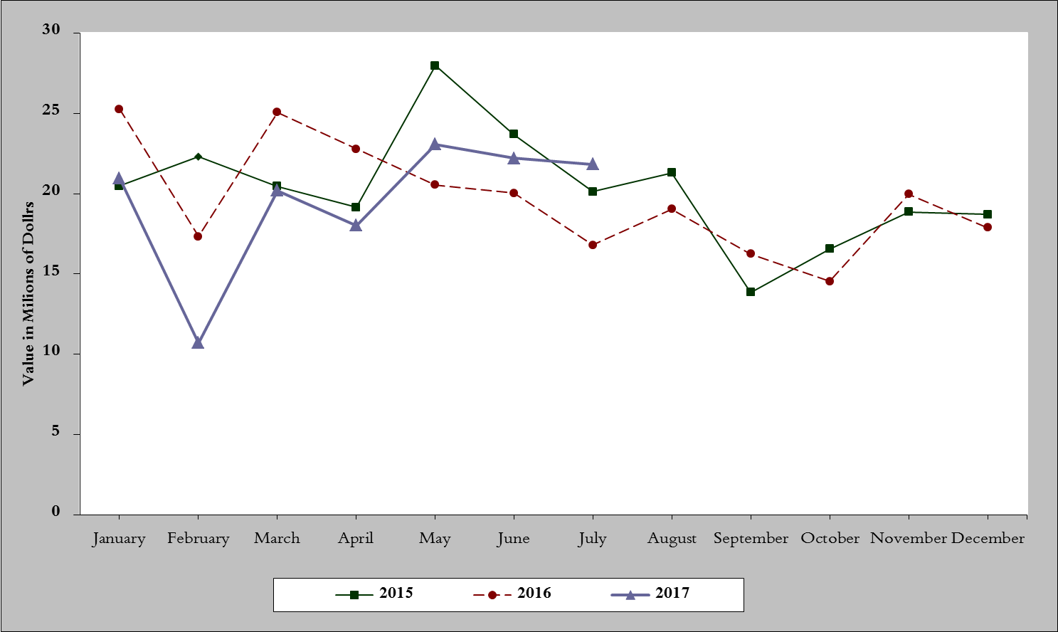
Chart 5: Imports of industrial machinery and equipment during years 2015-2016-2017
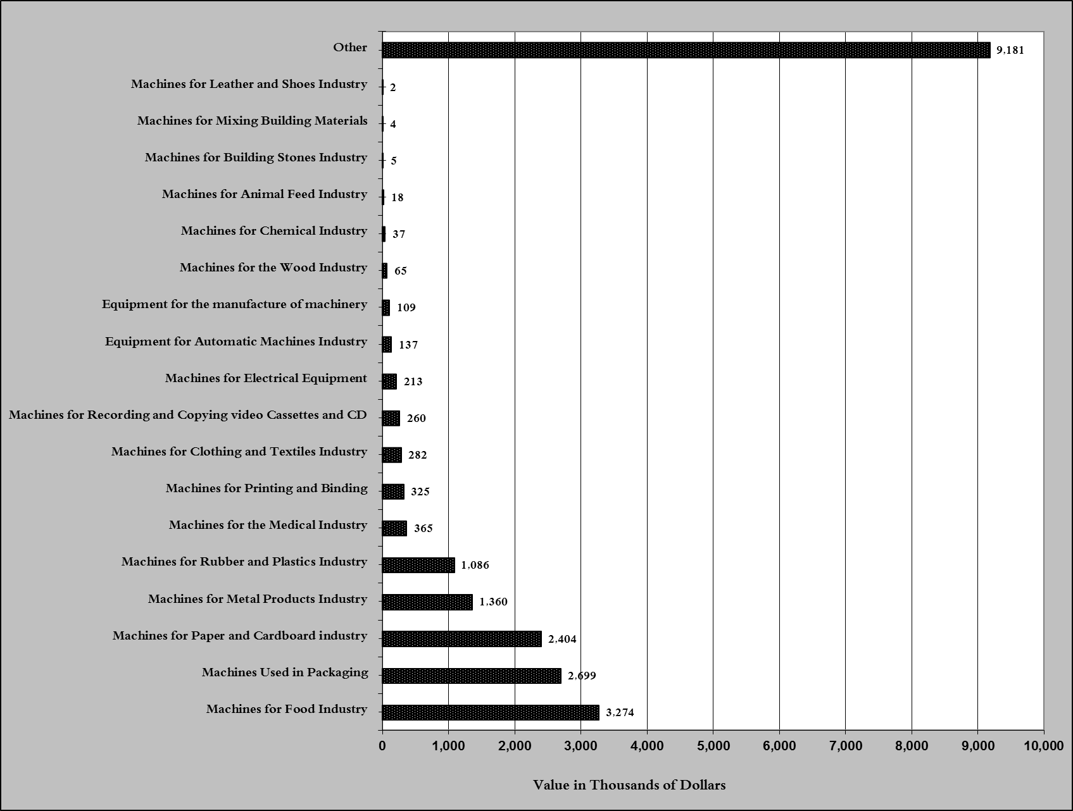
Chart 6: Imports of industrial equipment and machinery according to industrial activity during July 2017

Exports of unworked Diamonds, Silver and Gold Ingots reached this month a value of 16 million USD
The machineries and equipment are classified in this table according to the industrial sectors that are used in, while heading "other" includes machineries and equipment that can be used in various sectors.

