

A detailed report on industrial exports
and imports of industrial machinery and equipment in June 2017

Prepared by:
Ministry of Industry
Industrial Information Department

www.industry.gov.lb
Index

I. Introduction 3
II. Industrial exports in June 2017 4
1. Main exported products 4
2. Products with increased exports value 4
2.1. Base metals and articles of base metal 4
2.2. Paper and paperboard and articles thereof 4
3. Products with decreased exports value 5
3.1. Products of the chemical industries 5
3.2. Machinery and eletrical equipment 5
4. Main export markets 5
4.1. Main export markets by groups of countries 5
4.2. Main export markets by country 5
III. Imports of industrial machinery and equipment 6
1. Imported industrial machinery and equipment by country of origin and industrial activity 6
IV. Appendix tables 7
V. Appendix charts 20

Introduction
The Industrial Information Department of the Ministry of Industry has prepared a detailed report on industrial exports and imports of industrial machinery and equipment for the month of June 2017.
It should be noted that the total value of industrial exports during the first six months of the year 2017 amounted about 1 billion and 212 million US dollars compared to 1 billion and 301 million US dollars during the same period of the year 2016, and 1 billion and 540 million US dollars during the same period of the year 2015. Therefore we notice a decline of 6.8% compared to the year 2016, and a decline of 21.3% compared to the year 2015. (Tables 1 and 11(
It should also be noted that the monthly average of the Lebanese industrial exports during the first six months of the year 2017 amounted about 202 million US dollars compared to 216.8 million US dollars during the year 2016, and 256.7 million US dollars during the year 2015.
On the other hand, the total value of imports of industrial machinery and equipment during the first six months of the year 2017 amounted about 115.2 million US dollars compared to 131 million US dollars during the same period of the year 2016, and 134.1 million US dollars during the same period of the year 2015. Therefore, we notice a decline of 12.1% compared to the year 2016, and a decline of 14.1% compared to the year 2015. (Table 17)

Industrial exports in June 2017
The total value of industrial exports in June 2017 amounted to nearly 199 million US dollars, compared to 225.3 million US dollars in June 2016, and 292.1 million US dollars in June 2015, which is equivalent to a decline of 26.3 million US dollars, with the rate of 11.7% compared to year 2016, and a decline of 93 million US dollars with the rate of 31.9%, compared to year 2015. (Table 1, Chart 1)

Main exported products
Exports of machinery and electrical equipment came first in June 2017, with a total value of 48.8 million US dollars; Iraq was on top of importers list of this product, with an import value of 9.3 million US dollars. Followed by exports of prepared foodstuffs and tobacco, with a total value of 38 million US dollars, Syria was the largest importer of this product, with an import value of 10.1 million US dollars. Then products of the chemical industries, with a total value of 25.9 million US dollars, Ivory Coast topped the importers list of this product, with an import value of 6.6 million US dollars, followed by base metals and articles of base metal, with a total value of 25.1 million US dollars. (For more details tables 2, 4, 6, 8, 10, 15, and 16)

Products with increased exports value
Statistics showed a significant increase in exports of the following products:

Base metals and articles of base metal
Exports of this product increased from 17.3 million US dollars in June 2016 to 25.1 million US dollars in June 2017 (Table 2 and Chart 2). The exports of this product mainly increased to Turkey and Republic of Korea which led to an increase in the total value of about 7.8 million US dollars. (Tables 3 and 4)

Paper and paperboard and articles thereof
Exports of this product increased from 9.1 million US dollars in June 2016 to 12.1 million US dollars in June 2017 (Table 2 and Chart 2). The exports of this product mainly increased to Morocco, Egypt, United Arab Emirates and Iraq which led to an increase of the total value of about 3 million US dollars. (Tables 5 and 6)

Products with decreased exports value
Statistics showed a significant decrease in exports of the following products:

Products of the chemical industries
Exports of this product decreased from 46.9 million US dollars in June 2016 to 25.9 million US dollars in June 2017 (Table 2 and Chart 2). The exports of this product increased to Ivory Coast whereas it mainly decreased to Bangladesh, France, Saudi Arabia, Spain, Brazil and United Arab Emirates which led to a fall of the total value of about 21.1 million US dollars. (Tables 7 and 8)

Machinery and electrical equipment
Exports of this product decreased from 57.9 million US dollars in June 2016 to 48.8 million US dollars in June 2017 (Table 2 and Chart 2). The exports of this product increased to Libya, United Arab Emirates and Iraq whereas it mainly decreased to Saudi Arabia, Algeria, Egypt, Syria and Angola which led to a fall of the total value of about 9.1 million US dollars. (Tables 9 and 10)

Main export markets

Main export markets by groups of countries
Arab countries were the main markets for Lebanese industrial exports in June 2017, with a total export value of 120.7 million US dollars, with a rate of 60.6% of the total export value. Non-arab African countries were the second largest export markets with a rate of 14.3% of the total export value. Followed by, European countries with a rate of 10.4% of the total export value, and, the Non-arab Asian countries with a rate of 8.9% of the total export value. The main products exported to Arab countries are: machinery and electrical equipment with the total value of 35.2 million US dollars, prepared foodstuffs and tobacco with the total value of 26.1 million US dollars, and the products of the chemical industries with the total value of 15.7 million US dollars. (Table 12)

Main export markets by country
Among countries importing Lebanese industrial products, United Arab Emirates ranked first with a total value of 22.3 million US dollars, with a rate of 11.2% of the total export value. Iraq came second with a total value of 20.2 million US dollars with a rate of 10.2% of the total export value. Followed by, Saudi Arabia with a total value of 19.6 million US dollars with a rate of 9.8% of the total exports value. (Table 13)
During this month, Lebanese products were exported to 44 European countries, 40 Non-arab African countries, 26 Non-arab Asian countries, 24 American countries, 19 Arab countries, and 6 Oceanic countries. Countries that imported Lebanese goods by over 1 million US dollars are as following: 13 Arab countries, 9 Non-arab African countries, 8 European countries, 4 Non-arab Asian countries, 2 American countries . (Table 14, Charts 3 and 4)

Imports of industrial machinery and equipment
The total import value of industrial machinery and equipment in June 2017 reached about 22.2 million US dollars compared to 20 million US dollars during the same period in 2016, and 23.7 million US dollars during the same period in 2015, an increase by 10.9% compared to year 2016, and a decline of 6.2% compared to year 2015. (Tables 17 and 18 and Chart 5)
China ranked first on the list of countries exporting industrial machinery and equipment to Lebanon, with a total value amounting to about 5.3 million US dollars, followed by Germany, with a total value of 5.1 million US dollars, and Italy, with a total value of 2.9 million US dollars. (Table 18)

Imported industrial machinery and equipment by country of origin and industrial activity
In June 2017, imports of machines for food industry, ranked first, with a total value of 4.5 million US dollars, and Germany topped the list of countries exporting of this product to Lebanon with exports value of 1.3 million US dollars, followed by machines used in packaging, with a total value of 2.1 million US dollars. France was the leading exporter of this product with an export value of 1.4 million US dollars. Followed by machines for rubber and plastics industry, with a total value of 1.9 million US dollars. (Table 19, Chart 6)

Appendix tables

Table 1: Industrial exports during Years 2015 – 2016 – 2017
Month | Year  2015 | Year  2016 | Year  2017 | Variation  2015/2017 | Variation  2016/2017
January | 243.2 | 199.5 | 175.9 | -27.7% | -11.8%
February | 237.5 | 222.8 | 196.8 | -17.1% | -11.7%
March | 246.5 | 211.6 | 223.9 | -9.2% | 5.8%
April | 240.2 | 231.1 | 210.4 | -12.4% | -8.9%
May | 280.6 | 210.6 | 205.9 | -26.6% | -2.3%
June | 292.1 | 225.3 | 199.0 | -31.9% | -11.7%
July | 233.5 | 178.8
August | 233.4 | 232.9
September | 242.5 | 184.3
October | 255.3 | 220.0
November | 219.9 | 193.7
December | 231.1 | 216.3
Total | 2,955.8 | 2,526.9 | 1,211.8
All above figures are in Millions of USD

Table 2: Comparison of industrial exports during June 2017 and June 2016
Section | Goods | June 2016 | June 2017 | Variation 2016/2017 | Variation in % 2016/2017
1 | Animal products | 0.4 | 0.4 | 0.0 | -2.0%
2 | Vegetable products | 4.3 | 3.4 | -0.8 | -19.4%
3 | Fats and edible fats and oils | 2.4 | 2.4 | 0.1 | 3.3%
4 | Prepared foodstuffs and tobacco | 39.7 | 38.0 | -1.7 | -4.2%
5 | Mineral products | 1.3 | 0.7 | -0.6 | -46.7%
6 | Products of the chemical industries | 46.9 | 25.9 | -21.1 | -44.9%
7 | Plastics and rubber and articles thereof | 11.0 | 10.8 | -0.2 | -1.8%
8 | Raw hides and skins, leather, furskins and articles thereof | 1.0 | 0.8 | -0.2 | -16.6%
9 | Wood and articles of wood | 1.4 | 0.8 | -0.6 | -43.5%
10 | Paper and paperboard and articles thereof | 9.1 | 12.1 | 3.0 | 32.9%
11 | Textiles and textile articles | 7.3 | 4.9 | -2.4 | -33.3%
12 | Footwear, headgear, prepared feather | 1.2 | 0.8 | -0.4 | -34.6%
13 | Articles of stone, plaster, cement; glass and glassware | 2.1 | 1.7 | -0.4 | -20.0%
14 | Pearls, precious or semi-precious stones, precious metals and articles thereof (Excluding unworked diamonds, silver and gold Ingots) | 9.6 | 12.2 | 2.6 | 27.5%
15 | Base metals and articles of base metal | 17.3 | 25.1 | 7.8 | 44.8%
16 | Machinery and electrical equipment | 57.9 | 48.8 | -9.1 | -15.8%
17 | Transport equipment | 1.2 | 2.2 | 1.1 | 92.2%
18 | Optical, measuring, medical, and musical instruments; clocks and watches | 3.7 | 1.1 | -2.6 | -70.9%
19 | Arms and ammunition | 0.1 | 0.1 | 0.0 | -34.6%
20 | Miscellaneous manufactured articles | 7.5 | 6.8 | -0.7 | -9.4%
 | Total | 225.3 | 199.0 | -26.3 | -11.7%
All above figures are in Millions of USD
Table 3: Exports of base metals and articles of base metal according to the main importing countries during June 2016
Export destination Country | Republic of Korea | Italy | Turkey | India | Congo | Greece | Saudi Arabia | United Arab Emirates
Value in thousands of USD | 2,562 | 1,862 | 1,453 | 1,021 | 670 | 662 | 634 | 558

Table 4: Exports of base metals and articles of base metal according to the main importing countries during June 2017
Export destination Country | Turkey | Republic of Korea | Greece | Japan | Italy | Algeria | China | Spain
Value in thousands of USD | 6,593 | 5,123 | 1,210 | 1,108 | 1,060 | 830 | 776 | 616

Table 5: Exports of paper and paperboard and articles thereof according to the main importing countries during June 2016
Export destination Country | Saudi Arabia | Iraq | United Arab Emirates | Morocco | Algeria | Ivory Coast | Egypt | Jordan
Value in thousands of USD | 1,329 | 992 | 718 | 688 | 623 | 536 | 474 | 422

Table 6: Exports of paper and paperboard and articles thereof according to the main importing countries during June 2017
Export destination Country | Morocco | Iraq | Saudi Arabia | Egypt | United Arab Emirates | Syria | Jordan | Burundi
Value in thousands of USD | 1,470 | 1,364 | 1,259 | 1,208 | 1,115 | 667 | 648 | 555

Table 7: Exports of products of the chemical industries according to the main importing countries during June 2016
Export destination Country | Bangladesh | France | United Arab Emirates | Iraq | Saudi Arabia | Jordan | Spain | Brazil
Value in thousands of USD | 10,607 | 7,944 | 4,201 | 3,768 | 3,396 | 3,017 | 2,237 | 1,807

Table 8: Exports of products of the chemical industries according to the main importing countries during June 2017
Export destination Country | Ivory Coast | Iraq | United Arab Emirates | Jordan | Saudi Arabia | Syria | United States Of America | Kuwait
Value in thousands of USD | 6,589 | 4,639 | 2,985 | 2,444 | 1,707 | 975 | 648 | 579

Table 9: Exports of machinery and electrical equipment according to the main importing countries during June 2016
Export destination Country | Saudi Arabia | Iraq | Algeria | Syria | Egypt | United Arab Emirates | Angola | Other
Value in thousands of USD | 8,670 | 8,290 | 5,114 | 4,085 | 3,453 | 2,637 | 2,587 | 2,470

Table 10: Exports of machinery and electrical equipment according to the main importing countries during June 2017
Export destination Country | Iraq | Libya | Saudi Arabia | United Arab Emirates | Kuwait | Syria | Senegal | Sudan
Value in thousands of USD | 9,256 | 6,880 | 4,620 | 3,940 | 3,146 | 2,461 | 2,351 | 1,565

Table 11: Industrial exports according to exported goods during year 2017

Table 12: Industrial exports according to exported goods and countries groups during June 2017
Goods | Arab Countries | European Countries | Oceanic Countries | Non-Arab Asian countries | American Countries | Non-Arab African countries | Other* | Total
Animal products | 303 |  |  |  |  | 131 |  | 434
Vegetable products | 1,784 | 957 | 53 | 48 | 257 | 335 |  | 3,434
Fats and edible fats and oils | 1,181 | 538 | 8 | 1 | 563 | 147 |  | 2,439
Prepared foodstuffs and tobacco | 26,072 | 4,698 | 591 | 322 | 3,805 | 1,722 | 829 | 38,038
Mineral products | 340 | 111 |  | 23 |  | 132 | 69 | 675
Products of the chemical industries | 15,715 | 1,103 | 89 | 279 | 665 | 7,543 | 457 | 25,851
Plastics and rubber and articles thereof | 7,228 | 1,577 | 7 | 611 | 95 | 1,172 | 105 | 10,796
Raw hides and skins, leather, furskins and articles thereof | 309 | 352 |  | 90 | 2 | 57 | 2 | 812
Wood and articles of wood | 600 | 43 |  | 5 |  | 155 |  | 804
Paper and paperboard and articles thereof | 8,692 | 661 | 3 | 481 | 9 | 2,161 | 141 | 12,147
Textiles and textile articles | 2,283 | 2,007 | 4 | 72 | 158 | 260 | 88 | 4,872
Footwear, headgear, prepared feather | 674 | 15 |  |  |  | 54 | 14 | 757
Articles of stone, plaster, cement; glass and glassware | 1,028 | 115 | 1 | 3 | 89 | 435 |  | 1,672
Pearls, precious or semi-precious stones, precious metals and articles thereof (Excluding unworked diamonds, silver and gold Ingots) | 9,857 | 571 |  | 443 | 1,200 | 104 | 16 | 12,191
Base metals and articles of base metal | 4,023 | 4,167 | 206 | 14,309 | 9 | 2,268 | 107 | 25,089
Machinery and electrical equipment | 35,188 | 2,734 | 24 | 903 | 478 | 8,680 | 809 | 48,817
Transport equipment | 1,051 | 421 |  | 61 | 96 | 620 |  | 2,249
Optical, measuring, medical, and musical instruments; clocks and watches | 525 | 303 |  | 1 | 134 | 104 |  | 1,067
Arms and ammunition |  |  |  | 50 |  | 18 |  | 68
Miscellaneous manufactured articles | 3,760 | 414 | 1 | 66 | 116 | 2,458 |  | 6,815
Total | 120,614 | 20,787 | 987 | 17,768 | 7,677 | 28,557 | 2,638 | 199,026
All the above figures are in thousands of US dollars.
* "other" Includes exported goods to the duty free market and those that are supplied to ships and aircraft.
Table 13: Distribution of the industrial exports according to the main importing countries during June 2017
Export destination Country | United Arab Emirates | Iraq | Saudi Arabia | Syria | Ivory Coast | Libya | Turkey | Jordan
Value in thousands of USD | 22,320 | 20,244 | 19,552 | 18,492 | 9,417 | 7,539 | 7,204 | 6,292

Export destination Country | Qatar | Kuwait | United States Of America | Republic of Korea | Egypt | France | Algeria | Senegal
Value in thousands of USD | 5,777 | 5,770 | 5,511 | 5,130 | 3,425 | 3,208 | 2,961 | 2,813

Export destination Country | Netherlands | United Kingdom | Sudan | Nigeria | Italy | Oman | Liberia | Morocco
Value in thousands of USD | 2,564 | 2,507 | 2,472 | 2,086 | 2,061 | 2,027 | 1,960 | 1,930

Table 14: Distribution of importing countries according to countries groups and the value of exports during June 2017
Exports Value  (in million USD) | Arab Countries | European Countries | Oceania Countries | Non-Arab Asian countries | American Countries | Non-Arab African countries | Total
]0-1[ | 6 | 36 | 6 | 22 | 22 | 31 | 123
[1-5[ | 5 | 8 |  | 2 | 1 | 8 | 24
[5-10[ | 4 |  |  | 2 | 1 | 1 | 8
[10-15[
More than 15 million USD | 4 |  |  |  |  |  | 4
Total | 19 | 44 | 6 | 26 | 24 | 40 | 159

Table 15: Distribution of the industrial exports according to product and to the main importing countries during June 2017
Animal products | Qatar | United Arab Emirates | Nigeria | Iraq | Liberia | Kuwait | Senegal | Congo
Value in 1000 of USD | 108 | 98 | 83 | 70 | 30 | 20 | 6 | 5

Vegetable products | Netherlands | Saudi Arabia | United Arab Emirates | Qatar | Sweden | Jordan | Germany | Sudan
Value in 1000 of USD | 490 | 484 | 310 | 261 | 259 | 218 | 151 | 140

Fats and edible fats and oils | United States Of America | Portugal | Sudan | United Arab Emirates | Kuwait | Canada | Qatar | Netherlands
Value in 1000 of USD | 377 | 347 | 305 | 285 | 153 | 150 | 103 | 102

Prepared foodstuffs and tobacco | Syria | Saudi Arabia | Iraq | United States Of America | Qatar | United Arab Emirates | Jordan | United Kingdom
Value in 1000 of USD | 10,129 | 5,381 | 2,680 | 2,408 | 2,022 | 1,752 | 1,240 | 1,228

Mineral products | Syria | Other | Sierra Leone | Belgium | Angola | France | United Kingdom | Iraq
Value in 1000 of USD | 294 | 69 | 64 | 40 | 35 | 34 | 34 | 25

Plastics and rubber and articles thereof | Syria | Saudi Arabia | Iraq | Algeria | Spain | Egypt | Ivory Coast | United Arab Emirates
Value in 1000 of USD | 2,973 | 1,332 | 628 | 517 | 493 | 357 | 334 | 280

Raw hides and skins, leather, furskins and articles thereof | United Arab Emirates | Portugal | Turkey | Switzerland | Egypt | Italy | Nigeria | Jordan
Value in 1000 of USD | 158 | 139 | 83 | 65 | 46 | 44 | 37 | 36

Wood and articles of wood | Qatar | Saudi Arabia | Jordan | Syria | Nigeria | Iraq | United Arab Emirates | Liberia
Value in 1000 of USD | 151 | 129 | 120 | 86 | 55 | 49 | 46 | 33

Textiles and textile articles | United Arab Emirates | France | Kuwait | Syria | United Kingdom | Saudi Arabia | Italy | Germany
Value in 1000 of USD | 640 | 468 | 341 | 328 | 314 | 299 | 293 | 222

Table 15: (continued) Distribution of the industrial exports according to product and the main importing countries during June 2017
Footwear, headgear, prepared feather | United Arab Emirates | Saudi Arabia | Ghana | Jordan | Other | Egypt | United Kingdom | Kuwait
Value in 1000 of USD | 397 | 212 | 50 | 37 | 14 | 12 | 11 | 8

Articles of stone, plaster, cement; glass and glassware | United Arab Emirates | Kuwait | Saudi Arabia | Qatar | Gabon | Bahrain | Nigeria | United States Of America
Value in 1000 of USD | 314 | 238 | 133 | 110 | 85 | 84 | 83 | 57

Pearls, precious or semi-precious stones, precious metals and articles thereof (Excluding unworked diamonds, silver and gold Ingots) | United Arab Emirates | Saudi Arabia | United States Of America | Thailand | Switzerland | Germany | Hong Kong | Upper Volta
Value in 1000 of USD | 8,214 | 1,544 | 1,200 | 332 | 239 | 167 | 106 | 104

Transport equipment | United Arab Emirates | Ivory Coast | Libya | France | Iraq | Senegal | Cyprus | Colombia
Value in 1000 of USD | 438 | 403 | 339 | 192 | 133 | 107 | 88 | 88

Optical, measuring, medical, and musical instruments; clocks and watches | United Arab Emirates | France | United States Of America | Germany | Upper Volta | Syria | Iraq | Belgium
Value in 1000 of USD | 411 | 152 | 134 | 102 | 60 | 35 | 35 | 28

Arms and ammunition | Turkey | Afghanistan | Mali
Value in 1000 of USD | 30 | 21 | 18

Miscellaneous manufactured articles | Saudi Arabia | Nigeria | Iraq | Ivory Coast | United Arab Emirates | Qatar | Sierra Leone | Jordan
Value in 1000 of USD | 1,882 | 782 | 536 | 435 | 388 | 362 | 322 | 224

Table 16: Distribution of industrial exports, according to the main exported goods and main importing countries during June 2017

Table 17: Imports of industrial machinery and equipment during years 2015-2016-2017
Month | Year  2015 | Year  2016 | Year  2017 | Variation  2015/2017 | Variation  2016/2017
January | 20.5 | 25.3 | 21.0 | 2.4% | -17.1%
February | 22.3 | 17.3 | 10.7 | -52.1% | -38.3%
March | 20.5 | 25.1 | 20.2 | -1.3% | -19.4%
April | 19.1 | 22.8 | 18.0 | -5.8% | -20.9%
May | 28.0 | 20.5 | 23.1 | -17.5% | 12.3%
June | 23.7 | 20.0 | 22.2 | -6.2% | 10.9%
July | 20.1 | 16.8
August | 21.3 | 19.0
September | 13.8 | 16.2
October | 16.5 | 14.5
November | 18.9 | 20.0
December | 18.7 | 17.9
Total | 243.4 | 235.5 | 115.2
All above figures are in Millions of USD

Table 18: Imports of industrial equipment and machinery according to exporting country for the year 2017
Table 19: Imports of industrial equipment and machinery according to industrial activity and country during June 2017

Appendix charts
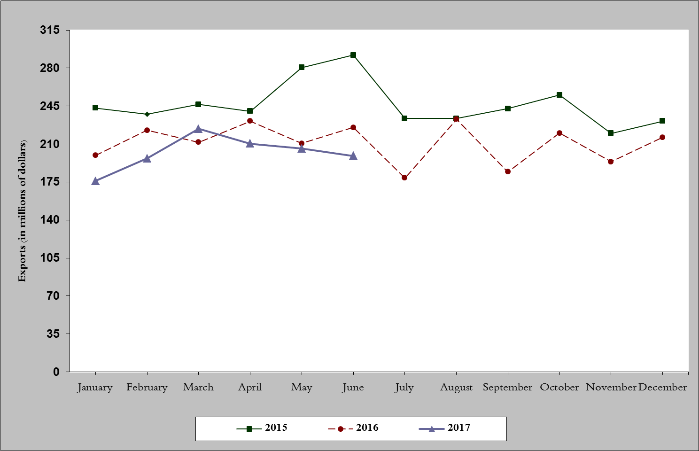
Chart 1: Industrial exports during years 2015-2016-2017
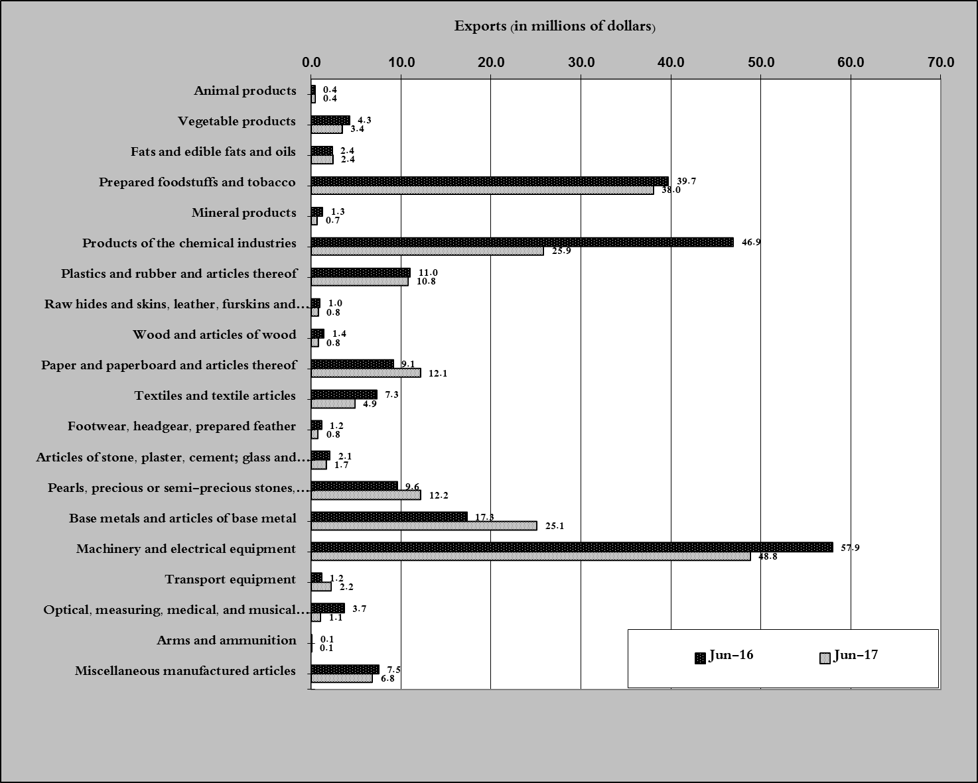
Chart 2: Comparison of industrial exports during June 2017 and June 2016

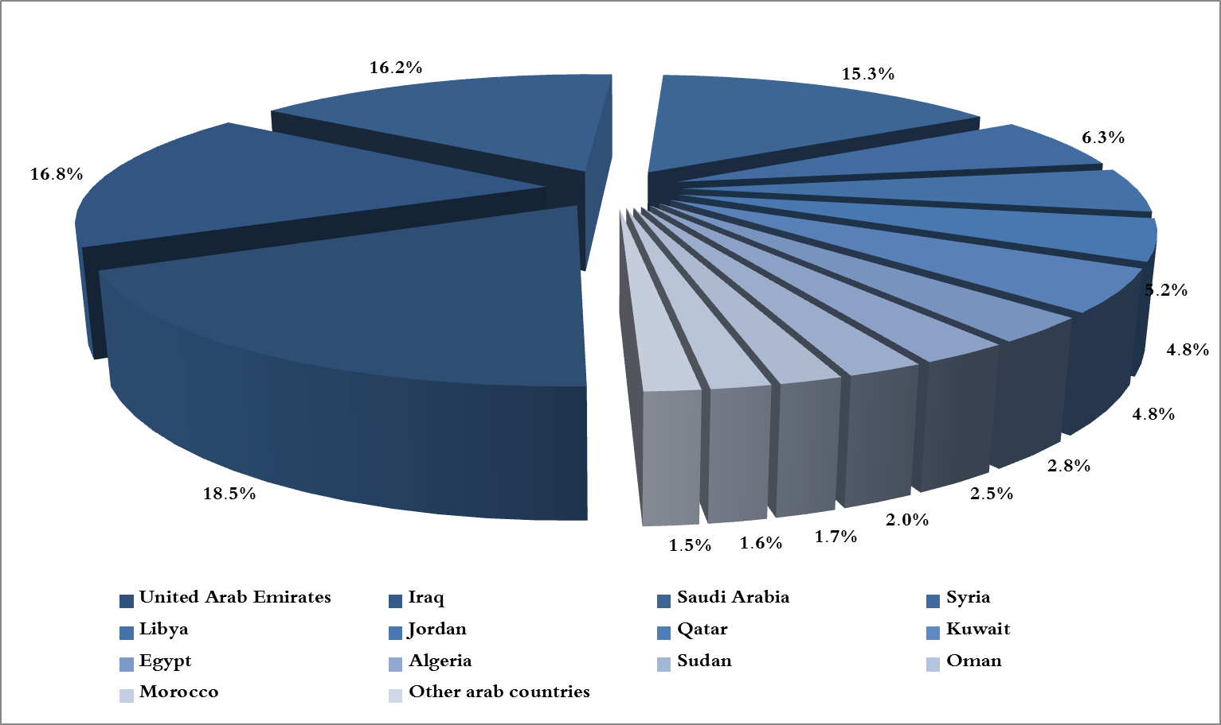
Chart 3: Distribution of industrial exports to Arab countries during June 2017

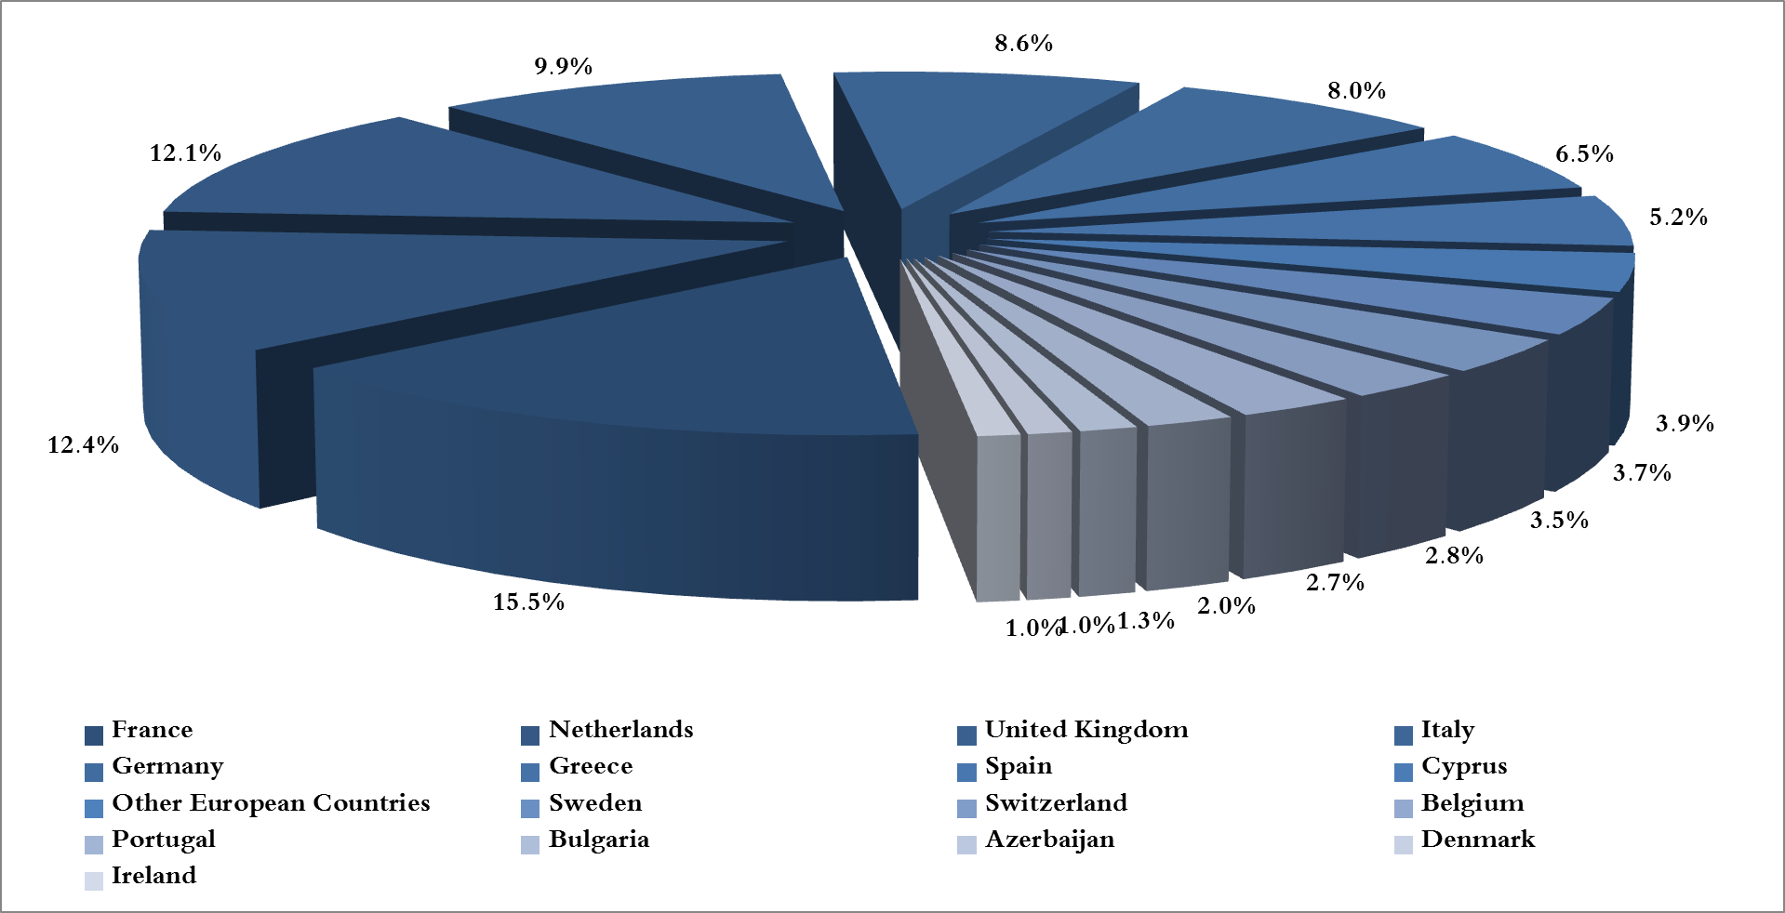
Chart 4: Distribution of industrial exports to European countries during June 2017
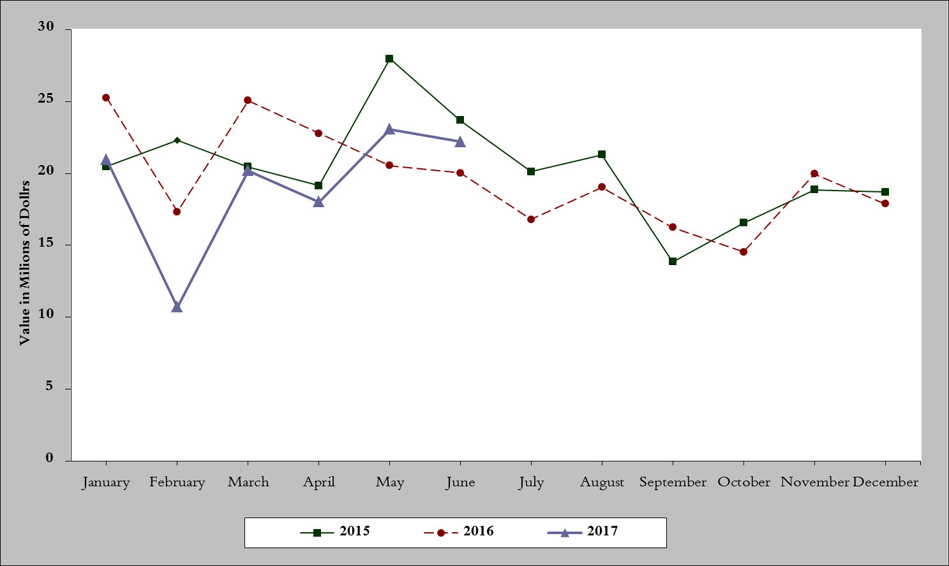
Chart 5: Imports of industrial machinery and equipment during years 2015-2016-2017
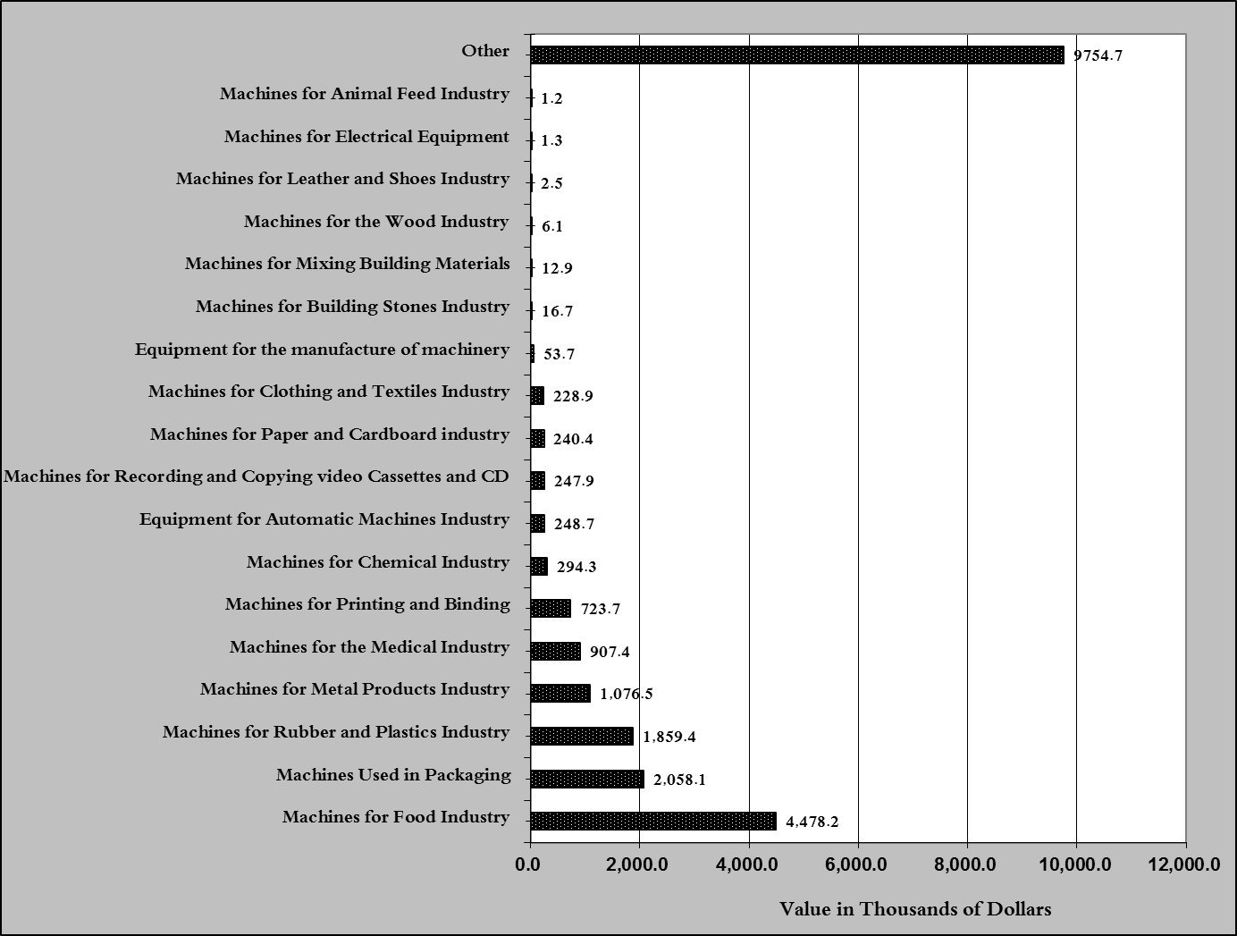
Chart 6: Imports of industrial equipment and machinery according to industrial activity during June 2017

Exports of unworked Diamonds, Silver and Gold Ingots reached this month a value of 45.7 million USD
The machineries and equipment are classified in this table according to the industrial sectors that are used in, while heading "other" includes machineries and equipment that can be used in various sectors.

