

A detailed report on industrial exports
and imports of industrial machinery and equipment in March 2017

Prepared by:
Ministry of Industry
Industrial Information Department

www.industry.gov.lb

Index

I. Introduction 3
II. Industrial exports in March 2017 4
1. Main exported products 4
2. Products with increased exports value 4
2.1. Pearls, precious or semi-precious stones, precious metals and articles thereof (Excluding unworked diamonds, silver and gold Ingots) 4
2.2. Base metals and articles of base metal 4
3. Products with decreased exports value 5
3.1. Machinery and electrical equipment 5
3.2. Animal products 5
4. Main export markets 5
4.1. Main export markets by groups of countries 5
4.2. Main export markets by country 5
III. Imports of industrial machinery and equipment 6
1. Imported industrial machinery and equipment by country of origin and industrial activity 6
IV. Appendix tables 7
V. Appendix charts 20

Introduction
The Industrial Information Department of the Ministry of Industry has prepared a detailed report on industrial exports and imports of industrial machinery and equipment for the month of March 2017.
It should be noted that the total value of industrial exports during the first three months of the year 2017 amounted about 596.6 million US dollars compared to 633.9 million US dollars during the same period of the year 2016, and 727.2 million US dollars during the same period of the year 2015. Therefore we notice a decline of 5.9% compared to the year 2016, and a decline of 18% compared to the year 2015. (Tables 1 and 11(
It should also be noted that the monthly average of the Lebanese industrial exports during the first three months of the year 2017 amounted about 198.9 million US dollars compared to 211.3 million US dollars during the year 2016, and 242.4 million US dollars during the year 2015.
On the other hand, the total value of imports of industrial machinery and equipment during the first three months of the year 2017 amounted about 51.8 million US dollars compared to 67.7 million US dollars during the same period of the year 2016, and 63.2 million US dollars during the same period of the year 2015. Therefore, we notice a decline of 23.4% compared to the year 2016, and a decline of 18% compared to the year 2015. (Table 17)

Industrial exports in March 2017
The total value of industrial exports in March 2017 amounted to nearly 223.9 million US dollars, compared to 211.6 million US dollars in March 2016, and 246.5 million US dollars in March 2015, which is equivalent to an increase of 12.3 million US dollars, with the rate of 5.8% compared to year 2016, and a decline of 22.6 million US dollars with the rate of 9.2%, compared to year 2015. (Table 1, Chart 1)

Main exported products
Exports of machinery and electrical equipment came first in March 2017, with a total value of 43.2 million US dollars; Iraq was on top of importers list of this product, with an import value of 6.9 million US dollars. Followed by exports of prepared foodstuffs and tobacco, with a total value of 42.5 million US dollars, Syria was the largest importer of this product, with an import value of 6.2 million US dollars. Then base metals and articles of base metal, with a total value of 30.5 million US dollars, Turkey topped the importers list of this product, with an import value of 10.3 million US dollars, followed by products of the chemical industries, with a total value of 27.4 million US dollars. (For more details tables 2, 4, 6, 8, 10, 15, and 16)

Products with increased exports value
Statistics showed a significant increase in exports of the following products:

Pearls, precious or semi-precious stones, precious metals and articles thereof (Excluding unworked diamonds, silver and gold Ingots)
Exports of this product increased from 9.2 million US dollars in March 2016 to 21.3 million US dollars in March 2017 (Table 2 and Chart 2). The exports of this product mainly increased to United Arab Emirates, Germany and Saudi Arabia which led to an increase in the total value of about 12.1 million US dollars. (Tables 3 and 4)

Base metals and articles of base metal
Exports of this product increased from 24 million US dollars in March 2016 to 30.5 million US dollars in March 2017 (Table 2 and Chart 2). The exports of this product decreased to Japan whereas it mainly increased to Turkey, Republic of Korea, and Spain which led to an increase of the total value of about 6.4 million US dollars. (Tables 5 and 6)

Products with decreased exports value
Statistics showed a significant decrease in exports of the following products:

Machinery and electrical equipment
Exports of this product decreased from 54.3 million US dollars in March 2016 to 43.2 million US dollars in March 2017 (Table 2 and Chart 2). The exports of this product increased to Syria whereas it mainly decreased to Saudi Arabia, United Arab Emirates, and Angola which led to a fall of the total value of about 11.1 million US dollars. (Tables 7 and 8)

Animal products
Exports of this product decreased from 0.8 million US dollars in March 2016 to 0.4 million US dollars in March 2017 (Table 2 and Chart 2). The exports of this product mainly decreased to Iraq, and Greece which led to a fall of the total value of about 0.4 million US dollars. (Tables 9 and 10)

Main export markets

Main export markets by groups of countries
Arab countries were the main market for Lebanese industrial exports in March 2017, with a total export value of 128 million US dollars, with a rate of 57.2% of the total export value. European countries were the second largest export market with a rate of 15.5% of the total export value. Followed by, Non-arab African countries with a rate of 10.9% of the total export value, and, the Non-arab Asian countries with a rate of 10.1% of the total export value. The main products exported to Arab countries are: machinery and electrical equipment with the total value of 26.6 million US dollars, prepared foodstuffs and tobacco with the total value of 25.8 million US dollars, and the products of the chemical industries with the total value of 23.4 million US dollars. (Table 12)

Main export markets by country
Among countries importing Lebanese industrial products, United Arab Emirates ranked first with a total value of 32.3 million US dollars, with a rate of 14.4% of the total export value. Saudi Arabia came second with a total value of 27.5 million US dollars with a rate of 12.3% of the total export value. Followed by, Iraq with a total value of 19.4 million US dollars with a rate of 8.7% of the total exports value. (Table 13)
During this month, Lebanese products were exported to 41 European countries, 38 Non-arab African countries, 26 Non-arab Asian countries, 22 American countries, 19 Arab countries, and 4 Oceanic countries. Countries that imported Lebanese goods by over 1 million US dollars are as following: 12 Arab countries, 8 Non-arab African countries, 7 European countries, 5 Non-arab Asian countries, 2 American countries, and 1 Oceanic country. (Table 14, Charts 3 and 4)

Imports of industrial machinery and equipment
The total import value of industrial machinery and equipment in March 2017 reached about 20.2 million US dollars compared to 25.1 million US dollars during the same period in 2016, and 20.5 million US dollars during the same period in 2015, a decline by 19.4% compared to year 2016, and a decline of 1.3% compared to year 2015. (Tables 17 and 18 and Chart 5)
Italy ranked first on the list of countries exporting industrial machinery and equipment to Lebanon, with a total value amounting to about 4.8 million US dollars, followed by China, with a total value of 4.2 million US dollars, and Germany, with a total value of 3.9 million US dollars. (Table 18)

Imported industrial machinery and equipment by country of origin and industrial activity
In March 2017, imports of machines for food industry, ranked first, with a total value of 2.6 million US dollars, and Italy topped the list of countries exporting of this product to Lebanon with exports value of 1.1 million US dollars, followed by machines used in packaging, with a total value of 1.8 million US dollars. Italy was the leading exporter of this product with an export value of 0.7 million US dollars. Followed by machines for rubber and plastics industry, with a total value of 1.7 million US dollars. (Table 19, Chart 6)

Appendix tables

Table 1: Industrial exports during Years 2015 – 2016 – 2017
Month | Year  2015 | Year  2016 | Year  2017 | Variation  2015/2017 | Variation  2016/2017
January | 243.2 | 199.5 | 175.9 | -27.7% | -11.8%
February | 237.5 | 222.8 | 196.8 | -17.1% | -11.7%
March | 246.5 | 211.6 | 223.9 | -9.2% | 5.8%
April | 240.2 | 231.1
May | 280.6 | 210.6
June | 292.1 | 225.3
July | 233.5 | 178.8
August | 233.4 | 232.9
September | 242.5 | 184.3
October | 255.3 | 220.0
November | 219.9 | 193.7
December | 231.1 | 216.3
Total | 2,955.8 | 2,526.9 | 596.6
All above figures are in Millions of USD

Table 2: Comparison of industrial exports during March 2017 and March 2016
Section | Goods | March 2016 | March 2017 | Variation 2016/2017 | Variation in % 2016/2017
1 | Animal products | 0.8 | 0.4 | -0.4 | -49.6%
2 | Vegetable products | 3.6 | 4.5 | 0.9 | 24.1%
3 | Fats and edible fats and oils | 3.7 | 4.0 | 0.3 | 8.2%
4 | Prepared foodstuffs and tobacco | 42.3 | 42.5 | 0.2 | 0.5%
5 | Mineral products | 0.8 | 0.6 | -0.2 | -28.6%
6 | Products of the chemical industries | 27.6 | 27.4 | -0.2 | -0.7%
7 | Plastics and rubber and articles thereof | 12.3 | 13.9 | 1.6 | 13.1%
8 | Raw hides and skins, leather, furskins and articles thereof | 1.3 | 1.5 | 0.2 | 11.6%
9 | Wood and articles of wood | 0.9 | 0.8 | -0.1 | -7.8%
10 | Paper and paperboard and articles thereof | 9.2 | 12.2 | 2.9 | 31.9%
11 | Textiles and textile articles | 5.9 | 6.5 | 0.6 | 11.0%
12 | Footwear, headgear, prepared feather | 1.6 | 1.8 | 0.3 | 17.5%
13 | Articles of stone, plaster, cement; glass and glassware | 2.3 | 2.1 | -0.2 | -9.0%
14 | Pearls, precious or semi-precious stones, precious metals and articles thereof (Excluding unworked diamonds, silver and gold Ingots) | 9.2 | 21.3 | 12.1 | 131.6%
15 | Base metals and articles of base metal | 24.0 | 30.5 | 6.4 | 26.9%
16 | Machinery and electrical equipment | 54.3 | 43.2 | -11.1 | -20.4%
17 | Transport equipment | 1.6 | 2.2 | 0.6 | 34.0%
18 | Optical, measuring, medical, and musical instruments; clocks and watches | 1.7 | 1.7 | 0.0 | 3.0%
19 | Arms and ammunition | 0.1 | 0.0 | 0.0 | -50.4%
20 | Miscellaneous manufactured articles | 8.4 | 6.8 | -1.6 | -19.5%
 | Total | 211.6 | 223.9 | 12.3 | 5.8%
All above figures are in Millions of USD
Table 3: Exports of pearls, precious or semi-precious stones, precious metals and articles thereof (Excluding unworked diamonds, silver and gold Ingots) according to the main importing countries during March 2016
Export destination Country | United Arab Emirates | Germany | Saudi Arabia | Hong Kong | Jordan | Belgium | Switzerland | United States Of America
Value in thousands of USD | 5,536 | 871 | 801 | 470 | 269 | 252 | 244 | 190

Table 4: Exports of pearls, precious or semi-precious stones, precious metals and articles thereof (Excluding unworked diamonds, silver and gold Ingots) according to the main importing countries during March 2017
Export destination Country | United Arab Emirates | Germany | United Kingdom | Saudi Arabia | United States Of America | Qatar | Belgium | Upper Volta
Value in thousands of USD | 9,308 | 4,324 | 3,234 | 2,494 | 578 | 272 | 190 | 170

Table 5: Exports of base metals and articles of base metal according to the main importing countries during March 2016
Export destination Country | Turkey | Republic of Korea | Japan | Nigeria | Saudi Arabia | Iraq | Congo | India
Value in thousands of USD | 4,740 | 3,038 | 1,609 | 1,248 | 1,112 | 1,076 | 1,065 | 920

Table 6: Exports of base metals and articles of base metal according to the main importing countries during March 2017
Export destination Country | Turkey | Republic of Korea | Spain | China | Algeria | India | Italy | Japan
Value in thousands of USD | 10,341 | 4,901 | 2,624 | 1,052 | 965 | 934 | 864 | 771

Table 7: Exports of machinery and electrical equipment according to the main importing countries during March 2016
Export destination Country | Saudi Arabia | United Arab Emirates | Iraq | Angola | Ghana | Jordan | Congo | Italy
Value in thousands of USD | 12,511 | 6,894 | 6,382 | 2,689 | 2,588 | 1,766 | 1,685 | 1,593

Table 8: Exports of machinery and electrical equipment according to the main importing countries during March 2017
Export destination Country | Iraq | Saudi Arabia | United Arab Emirates | Syria | Ghana | Kuwait | Congo | Netherlands
Value in thousands of USD | 6,896 | 6,807 | 5,230 | 3,666 | 2,846 | 1,777 | 1,192 | 1,150

Table 9: Exports of animal products according to the main importing countries during March 2016
Export destination Country | Iraq | United Arab Emirates | Greece | Qatar | Saudi Arabia | Ivory Coast | United States Of America | Kuwait
Value in thousands of USD | 160 | 144 | 115 | 79 | 61 | 59 | 49 | 38

Table 10: Exports of animal products according to the main importing countries during March 2017
Export destination Country | United Arab Emirates | Qatar | Iraq | Congo | United States Of America | Liberia | Saudi Arabia | Kuwait
Value in thousands of USD | 144 | 68 | 46 | 37 | 23 | 19 | 18 | 9

Table 11: Industrial exports according to exported goods during year 2017

Table 12: Industrial exports according to exported goods and countries groups during March 2017
Goods | Arab Countries | European Countries | Oceanic Countries | Non-Arab Asian countries | American Countries | Non-Arab African countries | Other* | Total
Animal products | 290 | 1 |  | 7 | 26 | 102 |  | 427
Vegetable products | 1,590 | 1,177 | 168 | 269 | 783 | 538 |  | 4,525
Fats and edible fats and oils | 2,275 | 701 | 146 | 37 | 719 | 155 |  | 4,034
Prepared foodstuffs and tobacco | 25,818 | 6,017 | 1,263 | 623 | 5,335 | 2,754 | 715 | 42,525
Mineral products | 160 | 36 |  | 77 |  | 159 | 136 | 569
Products of the chemical industries | 23,444 | 1,789 | 94 | 496 | 414 | 961 | 199 | 27,397
Plastics and rubber and articles thereof | 8,267 | 2,319 | 18 | 486 | 255 | 2,454 | 75 | 13,873
Raw hides and skins, leather, furskins and articles thereof | 653 | 626 |  | 114 | 2 | 76 |  | 1,470
Wood and articles of wood | 622 | 4 |  | 4 | 4 | 192 |  | 826
Paper and paperboard and articles thereof | 9,215 | 818 | 10 | 714 | 103 | 1,238 | 94 | 12,193
Textiles and textile articles | 3,409 | 2,311 | 21 | 33 | 207 | 459 | 79 | 6,519
Footwear, headgear, prepared feather | 1,408 | 88 |  | 101 | 13 | 142 | 83 | 1,834
Articles of stone, plaster, cement; glass and glassware | 1,238 | 95 | 4 | 65 | 96 | 566 |  | 2,064
Pearls, precious or semi-precious stones, precious metals and articles thereof (Excluding unworked diamonds, silver and gold Ingots) | 12,267 | 7,954 | 1 | 277 | 578 | 170 | 31 | 21,276
Base metals and articles of base metal | 3,775 | 5,701 | 157 | 18,027 | 38 | 2,701 | 52 | 30,452
Machinery and electrical equipment | 26,609 | 3,848 | 327 | 1,143 | 348 | 9,729 | 1,193 | 43,196
Transport equipment | 1,127 | 238 |  | 178 | 18 | 637 |  | 2,198
Optical, measuring, medical, and musical instruments; clocks and watches | 1,004 | 479 | 3 |  | 126 | 64 | 25 | 1,700
Arms and ammunition | 37 |  |  |  |  |  |  | 37
Miscellaneous manufactured articles | 4,814 | 470 | 15 | 34 | 156 | 1,253 | 46 | 6,788
Total | 128,023 | 34,672 | 2,226 | 22,685 | 9,220 | 24,348 | 2,728 | 223,902
All the above figures are in thousands of US dollars.
* "other" Includes exported goods to the duty free market and those that are supplied to ships and aircraft.

Table 13: Distribution of the industrial exports according to the main importing countries during March 2017
Export destination Country | United Arab Emirates | Saudi Arabia | Iraq | Syria | Turkey | Germany | Kuwait | Jordan
Value in thousands of USD | 32,334 | 27,520 | 19,418 | 15,398 | 11,325 | 7,755 | 7,330 | 7,005

Export destination Country | United Kingdom | United States Of America | Qatar | Republic of Korea | Spain | Ghana | Egypt | Congo
Value in thousands of USD | 6,314 | 6,214 | 6,088 | 4,904 | 4,058 | 3,684 | 3,591 | 3,339

Export destination Country | France | Ivory Coast | Italy | Netherlands | Algeria | Canada | Australia | Liberia
Value in thousands of USD | 3,330 | 3,217 | 2,867 | 2,850 | 2,537 | 2,094 | 2,021 | 1,872

Table 14: Distribution of importing countries according to countries groups and the value of exports during March 2017
Exports Value  (in million USD) | Arab Countries | European Countries | Oceania Countries | Non-Arab Asian countries | American Countries | Non-Arab African countries | Total
]0-1[ | 7 | 34 | 3 | 21 | 20 | 30 | 115
[1-5[ | 5 | 5 | 1 | 4 | 1 | 8 | 24
[5-10[ | 3 | 2 |  |  | 1 |  | 6
[10-15[ |  |  |  | 1 |  |  | 1
More than 15 million USD | 4 |  |  |  |  |  | 4
Total | 19 | 41 | 4 | 26 | 22 | 38 | 150

Table 15: Distribution of the industrial exports according to product and to the main importing countries during March 2017
Vegetable products | Saudi Arabia | Canada | Netherlands | United States Of America | Germany | United Arab Emirates | Qatar | Turkey
Value in 1000 of USD | 449 | 384 | 373 | 371 | 363 | 352 | 273 | 241

Fats and edible fats and oils | United States Of America | United Arab Emirates | Saudi Arabia | Kuwait | Portugal | Sudan | Netherlands | Syria
Value in 1000 of USD | 515 | 504 | 486 | 485 | 335 | 320 | 268 | 161

Prepared foodstuffs and tobacco | Syria | Saudi Arabia | Iraq | United States Of America | United Arab Emirates | Qatar | Jordan | United Kingdom
Value in 1000 of USD | 6,213 | 5,984 | 4,166 | 3,606 | 2,675 | 2,258 | 1,534 | 1,480

Mineral products | Syria | Others | Sierra Leone | Turkey | China | Angola | Liberia | Italy
Value in 1000 of USD | 145 | 136 | 84 | 40 | 37 | 24 | 23 | 14

Products of the chemical industries | United Arab Emirates | Iraq | Saudi Arabia | Jordan | Kuwait | Italy | Syria | Qatar
Value in 1000 of USD | 7,973 | 5,624 | 2,619 | 2,402 | 1,822 | 890 | 772 | 521

Plastics and rubber and articles thereof | Syria | Saudi Arabia | Spain | Iraq | Egypt | Jordan | Morocco | United Arab Emirates
Value in 1000 of USD | 2,839 | 1,311 | 1,040 | 870 | 812 | 764 | 488 | 471

Raw hides and skins, leather, furskins and articles thereof | United Arab Emirates | Italy | Portugal | Turkey | Switzerland | Saudi Arabia | Syria | Egypt
Value in 1000 of USD | 279 | 158 | 142 | 113 | 109 | 104 | 95 | 80

Wood and articles of wood | United Arab Emirates | Jordan | Egypt | Qatar | Saudi Arabia | Liberia | Congo | Nigeria
Value in 1000 of USD | 253 | 116 | 90 | 69 | 54 | 45 | 36 | 35

Paper and paperboard and articles thereof | Saudi Arabia | United Arab Emirates | Egypt | Jordan | Algeria | Morocco | Iraq | Syria
Value in 1000 of USD | 1,985 | 1,502 | 985 | 886 | 823 | 633 | 609 | 562

Table 15: (continued) Distribution of the industrial exports according to product and the main importing countries during March 2017
Textiles and textile articles | United Arab Emirates | Saudi Arabia | United Kingdom | France | Kuwait | Syria | Denmark | Qatar
Value in 1000 of USD | 1,042 | 847 | 538 | 506 | 458 | 443 | 249 | 224

Footwear, headgear, prepared feather | Saudi Arabia | United Arab Emirates | Kuwait | Free Zone | Philippines | Angola | Iraq | Switzerland
Value in 1000 of USD | 891 | 270 | 93 | 83 | 78 | 65 | 63 | 51

Articles of stone, plaster, cement; glass and glassware | Qatar | Kuwait | Saudi Arabia | Iraq | Guinea | United States Of America | Ghana | Ethiopia
Value in 1000 of USD | 503 | 210 | 202 | 150 | 133 | 96 | 78 | 56

Transport equipment | Ivory Coast | United Arab Emirates | Qatar | Iran | France | Germany | Libya | Iraq
Value in 1000 of USD | 533 | 482 | 410 | 165 | 80 | 68 | 68 | 65

Optical, measuring, medical, and musical instruments; clocks and watches | United Arab Emirates | France | Qatar | United States Of America | Germany | Syria | Switzerland | South Africa
Value in 1000 of USD | 631 | 308 | 230 | 126 | 82 | 79 | 71 | 31

Arms and ammunition | Jordan
Value in 1000 of USD | 37

Miscellaneous manufactured articles | Saudi Arabia | United Arab Emirates | Qatar | Iraq | Gabon | Jordan | Kuwait | France
Value in 1000 of USD | 2,522 | 673 | 537 | 450 | 295 | 258 | 248 | 246

Table 16: Distribution of industrial exports, according to the main exported goods and main importing countries during March 2017

Table 17: Imports of industrial machinery and equipment during years 2015-2016-2017
Month | Year  2015 | Year  2016 | Year  2017 | Variation  2015/2017 | Variation  2016/2017
January | 20.5 | 25.3 | 21.0 | 2.4% | -17.1%
February | 22.3 | 17.3 | 10.7 | -52.1% | -38.3%
March | 20.5 | 25.1 | 20.2 | -1.3% | -19.4%
April | 19.1 | 22.8
May | 28.0 | 20.5
June | 23.7 | 20.0
July | 20.1 | 16.8
August | 21.3 | 19.0
September | 13.8 | 16.2
October | 16.5 | 14.5
November | 18.9 | 20.0
December | 18.7 | 17.9
Total | 243.4 | 235.5 | 51.8
All above figures are in Millions of USD

Table 18: Imports of industrial equipment and machinery according to exporting country for the year 2017
Table 19: Imports of industrial equipment and machinery according to industrial activity and country during March 2017

Appendix charts
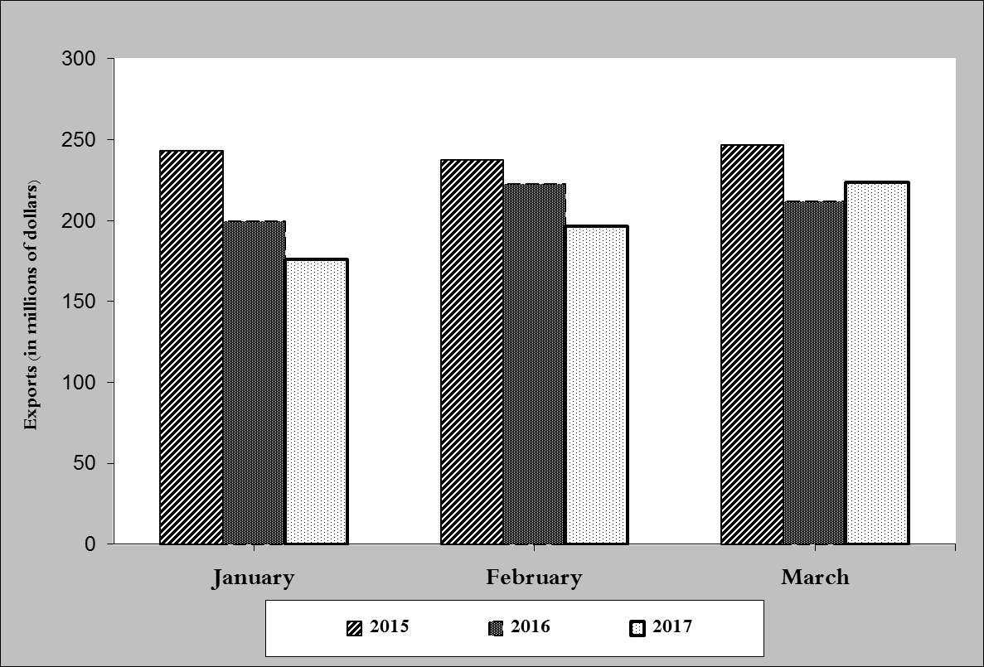
Chart 1: Industrial exports during years 2015-2016-2017
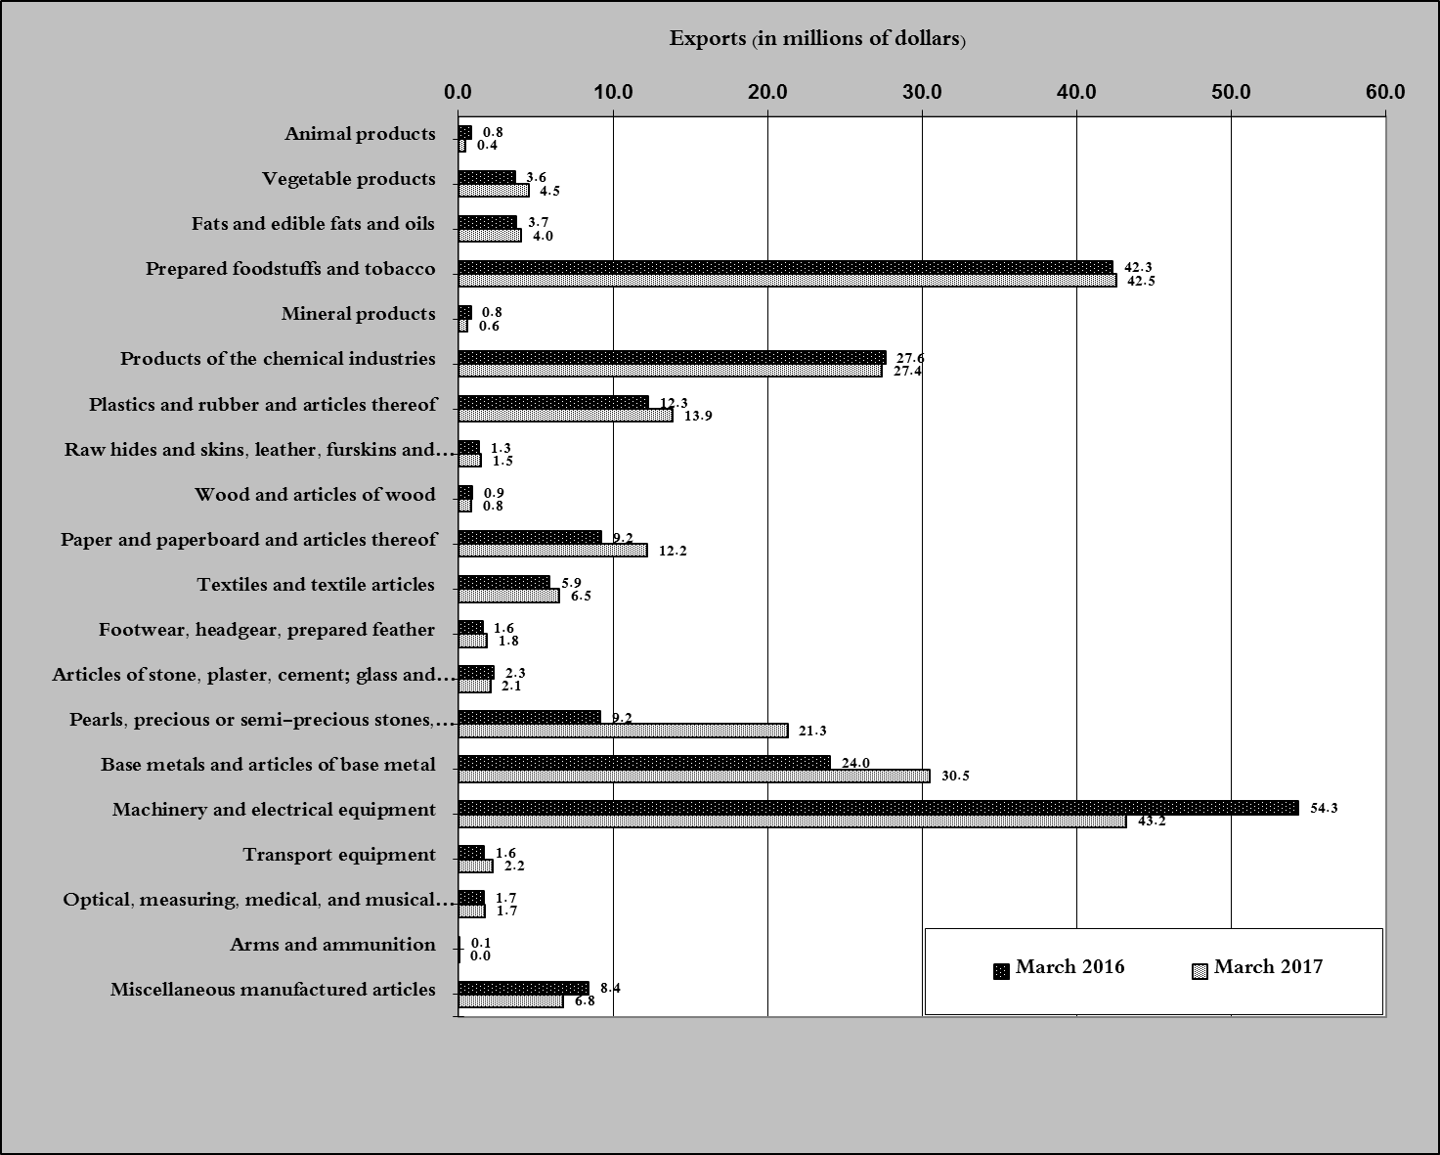
Chart 2: Comparison of industrial exports during March 2017 and March 2016

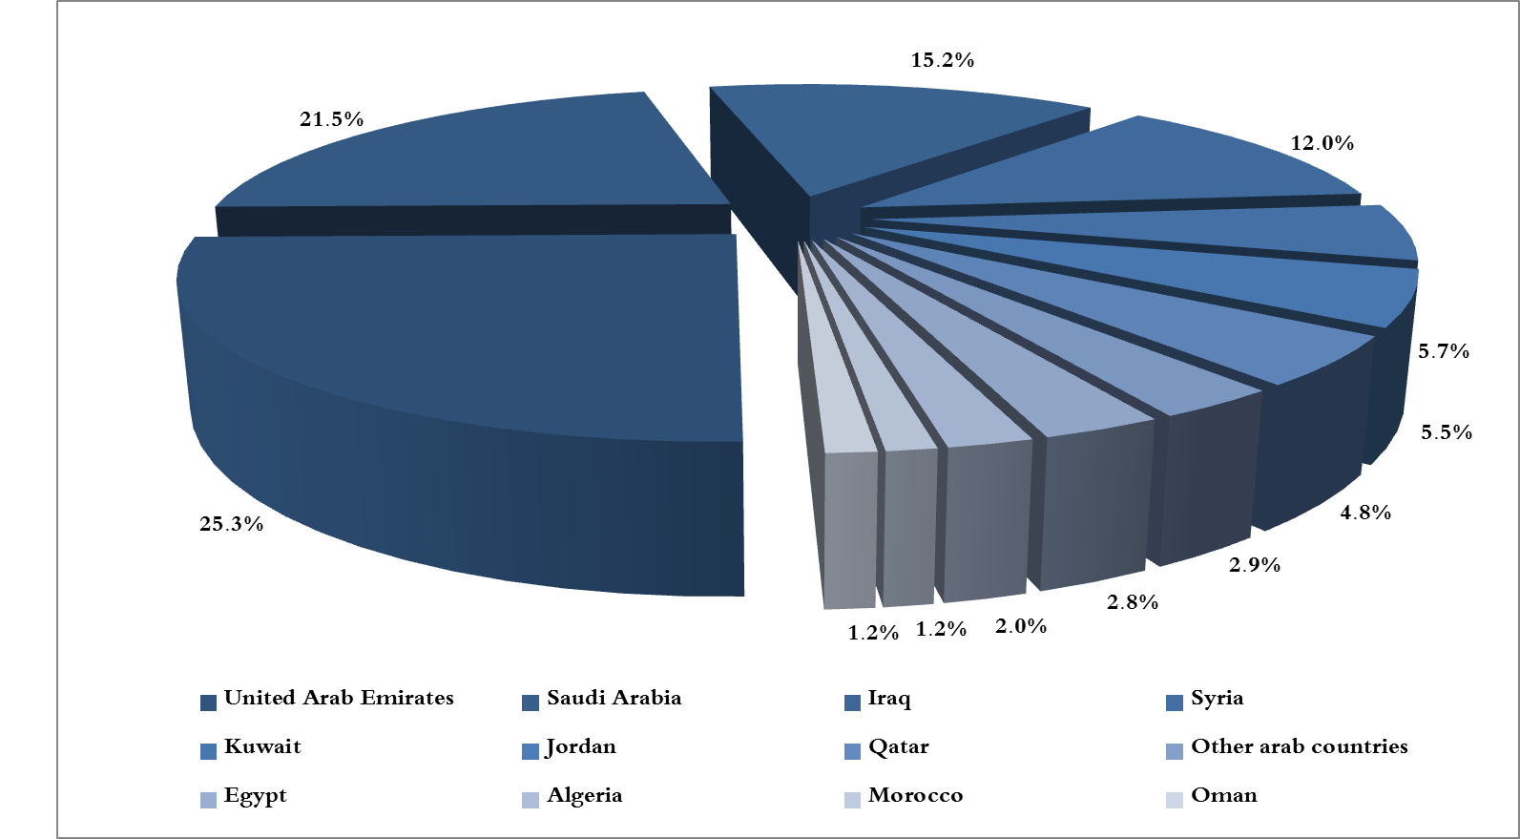
Chart 3: Distribution of industrial exports to Arab countries during March 2017

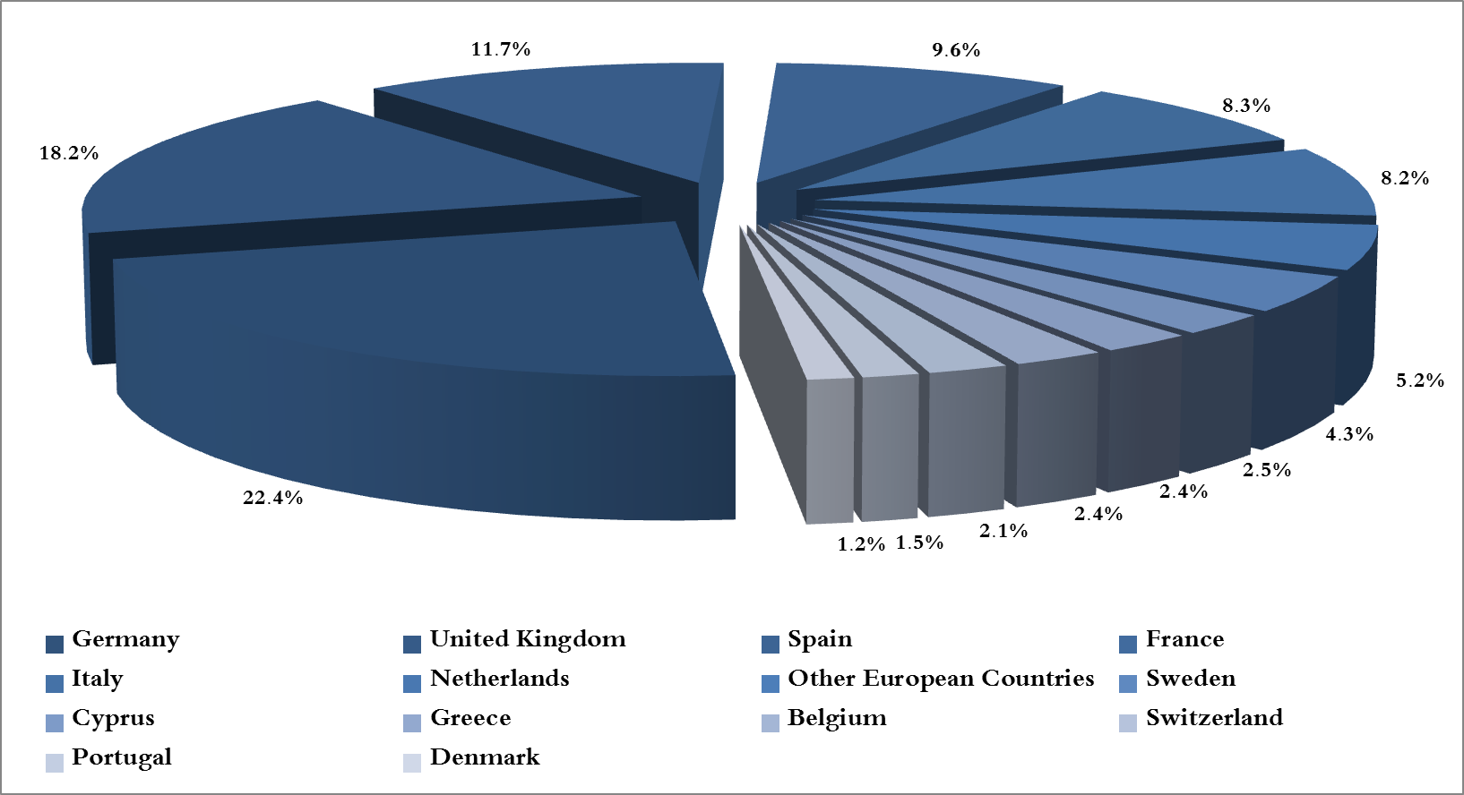
Chart 4: Distribution of industrial exports to European countries during March 2017

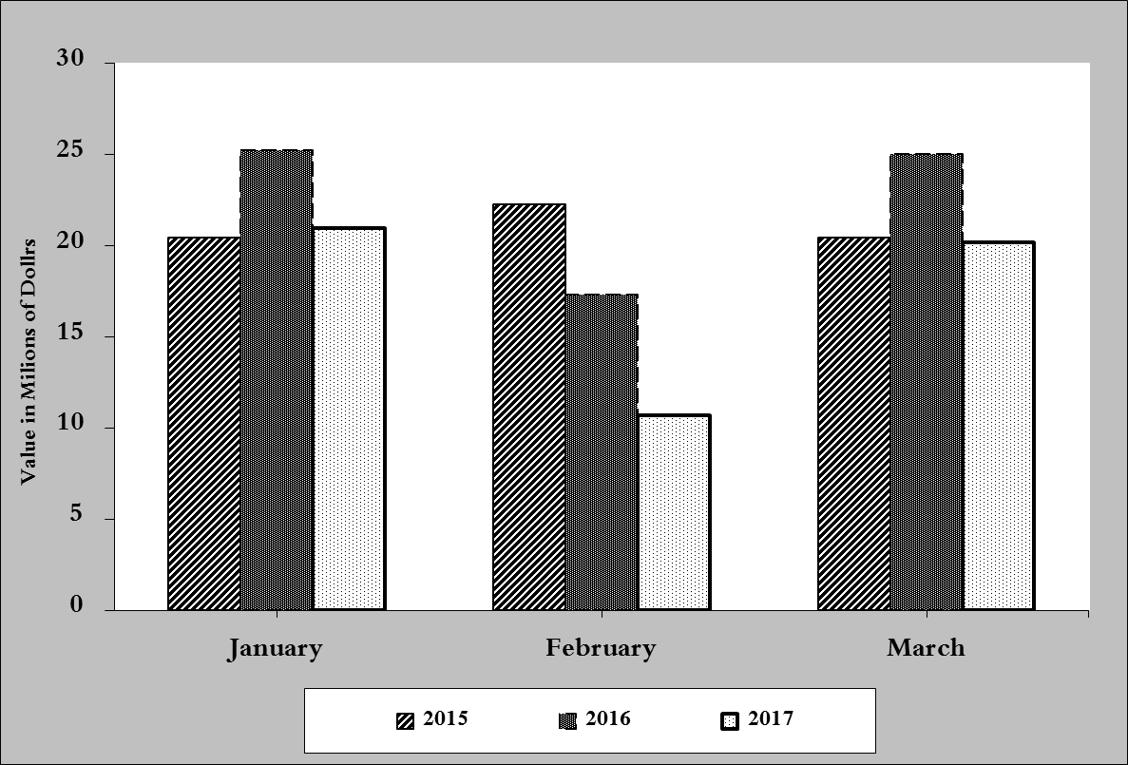
Chart 5: Imports of industrial machinery and equipment during years 2015-2016-2017
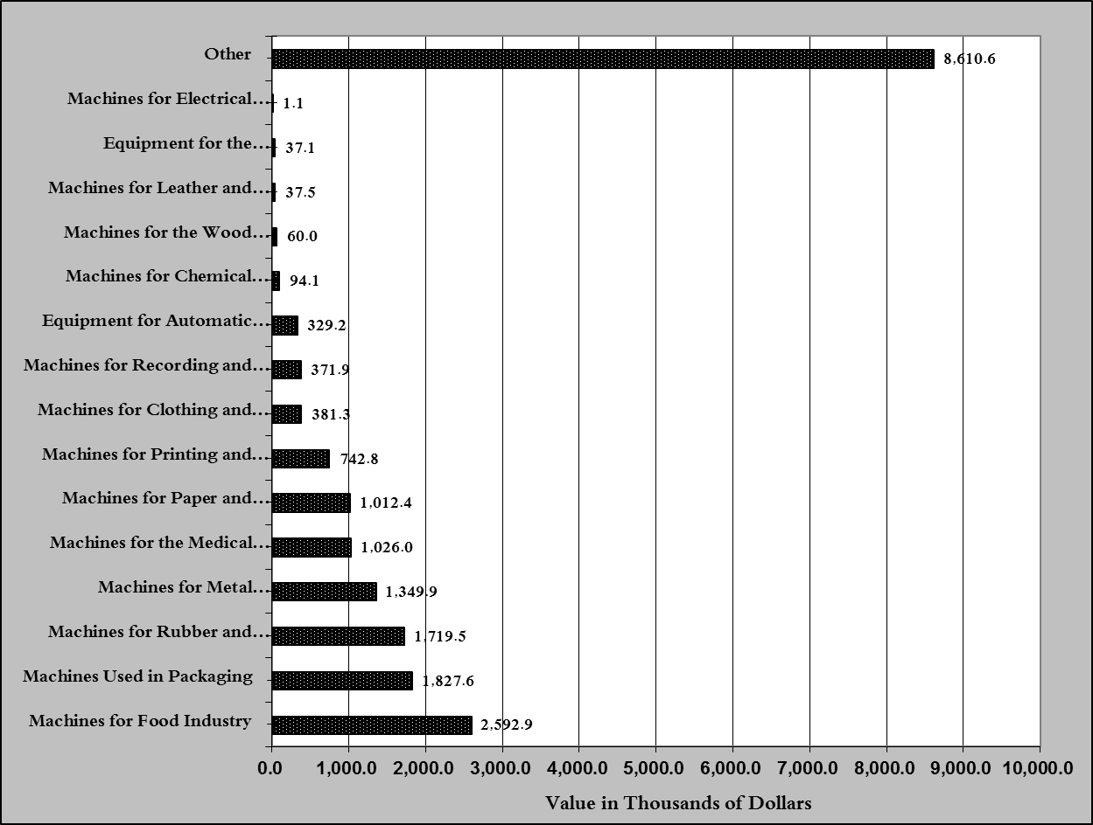
Chart 6: Imports of industrial equipment and machinery according to industrial activity during March 2017

Exports of unworked Diamonds, Silver and Gold Ingots reached this month a value of 47.6 million USD
The machineries and equipment are classified in this table according to the industrial sectors that are used in, while heading "other" includes machineries and equipment that can be used in various sectors.

