

A detailed report on industrial exports
and imports of industrial machinery and equipment in May 2017

Prepared by:
Ministry of Industry
Industrial Information Department

www.industry.gov.lb
Index

I. Introduction 3
II. Industrial exports in May 2017 4
1. Main exported products 4
2. Products with increased exports value 4
2.1. Prepared foodstuffs and tobacco 4
2.2. Base metals and articles of base metal 4
3. Products with decreased exports value 5
3.1. Machinery and electrical equipment 5
3.2. Products of the chemical industries 5
4. Main export markets 5
4.1. Main export markets by groups of countries 5
4.2. Main export markets by country 5
III. Imports of industrial machinery and equipment 6
1. Imported industrial machinery and equipment by country of origin and industrial activity 6
IV. Appendix tables 7
V. Appendix charts 20

Introduction
The Industrial Information Department of the Ministry of Industry has prepared a detailed report on industrial exports and imports of industrial machinery and equipment for the month of May 2017.
It should be noted that the total value of industrial exports during the first four months of the year 2017 amounted about 1 billion and 13 million US dollars compared to 1 billion and 76 million US dollars during the same period of the year 2016, and 1 billion and 248 million US dollars during the same period of the year 2015. Therefore we notice a decline of 5.8% compared to the year 2016, and a decline of 18.8% compared to the year 2015. (Tables 1 and 11(
It should also be noted that the monthly average of the Lebanese industrial exports during the first five months of the year 2017 amounted about 202.6 million US dollars compared to 215.1 million US dollars during the year 2016, and 249.6 million US dollars during the year 2015.
On the other hand, the total value of imports of industrial machinery and equipment during the first five months of the year 2017 amounted about 92.9 million US dollars compared to 111 million US dollars during the same period of the year 2016, and 110.4 million US dollars during the same period of the year 2015. Therefore, we notice a decline of 16.3% compared to the year 2016, and a decline of 15.8% compared to the year 2015. (Table 17)

Industrial exports in May 2017
The total value of industrial exports in May 2017 amounted to nearly 205.9 million US dollars, compared to 210.6 million US dollars in May 2016, and 280.6 million US dollars in May 2015, which is equivalent to a decline of 4.8 million US dollars, with the rate of 2.3% compared to year 2016, and a decline of 74.7 million US dollars with the rate of 26.6%, compared to year 2015. (Table 1, Chart 1)

Main exported products
Exports of prepared foodstuffs and tobacco came first in May 2017, with a total value of 49.4 million US dollars; Saudi Arabia was on top of importers list of this product, with an import value of 8.1 million US dollars. Followed by exports of machinery and electrical equipment, with a total value of 40.1 million US dollars, Iraq was the largest importer of this product, with an import value of 12.5 million US dollars. Then base metals and articles of base metal, with a total value of 28.6 million US dollars, Turkey topped the importers list of this product, with an import value of 7 million US dollars, followed by products of the chemical industries, with a total value of 21.7 million US dollars. (For more details tables 2, 4, 6, 8, 10, 15, and 16)

Products with increased exports value
Statistics showed a significant increase in exports of the following products:

Prepared foodstuffs and tobacco
Exports of this product increased from 40.8 million US dollars in May 2016 to 49.4 million US dollars in May 2017 (Table 2 and Chart 2). The exports of this product mainly increased to Greece, Iraq and Saudi Arabia which led to an increase in the total value of about 8.6 million US dollars. (Tables 3 and 4)

Base metals and articles of base metal
Exports of this product increased from 23.8 million US dollars in May 2016 to 28.6 million US dollars in May 2017 (Table 2 and Chart 2). The exports of this product mainly increased to Spain and Turkey which led to an increase of the total value of about 4.8 million US dollars. (Tables 5 and 6)

Products with decreased exports value
Statistics showed a significant decrease in exports of the following products:

Machinery and electrical equipment
Exports of this product decreased from 54 million US dollars in May 2016 to 40.1 million US dollars in May 2017 (Table 2 and Chart 2). The exports of this product increased to Iraq whereas it mainly decreased to Saudi Arabia, Angola, United Arab Emirates and Germany which led to a fall of the total value of about 13.9 million US dollars. (Tables 7 and 8)

Products of the chemical industries
Exports of this product decreased from 23.9 million US dollars in May 2016 to 21.7 million US dollars in May 2017 (Table 2 and Chart 2). The exports of this product increased to Turkey whereas it mainly decreased to Bangladesh, Spain, and Jordan which led to a fall of the total value of about 2.2 million US dollars. (Tables 9 and 10)

Main export markets

Main export markets by groups of countries
Arab countries were the main market for Lebanese industrial exports in May 2017, with a total export value of 116.7 million US dollars, with a rate of 56.7% of the total export value. European countries Were the second largest export markets with a rate of 17.8% of the total export value. Followed by, Non-arab African countries with a rate of 10.5% of the total export value, and, the Non-arab Asian countries with a rate of 9.6% of the total export value. The main products exported to Arab countries are: prepared foodstuffs and tobacco with the total value of 28.4 million US dollars, machinery and electrical equipment with the total value of 26.9 million US dollars, and the products of the chemical industries with the total value of 16.7 million US dollars. (Table 12)

Main export markets by country
Among countries importing Lebanese industrial products, Iraq ranked first with a total value of 25.8 million US dollars, with a rate of 12.5% of the total export value. Saudi Arabia came second with a total value of 23.7 million US dollars with a rate of 11.5% of the total export value. Followed by, United Arab Emirates with a total value of 19 million US dollars with a rate of 9.2% of the total exports value. (Table 13)
During this month, Lebanese products were exported to 42 European countries, 39 Non-arab African countries, 26 Non-arab Asian countries, 24 American countries, 19 Arab countries, and 5 Oceanic countries. Countries that imported Lebanese goods by over 1 million US dollars are as following: 13 Arab countries, 10 European countries, 7 Non-arab African countries, 4 Non-arab Asian countries, 2 American countries, and 1 Oceanic country. (Table 14, Charts 3 and 4)

Imports of industrial machinery and equipment
The total import value of industrial machinery and equipment in May 2017 reached about 23.1 million US dollars compared to 20.5 million US dollars during the same period in 2016, and 28 million US dollars during the same period in 2015, an increase by 12.3% compared to year 2016, and a decline of 17.5% compared to year 2015. (Tables 17 and 18 and Chart 5)
Italy ranked first on the list of countries exporting industrial machinery and equipment to Lebanon, with a total value amounting to about 4.9 million US dollars, followed by China, with a total value of 4.3 million US dollars, and Germany, with a total value of 3.4 million US dollars. (Table 18)

Imported industrial machinery and equipment by country of origin and industrial activity
In May 2017, imports of machines for food industry, ranked first, with a total value of 6.3 million US dollars, and Holland topped the list of countries exporting of this product to Lebanon with exports value of 1.8 million US dollars, followed by machines for printing and binding, with a total value of 2.3 million US dollars. Italy was the leading exporter of this product with an export value of 0.9 million US dollars. Followed by machines used in packaging, with a total value of 1.1 million US dollars. (Table 19, Chart 6)

Appendix tables

Table 1: Industrial exports during Years 2015 – 2016 – 2017
Month | Year  2015 | Year  2016 | Year  2017 | Variation  2015/2017 | Variation  2016/2017
January | 243.2 | 199.5 | 175.9 | -27.7% | -11.8%
February | 237.5 | 222.8 | 196.8 | -17.1% | -11.7%
March | 246.5 | 211.6 | 223.9 | -9.2% | 5.8%
April | 240.2 | 231.1 | 210.4 | -12.4% | -8.9%
May | 280.6 | 210.6 | 205.9 | -26.6% | -2.3%
June | 292.1 | 225.3
July | 233.5 | 178.8
August | 233.4 | 232.9
September | 242.5 | 184.3
October | 255.3 | 220.0
November | 219.9 | 193.7
December | 231.1 | 216.3
Total | 2,955.8 | 2,526.9 | 1,012.8
All above figures are in Millions of USD

Table 2: Comparison of industrial exports during May 2017 and May 2016
Section | Goods | May 2016 | May 2017 | Variation 2016/2017 | Variation in % 2016/2017
1 | Animal products | 0.8 | 1.0 | 0.2 | 23.9%
2 | Vegetable products | 4.5 | 4.0 | -0.6 | -12.5%
3 | Fats and edible fats and oils | 3.6 | 3.2 | -0.4 | -11.3%
4 | Prepared foodstuffs and tobacco | 40.8 | 49.4 | 8.6 | 21.2%
5 | Mineral products | 1.1 | 0.7 | -0.4 | -33.7%
6 | Products of the chemical industries | 23.9 | 21.7 | -2.2 | -9.2%
7 | Plastics and rubber and articles thereof | 11.4 | 12.0 | 0.6 | 5.2%
8 | Raw hides and skins, leather, furskins and articles thereof | 1.1 | 0.6 | -0.5 | -45.7%
9 | Wood and articles of wood | 1.6 | 1.2 | -0.4 | -22.7%
10 | Paper and paperboard and articles thereof | 9.8 | 10.8 | 0.9 | 9.6%
11 | Textiles and textile articles | 6.3 | 6.0 | -0.3 | -5.4%
12 | Footwear, headgear, prepared feather | 0.8 | 0.9 | 0.1 | 13.7%
13 | Articles of stone, plaster, cement; glass and glassware | 1.6 | 2.2 | 0.6 | 39.9%
14 | Pearls, precious or semi-precious stones, precious metals and articles thereof (Excluding unworked diamonds, silver and gold Ingots) | 14.4 | 12.9 | -1.6 | -10.9%
15 | Base metals and articles of base metal | 23.8 | 28.6 | 4.8 | 20.1%
16 | Machinery and electrical equipment | 54.0 | 40.1 | -13.9 | -25.8%
17 | Transport equipment | 0.8 | 1.5 | 0.7 | 84.8%
18 | Optical, measuring, medical, and musical instruments; clocks and watches | 1.7 | 1.2 | -0.5 | -30.9%
19 | Arms and ammunition | 0.1 | 0.2 | 0.1 | 165.7%
20 | Miscellaneous manufactured articles | 8.3 | 7.6 | -0.7 | -8.2%
 | Total | 210.6 | 205.9 | -4.8 | -2.3%
All above figures are in Millions of USD
Table 3: Exports of prepared foodstuffs and tobacco according to the main importing countries during May 2016
Export destination Country | Saudi Arabia | Syria | Iraq | United Arab Emirates | United States Of America | Qatar | Belgium | Jordan
Value in thousands of USD | 6,670 | 4,475 | 3,791 | 2,419 | 2,283 | 2,191 | 1,982 | 1,623

Table 4: Exports of prepared foodstuffs and tobacco according to the main importing countries during May 2017
Export destination Country | Saudi Arabia | Iraq | Greece | Syria | United States Of America | Jordan | Bulgaria | United Arab Emirates
Value in thousands of USD | 8,101 | 5,299 | 5,136 | 4,230 | 2,762 | 2,275 | 2,055 | 1,768

Table 5: Exports of base metals and articles of base metal according to the main importing countries during May 2016
Export destination Country | Turkey | Republic of Korea | Greece | India | Saudi Arabia | Syria | Ghana | Japan
Value in thousands of USD | 5,614 | 4,063 | 2,743 | 1,146 | 915 | 673 | 591 | 564

Table 6: Exports of base metals and articles of base metal according to the main importing countries during May 2017
Export destination Country | Turkey | Korea, Republic of | Spain | Greece | China | Italy | Saudi Arabia | Ivory Coast
Value in thousands of USD | 7,003 | 4,524 | 3,841 | 2,149 | 1,390 | 1,035 | 800 | 759

Table 7: Exports of machinery and electrical equipment according to the main importing countries during May 2016
Export destination Country | Iraq | Saudi Arabia | United Arab Emirates | Angola | Syria | Germany | Qatar | Mali
Value in thousands of USD | 10,093 | 7,475 | 4,326 | 4,237 | 2,891 | 2,108 | 1,457 | 1,346

Table 8: Exports of machinery and electrical equipment according to the main importing countries during May 2017
Export destination Country | Iraq | Saudi Arabia | United Arab Emirates | Syria | Ghana | Kuwait | Algeria | Other
Value in thousands of USD | 12,482 | 2,864 | 2,461 | 2,297 | 2,026 | 1,943 | 1,852 | 1,128

Table 9: Exports of products of the chemical industries according to the main importing countries during May 2016
Export destination Country | United Arab Emirates | Iraq | Jordan | Bangladesh | Spain | Saudi Arabia | Syria | Kuwait
Value in thousands of USD | 4,414 | 3,809 | 3,153 | 2,509 | 2,262 | 1,947 | 720 | 675

Table 10: Exports of products of the chemical industries according to the main importing countries during May 2017
Export destination Country | Iraq | United Arab Emirates | Saudi Arabia | Turkey | Jordan | Kuwait | Syria | Qatar
Value in thousands of USD | 3,980 | 3,971 | 2,477 | 1,955 | 1,922 | 1,389 | 901 | 680

Table 11: Industrial exports according to exported goods during year 2017

Table 12: Industrial exports according to exported goods and countries groups during May 2017
Goods | Arab Countries | European Countries | Oceanic Countries | Non-Arab Asian countries | American Countries | Non-Arab African countries | Other* | Total
Animal products | 867 | 5 |  |  | 50 | 109 |  | 1,031
Vegetable products | 1,436 | 1,285 | 24 | 90 | 686 | 456 |  | 3,977
Fats and edible fats and oils | 1,559 | 650 | 137 | 61 | 680 | 80 |  | 3,168
Prepared foodstuffs and tobacco | 28,443 | 13,510 | 637 | 456 | 4,100 | 1,962 | 339 | 49,447
Mineral products | 503 | 12 |  | 8 |  | 65 | 137 | 724
Products of the chemical industries | 16,652 | 1,668 | 120 | 2,150 | 273 | 816 | 14 | 21,693
Plastics and rubber and articles thereof | 8,482 | 1,069 | 69 | 516 | 136 | 1,650 | 100 | 12,023
Raw hides and skins, leather, furskins and articles thereof | 356 | 174 |  | 11 |  | 76 | 1 | 619
Wood and articles of wood | 957 | 17 |  |  | 27 | 230 |  | 1,231
Paper and paperboard and articles thereof | 8,269 | 954 | 1 | 148 | 14 | 1,375 | 26 | 10,786
Textiles and textile articles | 2,885 | 2,206 | 7 | 148 | 125 | 539 | 60 | 5,970
Footwear, headgear, prepared feather | 645 | 6 |  | 1 | 2 | 223 | 6 | 883
Articles of stone, plaster, cement; glass and glassware | 1,369 | 123 | 19 |  | 67 | 666 | 4 | 2,249
Pearls, precious or semi-precious stones, precious metals and articles thereof (Excluding unworked diamonds, silver and gold Ingots) | 8,121 | 3,291 |  | 150 | 1,206 | 91 | 9 | 12,869
Base metals and articles of base metal | 2,954 | 8,214 | 81 | 14,198 | 14 | 3,010 | 139 | 28,609
Machinery and electrical equipment | 26,928 | 2,299 | 35 | 1,484 | 207 | 8,000 | 1,129 | 40,083
Transport equipment | 965 | 316 |  | 77 | 34 | 137 |  | 1,530
Optical, measuring, medical, and musical instruments; clocks and watches | 639 | 246 |  | 123 | 46 | 127 |  | 1,181
Arms and ammunition | 76 |  |  | 23 |  | 72 |  | 171
Miscellaneous manufactured articles | 4,633 | 523 | 37 | 200 | 261 | 1,987 | 7 | 7,648
Total | 116,739 | 36,570 | 1,168 | 19,843 | 7,928 | 21,673 | 1,971 | 205,891
All the above figures are in thousands of US dollars.
* "other" Includes exported goods to the duty free market and those that are supplied to ships and aircraft.

Table 13: Distribution of the industrial exports according to the main importing countries during May 2017
Export destination Country | Iraq | Saudi Arabia | United Arab Emirates | Syria | Turkey | Jordan | Greece | Kuwait
Value in thousands of USD | 25,757 | 23,663 | 19,030 | 12,211 | 9,493 | 8,884 | 7,459 | 6,901

Export destination Country | United States Of America | Qatar | Egypt | Republic of Korea | Spain | France | Ivory Coast | Germany
Value in thousands of USD | 5,787 | 5,181 | 4,801 | 4,524 | 4,269 | 3,809 | 3,647 | 3,564

Export destination Country | United Kingdom | Ghana | Algeria | Bulgaria | Liberia | Switzerland | Congo | Netherlands
Value in thousands of USD | 3,369 | 3,211 | 3,138 | 2,436 | 2,090 | 2,087 | 2,063 | 2,000

Table 14: Distribution of importing countries according to countries groups and the value of exports during May 2017
Exports Value  (in million USD) | Arab Countries | European Countries | Oceania Countries | Non-Arab Asian countries | American Countries | Non-Arab African countries | Total
]0-1[ | 6 | 32 | 4 | 22 | 22 | 32 | 118
[1-5[ | 6 | 9 | 1 | 3 | 1 | 7 | 27
[5-10[ | 3 | 1 |  | 1 | 1 |  | 6
[10-15[ | 1 |  |  |  |  |  | 1
More than 15 million USD | 3 |  |  |  |  |  | 3
Total | 19 | 42 | 5 | 26 | 24 | 39 | 155

Table 15: Distribution of the industrial exports according to product and to the main importing countries during May 2017
Animal products | United Arab Emirates | Iraq | Jordan | Saudi Arabia | United States Of America | Qatar | Liberia | Bahrain
Value in 1000 of USD | 368 | 182 | 114 | 84 | 50 | 47 | 44 | 38

Vegetable products | United States Of America | Netherlands | Saudi Arabia | Germany | Qatar | Jordan | Sweden | South Africa
Value in 1000 of USD | 550 | 424 | 398 | 319 | 295 | 278 | 267 | 127

Fats and edible fats and oils | United States Of America | Iraq | Saudi Arabia | Portugal | Kuwait | Netherlands | Canada | United Arab Emirates
Value in 1000 of USD | 438 | 409 | 342 | 336 | 319 | 210 | 181 | 172

Mineral products | Syria | Other | Guinea | Liberia | Kuwait | United Kingdom | Iraq | China
Value in 1000 of USD | 467 | 137 | 23 | 14 | 13 | 12 | 10 | 8

Plastics and rubber and articles thereof | Syria | Saudi Arabia | Iraq | Egypt | Jordan | United Arab Emirates | Tunisia | Qatar
Value in 1000 of USD | 2,311 | 1,568 | 898 | 814 | 761 | 476 | 435 | 431

Raw hides and skins, leather, furskins and articles thereof | United Arab Emirates | Egypt | Jordan | Portugal | Italy | France | Nigeria | Ivory Coast
Value in 1000 of USD | 154 | 99 | 69 | 59 | 37 | 35 | 33 | 31

Wood and articles of wood | Syria | Saudi Arabia | Jordan | Qatar | Iraq | Ivory Coast | Nigeria | Guinea
Value in 1000 of USD | 328 | 221 | 191 | 95 | 70 | 55 | 39 | 33

Paper and paperboard and articles thereof | Saudi Arabia | Iraq | United Arab Emirates | Egypt | Morocco | Syria | Jordan | Burundi
Value in 1000 of USD | 1,643 | 1,557 | 930 | 924 | 743 | 601 | 410 | 396

Textiles and textile articles | United Arab Emirates | France | United Kingdom | Syria | Saudi Arabia | Jordan | Ivory Coast | Switzerland
Value in 1000 of USD | 1,100 | 893 | 487 | 426 | 413 | 282 | 263 | 221

Table 15: (continued) Distribution of the industrial exports according to product and the main importing countries during May 2017
Footwear, headgear, prepared feather | Saudi Arabia | Ivory Coast | United Arab Emirates | Qatar | Kuwait | Liberia | Ghana | Jordan
Value in 1000 of USD | 402 | 203 | 138 | 44 | 40 | 9 | 8 | 7

Articles of stone, plaster, cement; glass and glassware | Qatar | Nigeria | United Arab Emirates | Saudi Arabia | Guinea | Kuwait | Algeria | United States Of America
Value in 1000 of USD | 623 | 240 | 221 | 203 | 151 | 140 | 67 | 65

Pearls, precious or semi-precious stones, precious metals and articles thereof (Excluding unworked diamonds, silver and gold Ingots) | United Arab Emirates | Saudi Arabia | Switzerland | Germany | United States Of America | Jordan | United Kingdom | Belgium
Value in 1000 of USD | 5,081 | 1,976 | 1,535 | 1,407 | 1,203 | 959 | 112 | 107

Transport equipment | United Arab Emirates | Iraq | Syria | Germany | Yemen | France | Iran | United Kingdom
Value in 1000 of USD | 519 | 165 | 143 | 122 | 97 | 97 | 75 | 48

Optical, measuring, medical, and musical instruments; clocks and watches | Jordan | United Arab Emirates | Germany | Switzerland | Hong Kong | Upper Volta | United States Of America | Congo
Value in 1000 of USD | 297 | 261 | 110 | 102 | 100 | 57 | 44 | 41

Arms and ammunition | Mali | Sudan | Afghanistan | Jordan
Value in 1000 of USD | 72 | 70 | 23 | 6

Miscellaneous manufactured articles | Saudi Arabia | United Arab Emirates | Ivory Coast | Jordan | Qatar | Ghana | Iraq | United States Of America
Value in 1000 of USD | 2,146 | 926 | 851 | 604 | 472 | 267 | 251 | 251

Table 16: Distribution of industrial exports, according to the main exported goods and main importing countries during May 2017

Table 17: Imports of industrial machinery and equipment during years 2015-2016-2017
Month | Year  2015 | Year  2016 | Year  2017 | Variation  2015/2017 | Variation  2016/2017
January | 20.5 | 25.3 | 21.0 | 2.4% | -17.1%
February | 22.3 | 17.3 | 10.7 | -52.1% | -38.3%
March | 20.5 | 25.1 | 20.2 | -1.3% | -19.4%
April | 19.1 | 22.8 | 18.0 | -5.8% | -20.9%
May | 28.0 | 20.5 | 23.1 | -17.5% | 12.3%
June | 23.7 | 20.0
July | 20.1 | 16.8
August | 21.3 | 19.0
September | 13.8 | 16.2
October | 16.5 | 14.5
November | 18.9 | 20.0
December | 18.7 | 17.9
Total | 243.4 | 235.5 | 92.9
All above figures are in Millions of USD

Table 18: Imports of industrial equipment and machinery according to exporting country for the year 2017
Table 19: Imports of industrial equipment and machinery according to industrial activity and country during May 2017

Appendix charts
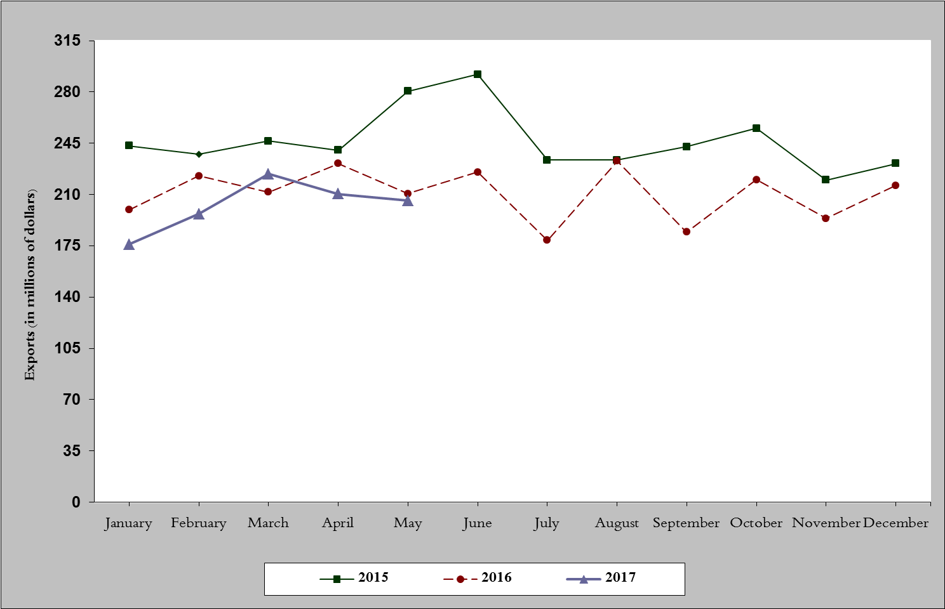
Chart 1: Industrial exports during years 2015-2016-2017
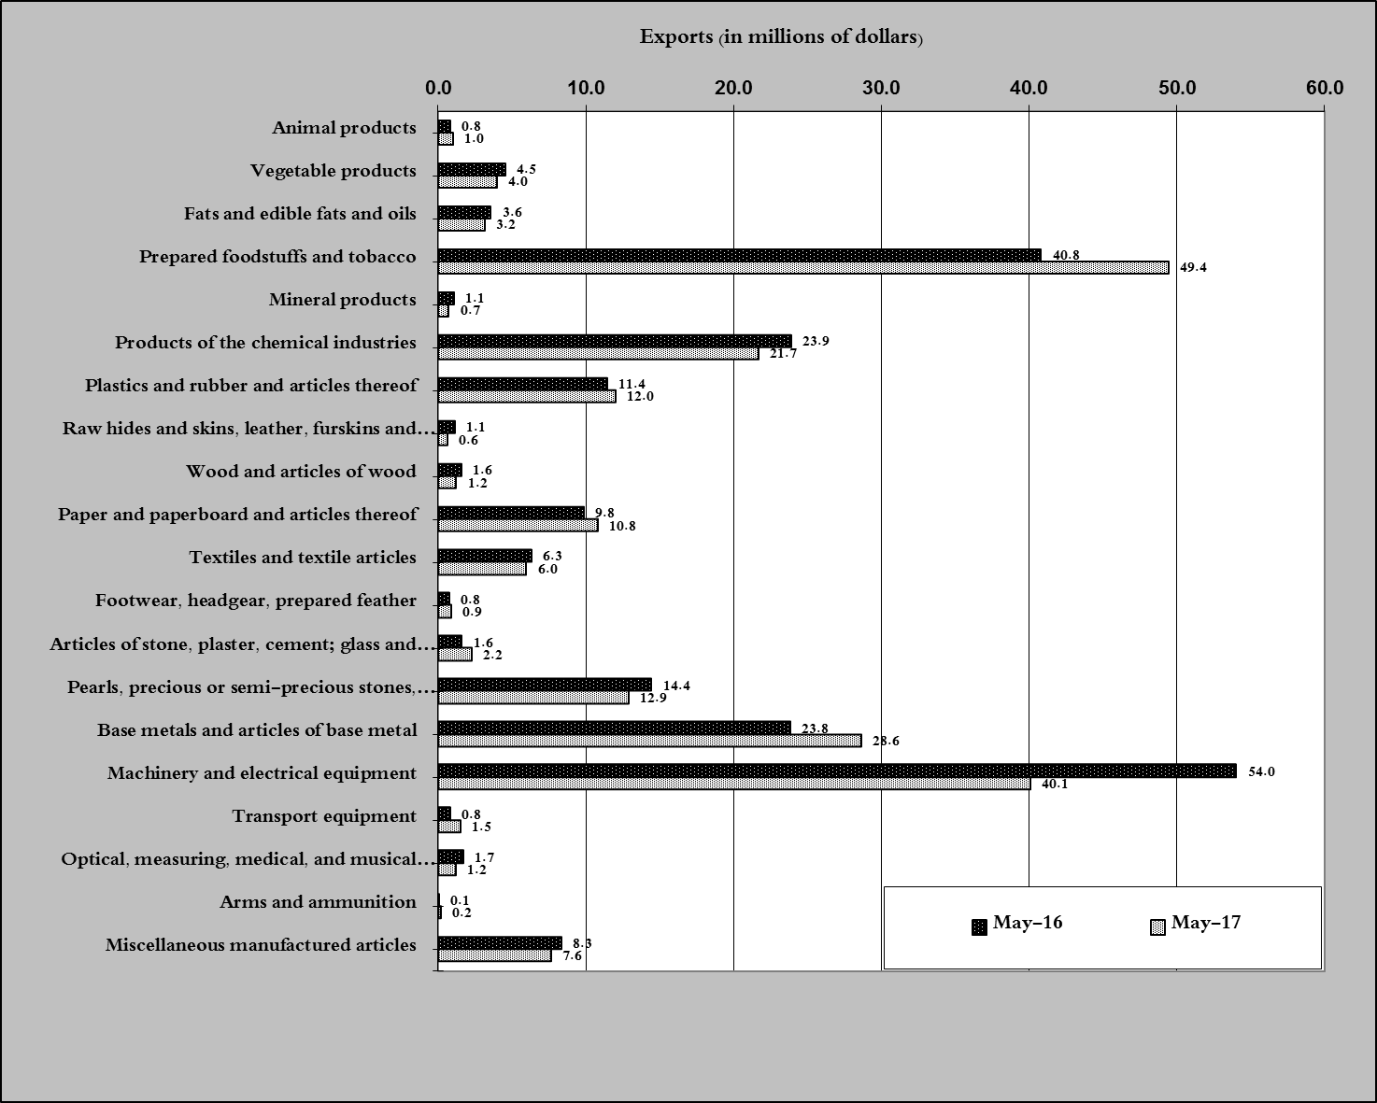
Chart 2: Comparison of industrial exports during May 2017 and May 2016

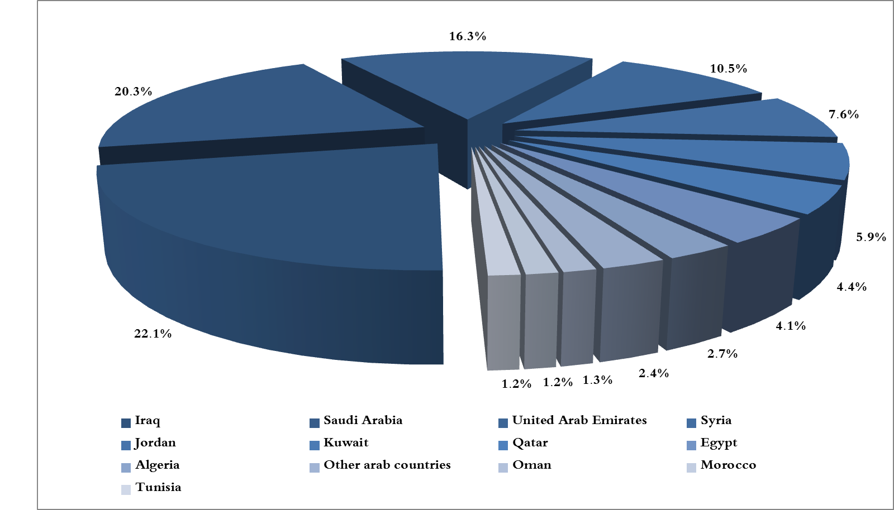
Chart 3: Distribution of industrial exports to Arab countries during May 2017

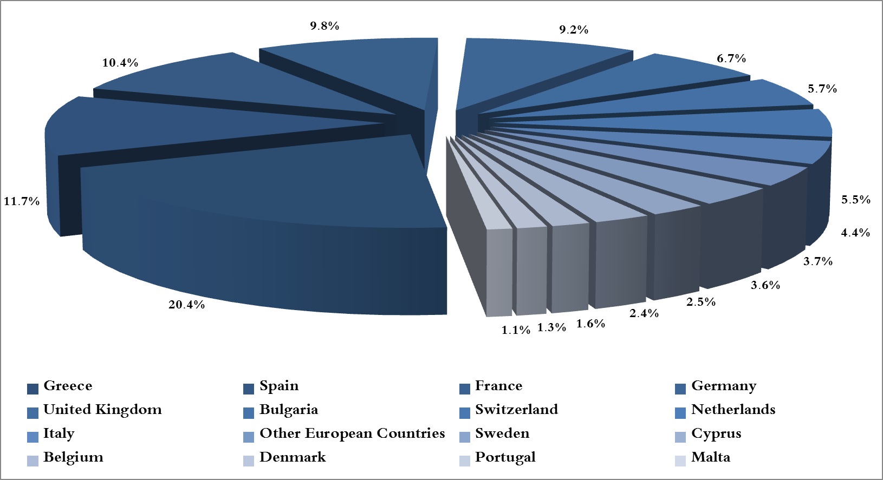
Chart 4: Distribution of industrial exports to European countries during May 2017

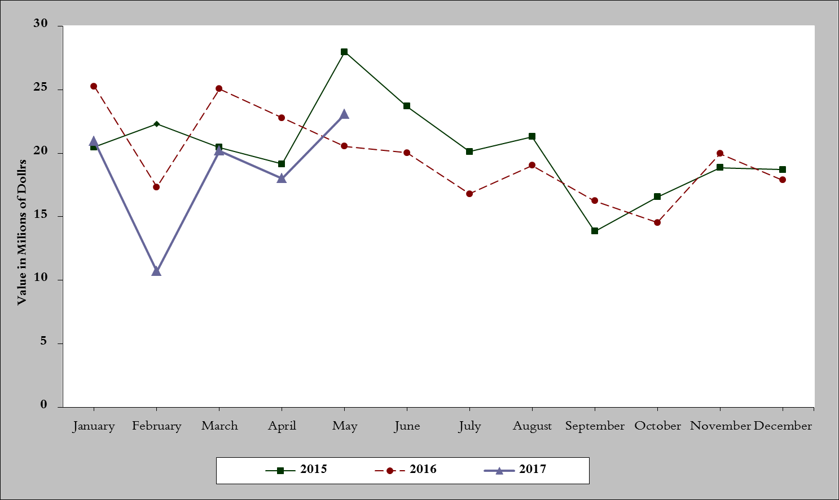
Chart 5: Imports of industrial machinery and equipment during years 2015-2016-2017
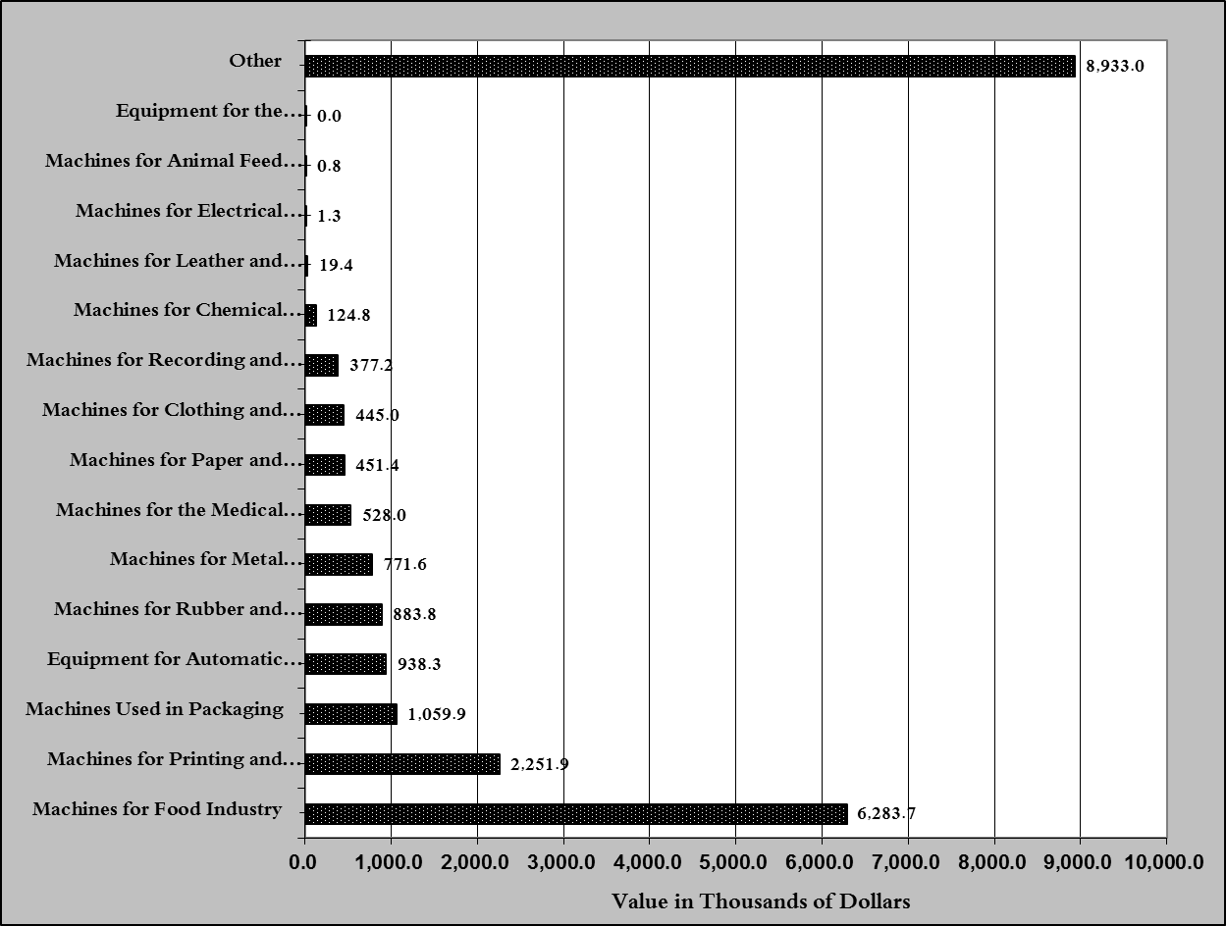
Chart 6: Imports of industrial equipment and machinery according to industrial activity during May 2017

Exports of unworked Diamonds, Silver and Gold Ingots reached this month a value of 41.8 million USD
The machineries and equipment are classified in this table according to the industrial sectors that are used in, while heading "other" includes machineries and equipment that can be used in various sectors.

