

A detailed report on industrial exports
and imports of industrial machinery and equipment in September 2017

Prepared by:
Ministry of Industry
Industrial Information Department

www.industry.gov.lb
Index

I. Introduction 3
II. Industrial exports in September 2017 4
1. Main exported products 4
2. Products with increased exports value 4
2.1. Base metals and articles of base metal 4
2.2. Pearls, precious or semi-precious stones, precious metals and articles thereof (Excluding unworked diamonds, silver and gold Ingots) 4
3. Products with decreased exports value 5
3.1. Machinery and electrical equipment 5
3.2. Paper and paperboard and articles thereof 5
4. Main export markets 5
4.1. Main export markets by groups of countries 5
4.2. Main export markets by country 5
III. Imports of industrial machinery and equipment 6
1. Imported industrial machinery and equipment by country of origin 6
2. Imported industrial machinery and equipment by country of origin and industrial activity 6
IV. Appendix tables 7
V. Appendix charts 21

Introduction
The Industrial Information Department of the Ministry of Industry has prepared a detailed report on industrial exports and imports of industrial machinery and equipment for the month of September 2017.
It should be noted that the total value of industrial exports during the first nine months of the year 2017 amounted about 1 billion and 822 million US dollars compared to 1 billion and 897 million US dollars during the same period of the year 2016, and 2 billion and 249 million US dollars during the same period of the year 2015. Therefore we notice a decline of 3.9% compared to the year 2016, and a decline of 19% compared to the year 2015. (Tables 1 and 11(
It should also be noted that the monthly average of the Lebanese industrial exports during the first nine months of the year 2017 amounted about 202.5 million US dollars compared to 210.8 million US dollars during the year 2016, and 249.9 million US dollars during the year 2015.
On the other hand, the total value of imports of industrial machinery and equipment during the first nine months of the year 2017 amounted about 194.1 million US dollars compared to 183.1 million US dollars during the same period of the year 2016, and 189.3 million US dollars during the same period of the year 2015. Therefore, we notice an increase of 6% compared to the year 2016, and an increase of 2.5% compared to the year 2015. (Table 17)

Industrial exports in September 2017
The total value of industrial exports in September 2017 amounted to nearly 167.6 million US dollars, compared to 184.3 million US dollars in September 2016, and 242.5 million US dollars in September 2015, which is equivalent to a decline of 16.7 million US dollars, with the rate of 9% compared to year 2016, and a decline of 74.9 million US dollars with the rate of 30.9%, compared to year 2015. (Table 1, Chart 1)

Main exported products
Exports of products of the chemical industries came first in September 2017, with a total value of 34.8 million US dollars; Iran was on top of importers list of this product, with an import value of 15.3 million US dollars. Followed by exports of prepared foodstuffs and tobacco, with a total value of 27.9 million US dollars, Saudi Arabia was the largest importer of this product, with an import value of 4.6 million US dollars. Then machinery and electrical equipment, with a total value of 25.6 million US dollars, Iraq topped the importers list of this product, with an import value of 3.6 million US dollars, followed by base metals and articles of base metal, with a total value of 24.3 million US dollars. (For more details tables 2, 4, 6, 8, 10, 15, and 16)

Products with increased exports value
Statistics showed a significant increase in exports of the following products:

Base metals and articles of base metal
Exports of this product increased from 16.2 million US dollars in September 2016 to 24.3 million US dollars in September 2017 (Table 2 and Chart 2). The exports of this product mainly increased to Turkey, Republic of Korea, Spain, and Greece which led to an increase in the total value of about 8.1 million US dollars. (Tables 3 and 4)

Pearls, precious or semi-precious stones, precious metals and articles thereof (Excluding unworked diamonds, silver and gold Ingots)
Exports of this product increased from 7.4 million US dollars in September 2016 to 14.9 million US dollars in September 2017 (Table 2 and Chart 2). The exports of this product mainly increased to Hong Kong and United Arab Emirates which led to an increase of the total value of about 7.5 million US dollars. (Tables 5 and 6)

Products with decreased exports value
Statistics showed a significant decrease in exports of the following products:

Machinery and electrical equipment
Exports of this product decreased from 47.3 million US dollars in September 2016 to 25.6 million US dollars in September 2017 (Table 2 and Chart 2). The exports of this product mainly decreased to Iraq, Saudi Arabia, Syria, Algeria, Brazil, and Nigeria which led to a fall of the total value of about 21.7 million US dollars. (Tables 7 and 8)

Paper and paperboard and articles thereof
Exports of this product decreased from 11.2 million US dollars in September 2016 to 7.6 million US dollars in September 2017 (Table 2 and Chart 2). The exports of this product mainly decreased to Iraq and Syria which led to a fall of the total value of about 3.6 million US dollars. (Tables 9 and 10)

Main export markets

Main export markets by groups of countries
Arab countries were the main market for Lebanese industrial exports in September 2017, with a total export value of 85 million US dollars, with a rate of 50.7% of the total export value. Non-arab Asian countries were the second largest export markets with a rate of 21.3% of the total export value. Followed by, European countries with a rate of 14.1% of the total export value, and, the Non-arab African countries with a rate of 9.4% of the total export value. The main products exported to Arab countries are: prepared foodstuffs and tobacco with the total value of 19.5 million US dollars, machinery and electrical equipment with the total value of 15.3 million US dollars, and the products of the chemical industries with the total value of 13 million US dollars. (Table 12)

Main export markets by country
Among countries importing Lebanese industrial products, United Arab Emirates ranked first with a total value of 17.6 million US dollars, with a rate of 10.5% of the total export value. Iran came second with a total value of 15.7 million US dollars with a rate of 9.4% of the total export value. Followed by, Saudi Arabia with a total value of 13.6 million US dollars with a rate of 8.1% of the total exports value. (Table 13)
During this month, Lebanese products were exported to 44 European countries, 40 Non-arab African countries, 27 Non-arab Asian countries, 27 American countries, 19 Arab countries, and 8 Oceanic countries. Countries that imported Lebanese goods by over 1 million US dollars are as following: 10 Arab countries, 8 European countries, 5 Non-arab Asian countries, 4 Non-arab African countries, and 2 American countries . (Table 14, Charts 3 and 4)

Imports of industrial machinery and equipment
The total import value of industrial machinery and equipment in September 2017 reached about 30.1 million US dollars compared to 16.2 million US dollars during the same period in 2016, and 13.8 million US dollars during the same period in 2015, an increase by 85.4% compared to year 2016, and an increase of 117.5% compared to year 2015. (Tables 17 and 18 and Chart 5)

Imported industrial machinery and equipment by country of origin
Italy ranked first on the list of countries exporting industrial machinery and equipment to Lebanon, with a total value amounting to about 6.3 million US dollars, followed by Romania, with a total value of 5.6 million US dollars, and China, with a total value of 3.6 million US dollars. (Table 18)

Imported industrial machinery and equipment by country of origin and industrial activity
In September 2017, imports of machines for food industry, ranked first, with a total value of 3.2 million US dollars, and Spain topped the list of countries exporting of this product to Lebanon with exports value of 1.6 million US dollars, followed by machines for paper and cardboard industry, with a total value of 3 million US dollars. Italy was the leading exporter of this product with an export value of 2.8 million US dollars. Followed by machines used in packaging, with a total value of 1.9 million US dollars. (Table 19, Chart 6)

Appendix tables

Table 1: Industrial exports during Years 2015 – 2016 – 2017
Month | Year  2015 | Year  2016 | Year  2017 | Variation in %  2015/2017 | Variation in %  2016/2017
January | 243.2 | 199.5 | 175.9 | -27.7% | -11.8%
February | 237.5 | 222.8 | 196.8 | -17.1% | -11.7%
March | 246.5 | 211.6 | 223.9 | -9.2% | 5.8%
April | 240.2 | 231.1 | 210.4 | -12.4% | -8.9%
May | 280.6 | 210.6 | 205.9 | -26.6% | -2.3%
June | 292.1 | 225.3 | 199.0 | -31.9% | -11.7%
July | 233.5 | 178.8 | 215.7 | -7.6% | 20.7%
August | 233.4 | 232.9 | 227.0 | -2.8% | -2.5%
September | 242.5 | 184.3 | 167.6 | -30.9% | -9.0%
October | 255.3 | 220.0
November | 219.9 | 193.7
December | 231.1 | 216.3
Total | 2,955.8 | 2,526.9 | 1,822.2
All above figures are in Millions of USD

Table 2: Comparison of industrial exports during September 2017 and September 2016
Section | Goods | September 2016 | September 2017 | Variation 2016/2017 | Variation in % 2016/2017
1 | Animal products | 0.3 | 0.6 | 0.2 | 65.6%
2 | Vegetable products | 4.0 | 2.7 | -1.2 | -30.7%
3 | Fats and edible fats and oils | 2.9 | 1.8 | -1.1 | -36.4%
4 | Prepared foodstuffs and tobacco | 30.7 | 27.9 | -2.8 | -9.2%
5 | Mineral products | 0.7 | 0.5 | -0.2 | -27.2%
6 | Products of the chemical industries | 31.2 | 34.8 | 3.6 | 11.5%
7 | Plastics and rubber and articles thereof | 11.9 | 11.6 | -0.2 | -1.9%
8 | Raw hides and skins, leather, furskins and articles thereof | 0.6 | 0.8 | 0.1 | 23.2%
9 | Wood and articles of wood | 0.9 | 0.7 | -0.2 | -23.7%
10 | Paper and paperboard and articles thereof | 11.2 | 7.6 | -3.6 | -32.4%
11 | Textiles and textile articles | 6.2 | 4.0 | -2.2 | -35.3%
12 | Footwear, headgear, prepared feather | 0.8 | 0.2 | -0.5 | -68.1%
13 | Articles of stone, plaster, cement; glass and glassware | 1.4 | 1.5 | 0.1 | 5.6%
14 | Pearls, precious or semi-precious stones, precious metals and articles thereof (Excluding unworked diamonds, silver and gold Ingots) | 7.4 | 14.9 | 7.5 | 101.0%
15 | Base metals and articles of base metal | 16.2 | 24.3 | 8.1 | 50.1%
16 | Machinery and electrical equipment | 47.3 | 25.6 | -21.7 | -45.9%
17 | Transport equipment | 1.3 | 1.5 | 0.2 | 16.5%
18 | Optical, measuring, medical, and musical instruments; clocks and watches | 1.2 | 2.4 | 1.3 | 109.5%
19 | Arms and ammunition | 0.0 | 0.0 | 0.0 | 0.0%
20 | Miscellaneous manufactured articles | 8.0 | 4.0 | -3.9 | -49.4%
 | Total | 184.3 | 167.6 | -16.7 | -9.0%
All above figures are in Millions of USD
Table 3: Exports of base metals and articles of base metal according to the main importing countries during September 2016
Export destination Country | Republic of Korea | Turkey | Japan | Congo | Saudi Arabia | Italy | Bulgaria | Qatar
Value in thousands of USD | 2,439 | 2,060 | 810 | 763 | 685 | 662 | 601 | 563

Table 4: Exports of base metals and articles of base metal according to the main importing countries during September 2017
Export destination Country | Turkey | Republic of Korea | Spain | Greece | China | Italy | India | Syria
Value in thousands of USD | 7,304 | 3,753 | 1,737 | 1,570 | 1,244 | 696 | 623 | 622

Table 5: Exports of pearls, precious or semi-precious stones, precious metals and articles thereof (Excluding unworked diamonds, silver and gold Ingots) according to the main importing countries during September 2016
Export destination Country | United Arab Emirates | United States Of America | Saudi Arabia | Belgium | Spain | Jordan | Switzerland | France
Value in thousands of USD | 3,910 | 954 | 740 | 592 | 301 | 261 | 246 | 196

Table 6: Exports of pearls, precious or semi-precious stones, precious metals and articles thereof (Excluding unworked diamonds, silver and gold Ingots) according to the main importing countries during September 2017
Export destination Country | United Arab Emirates | Hong Kong | United States Of America | Belgium | Saudi Arabia | Jordan | Germany | Ethiopia
Value in thousands of USD | 7,393 | 4,385 | 1,517 | 467 | 460 | 318 | 71 | 64

Table 7: Exports of machinery and electrical equipment according to the main importing countries during September 2016
Export destination Country | Iraq | Saudi Arabia | United Arab Emirates | Syria | Algeria | Brazil | Nigeria | Kuwait
Value in thousands of USD | 10,940 | 6,151 | 3,834 | 2,437 | 1,900 | 1,753 | 1,682 | 1,553

Table 8: Exports of machinery and electrical equipment according to the main importing countries during September 2017
Export destination Country | Iraq | United Arab Emirates | Kuwait | Saudi Arabia | Syria | France | Libya | Ivory Coast
Value in thousands of USD | 3,606 | 3,358 | 1,653 | 1,644 | 1,230 | 1,222 | 957 | 938

Table 9: Exports of paper and paperboard and articles thereof according to the main importing countries during September 2016
Export destination Country | Iraq | Saudi Arabia | Algeria | Syria | Egypt | United Arab Emirates | Jordan | Morocco
Value in thousands of USD | 2,122 | 1,298 | 1,109 | 929 | 673 | 662 | 503 | 378

Table 10: Exports of paper and paperboard and articles thereof according to the main importing countries during September 2017
Export destination Country | Saudi Arabia | United Arab Emirates | Algeria | Egypt | Iraq | Qatar | Jordan | Syria
Value in thousands of USD | 927 | 741 | 647 | 503 | 502 | 473 | 421 | 395

Table 11: Industrial exports according to exported goods during year 2017

Table 12: Industrial exports according to exported goods and countries groups during September 2017
Goods | Arab Countries | European Countries | Oceanic Countries | Non-Arab Asian countries | American Countries | Non-Arab African countries | Other* | Total
Animal products | 487 |  |  |  | 29 | 47 |  | 563
Vegetable products | 1,236 | 627 | 55 | 96 | 165 | 561 |  | 2,740
Fats and edible fats and oils | 739 | 582 | 62 |  | 363 | 90 |  | 1,837
Prepared foodstuffs and tobacco | 19,472 | 3,427 | 379 | 141 | 2,377 | 1,760 | 316 | 27,872
Mineral products | 282 | 86 |  |  |  | 36 | 72 | 476
Products of the chemical industries | 12,976 | 4,996 | 19 | 15,481 | 454 | 824 | 14 | 34,764
Plastics and rubber and articles thereof | 8,632 | 887 | 22 | 461 | 21 | 1,498 | 114 | 11,636
Raw hides and skins, leather, furskins and articles thereof | 304 | 359 |  | 66 | 3 | 46 |  | 778
Wood and articles of wood | 610 | 5 |  |  |  | 82 |  | 697
Paper and paperboard and articles thereof | 5,958 | 634 | 8 | 339 | 10 | 655 |  | 7,603
Textiles and textile articles | 1,849 | 1,515 | 16 | 86 | 122 | 279 | 166 | 4,032
Footwear, headgear, prepared feather | 207 | 16 |  |  |  | 19 |  | 242
Articles of stone, plaster, cement; glass and glassware | 934 | 91 | 1 |  | 46 | 459 |  | 1,531
Pearls, precious or semi-precious stones, precious metals and articles thereof (Excluding unworked diamonds, silver and gold Ingots) | 8,234 | 613 |  | 4,448 | 1,517 | 67 | 22 | 14,900
Base metals and articles of base metal | 2,651 | 5,758 | 27 | 13,226 | 68 | 2,566 | 29 | 24,325
Machinery and electrical equipment | 15,264 | 2,761 | 92 | 1,359 | 511 | 5,421 | 216 | 25,624
Transport equipment | 765 | 266 |  | 3 | 36 | 467 |  | 1,537
Optical, measuring, medical, and musical instruments; clocks and watches | 1,286 | 907 |  | 26 | 53 | 169 | 3 | 2,443
Arms and ammunition |  |  |  |  |  |  |  | 0
Miscellaneous manufactured articles | 3,070 | 110 | 71 | 30 | 14 | 730 | 15 | 4,040
Total | 84,955 | 23,639 | 752 | 35,761 | 5,788 | 15,777 | 968 | 167,640
All the above figures are in thousands of US dollars.
* "other" Includes exported goods to the duty free market and those that are supplied to ships and aircraft.
Table 13: Distribution of the industrial exports according to the main importing countries during September 2017
Export destination Country | United Arab Emirates | Iran | Saudi Arabia | Iraq | Syria | Turkey | Qatar | Egypt
Value in thousands of USD | 17,606 | 15,701 | 13,624 | 12,846 | 12,469 | 7,890 | 6,010 | 5,385

Export destination Country | Kuwait | Spain | Jordan | Hong Kong | United States Of America | Republic of Korea | Italy | Ivory Coast
Value in thousands of USD | 5,164 | 4,752 | 4,466 | 4,451 | 3,860 | 3,764 | 3,029 | 2,840

Export destination Country | France | Congo | United Kingdom | Belgium | Netherlands | Greece | Canada | Libya
Value in thousands of USD | 2,494 | 2,190 | 1,926 | 1,795 | 1,753 | 1,726 | 1,639 | 1,608

Table 14: Distribution of importing countries according to countries groups and the value of exports during September 2017
Exports Value  (in million USD) | Arab Countries | European Countries | Oceania Countries | Non-Arab Asian countries | American Countries | Non-Arab African countries | Total
]0-1[ | 9 | 36 | 8 | 22 | 25 | 36 | 136
[1-5[ | 3 | 8 |  | 3 | 2 | 4 | 20
[5-10[ | 3 |  |  | 1 |  |  | 4
[10-15[ | 3 |  |  |  |  |  | 3
More than 15 million USD | 1 |  |  | 1 |  |  | 2
Total | 19 | 44 | 8 | 27 | 27 | 40 | 165

Table 15: Distribution of the industrial exports according to product and to the main importing countries during September 2017

Animal products | Qatar | Jordan | Saudi Arabia | Liberia | United States Of America | United Arab Emirates | Kuwait | Paraguay
Value in 1000 of USD | 270 | 114 | 72 | 19 | 17 | 14 | 14 | 12

Vegetable products | Saudi Arabia | Germany | Qatar | Iraq | Sweden | Jordan | United Arab Emirates | Canada
Value in 1000 of USD | 323 | 239 | 237 | 198 | 169 | 160 | 139 | 130

Fats and edible fats and oils | Portugal | Kuwait | United States Of America | Canada | Saudi Arabia | United Arab Emirates | Netherlands | Australia
Value in 1000 of USD | 320 | 311 | 190 | 163 | 163 | 159 | 153 | 61

Prepared foodstuffs and tobacco | Saudi Arabia | Egypt | Iraq | Syria | Qatar | United Arab Emirates | United States Of America | Kuwait
Value in 1000 of USD | 4,578 | 2,944 | 2,826 | 2,461 | 1,923 | 1,639 | 1,430 | 1,313

Mineral products | Syria | Other | Netherlands | Congo | France | Kuwait | Angola | Italy
Value in 1000 of USD | 269 | 72 | 58 | 20 | 20 | 7 | 5 | 5

Products of the chemical industries | Iran | Iraq | Spain | United Arab Emirates | Saudi Arabia | Italy | Syria | Jordan
Value in 1000 of USD | 15,274 | 4,747 | 2,758 | 2,127 | 1,552 | 1,515 | 1,419 | 1,025

Plastics and rubber and articles thereof | Syria | Saudi Arabia | Algeria | Egypt | Iraq | Jordan | Angola | Congo
Value in 1000 of USD | 4,520 | 1,326 | 570 | 564 | 562 | 309 | 281 | 257

Raw hides and skins, leather, furskins and articles thereof | Portugal | Italy | United Arab Emirates | Jordan | Turkey | Egypt | France | Qatar
Value in 1000 of USD | 175 | 92 | 83 | 70 | 66 | 51 | 42 | 33

Wood and articles of wood | Qatar | Syria | Jordan | United Arab Emirates | Nigeria | Saudi Arabia | Iraq | Bahrain
Value in 1000 of USD | 238 | 131 | 96 | 63 | 43 | 43 | 24 | 13

Table 15: (continued) Distribution of the industrial exports according to product and the main importing countries during September 2017
Textiles and textile articles | United Kingdom | United Arab Emirates | Syria | France | Qatar | Italy | Saudi Arabia | Kuwait
Value in 1000 of USD | 607 | 576 | 364 | 276 | 213 | 200 | 193 | 176

Footwear, headgear, prepared feather | United Arab Emirates | Jordan | Spain | Ghana | Iraq | Benin | Sudan | Ivory Coast
Value in 1000 of USD | 178 | 20 | 15 | 12 | 5 | 4 | 2 | 2

Articles of stone, plaster, cement; glass and glassware | Qatar | Kuwait | Congo | United Arab Emirates | Bahrain | Guinea | Saudi Arabia | Syria
Value in 1000 of USD | 289 | 177 | 156 | 139 | 127 | 105 | 93 | 57

Transport equipment | Syria | Ivory Coast | Libya | United Arab Emirates | France | Qatar | Germany | Gambia
Value in 1000 of USD | 306 | 187 | 155 | 113 | 95 | 91 | 70 | 65

Optical, measuring, medical, and musical instruments; clocks and watches | Syria | Belgium | Libya | Switzerland | United Arab Emirates | Congo | Jordan | Greece
Value in 1000 of USD | 676 | 447 | 352 | 281 | 160 | 123 | 94 | 73

Miscellaneous manufactured articles | Saudi Arabia | Qatar | Jordan | Bahrain | Congo | Iraq | United Arab Emirates | Guinea
Value in 1000 of USD | 1,669 | 452 | 257 | 220 | 181 | 169 | 163 | 159

Table 16: Distribution of industrial exports, according to the main exported goods and main importing countries during September 2017

Table 17: Imports of industrial machinery and equipment during years 2015-2016-2017
Month | Year  2015 | Year  2016 | Year  2017 | Variation in %  2015/2017 | Variation in %  2016/2017
January | 20.5 | 25.3 | 21.0 | 2.4% | -17.1%
February | 22.3 | 17.3 | 10.7 | -52.1% | -38.3%
March | 20.5 | 25.1 | 20.2 | -1.3% | -19.4%
April | 19.1 | 22.8 | 18.0 | -5.8% | -20.9%
May | 28.0 | 20.5 | 23.1 | -17.5% | 12.3%
June | 23.7 | 20.0 | 22.2 | -6.2% | 10.9%
July | 20.1 | 16.8 | 21.8 | 8.5% | 29.9%
August | 21.3 | 19.0 | 27.0 | 26.9% | 42.1%
September | 13.8 | 16.2 | 30.1 | 117.5% | 85.4%
October | 16.5 | 14.5
November | 18.9 | 20.0
December | 18.7 | 17.9
Total | 243.4 | 235.5 | 194.1
All above figures are in Millions of USD

Table 18: Imports of industrial equipment and machinery according to exporting country for the year 2017
Table 19: Imports of industrial equipment and machinery according to industrial activity and country during September 2017

Appendix charts
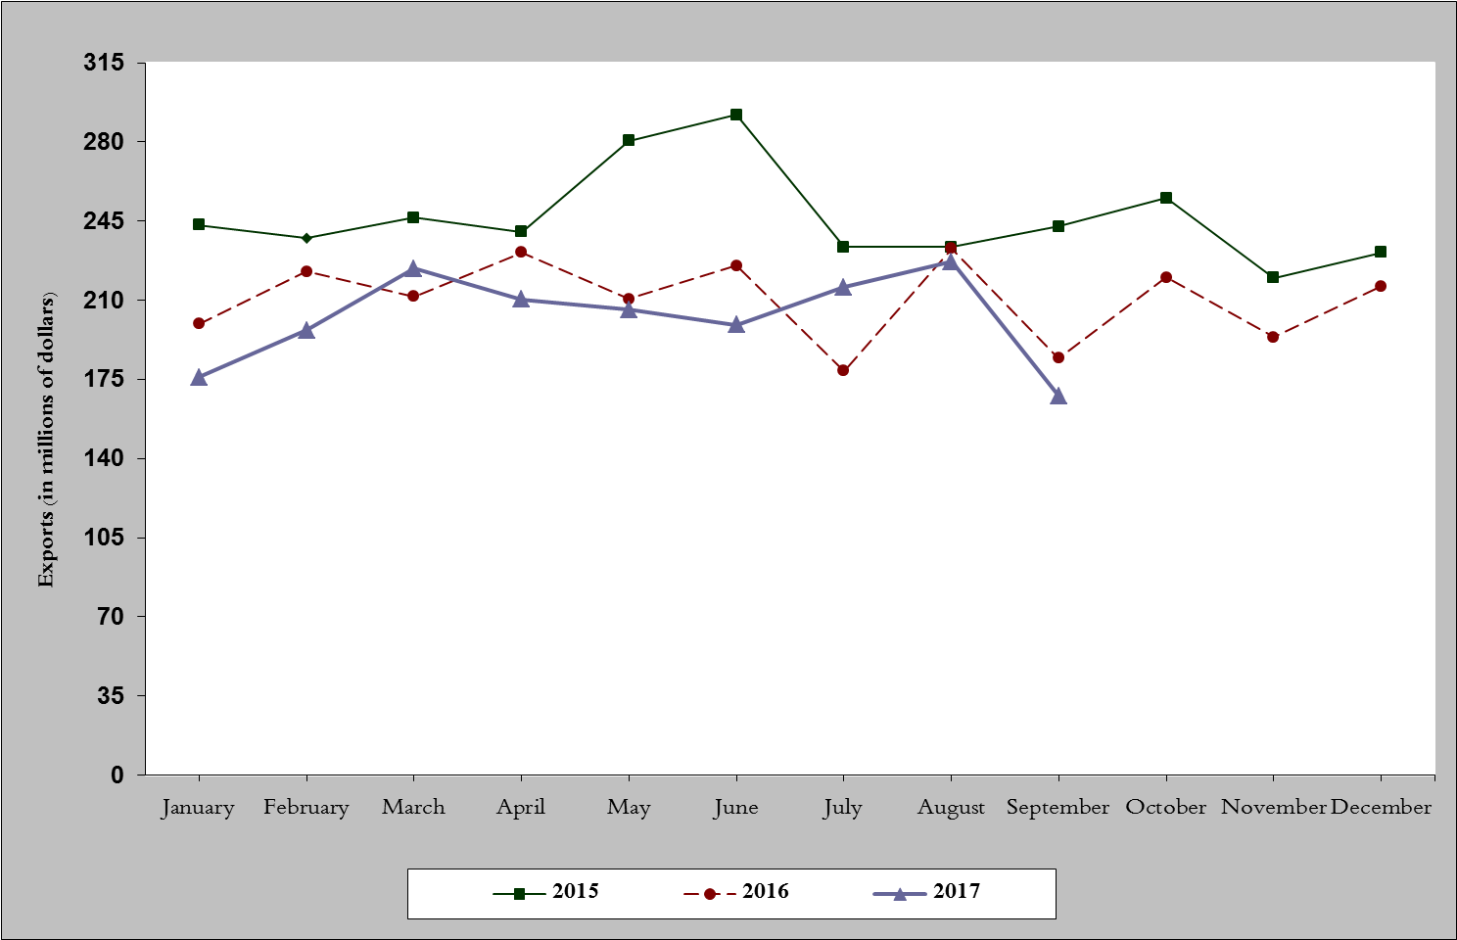
Chart 1: Industrial exports during years 2015-2016-2017
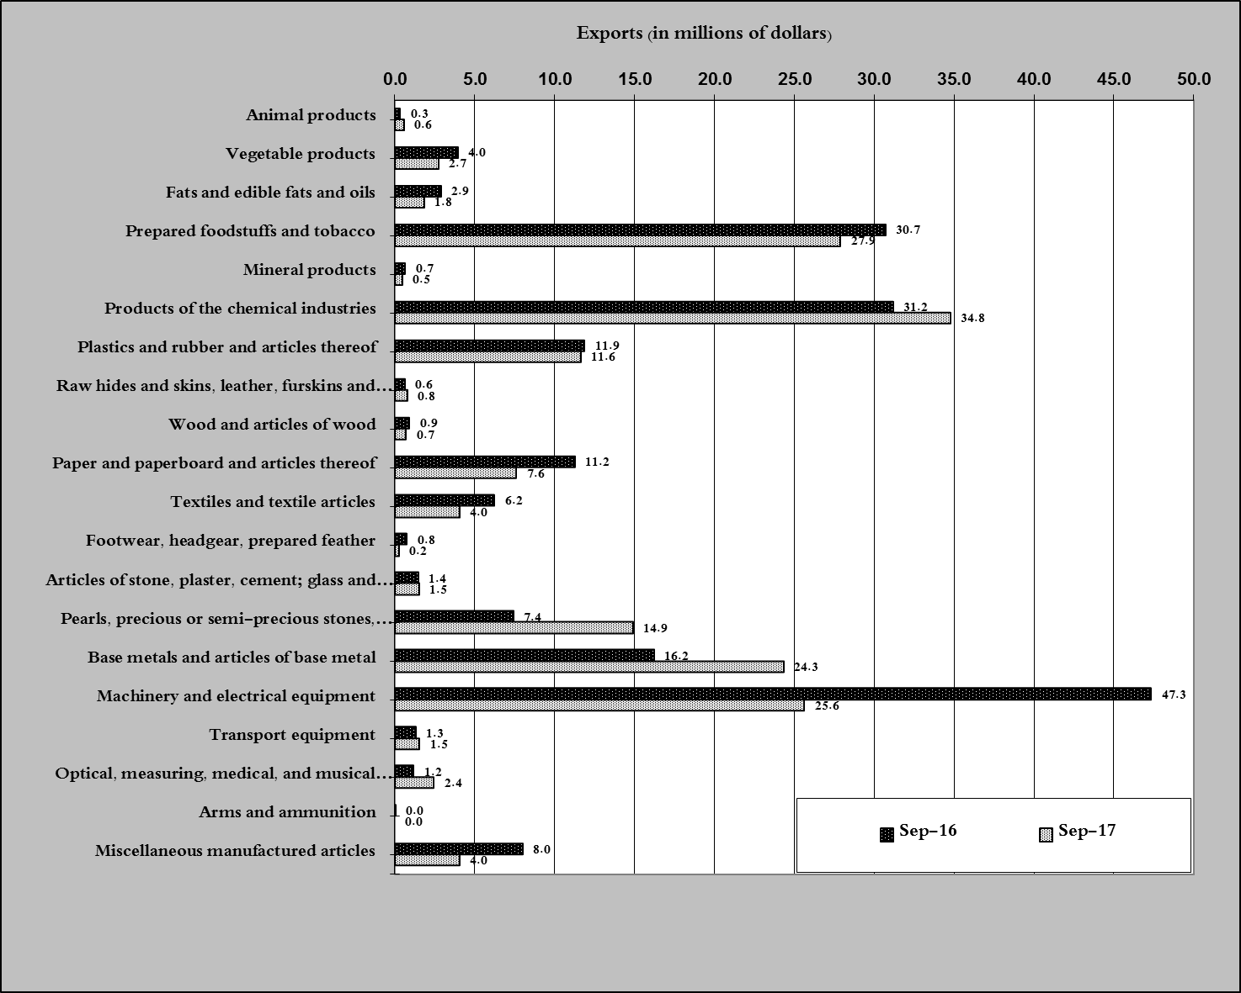
Chart 2: Comparison of industrial exports during September 2017 and September 2016

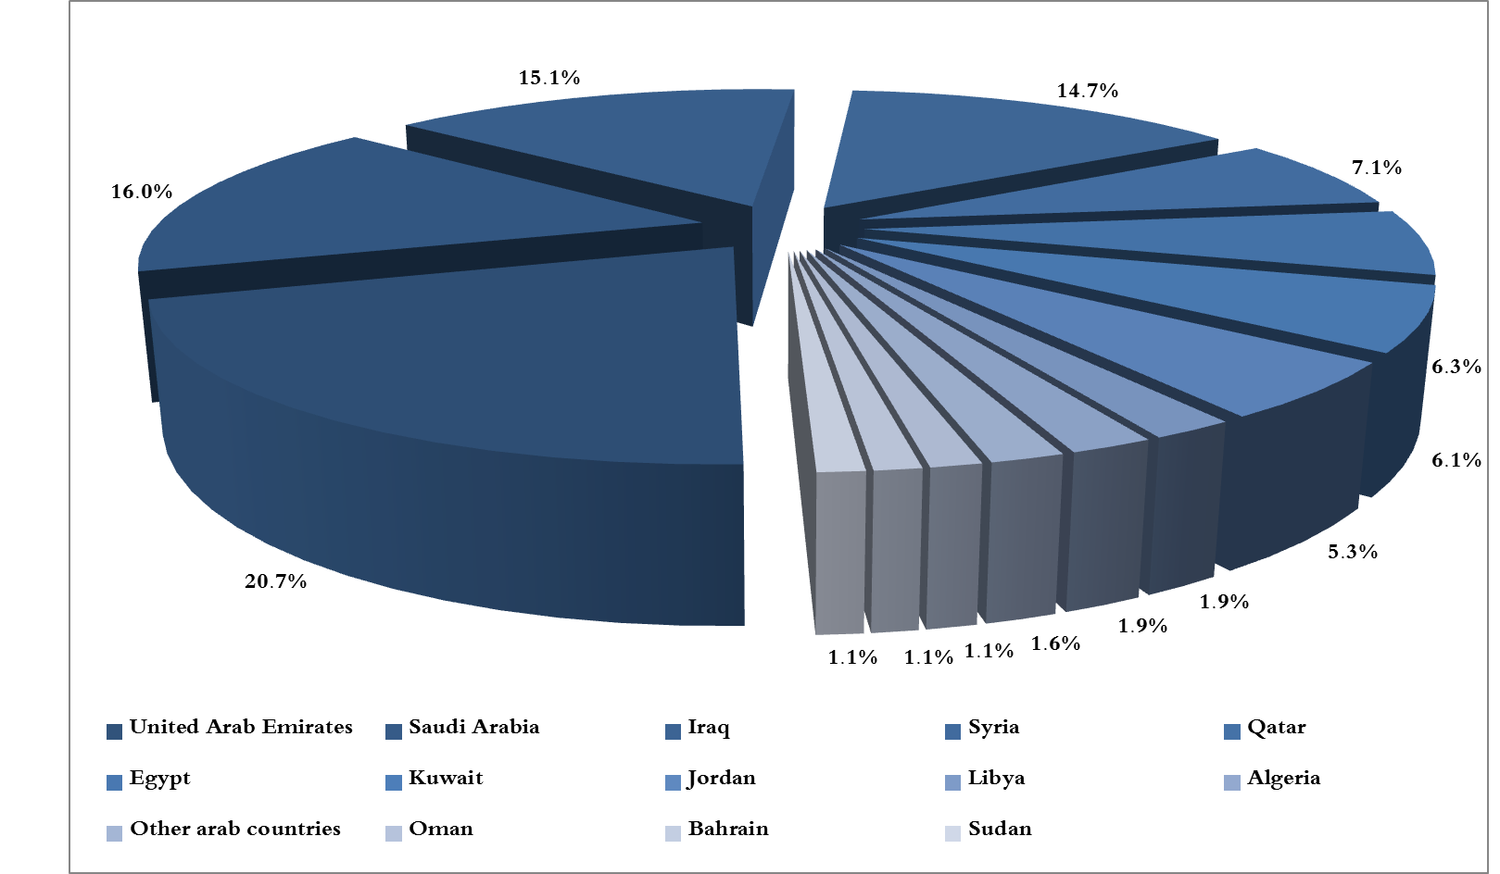
Chart 3: Distribution of industrial exports to Arab countries during September 2017

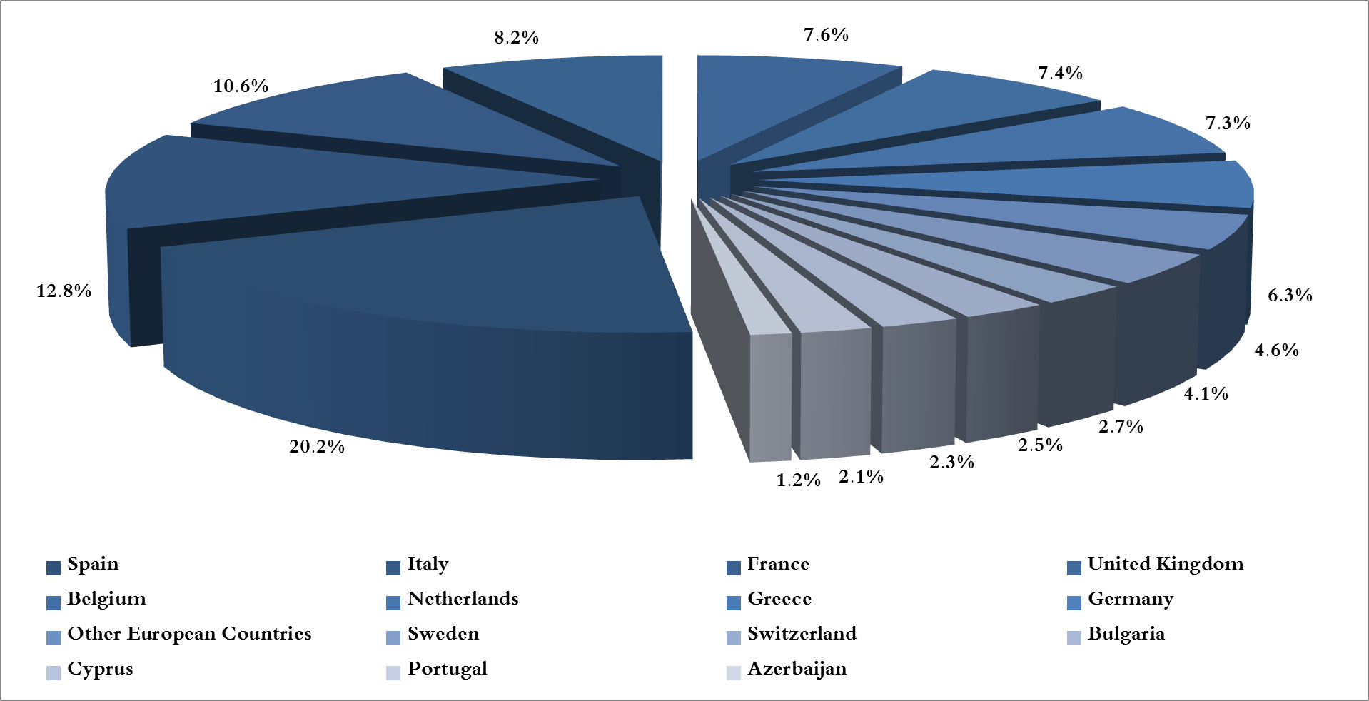
Chart 4: Distribution of industrial exports to European countries during September 2017

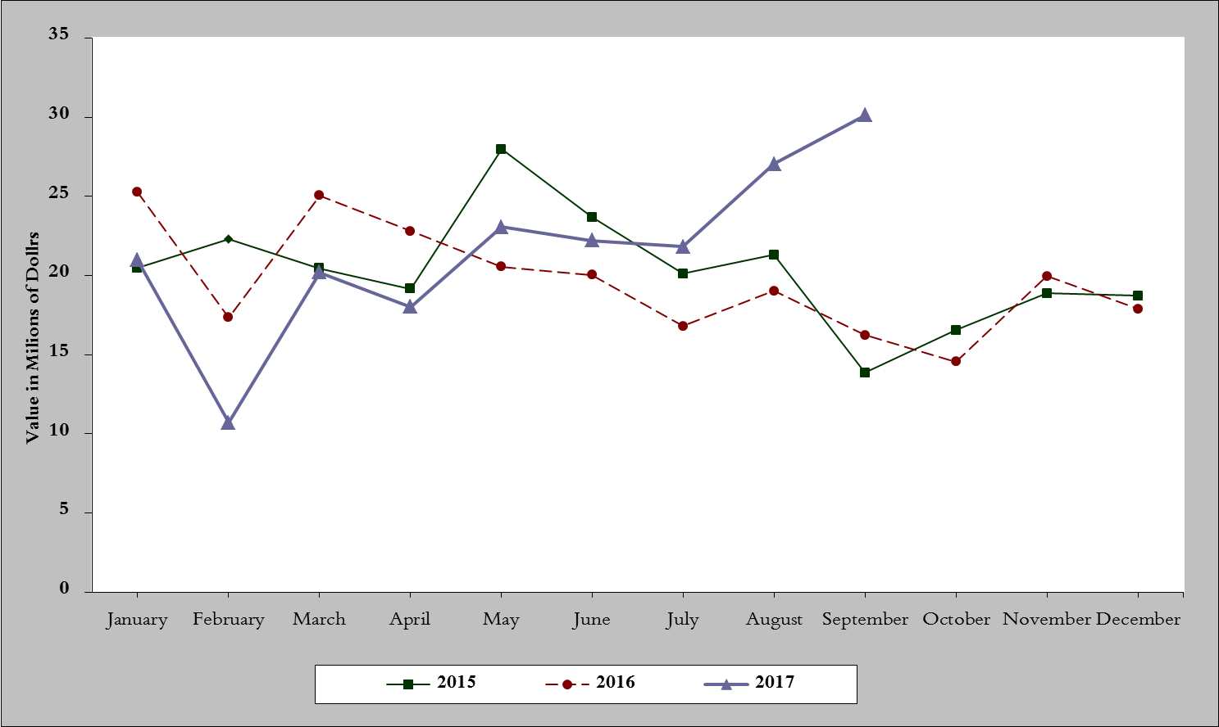
Chart 5: Imports of industrial machinery and equipment during years 2015-2016-2017
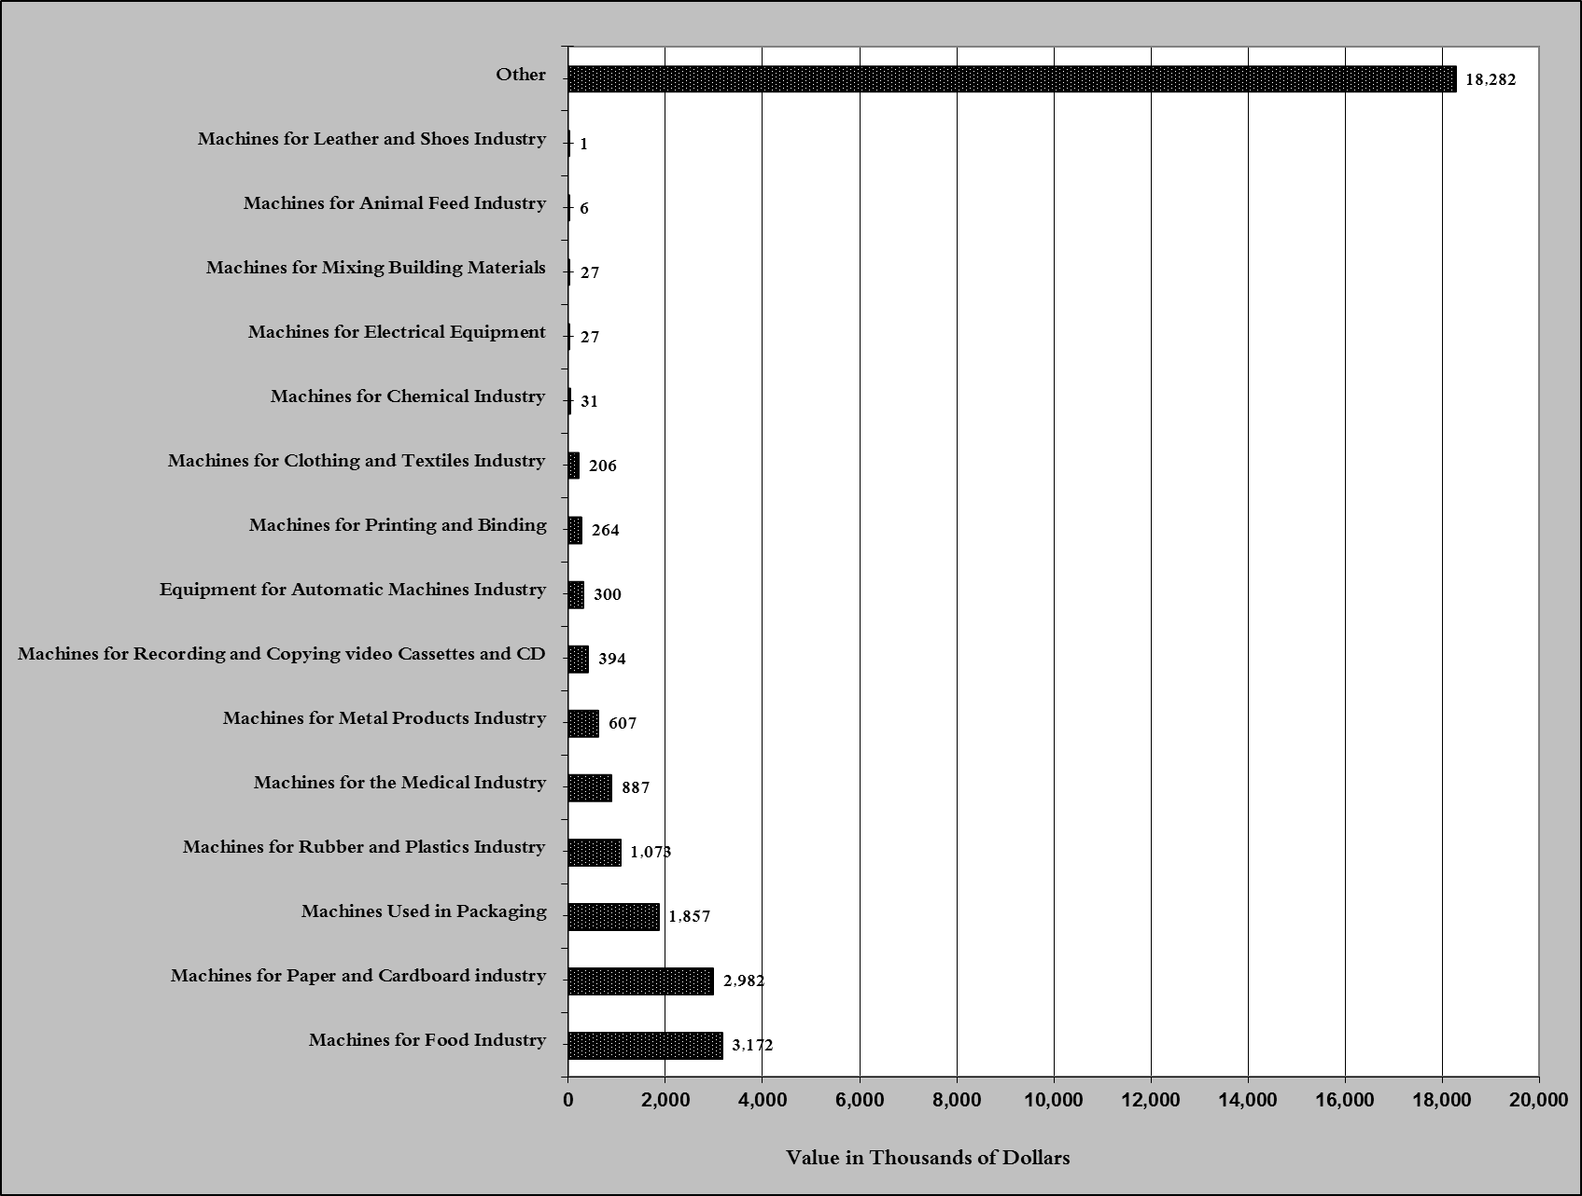
Chart 6: Imports of industrial equipment and machinery according to industrial activity during September 2017

Exports of unworked Diamonds, Silver and Gold Ingots reached this month a value of 44.9 million USD
The machineries and equipment are classified in this table according to the industrial sectors that are used in, while heading "other" includes machineries and equipment that can be used in various sectors.

