

A detailed report on industrial exports
and imports of industrial machinery and equipment in November 2017

Prepared by:
Ministry of Industry
Industrial Information Department

www.industry.gov.lb
Index

I. Introduction 3
II. Industrial exports in November 2017 4
1. Main exported products 4
2. Products with increased exports value 4
2.1. Pearls, precious or semi-precious stones, precious metals and articles thereof (Excluding unworked diamonds, silver and gold Ingots) 4
2.2. Machinery and electrical equipment 5
3. Products with decreased exports value 5
3.1. Products of the chemical industries 5
3.2. Textiles and textile articles 5
4. Main export markets 5
4.1. Main export markets by groups of countries 5
4.2. Main export markets by country 6
III. Imports of industrial machinery and equipment 6
1. Imported industrial machinery and equipment by country of origin 6
2. Imported industrial machinery and equipment by country of origin and industrial activity 6
IV. Appendix tables 8
V. Appendix charts 21

Introduction
The Industrial Information Department of the Ministry of Industry has prepared a detailed report on industrial exports and imports of industrial machinery and equipment for the month of November 2017.
It should be noted that the total value of industrial exports during the first eleven months of the year 2017 amounted about 2 billion and 254 million US dollars compared to 2 billion and 311 million US dollars during the same period of the year 2016, and 2 billion and 725 million US dollars during the same period of the year 2015. Therefore we notice a decline of 2.5% compared to the year 2016, and a decline of 17.3% compared to the year 2015. (Tables 1 and 11(
It should also be noted that the monthly average of the Lebanese industrial exports during the first eleven months of the year 2017 amounted about 204.9 million US dollars compared to 210.1 million US dollars during the year 2016, and 247.7 million US dollars during the year 2015.
On the other hand, the total value of imports of industrial machinery and equipment during the first eleven months of the year 2017 amounted about 234.2 million US dollars compared to 217.6 million US dollars during the same period of the year 2016, and 224.7 million US dollars during the same period of the year 2015. Therefore, we notice an increase of 7.6% compared to the year 2016, and an increase of 4.2% compared to the year 2015. (Table 17)

Industrial exports in November 2017
The total value of industrial exports in November 2017 amounted to nearly 205.1 million US dollars, compared to 193.7 million US dollars in November 2016, and 219.9 million US dollars in November 2015, which is equivalent to an increase of 11.4 million US dollars, with the rate of 5.9% compared to year 2016, and a decline of 14.9 million US dollars with the rate of 6.8%, compared to year 2015. (Table 1, Chart 1)

Main exported products
Exports of machinery and electrical equipment came first in November 2017, with a total value of 42 million US dollars; Iraq was on top of importers list of this product, with an import value of 6.4 million US dollars. Followed by exports of prepared foodstuffs and tobacco, with a total value of 38.5 million US dollars, Saudi Arabia was the largest importer of this product, with an import value of 5.9 million US dollars. Then base metals and articles of base metal, with a total value of 29.2 million US dollars, Republic of Korea topped the importers list of this product, with an import value of 5.1 million US dollars, followed by products of the chemical industries, with a total value of 26 million US dollars. (For more details tables 2, 4, 6, 8, 10, 15, and 16)

Products with increased exports value
Statistics showed a significant increase in exports of the following products:

Pearls, precious or semi-precious stones, precious metals and articles thereof (Excluding unworked diamonds, silver and gold Ingots)
Exports of this product increased from 6.9 million US dollars in November 2016 to 16.3 million US dollars in November 2017 (Table 2 and Chart 2). The exports of this product mainly decreased to Saudi Arabia whereas it mainly increased to United Arab Emirates and Germany which led to an increase in the total value of about 9.3 million US dollars. (Tables 3 and 4)

Machinery and electrical equipment
Exports of this product increased from 35 million US dollars in November 2016 to 42 million US dollars in November 2017 (Table 2 and Chart 2). The exports of this product mainly increased to Libya, Iraq, Syria and Saudi Arabia which led to an increase of the total value of about 7 million US dollars. (Tables 5 and 6)

Products with decreased exports value
Statistics showed a significant decrease in exports of the following products:

Products of the chemical industries
Exports of this product decreased from 29 million US dollars in November 2016 to 26 million US dollars in November 2017 (Table 2 and Chart 2). The exports of this product mainly increased to Saudi Arabia whereas it mainly decreased to Spain and Italy which led to a fall of the total value of about 2.9 million US dollars. (Tables 7 and 8)

Textiles and textile articles
Exports of this product decreased from 7.2 million US dollars in November 2016 to 5.2 million US dollars in November 2017 (Table 2 and Chart 2). The exports of this product mainly decreased to United Arab Emirates and Saudi Arabia which led to a fall of the total value of about 2.1 million US dollars. (Tables 9 and 10)

Main export markets

Main export markets by groups of countries
Arab countries were the main market for Lebanese industrial exports in November 2017, with a total export value of 122.1 million US dollars, with a rate of 59.5% of the total export value. European countries were the second largest export markets with a rate of 15.5% of the total export value. Followed by, Non-arab African countries with a rate of 10.4% of the total export value, and, the Non-arab Asian countries with a rate of 8.6% of the total export value. The main products exported to Arab countries are: machinery and electrical equipment with the total value of 26.9 million US dollars, prepared foodstuffs and tobacco with the total value of 24.8 million US dollars, and the products of the chemical industries with the total value of 22.3 million US dollars. (Table 12)

Main export markets by country
Among countries importing Lebanese industrial products, United Arab Emirates ranked first with a total value of 23.8 million US dollars, with a rate of 11.6% of the total export value. Saudi Arabia came second with a total value of 22.4 million US dollars with a rate of 10.9% of the total export value. Followed by, Syria with a total value of 18.9 million US dollars with a rate of 9.2% of the total exports value. (Table 13)
During this month, Lebanese products were exported to 45 European countries, 41 Non-arab African countries, 27 Non-arab Asian countries, 27 American countries, 19 Arab countries, and 8 Oceanic countries. Countries that imported Lebanese goods by over 1 million US dollars are as following: 14 Arab countries, 9 European countries, 8 Non-arab African countries, 3 Non-arab Asian countries, and 2 American countries, and 1 Oceanic country. (Table 14, Charts 3 and 4)

Imports of industrial machinery and equipment
The total import value of industrial machinery and equipment in November 2017 reached about 17.6 million US dollars compared to 20 million US dollars during the same period in 2016, and 18.9 million US dollars during the same period in 2015, a decline by 11.6% compared to year 2016, and a decline of 6.5% compared to year 2015. (Tables 17 and 18 and Chart 5)

Imported industrial machinery and equipment by country of origin
Italy ranked first on the list of countries exporting industrial machinery and equipment to Lebanon, with a total value amounting to about 5 million US dollars, followed by China, with a total value of 3.1 million US dollars, and Germany, with a total value of 2.8 million US dollars. (Table 18)

Imported industrial machinery and equipment by country of origin and industrial activity
In November 2017, imports of machines for food industry, ranked first, with a total value of 3 million US dollars, and Italy topped the list of countries exporting of this product to Lebanon with exports value of 1.7 million US dollars, followed by machines used in packaging, with a total value of 2.4 million US dollars. Italy was the leading exporter of this product with an export value of 1 million US dollars. Followed by machines for metal products industry, with a total value of 1.2 million US dollars. (Table 19, Chart 6)

Appendix tables

Table 1: Industrial exports during Years 2015 – 2016 – 2017
Month | Year  2015 | Year  2016 | Year  2017 | Variation in %  2015/2017 | Variation in %  2016/2017
January | 243.2 | 199.5 | 175.9 | -27.7% | -11.8%
February | 237.5 | 222.8 | 196.8 | -17.1% | -11.7%
March | 246.5 | 211.6 | 223.9 | -9.2% | 5.8%
April | 240.2 | 231.1 | 210.4 | -12.4% | -8.9%
May | 280.6 | 210.6 | 205.9 | -26.6% | -2.3%
June | 292.1 | 225.3 | 199.0 | -31.9% | -11.7%
July | 233.5 | 178.8 | 215.7 | -7.6% | 20.7%
August | 233.4 | 232.9 | 227.0 | -2.8% | -2.5%
September | 242.5 | 184.3 | 167.6 | -30.9% | -9.0%
October | 255.3 | 220.0 | 226.7 | -11.2% | 3.0%
November | 219.9 | 193.7 | 205.1 | -6.8% | 5.9%
December | 231.1 | 216.3
Total | 2,955.8 | 2,526.9 | 2,254.0
All above figures are in Millions of USD

Table 2: Comparison of industrial exports during November 2017 and November 2016
Section | Goods | November 2016 | November 2017 | Variation 2016/2017 | Variation in % 2016/2017
1 | Animal products | 0.31 | 0.44 | 0.12 | 39.3%
2 | Vegetable products | 4.19 | 3.65 | -0.54 | -13.0%
3 | Fats and edible fats and oils | 3.59 | 3.42 | -0.18 | -4.9%
4 | Prepared foodstuffs and tobacco | 39.81 | 38.53 | -1.29 | -3.2%
5 | Mineral products | 0.62 | 0.78 | 0.16 | 26.6%
6 | Products of the chemical industries | 28.99 | 26.04 | -2.95 | -10.2%
7 | Plastics and rubber and articles thereof | 11.83 | 13.22 | 1.39 | 11.7%
8 | Raw hides and skins, leather, furskins and articles thereof | 0.76 | 0.96 | 0.20 | 26.0%
9 | Wood and articles of wood | 0.81 | 1.19 | 0.38 | 46.9%
10 | Paper and paperboard and articles thereof | 11.96 | 9.95 | -2.02 | -16.9%
11 | Textiles and textile articles | 7.21 | 5.16 | -2.05 | -28.4%
12 | Footwear, headgear, prepared feather | 0.78 | 0.76 | -0.02 | -2.6%
13 | Articles of stone, plaster, cement; glass and glassware | 1.79 | 2.17 | 0.39 | 21.6%
14 | Pearls, precious or semi-precious stones, precious metals and articles thereof (Excluding unworked diamonds, silver and gold Ingots) | 6.92 | 16.26 | 9.34 | 134.9%
15 | Base metals and articles of base metal | 27.10 | 29.16 | 2.06 | 7.6%
16 | Machinery and electrical equipment | 35.02 | 42.03 | 7.01 | 20.0%
17 | Transport equipment | 3.20 | 3.83 | 0.62 | 19.4%
18 | Optical, measuring, medical, and musical instruments; clocks and watches | 1.95 | 1.37 | -0.59 | -30.0%
19 | Arms and ammunition | 0.03 | 0.00 | -0.03 | -100.0%
20 | Miscellaneous manufactured articles | 6.78 | 6.16 | -0.62 | -9.2%
 | Total | 193.70 | 205.10 | 11.38 | 5.9%
All above figures are in Millions of USD
Table 3: Exports of pearls, precious or semi-precious stones, precious metals and articles thereof (Excluding unworked diamonds, silver and gold Ingots) according to the main importing countries during November 2016
Export destination Country | Saudi Arabia | United Arab Emirates | Jordan | Switzerland | United States Of America | Germany | France | Upper Volta
Value in thousands of USD | 2,424 | 2,382 | 554 | 452 | 238 | 173 | 150 | 114

Table 4: Exports of pearls, precious or semi-precious stones, precious metals and articles thereof (Excluding unworked diamonds, silver and gold Ingots) according to the main importing countries during November 2017
Export destination Country | United Arab Emirates | Germany | Saudi Arabia | Jordan | United States Of America | Switzerland | France | United Kingdom
Value in thousands of USD | 10,622 | 2,238 | 1,330 | 622 | 435 | 187 | 180 | 141

Table 5: Exports of machinery and electrical equipment according to the main importing countries during November 2016
Export destination Country | Iraq | Saudi Arabia | United Arab Emirates | Kuwait | Congo | Jordan | Syria | Angola
Value in thousands of USD | 3,575 | 3,163 | 3,093 | 2,457 | 2,041 | 1,906 | 1,503 | 1,491

Table 6: Exports of machinery and electrical equipment according to the main importing countries during November 2017
Export destination Country | Iraq | Saudi Arabia | Libya | Syria | United Arab Emirates | Egypt | Azerbaijan | Qatar
Value in thousands of USD | 6,417 | 4,420 | 4,352 | 3,421 | 2,866 | 2,020 | 1,694 | 1,537

Table 7: Exports of products of the chemical industries according to the main importing countries during November 2016
Export destination Country | Spain | Iraq | United Arab Emirates | Saudi Arabia | Jordan | Italy | Kuwait | Syria
Value in thousands of USD | 4,708 | 3,786 | 3,547 | 3,045 | 2,831 | 2,492 | 1,118 | 1,082

Table 8: Exports of products of the chemical industries according to the main importing countries during November 2017
Export destination Country | Saudi Arabia | Iraq | United Arab Emirates | Jordan | Syria | Egypt | Kuwait | United Kingdom
Value in thousands of USD | 4,878 | 4,712 | 4,068 | 3,623 | 1,354 | 820 | 785 | 560

Table 9: Exports of textiles and textile articles according to the main importing countries during November 2016
Export destination Country | United Arab Emirates | Saudi Arabia | Syria | Turkey | Kuwait | United Kingdom | France | Tunisia
Value in thousands of USD | 1,026 | 601 | 530 | 503 | 419 | 373 | 364 | 353

Table 10: Exports of textiles and textile articles according to the main importing countries during November 2017
Export destination Country | Syria | United Arab Emirates | Qatar | Jordan | United Kingdom | Kuwait | Switzerland | Italy
Value in thousands of USD | 761 | 520 | 481 | 438 | 427 | 410 | 400 | 301

Table 11: Industrial exports according to exported goods during year 2017

Table 12: Industrial exports according to exported goods and countries groups during November 2017
Goods | Arab Countries | European Countries | Oceanic Countries | Non-Arab Asian countries | American Countries | Non-Arab African countries | Other* | Total
Animal products | 306 |  |  | 3 | 2 | 126 |  | 437
Vegetable products | 1,519 | 1,024 | 44 | 201 | 399 | 461 |  | 3,649
Fats and edible fats and oils | 1,025 | 608 | 241 | 53 | 1,306 | 187 |  | 3,419
Prepared foodstuffs and tobacco | 24,817 | 6,398 | 703 | 629 | 3,122 | 2,199 | 658 | 38,526
Mineral products | 530 | 20 |  |  |  | 54 | 181 | 785
Products of the chemical industries | 22,250 | 1,773 | 58 | 382 | 384 | 1,139 | 56 | 26,042
Plastics and rubber and articles thereof | 10,511 | 648 | 61 | 223 | 80 | 1,471 | 228 | 13,221
Raw hides and skins, leather, furskins and articles thereof | 372 | 512 |  | 55 |  | 24 |  | 964
Wood and articles of wood | 841 | 13 | 1 | 4 | 2 | 332 |  | 1,193
Paper and paperboard and articles thereof | 6,088 | 1,685 | 3 | 574 | 84 | 1,494 | 18 | 9,946
Textiles and textile articles | 2,814 | 1,561 | 10 | 117 | 47 | 529 | 84 | 5,163
Footwear, headgear, prepared feather | 624 | 47 | 0 |  |  | 76 | 15 | 763
Articles of stone, plaster, cement; glass and glassware | 1,472 | 75 | 17 | 14 | 144 | 448 |  | 2,171
Pearls, precious or semi-precious stones, precious metals and articles thereof (Excluding unworked diamonds, silver and gold Ingots) | 12,579 | 2,949 |  | 151 | 442 | 143 |  | 16,265
Base metals and articles of base metal | 3,807 | 8,375 | 72 | 13,454 | 298 | 3,131 | 24 | 29,161
Machinery and electrical equipment | 26,925 | 4,758 | 6 | 1,206 | 518 | 7,870 | 749 | 42,032
Transport equipment | 755 | 503 | 21 | 118 | 1,980 | 450 | 1 | 3,826
Optical, measuring, medical, and musical instruments; clocks and watches | 395 | 303 | 3 | 509 | 21 | 135 |  | 1,365
Arms and ammunition |  |  |  |  |  |  |  | 0
Miscellaneous manufactured articles | 4,464 | 449 | 24 | 23 | 140 | 1,055 |  | 6,155
Total | 122,092 | 31,700 | 1,265 | 17,718 | 8,971 | 21,324 | 2,012 | 205,081
All the above figures are in thousands of US dollars.
* "other" Includes exported goods to the duty free market and those that are supplied to ships and aircraft.
Table 13: Distribution of the industrial exports according to the main importing countries during November 2017
Export destination Country | United Arab Emirates | Saudi Arabia | Syria | Iraq | Qatar | Jordan | Egypt | United States Of America
Value in thousands of USD | 23,767 | 22,379 | 18,857 | 16,195 | 9,349 | 8,475 | 6,550 | 6,475

Export destination Country | Turkey | Republic of Korea | Germany | Spain | Libya | France | Kuwait | United Kingdom
Value in thousands of USD | 6,179 | 5,175 | 4,909 | 4,794 | 4,483 | 4,271 | 3,953 | 3,029

Export destination Country | Ivory Coast | Congo | Netherlands | Sweden | Italy | China | Canada | Azerbaijan
Value in thousands of USD | 2,947 | 2,473 | 2,275 | 2,273 | 2,164 | 2,114 | 2,085 | 1,971

Table 14: Distribution of importing countries according to countries groups and the value of exports during November 2017
Exports Value  (in million USD) | Arab Countries | European Countries | Oceania Countries | Non-Arab Asian countries | American Countries | Non-Arab African countries | Total
]0-1[ | 5 | 36 | 7 | 24 | 25 | 33 | 130
[1-5[ | 7 | 9 | 1 | 1 | 1 | 8 | 27
[5-10[ | 3 |  |  | 2 | 1 |  | 6
[10-15[ |  |  |  |  |  |  | 0
More than 15 million USD | 4 |  |  |  |  |  | 4
Total | 19 | 45 | 8 | 27 | 27 | 41 | 167

Table 15: Distribution of the industrial exports according to product and to the main importing countries during November 2017

Animal products | Qatar | Nigeria | United Arab Emirates | Kuwait | Liberia | Senegal | Saudi Arabia | Congo
Value in 1000 of USD | 213 | 53 | 52 | 26 | 19 | 12 | 10 | 7

Vegetable products | Sweden | Jordan | Qatar | United States Of America | Netherlands | Turkey | Saudi Arabia | Sudan
Value in 1000 of USD | 497 | 461 | 283 | 278 | 223 | 198 | 171 | 167

Fats and edible fats and oils | United States Of America | Saudi Arabia | Canada | Australia | Portugal | Kuwait | Netherlands | Egypt
Value in 1000 of USD | 978 | 333 | 322 | 241 | 232 | 231 | 168 | 144

Prepared foodstuffs and tobacco | Saudi Arabia | Syria | Qatar | Iraq | United Arab Emirates | Egypt | United States Of America | Sweden
Value in 1000 of USD | 5,899 | 5,766 | 3,318 | 2,760 | 1,764 | 1,753 | 1,665 | 1,307

Mineral products | Sudan | Syria | Other | Sierra Leone | Belgium | Kuwait | Congo | Senegal
Value in 1000 of USD | 296 | 224 | 181 | 23 | 17 | 8 | 7 | 4

Plastics and rubber and articles thereof | Syria | Saudi Arabia | Iraq | Algeria | Egypt | Jordan | Qatar | Congo
Value in 1000 of USD | 5,081 | 1,685 | 1,299 | 538 | 489 | 385 | 340 | 264

Raw hides and skins, leather, furskins and articles thereof | Germany | France | United Arab Emirates | Saudi Arabia | Egypt | Spain | Turkey | Romania
Value in 1000 of USD | 186 | 139 | 125 | 104 | 99 | 73 | 54 | 39

Wood and articles of wood | United Arab Emirates | Cameroon | Qatar | Syria | Congo | Jordan | Ivory Coast | Bahrain
Value in 1000 of USD | 462 | 178 | 123 | 92 | 58 | 58 | 37 | 27

Paper and paperboard and articles thereof | Saudi Arabia | Jordan | Syria | Morocco | Egypt | United Kingdom | United Arab Emirates | Qatar
Value in 1000 of USD | 1,213 | 1,044 | 1,000 | 606 | 547 | 452 | 396 | 347

Table 15: (continued) Distribution of the industrial exports according to product and the main importing countries during November 2017
Footwear, headgear, prepared feather | Saudi Arabia | United Arab Emirates | Jordan | Liberia | Bahrain | Italy | United Kingdom | Other
Value in 1000 of USD | 409 | 97 | 64 | 56 | 26 | 19 | 17 | 15

Articles of stone, plaster, cement; glass and glassware | Qatar | United Arab Emirates | Kuwait | Syria | Egypt | Congo | United States Of America | Bahrain
Value in 1000 of USD | 417 | 364 | 239 | 182 | 135 | 123 | 123 | 86

Base metals and articles of base metal | Republic of Korea | Turkey | Spain | China | Italy | Qatar | France | Indonesia
Value in 1000 of USD | 5,115 | 4,671 | 4,490 | 2,006 | 991 | 901 | 896 | 833

Transport equipment | United States Of America | France | Syria | Iraq | Ivory Coast | United Arab Emirates | Guinea | Saudi Arabia
Value in 1000 of USD | 1,980 | 306 | 239 | 199 | 179 | 159 | 126 | 90

Optical, measuring, medical, and musical instruments; clocks and watches | Hong Kong | United Arab Emirates | Germany | Upper Volta | France | Iran | Chad | Cameroon
Value in 1000 of USD | 477 | 357 | 207 | 45 | 39 | 23 | 22 | 22

Miscellaneous manufactured articles | Saudi Arabia | United Arab Emirates | Qatar | Kuwait | Egypt | Germany | Upper Volta | Jordan
Value in 1000 of USD | 1,241 | 1,173 | 769 | 349 | 323 | 234 | 206 | 167

Table 16: Distribution of industrial exports, according to the main exported goods and main importing countries during November 2017

Table 17: Imports of industrial machinery and equipment during years 2015-2016-2017
Month | Year  2015 | Year  2016 | Year  2017 | Variation in %  2015/2017 | Variation in %  2016/2017
January | 20.5 | 25.3 | 21.0 | 2.4% | -17.1%
February | 22.3 | 17.3 | 10.7 | -52.1% | -38.3%
March | 20.5 | 25.1 | 20.2 | -1.3% | -19.4%
April | 19.1 | 22.8 | 18.0 | -5.8% | -20.9%
May | 28.0 | 20.5 | 23.1 | -17.5% | 12.3%
June | 23.7 | 20.0 | 22.2 | -6.2% | 10.9%
July | 20.1 | 16.8 | 21.8 | 8.5% | 29.9%
August | 21.3 | 19.0 | 27.0 | 26.9% | 42.1%
September | 13.8 | 16.2 | 30.1 | 117.5% | 85.4%
October | 16.5 | 14.5 | 22.4 | 35.5% | 54.2%
November | 18.9 | 20.0 | 17.6 | -6.5% | -11.6%
December | 18.7 | 17.9
Total | 243.4 | 235.5 | 234.2
All above figures are in Millions of USD

Table 18: Imports of industrial equipment and machinery according to exporting country for the year 2017
Table 19: Imports of industrial equipment and machinery according to industrial activity and country during November 2017

Appendix charts
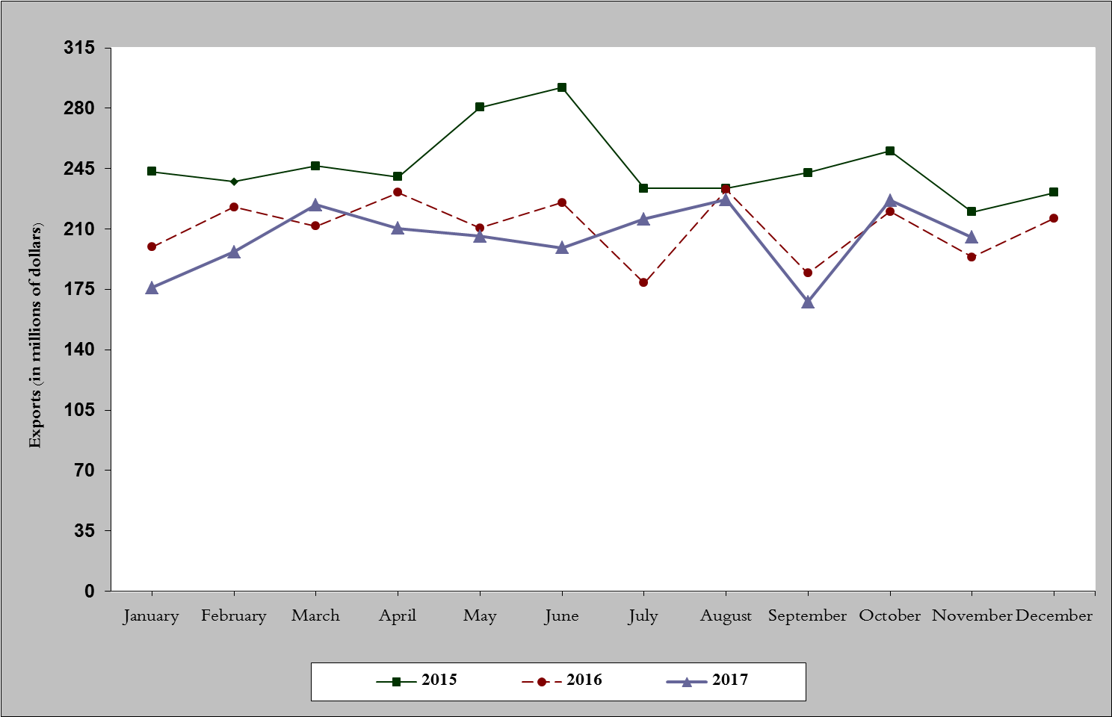
Chart 1: Industrial exports during years 2015-2016-2017
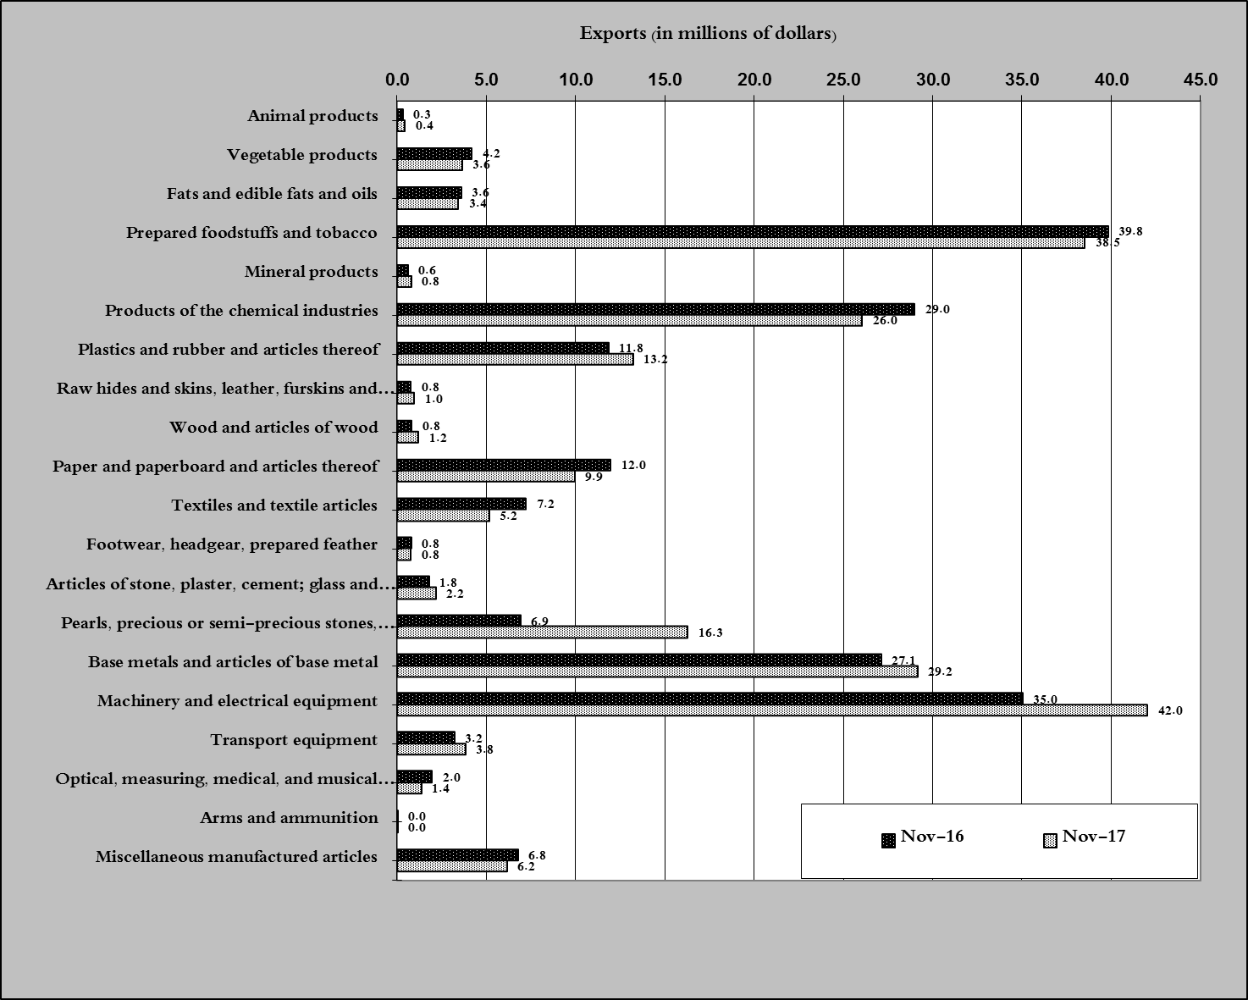
Chart 2: Comparison of industrial exports during November 2017 and November 2016

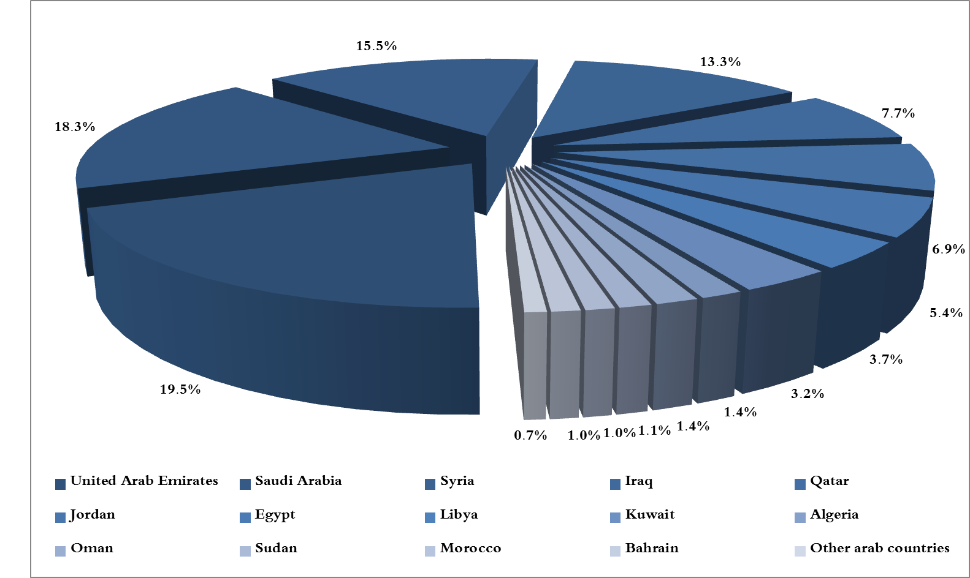
Chart 3: Distribution of industrial exports to Arab countries during November 2017
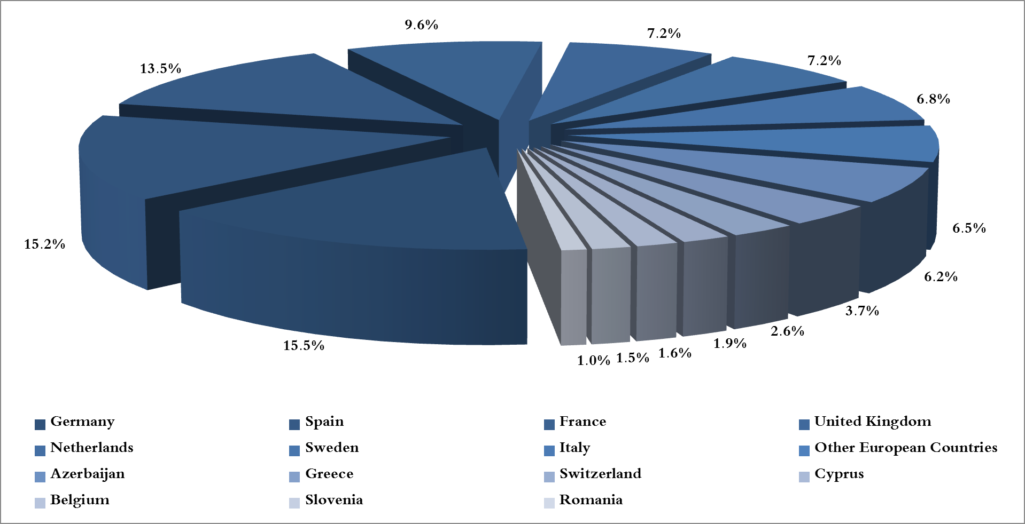
Chart 4: Distribution of industrial exports to European countries during November 2017

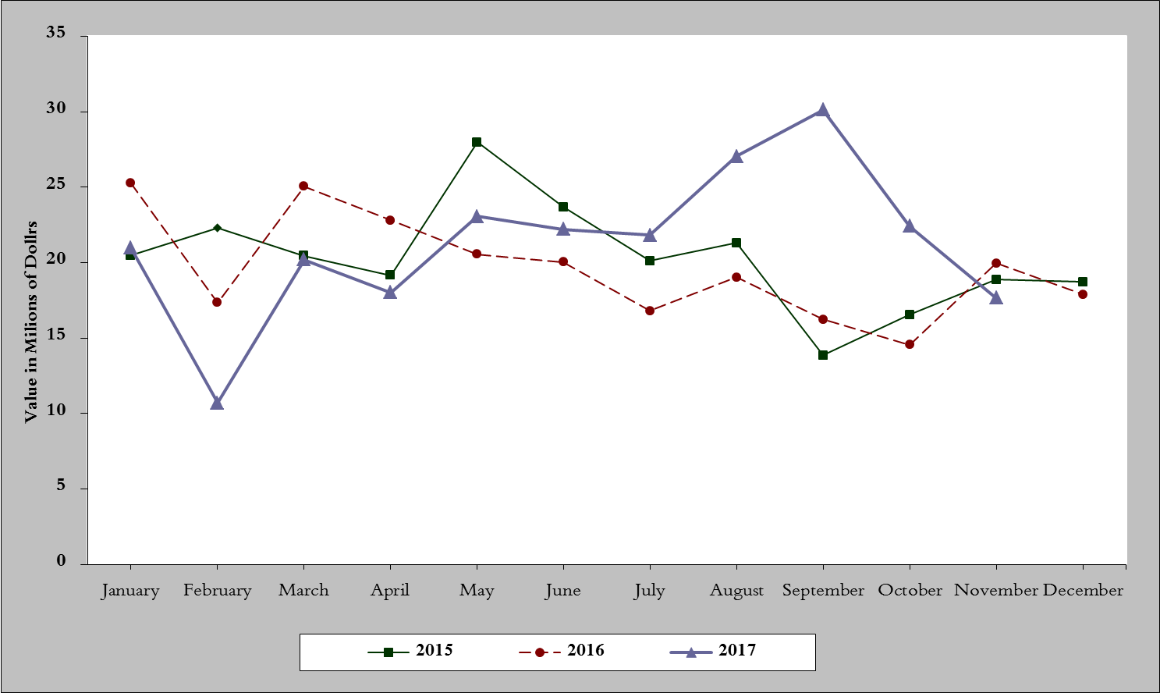
Chart 5: Imports of industrial machinery and equipment during years 2015-2016-2017
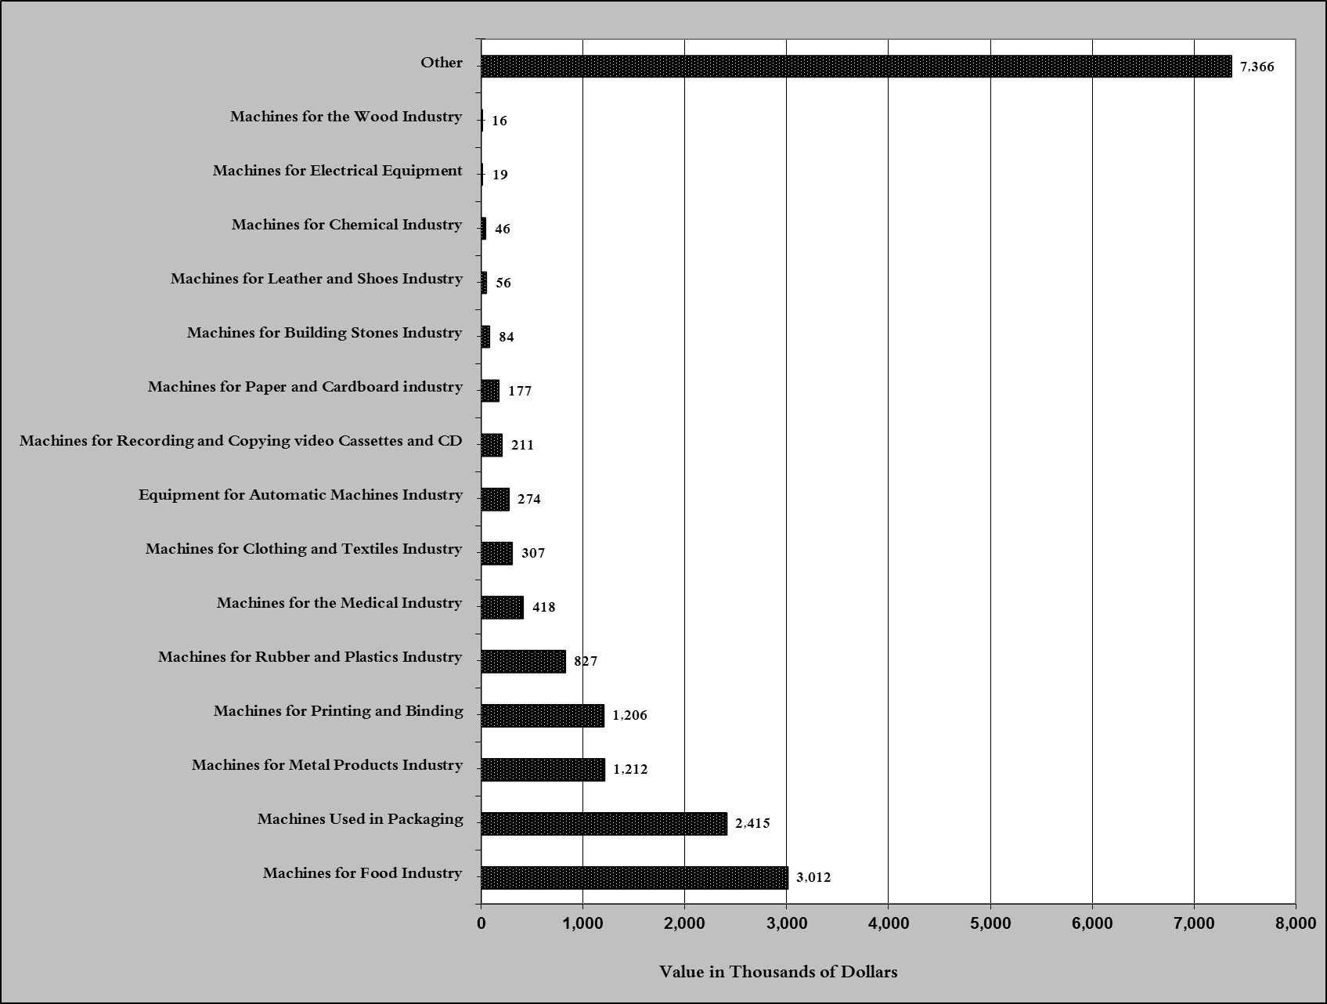
Chart 6: Imports of industrial equipment and machinery according to industrial activity during November 2017

Exports of unworked Diamonds, Silver and Gold Ingots reached this month a value of 28.8 million USD
The machineries and equipment are classified in this table according to the industrial sectors that are used in, while heading "other" includes machineries and equipment that can be used in various sectors.

