

A detailed report on industrial exports
and imports of industrial machinery and equipment in December 2018

Prepared by:
Ministry of Industry
Industrial Information Department

www.industry.gov.lb
Index

I. Introduction 3
II. Industrial exports in December 2018 4
1. Main exported products 4
2. Products with increased exports value 4
2.1. Products of the chemical industries 4
2.2. Pearls, precious or semi-precious stones, precious metals and articles thereof (Excluding unworked diamonds, silver and gold Ingots) 4
3. Products with decreased exports value 5
3.1. Base metals and articles of base metal 5
3.2. Prepared foodstuffs and tobacco 5
4. Main export markets 5
4.1. Main export markets by groups of countries 5
4.2. Main export markets by country 6
III. Imports of industrial machinery and equipment 6
1. Imported industrial machinery and equipment by country of origin 6
2. Imported industrial machinery and equipment by country of origin and industrial activity 6
IV. Appendix tables 8
IV. Appendix maps 21
VI. Appendix charts 25

Introduction
The Industrial Information Department of the Ministry of Industry has prepared a detailed report on industrial exports and imports of industrial machinery and equipment for the month of December 2018.
It should be noted that the total value of industrial exports during the year 2018 amounted about 2 billion and 548 million US dollars compared to 2 billion and 474 million US dollars during the same period of the year 2017, and 2 billion and 527 million US dollars during the same period of the year 2016. Therefore we notice an increase of 3.0% compared to the year 2017, and an increase of 0.8% compared to the year 2016. (Tables 1 and 11(
It should also be noted that the monthly average of the Lebanese industrial exports during the year 2018 amounted about 212.3 million US dollars compared to 206.1 million US dollars during the year 2017, and 210.6 million US dollars during the year 2016.
On the other hand, the total value of imports of industrial machinery and equipment during the year 2018 amounted about 266.4 million US dollars compared to 257.4 million US dollars during the same period of the year 2017, and 235.5 million US dollars during the same period of the year 2016. Therefore, we notice an increase of 3.5% compared to the year 2017, and an increase of 13.1% compared to the year 2016. (Table 17)

Industrial exports in December 2018
The total value of industrial exports in December 2018 amounted to nearly 213.8 million US dollars, compared to 219.6 million US dollars in December 2017, and 216.3 million US dollars in December 2016, which is equivalent to a decrease of 5.8 million US dollars, with the rate of 2.6% compared to year 2017, and a decrease of 2.5 million US dollars with the rate of 1.2%, compared to year 2016. (Table 1, and Map 1, and Chart 1)

Main exported products
Exports of Products of the chemical industries came first in December 2018, with a total value of 40.3 million US dollars; Turkey was on top of importers list of this product, with an import value of 5.4 million US dollars. Followed by exports of Machinery and electrical equipment, with a total value of 37.0 million US dollars, Syria was the largest importer of this product, with an import value of 5.3 million US dollars. Then Prepared foodstuffs and tobacco, with a total value of 32.0 million US dollars, Saudi Arabia topped the importers list of this product, with an import value of 4.9million US dollars, followed by Base metals and articles of base metal, with a total value of 21.6 million US dollars. (For more details tables 2, 4, 6, 8, 10, 15, and 16 and Maps 2, 3, and 4)

Products with increased exports value
Statistics showed a significant increase in exports of the following products:

Products of the chemical industries
Exports of this product increased from 30.1 million US dollars in December 2017 to 40.3 million US dollars in December 2018 (Table 2 and Chart 2). The exports of this product mainly decreased to Saudi Arabia whereas it mainly increased to Italy, Spain, Iraq, Jordan, and Turkey which led to an increase in the total value of about 10.2 million US dollars. (Tables 3 and 4)

Pearls, precious or semi-precious stones, precious metals and articles thereof (Excluding unworked diamonds, silver and gold Ingots)
Exports of this product increased from 12.2 million US dollars in December 2017 to 19.3 million US dollars in December 2018 (Table 2 and Chart 2). The exports of this product mainly increased to Saudi Arabia and United Arab Emirates which led to an increase of the total value of about 7.2 million US dollars. (Tables 5 and 6).

Products with decreased exports value
Statistics showed a significant decrease in exports of the following products:

Base metals and articles of base metal
Exports of this product decreased from 35.7 million US dollars in December 2017 to 21.6 million US dollars in December 2018 (Table 2 and Chart 2). The exports of this product mainly increased to Greece and Egypt whereas it mainly decreased to Turkey, Spain, Saudi Arabia and Republic of Korea which led to a fall of the total value of about 14.1 million US dollars. (Tables 7 and 8)

Prepared foodstuffs and tobacco
Exports of this product decreased from 41.6 million US dollars in December 2017 to 32.0 million US dollars in December 2018 (Table 2 and Chart 2). The exports of this product mainly decreased to Syria, Egypt, Iraq, and Qatar which led to a fall of the total value of about 9.6 million US dollars. (Tables 9 and 10)

Main export markets

Main export markets by groups of countries
Arab countries were the main market for Lebanese industrial exports in December 2018, with a total export value of 129.8 million US dollars, with a rate of 60.7% of the total export value. European countries were the second largest export markets with a rate of 15.1% of the total export value. Followed by, Non-arab African countries with a rate of 11.2% of the total export value, and, the Non-arab Asian countries with a rate of 7.4% of the total export value. The main products exported to Arab countries are: Machinery and electrical equipment with the total value of 24.9 million US dollars, Products of the chemical industries with the total value of 22.4 million US dollars, and the Prepared foodstuffs and tobacco with the total value of 18.2 million US dollars. (Table 12 and Map 1)

Main export markets by country
Among countries importing Lebanese industrial products, United Arab Emirates ranked first with a total value of 24.0 million US dollars, with a rate of 11.2% of the total export value. Saudi Arabia came second with a total value of 21.0 million US dollars with a rate of 9.8% of the total export value. Followed by, Syria with a total value of 18.8 million US dollars with a rate of 8.8% of the total exports value. (Table 13 and Map 1)
During this month, Lebanese products were exported to 45 European countries, 42 Non-arab African countries, 29 Non-arab Asian countries, 27 American countries, 19 Arab countries, and 7 Oceanic countries. Countries that imported Lebanese goods by over 1 million US dollars are as following: 15 Arab countries, 7 European countries, 5 Non-arab African countries, 4 Non-arab Asian countries, 2 American countries, and 1 Oceanic country. (Table 14, and Map 1, and Charts 3 and 4)

Imports of industrial machinery and equipment
The total import value of industrial machinery and equipment in December 2018 reached about 16.3 million US dollars compared to 23.2 million US dollars during the same period in 2017, and 17.9 million US dollars during the same period in 2016, a decline by 29.6% compared to year 2017, and a decline of 8.8% compared to year 2016. (Tables 17 and 18 and Chart 5)

Imported industrial machinery and equipment by country of origin
China ranked first on the list of countries exporting industrial machinery and equipment to Lebanon, with a total value amounting to about 3.6 million US dollars, followed by Germany, with a total value of 3.3 million US dollars, and Italy, with a total value of 2.9 million US dollars. (Table 18)

Imported industrial machinery and equipment by country of origin and industrial activity
In December 2018, imports of Machines for Food Industry, ranked first, with a total value of 2.3 million US dollars, and Italy topped the list of countries exporting of this product to Lebanon with exports value of 917 thousand US dollars, followed by Machines for Printing and Binding, with a total value of 1.9 million US dollars. Germany was the leading exporter of this product with an export value of 1.8 million US dollars. Followed by Machines for Paper and Cardboard industry, with a total value of 1.0 million US dollars. (Table 19, Chart 6)

Appendix tables

Table 1: Industrial exports during Years 2016 – 2017 – 2018
Month | Year  2016 | Year  2017 | Year  2018 | Variation in %  2016/2018 | Variation in %  2017/2018
January | 199.5 | 175.9 | 187.0 | -6.3% | 6.3%
February | 222.8 | 196.8 | 203.4 | -8.7% | 3.4%
March | 211.6 | 223.9 | 238.4 | 12.6% | 6.5%
April | 231.1 | 210.4 | 227.8 | -1.4% | 8.3%
May | 210.6 | 205.9 | 222.8 | 5.8% | 8.2%
June | 225.3 | 199.0 | 186.3 | -17.4% | -6.4%
July | 178.8 | 215.7 | 198.5 | 11.0% | -8.0%
August | 232.9 | 227.0 | 212.4 | -8.8% | -6.4%
September | 184.3 | 167.6 | 206.2 | 11.9% | 23.0%
October | 220.0 | 226.7 | 240.0 | 9.1% | 5.9%
November | 193.7 | 205.1 | 211.4 | 9.1% | 3.1%
December | 216.3 | 219.6 | 213.8 | -1.2% | -2.6%
Total | 2,526.9 | 2,473.5 | 2,548.0 | 0.8% | 3.0%
All above figures are in Millions of USD

Table 2: Comparison of industrial exports during December 2018 and December 2017
Section | Goods | December  2017 | December  2018 | Variation 2017/2018 | Variation in % 2017/2018
1 | Animal products | 0.51 | 0.56 | 0.04 | 8.6%
2 | Vegetable products | 5.78 | 4.61 | -1.17 | -20.3%
3 | Fats and edible fats and oils | 4.32 | 8.75 | 4.42 | 102.3%
4 | Prepared foodstuffs and tobacco | 41.61 | 31.98 | -9.63 | -23.1%
5 | Mineral products | 0.68 | 1.05 | 0.37 | 54.1%
6 | Products of the chemical industries | 30.14 | 40.35 | 10.20 | 33.9%
7 | Plastics and rubber and articles thereof | 14.86 | 17.66 | 2.80 | 18.8%
8 | Raw hides and skins, leather, furskins and articles thereof | 0.95 | 0.95 | 0.01 | 0.6%
9 | Wood and articles of wood | 0.76 | 0.58 | -0.18 | -23.9%
10 | Paper and paperboard and articles thereof | 10.88 | 10.49 | -0.39 | -3.6%
11 | Textiles and textile articles | 5.38 | 3.87 | -1.51 | -28.0%
12 | Footwear, headgear, prepared feather | 0.65 | 0.41 | -0.24 | -37.4%
13 | Articles of stone, plaster, cement; glass and glassware | 1.91 | 2.48 | 0.57 | 29.9%
14 | Pearls, precious or semi-precious stones, precious metals and articles thereof (Excluding unworked diamonds, silver and gold Ingots) | 12.18 | 19.35 | 7.16 | 58.8%
15 | Base metals and articles of base metal | 35.67 | 21.55 | -14.11 | -39.6%
16 | Machinery and electrical equipment | 42.50 | 37.01 | -5.49 | -12.9%
17 | Transport equipment | 1.22 | 2.14 | 0.92 | 75.7%
18 | Optical, measuring, medical, and musical instruments; clocks and watches | 1.36 | 1.27 | -0.09 | -6.8%
19 | Arms and ammunition
20 | Miscellaneous manufactured articles | 8.19 | 8.70 | 0.52 | 6.3%
 | Total | 219.56 | 213.76 | -5.80 | -2.6%
All above figures are in Millions of USD
Table 3: Exports of Products of the chemical industries according to the main importing countries during December 2017
Export destination Country | Saudi Arabia | United Arab Emirates | Turkey | Iraq | Qatar | Jordan | Syria | Kuwait
Value in thousands of USD | 6,630 | 4,959 | 4,550 | 3,973 | 1,595 | 1,490 | 1,264 | 1,119

Table 4: Exports of Products of the chemical industries according to the main importing countries during December 2018
Export destination Country | Turkey | Italy | Iraq | United Arab Emirates | Spain | Saudi Arabia | Jordan | Syria
Value in thousands of USD | 5,354 | 5,219 | 5,012 | 4,607 | 4,102 | 3,767 | 2,442 | 1,318

Table 5: Exports of Pearls, precious or semi-precious stones, precious metals and articles thereof (Excluding unworked diamonds, silver and gold Ingots) according to the main importing countries during December 2017
Export destination Country | United Arab Emirates | Saudi Arabia | United States Of America | Jordan | Hong Kong | United Kingdom | Upper Volta | France
Value in thousands of USD | 9,749 | 426 | 344 | 297 | 221 | 195 | 191 | 189

Table 6: Exports of Pearls, precious or semi-precious stones, precious metals and articles thereof (Excluding unworked diamonds, silver and gold Ingots) according to the main importing countries during December 2018
Export destination Country | United Arab Emirates | Saudi Arabia | France | United States Of America | Thailand | Jordan | Italy | Upper Volta
Value in thousands of USD | 12,219 | 3,864 | 978 | 864 | 351 | 229 | 212 | 182

Table 7: Exports of Base metals and articles of base metal according to the main importing countries during December 2017
Export destination Country | Turkey | Spain | Republic of Korea | Saudi Arabia | China | Algeria | Qatar | Greece
Value in thousands of USD | 12,056 | 4,970 | 4,932 | 2,388 | 1,504 | 833 | 811 | 688

Table 8: Exports of Base metals and articles of base metal according to the main importing countries during December 2018
Export destination Country | Republic of Korea | Greece | Spain | Egypt | Nigeria | Qatar | China | India
Value in thousands of USD | 3,831 | 3,611 | 1,926 | 1,829 | 1,203 | 1,044 | 915 | 737

Table 9: Exports of Prepared foodstuffs and tobacco according to the main importing countries during December 2017
Export destination Country | Saudi Arabia | Syria | Egypt | Iraq | Qatar | United States Of America | United Arab Emirates | Kuwait
Value in thousands of USD | 5,614 | 5,163 | 4,382 | 3,423 | 2,944 | 2,689 | 2,397 | 1,504

Table 10: Exports of Prepared foodstuffs and tobacco according to the main importing countries during December 2018
Export destination Country | Saudi Arabia | Iraq | United States Of America | United Arab Emirates | Qatar | Egypt | Kuwait | Jordan
Value in thousands of USD | 4,863 | 2,443 | 2,263 | 2,225 | 2,124 | 2,055 | 1,428 | 1,204

Table 11: Industrial exports according to exported goods during year 2018
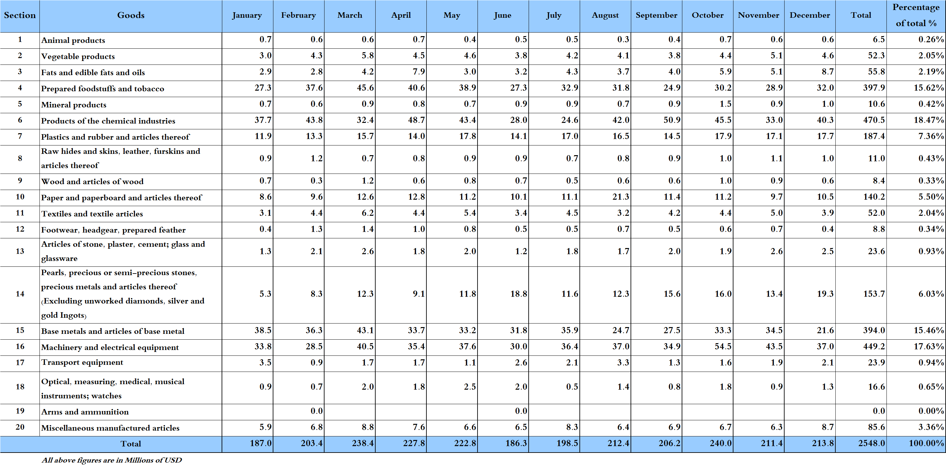

Table 12: Industrial exports according to exported goods and countries groups during December 2018
Goods | Arab Countries | European Countries | Oceanic Countries | Non-Arab Asian countries | American Countries | Non-Arab African countries | Other* | Total
Animal products | 409 |  | 4 | 0 |  | 144 | 1 | 558
Vegetable products | 2,636 | 726 | 122 | 168 | 270 | 678 | 9 | 4,609
Fats and edible fats and oils | 5,803 | 600 | 387 | 16 | 1,687 | 252 |  | 8,745
Prepared foodstuffs and tobacco | 18,186 | 5,479 | 989 | 583 | 3,734 | 2,696 | 318 | 31,985
Mineral products | 605 | 25 |  | 209 |  | 48 | 158 | 1,045
Products of the chemical industries | 22,373 | 10,576 | 53 | 5,543 | 709 | 937 | 156 | 40,347
Plastics and rubber and articles thereof | 14,049 | 832 | 6 | 514 | 247 | 1,902 | 112 | 17,662
Raw hides and skins, leather, furskins and articles thereof | 580 | 275 | 0 | 50 | 6 | 43 |  | 955
Wood and articles of wood | 448 | 1 | 0 | 1 | 36 | 95 |  | 580
Paper and paperboard and articles thereof | 7,716 | 727 | 10 | 623 | 84 | 1,277 | 58 | 10,494
Textiles and textile articles | 2,078 | 909 | 31 | 314 | 29 | 369 | 142 | 3,873
Footwear, headgear, prepared feather | 283 | 66 |  | 1 |  | 57 |  | 407
Articles of stone, plaster, cement; glass and glassware | 1,552 | 481 | 1 | 17 | 106 | 326 |  | 2,483
Pearls, precious or semi-precious stones, precious metals and articles thereof (Excluding unworked diamonds, silver and gold Ingots) | 16,471 | 1,322 |  | 412 | 928 | 214 |  | 19,346
Base metals and articles of base metal | 5,326 | 6,624 | 33 | 6,592 | 39 | 2,761 | 178 | 21,554
Machinery and electrical equipment | 24,920 | 1,743 | 279 | 607 | 394 | 8,966 | 105 | 37,015
Transport equipment | 471 | 1,147 | 8 | 1 | 42 | 469 |  | 2,139
Optical, measuring, medical, and musical instruments; clocks and watches | 715 | 303 |  | 75 | 102 | 59 | 12 | 1,265
Arms and ammunition
Miscellaneous manufactured articles | 5,171 | 508 | 13 | 188 | 127 | 2,682 | 14 | 8,703
Total | 129,793 | 32,346 | 1,936 | 15,913 | 8,540 | 23,975 | 1,262 | 213,764
All the above figures are in thousands of US dollars.
* "other" Includes exported goods to the duty free market and those that are supplied to ships and aircraft.
Table 13: Distribution of the industrial exports according to the main importing countries during December 2018
Export destination Country | United Arab Emirates | Saudi Arabia | Syria | Iraq | Qatar | Algeria | Egypt | Jordan
Value in thousands of USD | 23,951 | 21,042 | 18,838 | 14,972 | 10,882 | 10,215 | 8,514 | 7,604

Export destination Country | Turkey | Italy | Spain | United States Of America | Ivory Coast | France | Nigeria | Kuwait
Value in thousands of USD | 7,095 | 6,784 | 6,684 | 5,526 | 4,389 | 4,161 | 4,077 | 3,917

Export destination Country | Republic of Korea | Greece | Congo | Netherlands | Canada | Germany | United Kingdom | Oman
Value in thousands of USD | 3,839 | 3,704 | 2,600 | 2,385 | 2,171 | 2,148 | 2,067 | 1,989

Table 14: Distribution of importing countries according to countries groups and the value of exports during December 2018
Exports Value  (in million USD) | Arab Countries | European Countries | Oceania Countries | Non-Arab Asian countries | American Countries | Non-Arab African countries | Total
]0-1[ | 4 | 38 | 6 | 25 | 25 | 37 | 135
[1-5[ | 7 | 5 | 1 | 3 | 1 | 5 | 22
[5-10[ | 2 | 2 |  | 1 | 1 |  | 6
[10-15[ | 3 |  |  |  |  |  | 3
More than 15 million USD | 3 |  |  |  |  |  | 3
Total | 19 | 45 | 7 | 29 | 27 | 42 | 169

Table 15: Distribution of the industrial exports according to product and to the main importing countries during December 2018

Animal products | Qatar | Iraq | Kuwait | Nigeria | Ivory Coast | Saudi Arabia | United Arab Emirates | Ghana
Value in 1000 of USD | 176 | 119 | 66 | 55 | 53 | 25 | 21 | 12

Vegetable products | Saudi Arabia | Qatar | United Arab Emirates | Jordan | Ivory Coast | Tunisia | Germany | Iraq
Value in 1000 of USD | 507 | 398 | 379 | 341 | 320 | 278 | 267 | 224

Fats and edible fats and oils | Algeria | United States Of America | Canada | Syria | Australia | United Arab Emirates | Netherlands | Kuwait
Value in 1000 of USD | 4,070 | 925 | 665 | 603 | 387 | 291 | 269 | 231

Mineral products | Syria | China | Other | Iraq | Saudi Arabia | Netherlands | Guinea | United Kingdom
Value in 1000 of USD | 527 | 209 | 158 | 43 | 30 | 17 | 10 | 9

Plastics and rubber and articles thereof | Syria | Saudi Arabia | Algeria | Qatar | Egypt | United Arab Emirates | Morocco | Ivory Coast
Value in 1000 of USD | 8,409 | 1,051 | 912 | 848 | 625 | 486 | 467 | 411

Raw hides and skins, leather, furskins and articles thereof | United Arab Emirates | Oman | United Kingdom | Finland | Egypt | Italy | Turkey | Nigeria
Value in 1000 of USD | 283 | 173 | 79 | 70 | 40 | 39 | 37 | 31

Wood and articles of wood | United Arab Emirates | Qatar | Saudi Arabia | Syria | Jordan | Guinea | Liberia | Oman
Value in 1000 of USD | 118 | 105 | 66 | 59 | 50 | 33 | 30 | 28

Paper and paperboard and articles thereof | Saudi Arabia | Syria | Qatar | Jordan | Egypt | Iraq | Morocco | Bahrain
Value in 1000 of USD | 1,327 | 972 | 883 | 855 | 819 | 488 | 471 | 431

Textiles and textile articles | United Arab Emirates | Italy | Jordan | Saudi Arabia | Germany | Qatar | Syria | Angola
Value in 1000 of USD | 532 | 474 | 457 | 349 | 251 | 241 | 169 | 150
Table 15: (continued) Distribution of the industrial exports according to product and the main importing countries during December 2018
Footwear, headgear, prepared feather | Saudi Arabia | United Arab Emirates | Ivory Coast | France | Poland | Bahrain | Qatar | Equatorial Guinea
Value in 1000 of USD | 186 | 59 | 34 | 34 | 25 | 17 | 12 | 8

Articles of stone, plaster, cement; glass and glassware | Saudi Arabia | Belgium | Qatar | Oman | United Arab Emirates | Congo |  | Sudan | United States Of America
Value in 1000 of USD | 614 | 379 | 250 | 135 | 134 | 128 | 115 |  | 100

Machinery and electrical equipment | Syria | Iraq | Algeria | Saudi Arabia | Egypt | Qatar | Nigeria | United Arab Emirates
Value in 1000 of USD | 5,307 | 5,186 | 3,872 | 2,440 | 2,268 | 2,059 | 1,904 | 1,558

Transport equipment | France | Spain | Netherlands | Ivory Coast | Libya | Nigeria | Congo | United Arab Emirates
Value in 1000 of USD | 421 | 382 | 250 | 188 | 146 | 125 | 78 | 75

Optical, measuring, medical, and musical instruments; clocks and watches | Iraq | United Arab Emirates | Switzerland | Italy | United States Of America | Syria | Hong Kong | Upper Volta
Value in 1000 of USD | 415 | 166 | 126 | 118 | 95 | 83 | 72 | 39

Miscellaneous manufactured articles | Qatar | Saudi Arabia | Ivory Coast | Djibouti | Algeria | Angola | Egypt | Namibia
Value in 1000 of USD | 1,389 | 1,244 | 841 | 829 | 482 | 436 | 336 | 308

Table 16: Distribution of industrial exports, according to the main exported goods and main importing countries during December 2018
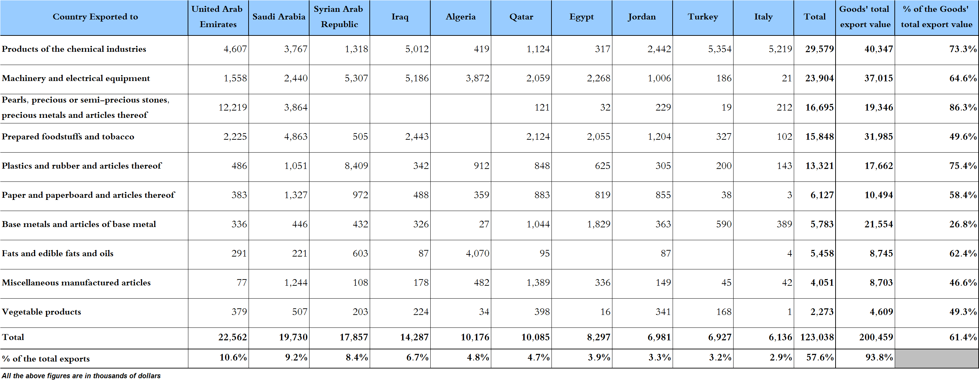

Table 17: Imports of industrial machinery and equipment during years 2016-2017-2018
Month | Year  2016 | Year  2017 | Year  2018 | Variation in %  2016/2018 | Variation in %  2017/2018
January | 25.3 | 21.0 | 24.0 | -4.9% | 14.7%
February | 17.3 | 10.7 | 18.8 | 8.3% | 75.6%
March | 25.1 | 20.2 | 28.2 | 12.4% | 39.5%
April | 22.8 | 18.0 | 31.1 | 36.4% | 72.5%
May | 20.5 | 23.1 | 25.2 | 22.6% | 9.1%
June | 20.0 | 22.2 | 23.7 | 18.3% | 6.7%
July | 16.8 | 21.8 | 18.3 | 8.9% | -16.2%
August | 19.0 | 27.0 | 27.6 | 44.9% | 2.0%
September | 16.2 | 30.1 | 13.5 | -16.9% | -55.2%
October | 14.5 | 22.4 | 24.5 | 68.2% | 9.0%
November | 20.0 | 17.6 | 15.3 | -23.4% | -13.4%
December | 17.9 | 23.2 | 16.3 | -8.8% | -29.6%
Total | 235.5 | 257.4 | 266.4 | 13.1% | 3.5%
All above figures are in Millions of USD

Table 18: Imports of industrial equipment and machinery according to exporting country for the year 2018
Table 19: Imports of industrial equipment and machinery according to industrial activity and country during December 2018

Appendix maps
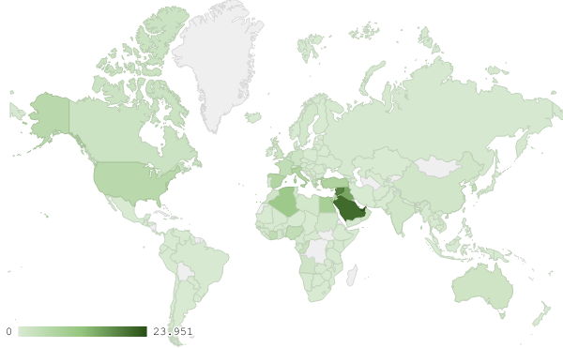
Map 1: Distribution of industrial exports during December 2018

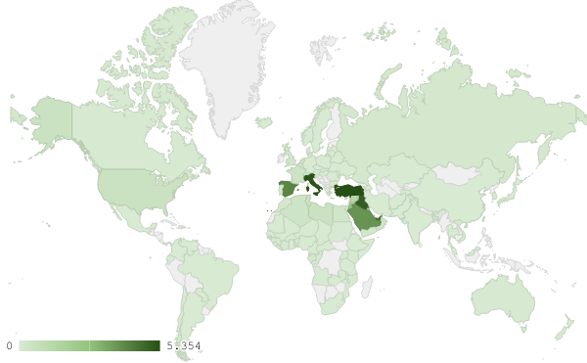
Map 2: Exports of products of the chemical industries during December 2018

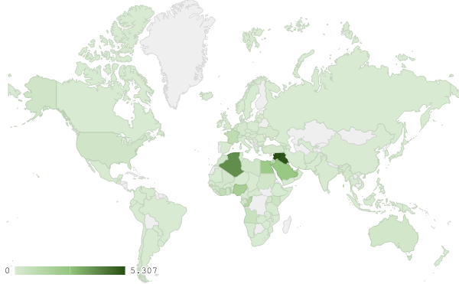
Map 3: Exports of machinery and electrical equipment during December 2018
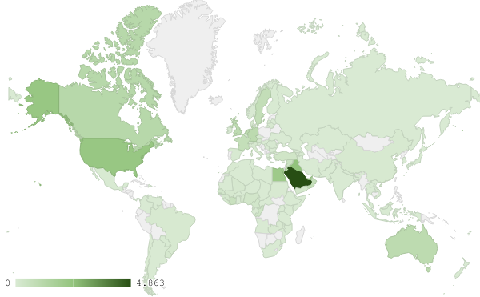
Map 4: Exports of prepared foodstuffs and tobacco during December 2018

Appendix charts
Chart 1: Industrial exports during years 2016-2017-2018
Chart 2: Comparison of industrial exports during December 2018 and December 2017
Chart 3: Distribution of industrial exports to Arab countries during December 2018

Chart 4: Distribution of industrial exports to European countries during December 2018

Chart 5: Imports of industrial machinery and equipment during years 2016-2017-2018

Chart 6: Imports of industrial equipment and machinery according to industrial activity during December 2018

Exports of unworked Diamonds, Silver and Gold Ingots reached this month a value of 35.4 million USD
The machineries and equipment are classified in this table according to the industrial sectors that are used in, while heading "other" includes machineries and equipment that can be used in various sectors.

