

A detailed report on industrial exports
and imports of industrial machinery and equipment in February 2018

Prepared by:
Ministry of Industry
Industrial Information Department

www.industry.gov.lb
Index

I. Introduction 3
II. Industrial exports in February 2018 4
1. Main exported products 4
2. Products with increased exports value 4
2.1. Base metals and articles of base metal 4
2.2. Plastics and rubber and articles thereof 5
3. Products with decreased exports value 5
3.1. Machinery and electrical equipment 5
3.2. Paper and paperboard and articles thereof 5
4. Main export markets 5
4.1. Main export markets by groups of countries 5
4.2. Main export markets by country 5
III. Imports of industrial machinery and equipment 6
1. Imported industrial machinery and equipment by country of origin 6
2. Imported industrial machinery and equipment by country of origin and industrial activity 6
IV. Appendix tables 7
IV. Appendix maps 20
VI. Appendix charts 24

Introduction
The Industrial Information Department of the Ministry of Industry has prepared a detailed report on industrial exports and imports of industrial machinery and equipment for the month of February 2018.
It should be noted that the total value of industrial exports during first two months of the year 2018 amounted about 390.4 million US dollars compared to 372.6 million US dollars during the same period of the year 2017, and 422.3 million US dollars during the same period of the year 2016. Therefore we notice an increase of 4.8% compared to the year 2017, and a decline of 7.5% compared to the year 2016. (Tables 1 and 11(
It should also be noted that the monthly average of the Lebanese industrial exports during the first two months of the year 2018 amounted about 195.2 million US dollars compared to 186.3 million US dollars during the year 2017, and 211.1 million US dollars during the year 2016.
On the other hand, the total value of imports of industrial machinery and equipment during the first two months of the year 2018 amounted about 42.8 million US dollars compared to 31.7 million US dollars during the same period of the year 2017, and 42.6 million US dollars during the same period of the year 2016. Therefore, we notice an increase of 35.2% compared to the year 2017, and an increase of 0.5% compared to the year 2016. (Table 17)

Industrial exports in February 2018
The total value of industrial exports in February 2018 amounted to nearly 203.4 million US dollars, compared to 196.8 million US dollars in February 2017, and 222.8 million US dollars in February 2016, which is equivalent to an increase of 6.6 million US dollars, with the rate of 3.4% compared to year 2017, and a decline of 19.3 million US dollars with the rate of 8.7%, compared to year 2016. (Table 1, and Map 1, and Chart 1)

Main exported products
Exports of products of the chemical industries came first in February 2018, with a total value of 43.8 million US dollars; Brazil was on top of importers list of this product, with an import value of 16.9 million US dollars. Followed by exports of prepared foodstuffs and tobacco, with a total value of 37.6 million US dollars, Saudi Arabia was the largest importer of this product, with an import value of 5.4 million US dollars. Then base metals and articles of base metal, with a total value of 36.3 million US dollars, Turkey topped the importers list of this product, with an import value of 14.1 million US dollars, followed by machinery and electrical equipment, with a total value of 28.5 million US dollars. (For more details tables 2, 4, 6, 8, 10, 15, and 16 and Maps 2, 3, and 4)

Products with increased exports value
Statistics showed a significant increase in exports of the following products:

Base metals and articles of base metal
Exports of this product increased from 25.1 million US dollars in February 2017 to 36.3 million US dollars in February 2018 (Table 2 and Chart 2). The exports of this product mainly decreased to Portugal and Italy whereas it mainly increased to Turkey, Republic of Korea, Spain, and China which led to an increase in the total value of about 11.2 million US dollars. (Tables 3 and 4)

Plastics and rubber and articles thereof
Exports of this product increased from 37.3 million US dollars in February 2017 to 43.8 million US dollars in February 2018 (Table 2 and Chart 2). The exports of this product mainly decreased to United Arab Emirates whereas it mainly increased to Brazil, Slovenia, and Saudi Arabia which led to an increase of the total value of about 6.5 million US dollars. (Tables 5 and 6).

Products with decreased exports value
Statistics showed a significant decrease in exports of the following products:

Machinery and electrical equipment
Exports of this product decreased from 37.5 million US dollars in February 2017 to 28.5 million US dollars in February 2018 (Table 2 and Chart 2). The exports of this product mainly increased to Qatar and Egypt whereas it mainly decreased to Iraq, Kuwait, Saudi Arabia and Syria which led to a fall of the total value of about 9 million US dollars. (Tables 7 and 8)

Paper and paperboard and articles thereof
Exports of this product decreased from 12.4 million US dollars in February 2017 to 9.6 million US dollars in February 2018 (Table 2 and Chart 2). The exports of this product mainly increased to Syria whereas it mainly decreased to United Arab Emirates, Saudi Arabia, and Jordan which led to a fall of the total value of about 2.7 million US dollars. (Tables 9 and 10)

Main export markets

Main export markets by groups of countries
Arab countries were the main market for Lebanese industrial exports in February 2018, with a total export value of 94.7 million US dollars, with a rate of 46.5% of the total export value. European countries were the second largest export markets with a rate of 17.2% of the total export value. Followed by, Non-arab Asian countries with a rate of 13.3% of the total export value, and, the American country with a rate of 11.8% of the total export value. The main products exported to Arab countries are: prepared foodstuffs and tobacco with the total value of 22.1 million US dollars, machinery and electrical equipment with the total value of 17.9 million US dollars, and the products of the chemical industries with the total value of 17.8 million US dollars. (Table 12 and Map 1)

Main export markets by country
Among countries importing Lebanese industrial products, Saudi Arabia ranked first with a total value of 18.8 million US dollars, with a rate of 9.3% of the total export value. Brazil came second with a total value of 17.3 million US dollars with a rate of 8.5% of the total export value. Followed by, United Arab Emirates with a total value of 16.2 million US dollars with a rate of 8% of the total exports value. (Table 13 and Map 1)
During this month, Lebanese products were exported to 39 European countries, 32 Non-arab African countries, 21 Non-arab Asian countries, 19 Arab countries, 15 American countries, and 2 Oceanic countries. Countries that imported Lebanese goods by over 1 million US dollars are as following: 10 Arab countries, 10 European countries, 7 Non-arab African countries, 5 Non-arab Asian countries, and 3 American countries, and 1 Oceanic country. (Table 14, and Map 1, and Charts 3 and 4)

Imports of industrial machinery and equipment
The total import value of industrial machinery and equipment in February 2018 reached about 18.8 million US dollars compared to 10.7 million US dollars during the same period in 2017, and 17.3 million US dollars during the same period in 2016, an increase by 75.6% compared to year 2017, and an increase of 8.3% compared to year 2016. (Tables 17 and 18 and Chart 5)

Imported industrial machinery and equipment by country of origin
Italy ranked first on the list of countries exporting industrial machinery and equipment to Lebanon, with a total value amounting to about 4.5 million US dollars, followed by Germany, with a total value of 4.3 million US dollars, and China, with a total value of 3.1 million US dollars. (Table 18)

Imported industrial machinery and equipment by country of origin and industrial activity
In February 2018, imports of machines for printing and binding, ranked first, with a total value of 3.8 million US dollars, and Germany topped the list of countries exporting of this product to Lebanon with exports value of 2.6 million US dollars, followed by machines for rubber and plastics industry, with a total value of 1.8 million US dollars. Italy was the leading exporter of this product with an export value of 693 thousand US dollars. Followed by machines for metal products industry, with a total value of 1.6 million US dollars. (Table 19, Chart 6)

Appendix tables

Table 1: Industrial exports during Years 2016 – 2017 – 2018
Month | Year  2016 | Year  2017 | Year  2018 | Variation in %  2016/2018 | Variation in %  2017/2018
January | 199.5 | 175.9 | 187.0 | -6.3% | 6.3%
February | 222.8 | 196.8 | 203.4 | -8.7% | 3.4%
March | 211.6 | 223.9
April | 231.1 | 210.4
May | 210.6 | 205.9
June | 225.3 | 199.0
July | 178.8 | 215.7
August | 232.9 | 227.0
September | 184.3 | 167.6
October | 220.0 | 226.7
November | 193.7 | 205.1
December | 216.3 | 219.6
Total | 2,526.9 | 2,473.5 | 390.4
All above figures are in Millions of USD

Table 2: Comparison of industrial exports during February 2018 and February 2017
Section | Goods | February 2017 | February 2018 | Variation 2017/2018 | Variation in % 2017/2018
1 | Animal products | 0.49 | 0.57 | 0.08 | 15.3%
2 | Vegetable products | 3.00 | 4.34 | 1.34 | 44.7%
3 | Fats and edible fats and oils | 2.24 | 2.84 | 0.59 | 26.5%
4 | Prepared foodstuffs and tobacco | 39.55 | 37.56 | -1.99 | -5.0%
5 | Mineral products | 0.63 | 0.60 | -0.03 | -4.0%
6 | Products of the chemical industries | 37.31 | 43.84 | 6.52 | 17.5%
7 | Plastics and rubber and articles thereof | 11.78 | 13.33 | 1.55 | 13.2%
8 | Raw hides and skins, leather, furskins and articles thereof | 0.89 | 1.22 | 0.33 | 36.8%
9 | Wood and articles of wood | 0.63 | 0.28 | -0.36 | -56.1%
10 | Paper and paperboard and articles thereof | 12.36 | 9.64 | -2.71 | -21.9%
11 | Textiles and textile articles | 6.27 | 4.35 | -1.92 | -30.6%
12 | Footwear, headgear, prepared feather | 1.27 | 1.28 | 0.01 | 0.4%
13 | Articles of stone, plaster, cement; glass and glassware | 1.54 | 2.05 | 0.51 | 33.0%
14 | Pearls, precious or semi-precious stones, precious metals and articles thereof (Excluding unworked diamonds, silver and gold Ingots) | 7.20 | 8.26 | 1.06 | 14.8%
15 | Base metals and articles of base metal | 25.09 | 36.26 | 11.17 | 44.5%
16 | Machinery and electrical equipment | 37.53 | 28.49 | -9.04 | -24.1%
17 | Transport equipment | 1.34 | 0.94 | -0.40 | -30.0%
18 | Optical, measuring, medical, and musical instruments; clocks and watches | 1.37 | 0.68 | -0.70 | -50.7%
19 | Arms and ammunition | 0.10 | 0.04 | -0.07 | -65.8%
20 | Miscellaneous manufactured articles | 6.17 | 6.85 | 0.67 | 10.9%
 | Total | 196.79 | 203.41 | 6.62 | 3.4%
All above figures are in Millions of USD
Table 3: Exports of base metals and articles of base metal according to the main importing countries during February 2017
Export destination Country | Turkey | Republic of Korea | Portugal | Italy | Greece | Ivory Coast | China | Saudi Arabia
Value in thousands of USD | 8,109 | 2,157 | 1,440 | 1,294 | 1,119 | 912 | 752 | 751

Table 4: Exports of base metals and articles of base metal according to the main importing countries during February 2018
Export destination Country | Turkey | Republic of Korea | Spain | Greece | China | Nigeria | Qatar | Ivory Coast
Value in thousands of USD | 14,058 | 5,509 | 3,711 | 1,847 | 1,752 | 813 | 804 | 590

Table 5: Exports of products of the chemical industries according to the main importing countries during February 2017
Export destination Country | Brazil | United Arab Emirates | Iraq | Saudi Arabia | Jordan | Italy | Kuwait | Greece
Value in thousands of USD | 14,844 | 4,771 | 3,563 | 1,919 | 1,725 | 1,648 | 1,451 | 1,171

Table 6: Exports of products of the chemical industries according to the main importing countries during February 2018
Export destination Country | Brazil | United Arab Emirates | Iraq | Saudi Arabia | Slovenia | Jordan | Italy | Qatar
Value in thousands of USD | 16,919 | 3,863 | 3,687 | 3,101 | 2,842 | 2,038 | 1,844 | 1,784

Table 7: Exports of machinery and electrical equipment according to the main importing countries during February 2017
Export destination Country | Iraq | Saudi Arabia | United Arab Emirates | Kuwait | Syria | Other | Egypt | Ghana
Value in thousands of USD | 6,213 | 4,409 | 3,492 | 3,291 | 2,560 | 1,879 | 1,385 | 1,137

Table 8: Exports of machinery and electrical equipment according to the main importing countries during February 2018
Export destination Country | Saudi Arabia | United Arab Emirates | Egypt | Qatar | Syria | Iraq | Jordan | Kuwait
Value in thousands of USD | 3,760 | 3,526 | 2,179 | 2,041 | 1,926 | 1,878 | 1,207 | 1,159

Table 9: Exports of paper and paperboard and articles thereof according to the main importing countries during February 2017
Export destination Country | Saudi Arabia | Jordan | United Arab Emirates | Egypt | Iraq | Tunisia | Morocco | Syria
Value in thousands of USD | 1,974 | 1,224 | 977 | 925 | 745 | 654 | 528 | 499

Table 10: Exports of paper and paperboard and articles thereof according to the main importing countries during February 2018
Export destination Country | Saudi Arabia | Egypt | Syria | Jordan | Qatar | United Arab Emirates | France | Cyprus
Value in thousands of USD | 1,471 | 1,085 | 1,015 | 777 | 470 | 468 | 424 | 411

Table 11: Industrial exports according to exported goods during year 2018

Table 12: Industrial exports according to exported goods and countries groups during February 2018
Goods | Arab Countries | European Countries | Oceanic Countries | Non-Arab Asian countries | American Countries | Non-Arab African countries | Other* | Total
Animal products | 439 |  |  | 1 | 63 | 63 |  | 566
Vegetable products | 2,134 | 900 | 70 | 114 | 579 | 533 | 6 | 4,335
Fats and edible fats and oils | 1,402 | 601 | 148 | 56 | 498 | 133 |  | 2,837
Prepared foodstuffs and tobacco | 22,106 | 6,968 | 785 | 626 | 3,745 | 2,559 | 767 | 37,556
Mineral products | 397 | 119 |  |  |  | 39 | 48 | 603
Products of the chemical industries | 17,764 | 7,328 | 49 | 477 | 17,132 | 1,039 | 45 | 43,835
Plastics and rubber and articles thereof | 8,356 | 1,561 | 2 | 599 | 313 | 2,156 | 344 | 13,329
Raw hides and skins, leather, furskins and articles thereof | 458 | 610 |  | 114 |  | 37 |  | 1,220
Wood and articles of wood | 256 | 2 |  |  |  | 20 |  | 278
Paper and paperboard and articles thereof | 6,628 | 1,214 |  | 832 | 72 | 798 | 101 | 9,644
Textiles and textile articles | 2,366 | 1,284 | 1 | 85 | 102 | 339 | 176 | 4,353
Footwear, headgear, prepared feather | 1,135 | 52 |  | 1 |  | 91 |  | 1,279
Articles of stone, plaster, cement; glass and glassware | 1,218 | 77 | 1 |  | 182 | 577 |  | 2,055
Pearls, precious or semi-precious stones, precious metals and articles thereof (Excluding unworked diamonds, silver and gold Ingots) | 3,679 | 2,612 |  | 1,130 | 680 | 158 |  | 8,259
Base metals and articles of base metal | 3,235 | 7,415 | 14 | 21,778 | 309 | 3,467 | 45 | 36,263
Machinery and electrical equipment | 17,945 | 3,087 | 35 | 1,162 | 108 | 6,098 | 60 | 28,495
Transport equipment | 427 | 285 | 1 |  | 78 | 149 |  | 941
Optical, measuring, medical, and musical instruments; clocks and watches | 303 | 165 |  | 10 | 145 | 54 |  | 677
Arms and ammunition | 36 |  |  |  |  |  |  | 36
Miscellaneous manufactured articles | 4,375 | 698 | 33 | 15 | 37 | 1,690 |  | 6,847
Total | 94,658 | 34,977 | 1,140 | 26,999 | 24,042 | 20,000 | 1,592 | 203,408
All the above figures are in thousands of US dollars.
* "other" Includes exported goods to the duty free market and those that are supplied to ships and aircraft.
Table 13: Distribution of the industrial exports according to the main importing countries during February 2018
Export destination Country | Saudi Arabia | Brazil | United Arab Emirates | Turkey | Qatar | Syria | Iraq | Jordan
Value in thousands of USD | 18,840 | 17,275 | 16,189 | 15,253 | 12,016 | 11,277 | 9,936 | 7,884

Export destination Country | Egypt | Republic of Korea | Kuwait | United States Of America | Spain | France | Germany | Greece
Value in thousands of USD | 6,771 | 5,509 | 4,674 | 4,581 | 4,509 | 4,432 | 3,522 | 3,415

Export destination Country | United Kingdom | Slovenia | Nigeria | Ivory Coast | Italy | Netherlands | Oman | Congo
Value in thousands of USD | 3,125 | 3,031 | 2,857 | 2,854 | 2,773 | 2,707 | 2,513 | 2,338

Table 14: Distribution of importing countries according to countries groups and the value of exports during February 2018
Exports Value  (in million USD) | Arab Countries | European Countries | Oceania Countries | Non-Arab Asian countries | American Countries | Non-Arab African countries | Total
]0-1[ | 9 | 29 | 1 | 16 | 12 | 25 | 92
[1-5[ | 3 | 10 | 1 | 3 | 2 | 7 | 26
[5-10[ | 3 |  |  | 1 |  |  | 4
[10-15[ | 2 |  |  |  |  |  | 2
More than 15 million USD | 2 |  |  | 1 | 1 |  | 4
Total | 19 | 39 | 2 | 21 | 15 | 32 | 128

Table 15: Distribution of the industrial exports according to product and to the main importing countries during February 2018

Animal products | Qatar | United Arab Emirates | Iraq | United States Of America | Bahrain | Kuwait | Gabon | Congo
Value in 1000 of USD | 188 | 90 | 83 | 50 | 37 | 20 | 17 | 16

Vegetable products | Saudi Arabia | Germany | Qatar | Jordan | Netherlands | Canada | United States Of America | Tunisia
Value in 1000 of USD | 457 | 402 | 398 | 390 | 282 | 256 | 236 | 205

Fats and edible fats and oils | Saudi Arabia | United States Of America | Kuwait | United Arab Emirates | Iraq | Netherlands | Portugal | Australia
Value in 1000 of USD | 428 | 351 | 275 | 266 | 238 | 211 | 189 | 148

Prepared foodstuffs and tobacco | Saudi Arabia | Qatar | Egypt | United Arab Emirates | Iraq | United States Of America | Kuwait | Jordan
Value in 1000 of USD | 5,357 | 3,057 | 2,991 | 2,355 | 2,261 | 2,167 | 1,651 | 1,475

Mineral products | Syria | United Arab Emirates | Italy | Qatar | United Kingdom | Other | France | Kuwait
Value in 1000 of USD | 232 | 110 | 71 | 29 | 26 | 48 | 19 | 11

Plastics and rubber and articles thereof | Syria | Saudi Arabia | Qatar | Jordan | Spain | Ivory Coast | United Arab Emirates | Ghana
Value in 1000 of USD | 4,322 | 1,193 | 853 | 442 | 407 | 366 | 342 | 335

Raw hides and skins, leather, furskins and articles thereof | Portugal | Germany | Romania | United Arab Emirates | Turkey | Oman | Jordan | France
Value in 1000 of USD | 186 | 176 | 145 | 140 | 114 | 83 | 77 | 51

Wood and articles of wood | Iraq | Qatar | United Arab Emirates | Saudi Arabia | Bahrain | Guinea | Kuwait | Jordan
Value in 1000 of USD | 144 | 45 | 40 | 8 | 8 | 7 | 5 | 4

Textiles and textile articles | United Arab Emirates | Syria | Jordan | Italy | Qatar | Germany | Switzerland | Kuwait
Value in 1000 of USD | 883 | 445 | 286 | 284 | 253 | 225 | 206 | 164

Table 15: (continued) Distribution of the industrial exports according to product and the main importing countries during February 2018
Footwear, headgear, prepared feather | Saudi Arabia | United Arab Emirates | Sierra Leone | Italy | Jordan | Qatar | Kuwait | Spain
Value in 1000 of USD | 805 | 256 | 77 | 40 | 26 | 22 | 11 | 11

Articles of stone, plaster, cement; glass and glassware | Qatar | United States Of America | Oman | Iraq | Congo | Kuwait | United Arab Emirates | Senegal
Value in 1000 of USD | 492 | 182 | 157 | 142 | 130 | 116 | 116 | 90

Pearls, precious or semi-precious stones, precious metals and articles thereof (Excluding unworked diamonds, silver and gold Ingots) | United Arab Emirates | Hong Kong | Belgium | United States Of America | United Kingdom | Germany | France | Jordan
Value in 1000 of USD | 2,809 | 1,068 | 804 | 680 | 644 | 595 | 552 | 514

Transport equipment | United Arab Emirates | France | Iraq | United States Of America | Gabon | Egypt | Poland | Cyprus
Value in 1000 of USD | 158 | 100 | 83 | 78 | 63 | 52 | 52 | 50

Optical, measuring, medical, and musical instruments; clocks and watches | United States Of America | France | Iraq | United Arab Emirates | Saudi Arabia | Kuwait | Upper Volta | Germany
Value in 1000 of USD | 145 | 108 | 75 | 59 | 52 | 51 | 37 | 29

Arms and ammunition | Kuwait | Qatar
Value in 1000 of USD | 29 | 7

Miscellaneous manufactured articles | Saudi Arabia | Qatar | Nigeria | Iraq | Syria | Romania | Ivory Coast | Congo
Value in 1000 of USD | 1,445 | 1,206 | 671 | 441 | 357 | 340 | 339 | 297

Table 16: Distribution of industrial exports, according to the main exported goods and main importing countries during February 2018

Table 17: Imports of industrial machinery and equipment during years 2016-2017-2018
Month | Year  2016 | Year  2017 | Year  2018 | Variation in %  2016/2018 | Variation in %  2017/2018
January | 25.3 | 21.0 | 24.0 | -4.9% | 14.7%
February | 17.3 | 10.7 | 18.8 | 8.3% | 75.6%
March | 25.1 | 20.2
April | 22.8 | 18.0
May | 20.5 | 23.1
June | 20.0 | 22.2
July | 16.8 | 21.8
August | 19.0 | 27.0
September | 16.2 | 30.1
October | 14.5 | 22.4
November | 20.0 | 17.6
December | 17.9 | 23.2
Total | 235.5 | 257.4 | 42.8
All above figures are in Millions of USD

Table 18: Imports of industrial equipment and machinery according to exporting country for the year 2018
Table 19: Imports of industrial equipment and machinery according to industrial activity and country during February 2018

Appendix maps
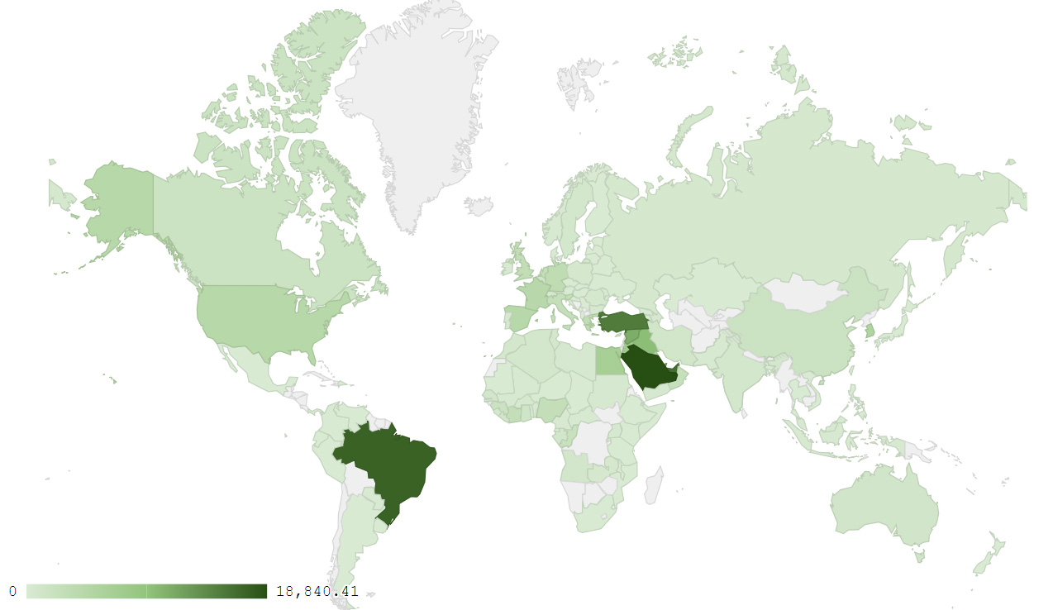
Map 1: Distribution of industrial exports during February 2018
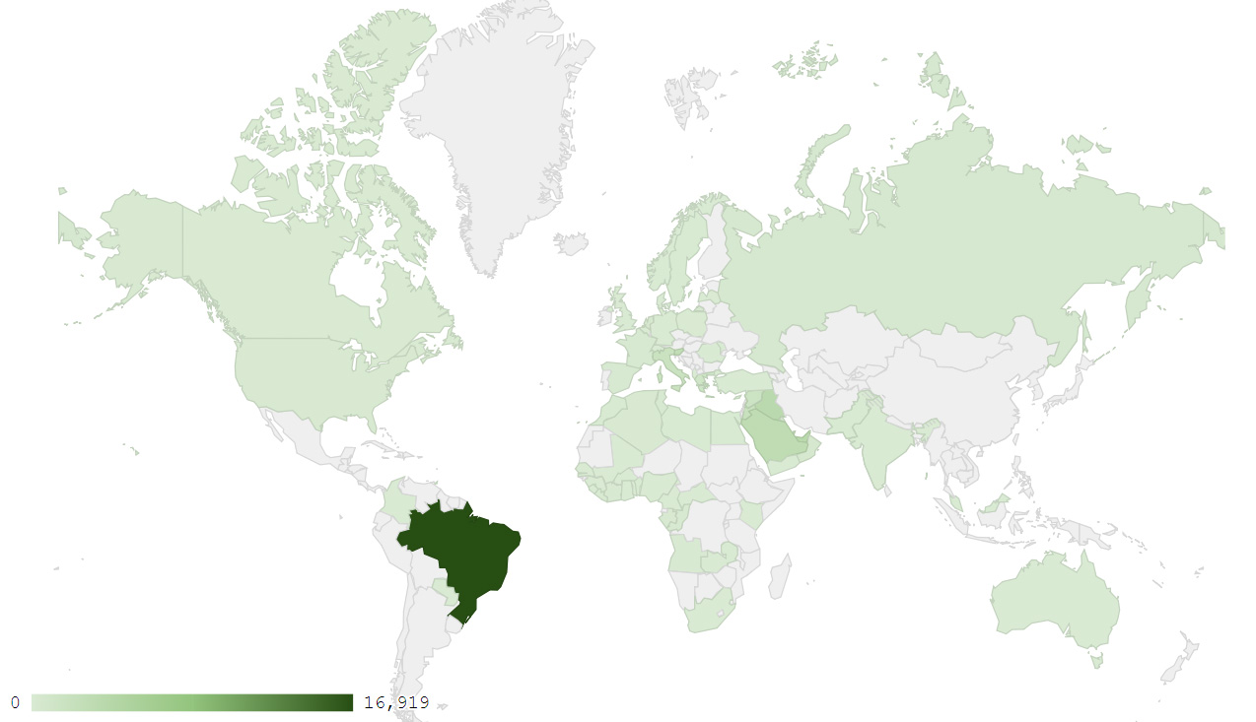
Map 2: Exports of products of the chemical industries during February 2018
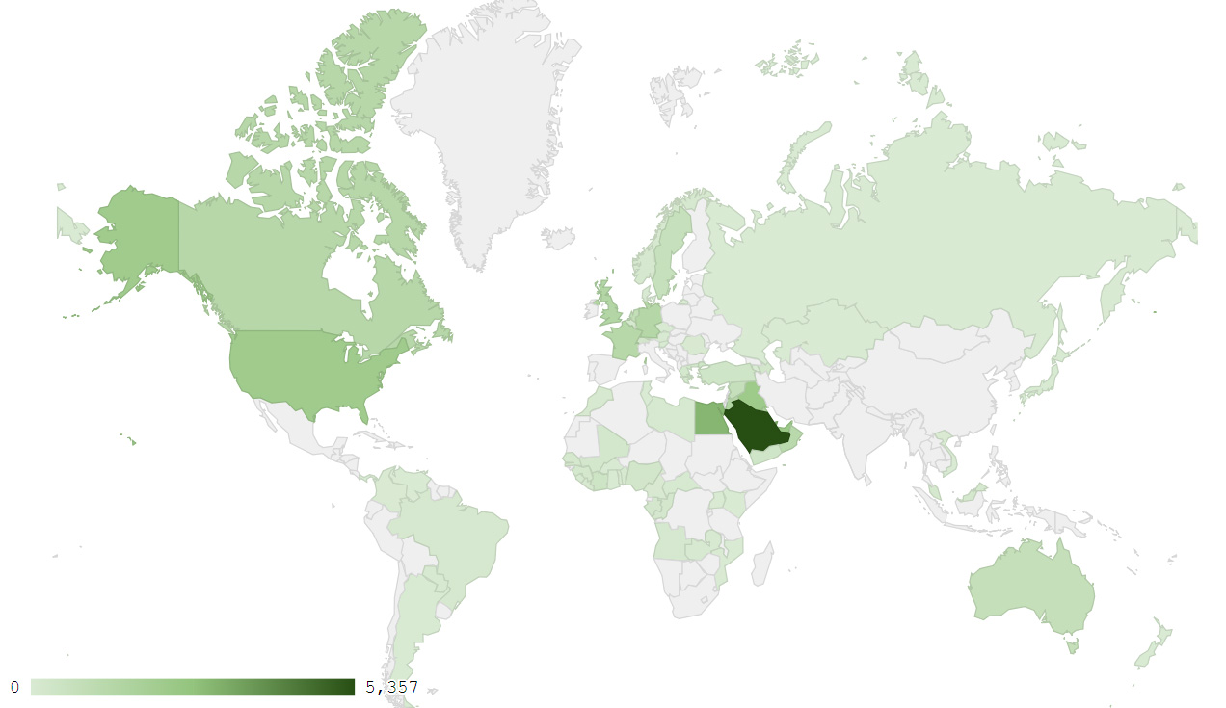
Map 3: Exports of prepared foodstuffs and tobacco during February 2018
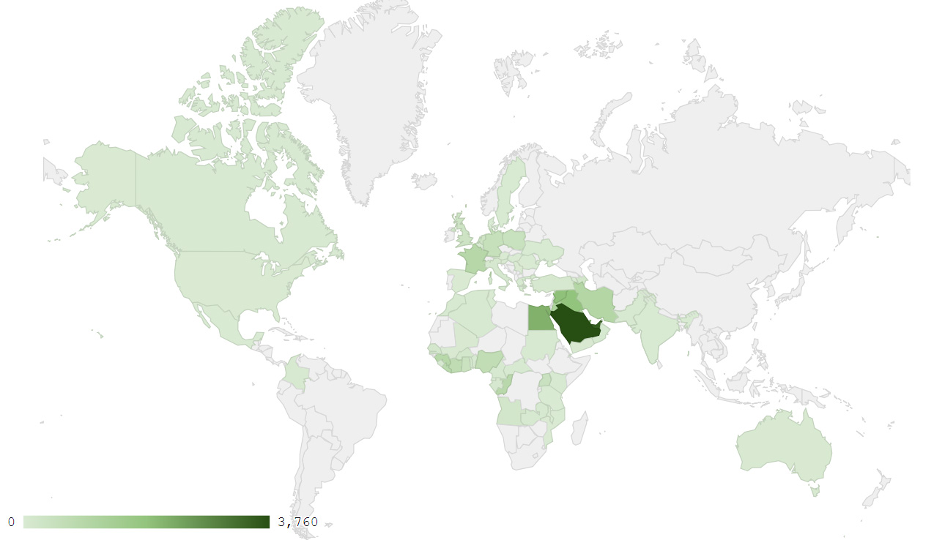
Map 4: Exports of machinery and electrical equipment during February 2018

Appendix charts
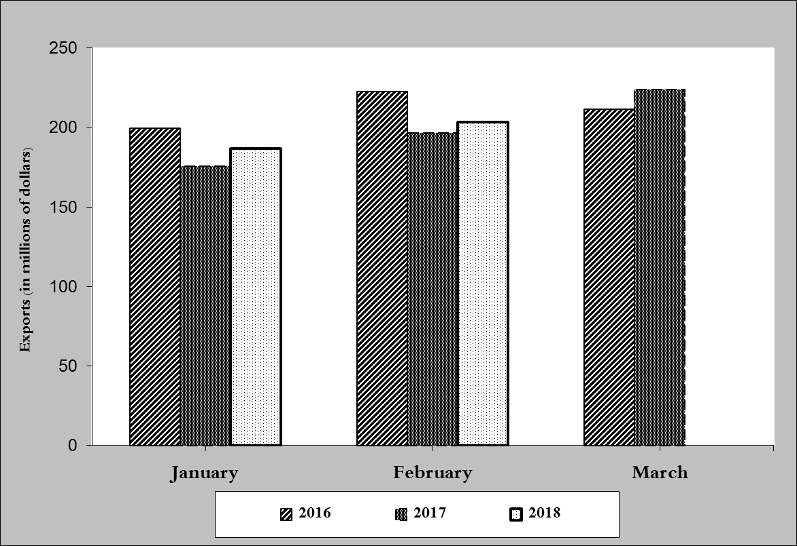
Chart 1: Industrial exports during years 2016-2017-2018
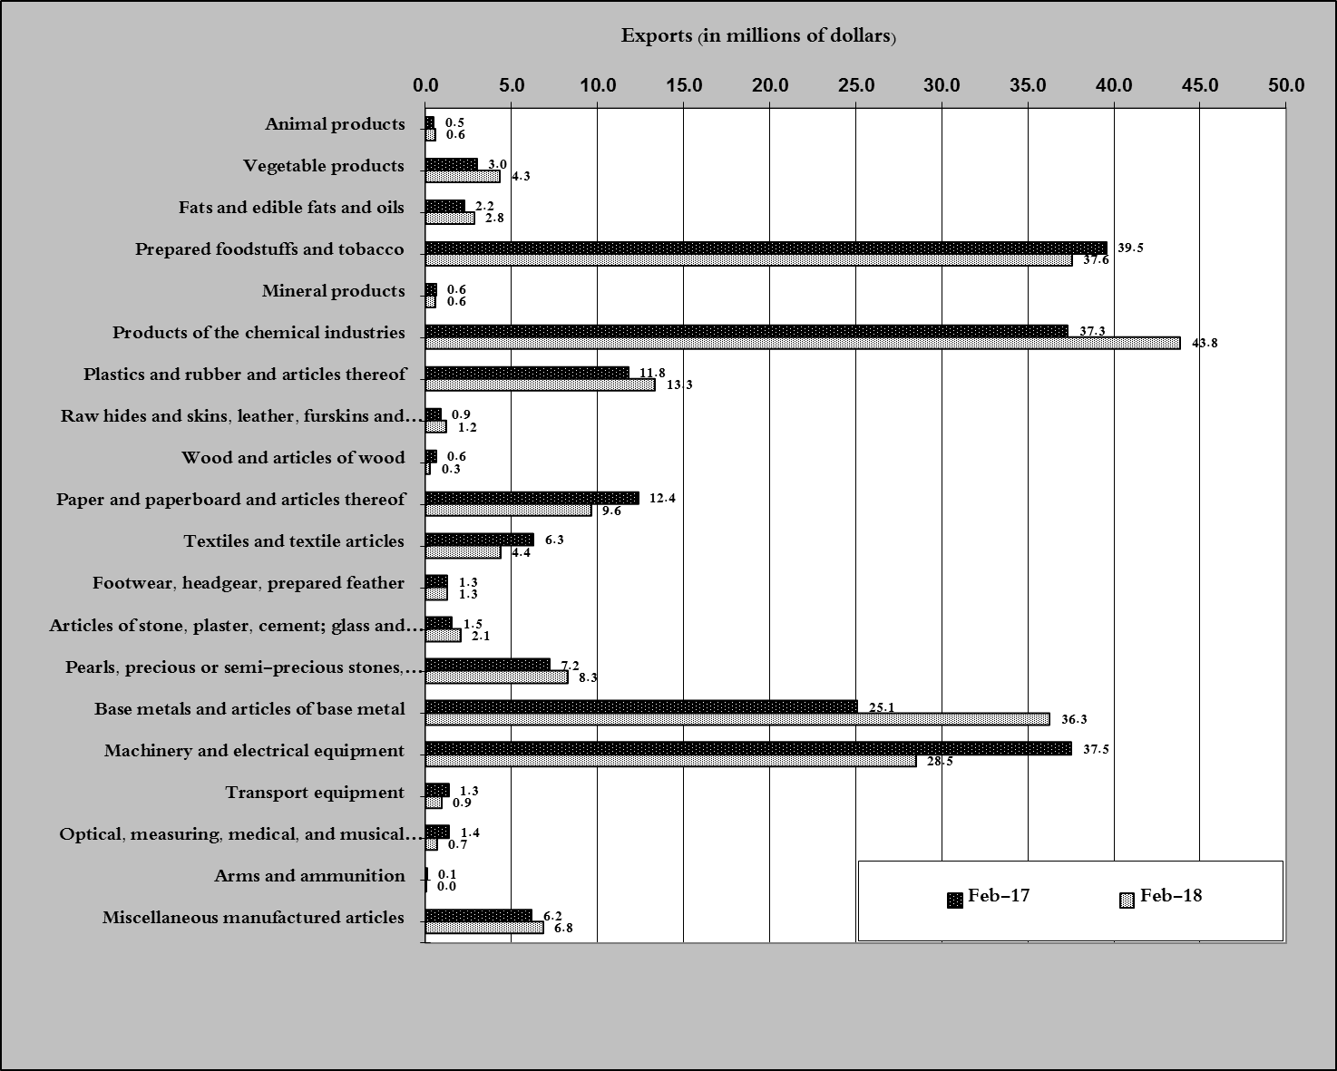
Chart 2: Comparison of industrial exports during February 2018 and February 2017

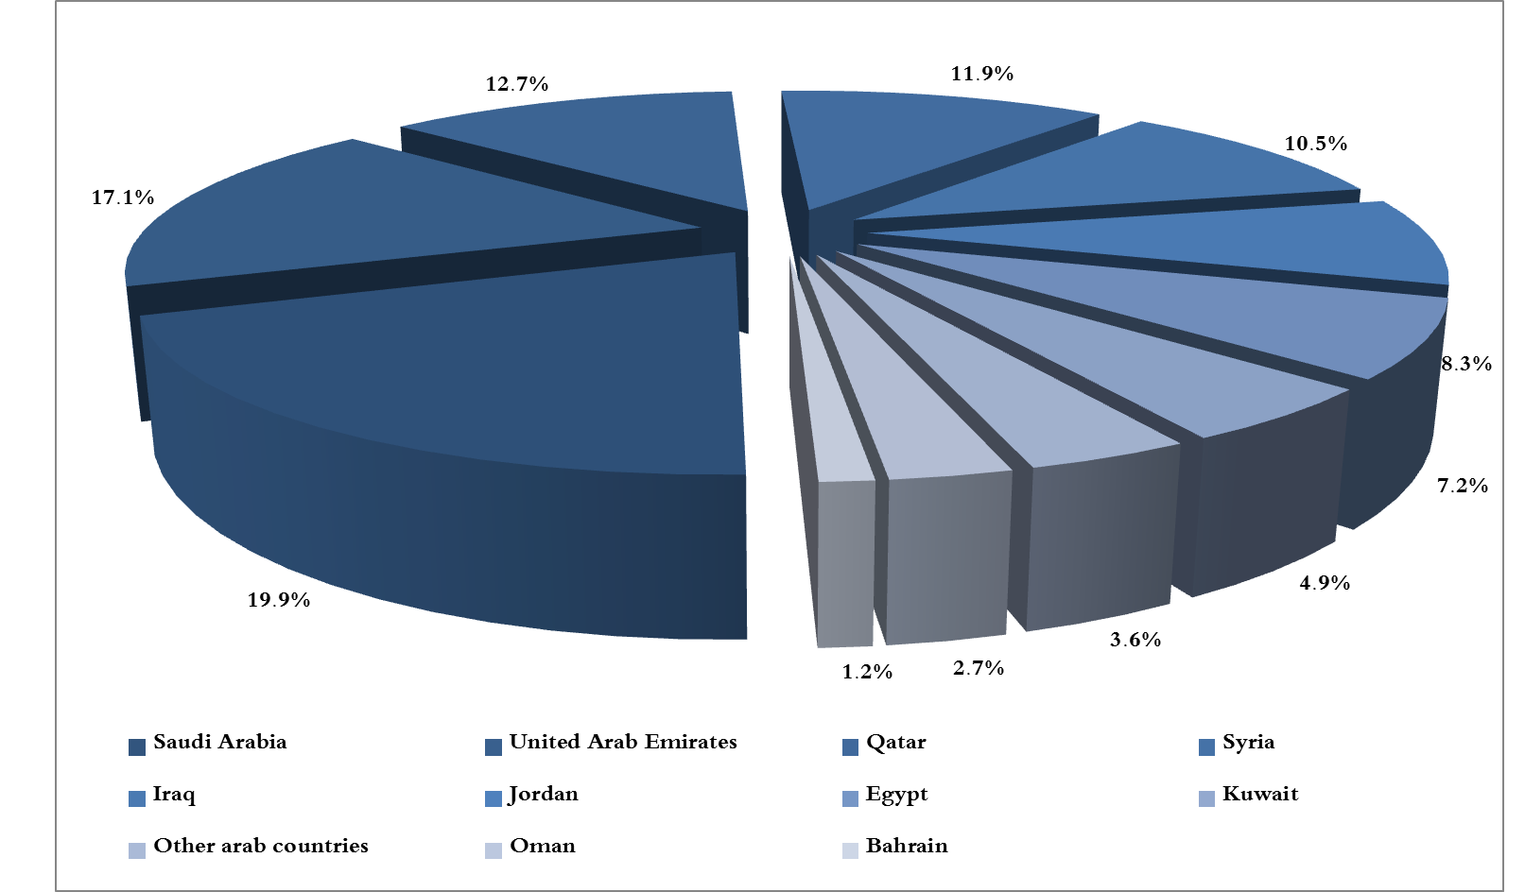
Chart 3: Distribution of industrial exports to Arab countries during February 2018

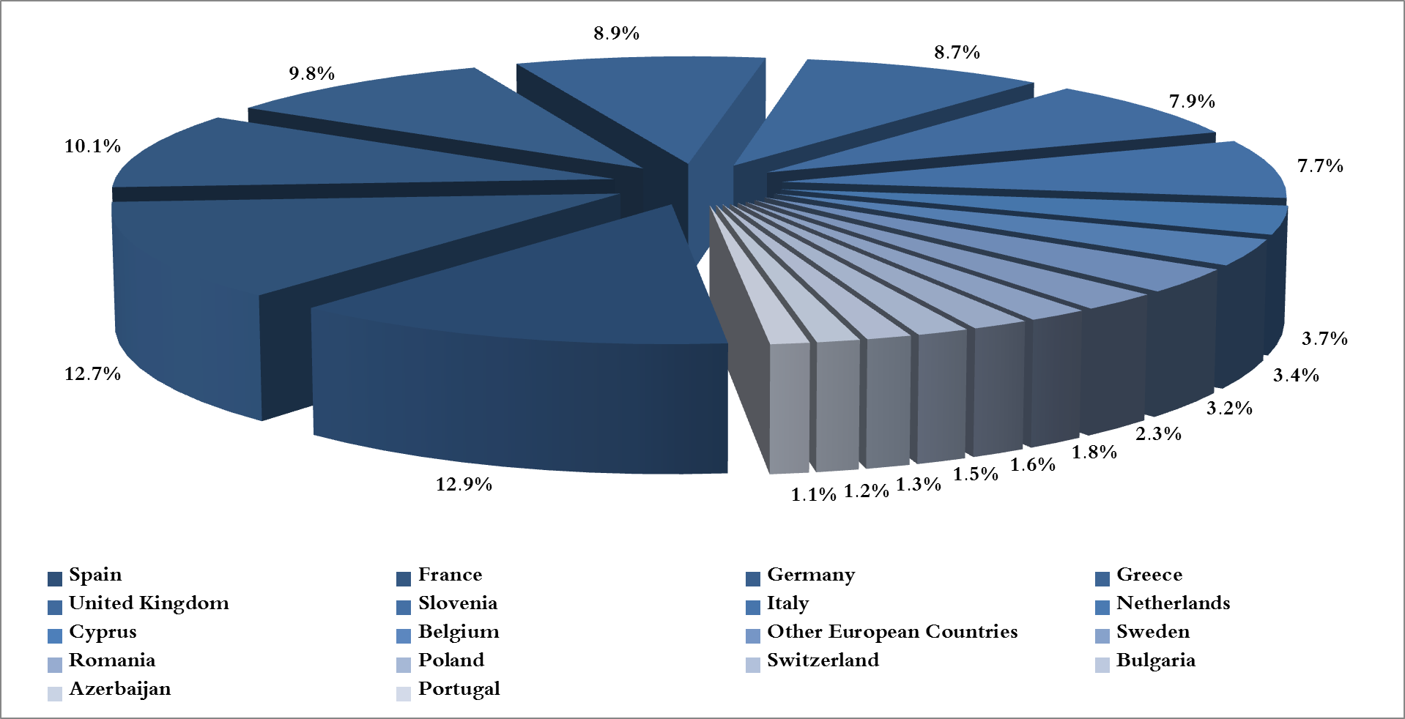
Chart 4: Distribution of industrial exports to European countries during February 2018

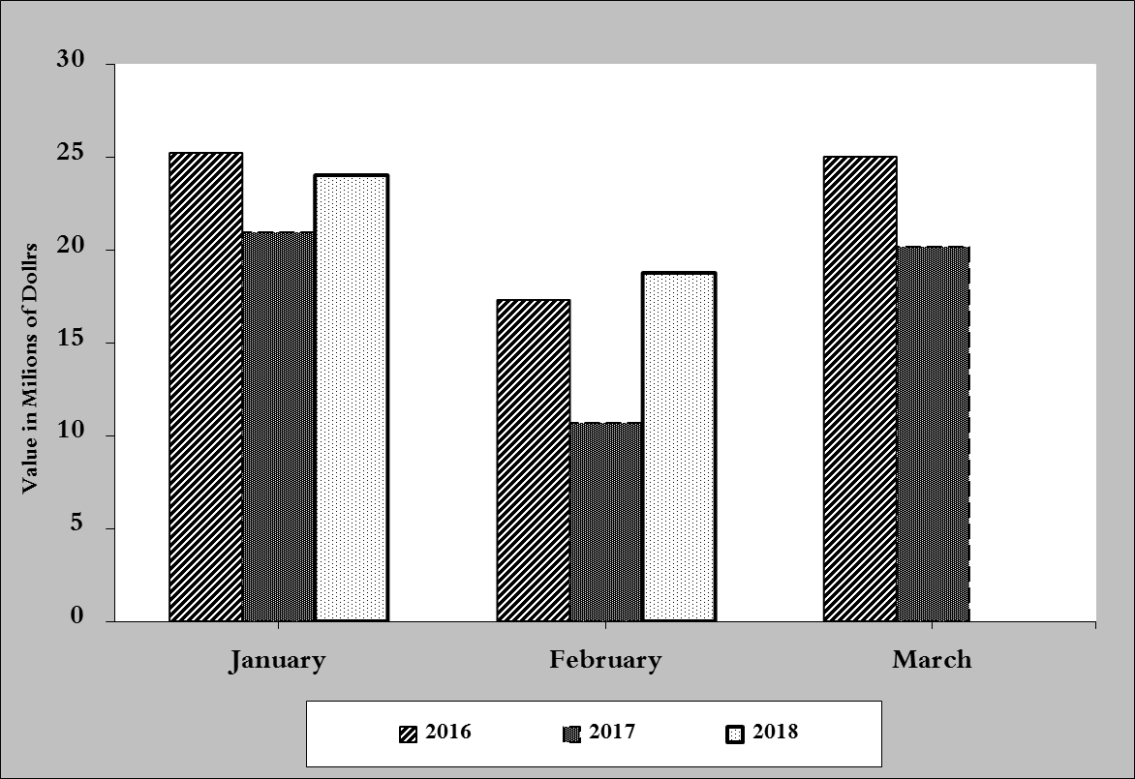
Chart 5: Imports of industrial machinery and equipment during years 2016-2017-2018

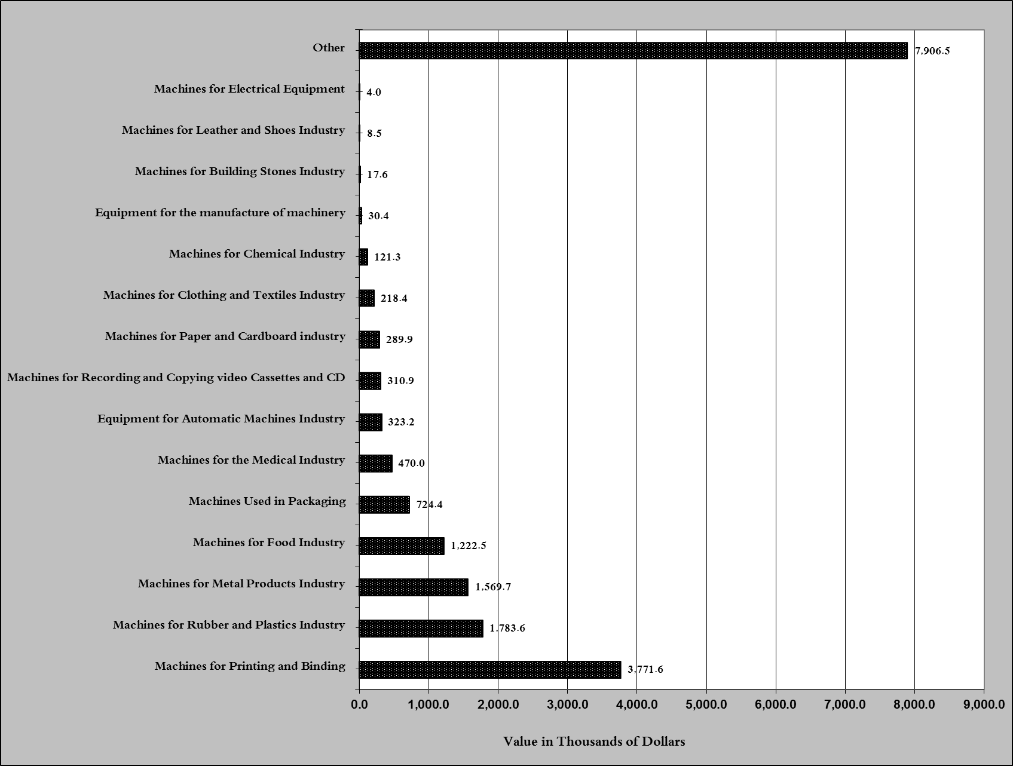
Chart 6: Imports of industrial equipment and machinery according to industrial activity during February 2018

Exports of unworked Diamonds, Silver and Gold Ingots reached this month a value of 56.5 million USD
The machineries and equipment are classified in this table according to the industrial sectors that are used in, while heading "other" includes machineries and equipment that can be used in various sectors.

