

A detailed report on industrial exports
and imports of industrial machinery and equipment in January 2018

Prepared by:
Ministry of Industry
Industrial Information Department

www.industry.gov.lb
Index

I. Industrial exports in January 2018 3
1. Main exported products 3
2. Products with increased exports value 3
2.1. Products of the chemical industries 3
2.2. Base metals and articles of base metal 3
3. Products with decreased exports value 4
3.1. Machinery and electrical equipment 4
3.2. Prepared foodstuffs and tobacco 4
4. Main export markets 4
4.1. Main export markets by groups of countries 4
4.2. Main export markets by country 4
II. Imports of industrial machinery and equipment 5
1. Imported industrial machinery and equipment by country of origin 5
2. Imported industrial machinery and equipment by country of origin and industrial activity 5
IV. Appendix tables 6
V. Appendix maps 19
VI. Appendix charts 23

Industrial exports in January 2018
The total value of industrial exports in January 2018 amounted to nearly 187 million US dollars, compared to 175.9 million US dollars in January 2017, and 199.5 million US dollars in January 2016, which is equivalent to an increase of 11.1 million US dollars, with the rate of 6.33% compared to year 2017, and a decline of 12.5 million US dollars with the rate of 6.27%, compared to year 2016. (Table 1, Map 1, Chart 1)

Main exported products
Exports of base metals and articles of base metal came first in January 2018, with a total value of 38.5 million US dollars; Turkey was on top of importers list of this product, with an import value of 14.6 million US dollars. Followed by exports of products of the chemical industries, with a total value of 37.7 million US dollars, France was the largest importer of this product, with an import value of 10.1 million US dollars. Then machinery and electrical equipment, with a total value of 33.8 million US dollars, Iraq topped the importers list of this product, with an import value of 7.6 million US dollars, followed by prepared foodstuffs and tobacco, with a total value of 27.3 million US dollars. (For more details tables 2, 4, 6, 8, 10, 15, and 16 and maps 2, 3, and 4)

Products with increased exports value
Statistics showed a significant increase in exports of the following products:

Products of the chemical industries
Exports of this product increased from 22.2 million US dollars in January 2017 to 37.7 million US dollars in January 2018 (Table 2 and Chart 2). The exports of this product mainly increased to France, Italy and Iraq which led to an increase in the total value of about 15.5 million US dollars. (Tables 3 and 4)

Base metals and articles of base metal
Exports of this product increased from 26.1 million US dollars in January 2017 to 38.5 million US dollars in January 2018 (Table 2 and Chart 2). The exports of this product mainly increased to Turkey, Spain and China which led to an increase of the total value of about 12.5 million US dollars. (Tables 5 and 6).

Products with decreased exports value
Statistics showed a significant decrease in exports of the following products:

Machinery and electrical equipment
Exports of this product decreased from 42.5 million US dollars in January 2017 to 33.8 million US dollars in January 2018 (Table 2 and Chart 2). The exports of this product mainly increased to Kuwait whereas it mainly decreased to Libya, Syria, United Arab Emirates and Qatar which led to a fall of the total value of about 8.7 million US dollars. (Tables 7 and 8)

Prepared foodstuffs and tobacco
Exports of this product decreased from 33.1 million US dollars in January 2017 to 27.3 million US dollars in January 2018 (Table 2 and Chart 2). The exports of this product mainly increased to Iraq whereas it mainly decreased to Syria which led to a fall of the total value of about 5.8 million US dollars. (Tables 9 and 10)

Main export markets

Main export markets by groups of countries
Arab countries were the main market for Lebanese industrial exports in January 2018, with a total export value of 88.7 million US dollars, with a rate of 47.4% of the total export value. European countries were the second largest export markets with a rate of 24% of the total export value. Followed by, Non-arab Asian countries with a rate of 14.4% of the total export value, and, the Non-arab African countries with a rate of 9.4% of the total export value. The main products exported to Arab countries are: machinery and electrical equipment with the total value of 22 million US dollars, products of the chemical industries with the total value of 15.9 million US dollars, and the prepared foodstuffs and tobacco with the total value of 15.1 million US dollars. (Table 12 and Map 1)

Main export markets by country
Among countries importing Lebanese industrial products, Iraq ranked first with a total value of 17.5 million US dollars, with a rate of 9.4% of the total export value. Turkey came second with a total value of 16.6 million US dollars with a rate of 8.9% of the total export value. Followed by, Saudi Arabia with a total value of 13.7 million US dollars with a rate of 7.3% of the total exports value. (Table 13 and Map 1)
During this month, Lebanese products were exported to 34 European countries, 30 Non-arab African countries, 19 Arab countries, 19 Non-arab Asian countries, 10 American countries, and 2 Oceanic countries. Countries that imported Lebanese goods by over 1 million US dollars are as following: 12 Arab countries, 8 European countries, 4 Non-arab African countries, 3 Non-arab Asian countries, and 2 American countries, and 1 Oceanic country. (Table 14, Map 1 and Charts 3 and 4)

Imports of industrial machinery and equipment
The total import value of industrial machinery and equipment in January 2018 reached about 24 million US dollars compared to 21 million US dollars during the same period in 2017, and 25.3 million US dollars during the same period in 2016, an increase by 14.7% compared to year 2017, and a decline of 4.9% compared to year 2016. (Tables 17 and 18 and Chart 5)

Imported industrial machinery and equipment by country of origin
Italy ranked first on the list of countries exporting industrial machinery and equipment to Lebanon, with a total value amounting to about 7.4 million US dollars, followed by Germany, with a total value of 4.8 million US dollars, and China, with a total value of 3.3 million US dollars. (Table 18)

Imported industrial machinery and equipment by country of origin and industrial activity
In January 2018, imports of machines for food industry, ranked first, with a total value of 4.7 million US dollars, and Italy topped the list of countries exporting of this product to Lebanon with exports value of 1.6 million US dollars, followed by machines used in packaging, with a total value of 3.3 million US dollars. Germany was the leading exporter of this product with an export value of 3.1 million US dollars. Followed by machines for metal products industry, with a total value of 1.7 million US dollars. (Table 19, Chart 6)

Appendix tables

Table 1: Industrial exports during Years 2016 – 2017 – 2018
Month | Year  2016 | Year  2017 | Year  2018 | Variation in %  2016/2018 | Variation in %  2017/2018
January | 199.5 | 175.9 | 187.0 | -6.3% | 6.3%
February | 222.8 | 196.8
March | 211.6 | 223.9
April | 231.1 | 210.4
May | 210.6 | 205.9
June | 225.3 | 199.0
July | 178.8 | 215.7
August | 232.9 | 227.0
September | 184.3 | 167.6
October | 220.0 | 226.7
November | 193.7 | 205.1
December | 216.3 | 219.6
Total | 2,526.9 | 2,473.5 | 187.0
All above figures are in Millions of USD

Table 2: Comparison of industrial exports during January 2018 and January 2017
Section | Goods | January 2017 | January 2018 | Variation 2017/2018 | Variation in % 2017/2018
1 | Animal products | 0.42 | 0.72 | 0.30 | 71.2%
2 | Vegetable products | 3.62 | 2.97 | -0.64 | -17.8%
3 | Fats and edible fats and oils | 2.67 | 2.90 | 0.23 | 8.8%
4 | Prepared foodstuffs and tobacco | 33.07 | 27.27 | -5.80 | -17.5%
5 | Mineral products | 0.66 | 0.71 | 0.05 | 7.6%
6 | Products of the chemical industries | 22.21 | 37.73 | 15.51 | 69.8%
7 | Plastics and rubber and articles thereof | 8.99 | 11.88 | 2.89 | 32.2%
8 | Raw hides and skins, leather, furskins and articles thereof | 0.91 | 0.95 | 0.04 | 4.2%
9 | Wood and articles of wood | 0.99 | 0.65 | -0.34 | -34.4%
10 | Paper and paperboard and articles thereof | 11.08 | 8.58 | -2.50 | -22.5%
11 | Textiles and textile articles | 4.50 | 3.05 | -1.45 | -32.2%
12 | Footwear, headgear, prepared feather | 0.28 | 0.39 | 0.11 | 41.4%
13 | Articles of stone, plaster, cement; glass and glassware | 1.30 | 1.28 | -0.01 | -1.1%
14 | Pearls, precious or semi-precious stones, precious metals and articles thereof (Excluding unworked diamonds, silver and gold Ingots) | 7.24 | 5.26 | -1.98 | -27.4%
15 | Base metals and articles of base metal | 26.07 | 38.53 | 12.46 | 47.8%
16 | Machinery and electrical equipment | 42.47 | 33.76 | -8.72 | -20.5%
17 | Transport equipment | 0.92 | 3.49 | 2.58 | 280.4%
18 | Optical, measuring, medical, and musical instruments; clocks and watches | 1.35 | 0.94 | -0.41 | -30.3%
19 | Arms and ammunition | 0.03 | 0.00 | -0.03 | -100.0%
20 | Miscellaneous manufactured articles | 7.08 | 5.91 | -1.16 | -16.5%
 | Total | 175.86 | 186.99 | 11.13 | 6.3%
All above figures are in Millions of USD
Table 3: Exports of products of the chemical industries according to the main importing countries during January 2017
Export destination Country | United Arab Emirates | Iraq | Spain | Jordan | Saudi Arabia | Oman | Italy | Tanzania
Value in thousands of USD | 3,962 | 3,262 | 3,179 | 3,145 | 1,833 | 763 | 729 | 718

Table 4: Exports of products of the chemical industries according to the main importing countries during January 2018
Export destination Country | France | Italy | Iraq | Spain | United Arab Emirates | Jordan | Greece | Syria
Value in thousands of USD | 10,058 | 4,598 | 4,310 | 3,445 | 3,118 | 3,031 | 1,411 | 1,351

Table 5: Exports of base metals and articles of base metal according to the main importing countries during January 2017
Export destination Country | Turkey | Republic of Korea | Spain | Japan | Greece | China | United Arab Emirates | Saudi Arabia
Value in thousands of USD | 6,383 | 4,753 | 2,608 | 955 | 952 | 931 | 661 | 659

Table 6: Exports of base metals and articles of base metal according to the main importing countries during January 2018
Export destination Country | Turkey | Republic of Korea | Spain | China | Italy | Greece | Qatar | Algeria
Value in thousands of USD | 14,551 | 5,081 | 4,591 | 2,520 | 1,346 | 1,246 | 971 | 903

Table 7: Exports of machinery and electrical equipment according to the main importing countries during January 2017
Export destination Country | Libya | Iraq | United Arab Emirates | Syria | Saudi Arabia | Qatar | Ghana | France
Value in thousands of USD | 8,227 | 6,833 | 4,463 | 3,789 | 2,567 | 2,241 | 1,282 | 1,228

Table 8: Exports of machinery and electrical equipment according to the main importing countries during January 2018
Export destination Country | Iraq | United Arab Emirates | Saudi Arabia | Kuwait | Syria | Egypt | Qatar | Ghana
Value in thousands of USD | 7,563 | 2,584 | 2,579 | 2,064 | 1,753 | 1,659 | 1,242 | 1,201

Table 9: Exports of prepared foodstuffs and tobacco according to the main importing countries during January 2017
Export destination Country | Syria | Saudi Arabia | Qatar | Iraq | United Arab Emirates | United States Of America | Canada | United Kingdom
Value in thousands of USD | 9,797 | 3,561 | 2,044 | 2,030 | 1,634 | 1,587 | 1,238 | 1,158

Table 10: Exports of prepared foodstuffs and tobacco according to the main importing countries during January 2018
Export destination Country | Saudi Arabia | Iraq | United States Of America | Qatar | United Arab Emirates | United Kingdom | Kuwait | Jordan
Value in thousands of USD | 3,417 | 3,341 | 2,146 | 1,992 | 1,811 | 1,607 | 1,486 | 1,219

Table 11: Industrial exports according to exported goods during year 2018
Table 12: Industrial exports according to exported goods and countries groups during January 2018
Goods | Arab Countries | European Countries | Oceanic Countries | Non-Arab Asian countries | American Countries | Non-Arab African countries | Other* | Total
Animal products | 660 |  |  |  |  | 56 |  | 716
Vegetable products | 1,113 | 603 | 106 | 157 | 423 | 573 |  | 2,975
Fats and edible fats and oils | 1,219 | 450 | 58 | 110 | 935 | 131 |  | 2,903
Prepared foodstuffs and tobacco | 15,091 | 5,235 | 673 | 467 | 3,570 | 1,819 | 420 | 27,275
Mineral products | 418 | 150 |  | 5 | 17 | 66 | 59 | 715
Products of the chemical industries | 15,942 | 20,371 | 34 | 321 | 368 | 654 | 36 | 37,725
Plastics and rubber and articles thereof | 8,661 | 1,160 | 11 | 328 | 33 | 1,557 | 131 | 11,881
Raw hides and skins, leather, furskins and articles thereof | 575 | 190 | 36 | 125 |  | 23 |  | 949
Wood and articles of wood | 466 | 12 | 1 |  | 1 | 171 |  | 652
Paper and paperboard and articles thereof | 6,375 | 789 | 14 | 315 | 65 | 1,023 |  | 8,580
Textiles and textile articles | 1,762 | 724 | 41 | 57 | 133 | 256 | 78 | 3,051
Footwear, headgear, prepared feather | 373 | 12 |  |  |  | 6 |  | 391
Articles of stone, plaster, cement; glass and glassware | 917 | 41 | 1 | 19 | 36 | 266 | 3 | 1,283
Pearls, precious or semi-precious stones, precious metals and articles thereof (Excluding unworked diamonds, silver and gold Ingots) | 3,801 | 850 |  | 350 | 177 | 80 |  | 5,257
Base metals and articles of base metal | 3,558 | 8,422 | 60 | 23,155 | 71 | 3,235 | 31 | 38,532
Machinery and electrical equipment | 22,021 | 3,587 | 36 | 1,496 | 292 | 6,240 | 84 | 33,755
Transport equipment | 823 | 1,653 |  |  | 620 | 398 |  | 3,494
Optical, measuring, medical, and musical instruments; clocks and watches | 356 | 431 |  | 6 | 109 | 32 | 5 | 939
Arms and ammunition |  |  |  |  |  |  |  | 0
Miscellaneous manufactured articles | 4,581 | 173 | 30 | 24 | 35 | 1,065 | 4 | 5,912
Total | 88,710 | 44,854 | 1,102 | 26,934 | 6,884 | 17,651 | 852 | 186,987
All the above figures are in thousands of US dollars.
* "other" Includes exported goods to the duty free market and those that are supplied to ships and aircraft.
Table 13: Distribution of the industrial exports according to the main importing countries during January 2018
Export destination Country | Iraq | Turkey | Saudi Arabia | United Arab Emirates | France | Syria | Spain | Qatar
Value in thousands of USD | 17,519 | 16,624 | 13,710 | 13,116 | 12,657 | 9,651 | 8,643 | 8,450

Export destination Country | Jordan | Kuwait | Italy | Republic of Korea | United States Of America | Egypt | United Kingdom | Germany
Value in thousands of USD | 6,447 | 6,307 | 6,243 | 5,100 | 4,716 | 4,212 | 3,525 | 3,136

Export destination Country | Ivory Coast | Greece | China | Congo | Ghana | Algeria | Libya | Belgium
Value in thousands of USD | 2,928 | 2,890 | 2,580 | 2,167 | 2,104 | 2,013 | 1,754 | 1,719

Table 14: Distribution of importing countries according to countries groups and the value of exports during January 2018
Exports Value  (in million USD) | Arab Countries | European Countries | Oceania Countries | Non-Arab Asian countries | American Countries | Non-Arab African countries | Total
]0-1[ | 7 | 26 | 1 | 16 | 8 | 26 | 84
[1-5[ | 5 | 5 | 1 | 1 | 2 | 4 | 18
[5-10[ | 4 | 2 |  | 1 |  |  | 7
[10-15[ | 2 | 1 |  |  |  |  | 3
More than 15 million USD | 1 |  |  | 1 |  |  | 2
Total | 19 | 34 | 2 | 19 | 10 | 30 | 114

Table 15: Distribution of the industrial exports according to product and to the main importing countries during January 2018

Animal products | Iraq | Qatar | United Arab Emirates | Kuwait | Saudi Arabia | Zambia | Ivory Coast | Sierra Leone
Value in 1000 of USD | 282 | 255 | 65 | 38 | 14 | 13 | 13 | 8

Vegetable products | Germany | United Arab Emirates | Saudi Arabia | Canada | South Africa | Tunisia | Turkey | United States Of America
Value in 1000 of USD | 360 | 291 | 271 | 257 | 199 | 167 | 157 | 147

Fats and edible fats and oils | United States Of America | Saudi Arabia | Kuwait | United Arab Emirates | Netherlands | Portugal | Qatar | Turkey
Value in 1000 of USD | 811 | 369 | 353 | 235 | 196 | 138 | 114 | 108

Mineral products | Syria | Netherlands | Other | France | Saudi Arabia | Iraq | Italy | Gambia
Value in 1000 of USD | 342 | 68 | 59 | 34 | 33 | 30 | 28 | 23

Plastics and rubber and articles thereof | Syria | Saudi Arabia | Iraq | Spain | Qatar | Egypt | United Arab Emirates | Algeria
Value in 1000 of USD | 3,942 | 1,848 | 843 | 558 | 429 | 391 | 336 | 321

Raw hides and skins, leather, furskins and articles thereof | United Arab Emirates | Oman | Egypt | Turkey | Syria | France | Australia | Germany
Value in 1000 of USD | 164 | 151 | 141 | 125 | 95 | 84 | 36 | 24

Wood and articles of wood | Saudi Arabia | Zambia | Nigeria | Algeria | Qatar | Ghana | United Arab Emirates | Cyprus
Value in 1000 of USD | 363 | 81 | 49 | 48 | 41 | 18 | 12 | 12

Paper and paperboard and articles thereof | Egypt | Qatar | Saudi Arabia | Morocco | Jordan | Syria | United Arab Emirates | Cyprus
Value in 1000 of USD | 883 | 752 | 692 | 603 | 539 | 483 | 469 | 378

Textiles and textile articles | United Arab Emirates | Saudi Arabia | France | Qatar | Syria | Jordan | Senegal | Tunisia
Value in 1000 of USD | 441 | 319 | 294 | 278 | 169 | 151 | 127 | 111

Table 15: (continued) Distribution of the industrial exports according to product and the main importing countries during January 2018
Footwear, headgear, prepared feather | Saudi Arabia | United Arab Emirates | Kuwait | Jordan | Qatar | Egypt | France | Senegal
Value in 1000 of USD | 184 | 62 | 54 | 36 | 23 | 11 | 10 | 3

Articles of stone, plaster, cement; glass and glassware | Qatar | Algeria | United Arab Emirates | Kuwait | Saudi Arabia | Ivory Coast | Congo | Sierra Leone
Value in 1000 of USD | 350 | 172 | 147 | 97 | 70 | 60 | 48 | 43

Pearls, precious or semi-precious stones, precious metals and articles thereof (Excluding unworked diamonds, silver and gold Ingots) | United Arab Emirates | Qatar | United Kingdom | Switzerland | Saudi Arabia | Kuwait | United States Of America | Russian Federation
Value in 1000 of USD | 2,631 | 497 | 426 | 288 | 287 | 194 | 176 | 170

Transport equipment | Belgium | United Kingdom | United States Of America | Iraq | Bahrain | Ivory Coast | Libya | Ghana
Value in 1000 of USD | 750 | 717 | 612 | 324 | 242 | 187 | 130 | 85

Optical, measuring, medical, and musical instruments; clocks and watches | United Arab Emirates | Germany | Switzerland | United States Of America | France | Jordan | Qatar | Upper Volta
Value in 1000 of USD | 267 | 233 | 129 | 109 | 46 | 32 | 25 | 25

Miscellaneous manufactured articles | Saudi Arabia | Qatar | Syria | Jordan | United Arab Emirates | Nigeria | Zambia | Iraq
Value in 1000 of USD | 1,396 | 1,177 | 1,014 | 299 | 271 | 236 | 170 | 165

Table 16: Distribution of industrial exports, according to the main exported goods and main importing countries during January 2018

Table 17: Imports of industrial machinery and equipment during years 2016-2017-2018
Month | Year  2016 | Year  2017 | Year  2018 | Variation in %  2016/2018 | Variation in %  2017/2018
January | 25.3 | 21.0 | 24.0 | -4.9% | 14.7%
February | 17.3 | 10.7
March | 25.1 | 20.2
April | 22.8 | 18.0
May | 20.5 | 23.1
June | 20.0 | 22.2
July | 16.8 | 21.8
August | 19.0 | 27.0
September | 16.2 | 30.1
October | 14.5 | 22.4
November | 20.0 | 17.6
December | 17.9 | 23.2
Total | 235.5 | 257.4 | 24.0
All above figures are in Millions of USD

Table 18: Imports of industrial equipment and machinery according to exporting country for the year 2018
Table 19: Imports of industrial equipment and machinery according to industrial activity and country during January 2018

Appendix maps
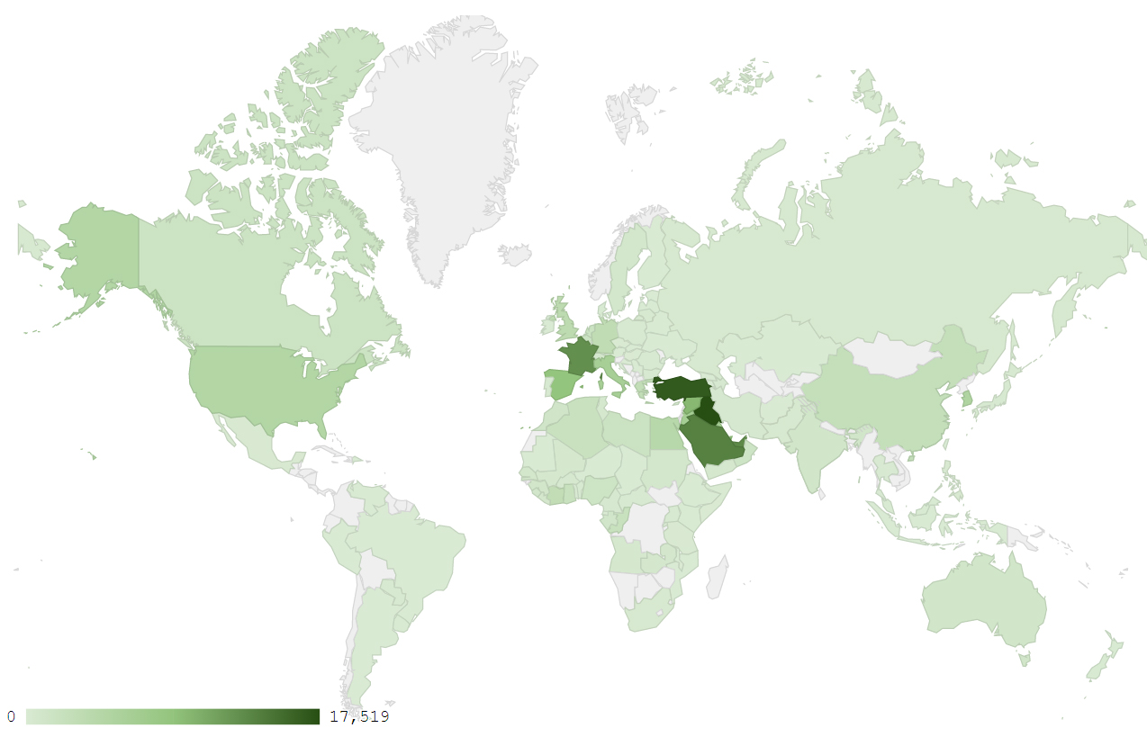
Map 1: Distribution of industrial exports during January 2018
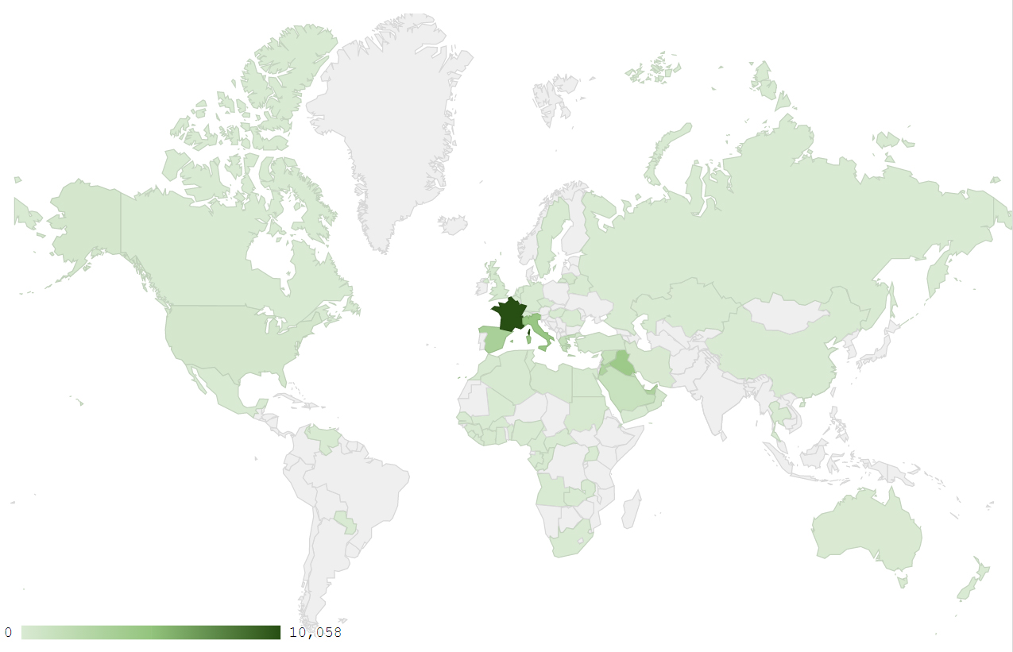
Map 2: Exports of products of the chemical industries during January 2018
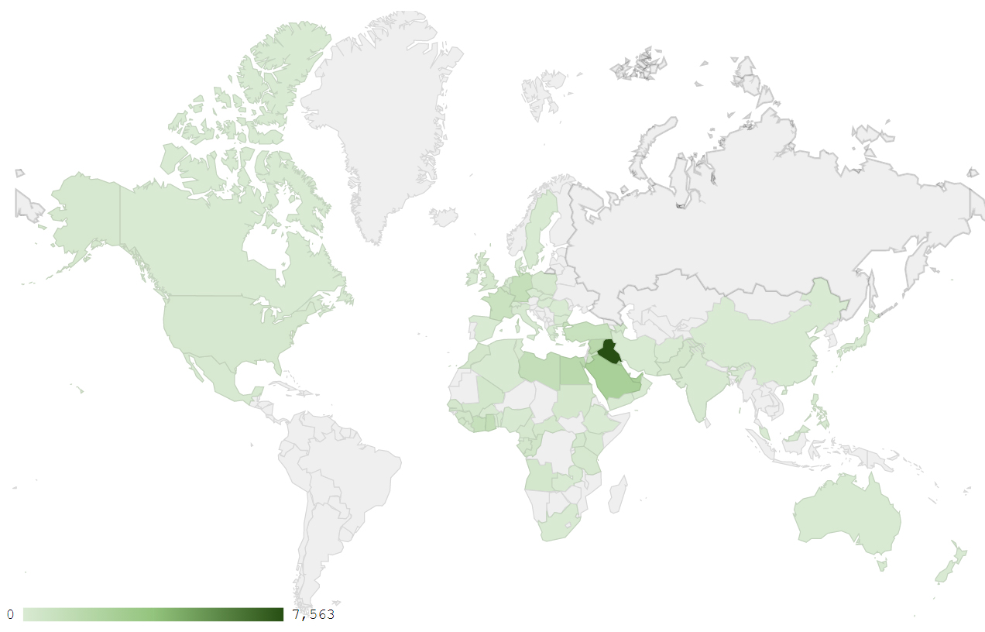
Map 3: Exports of machinery and electrical equipment during January 2018
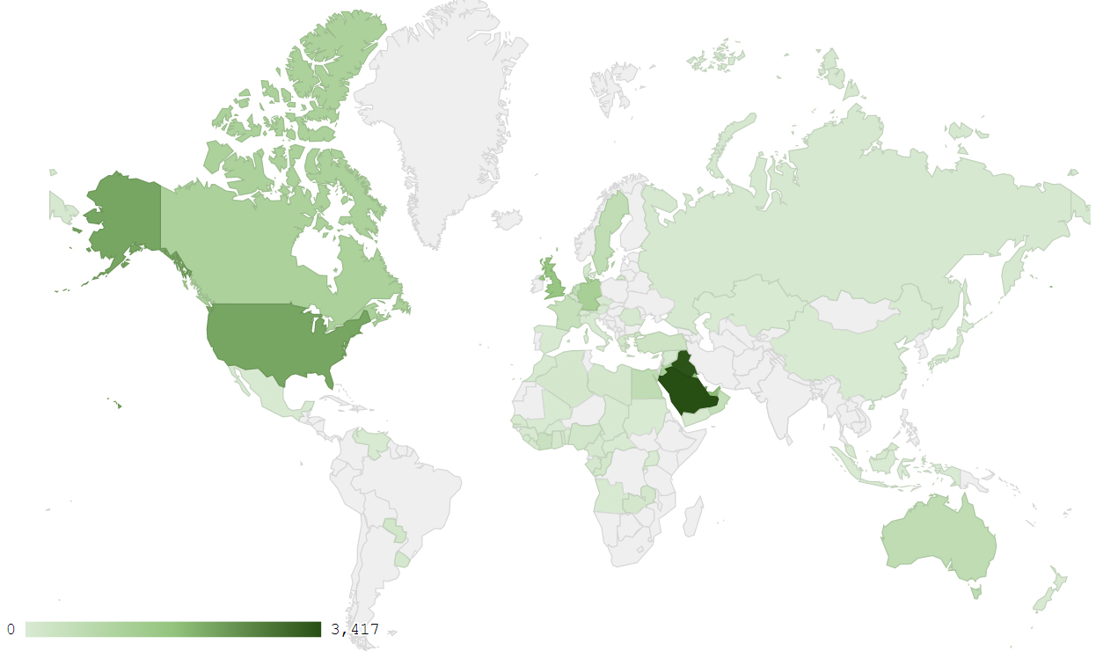
Map 4: Exports of prepared foodstuffs and tobacco during January 2018

Appendix charts
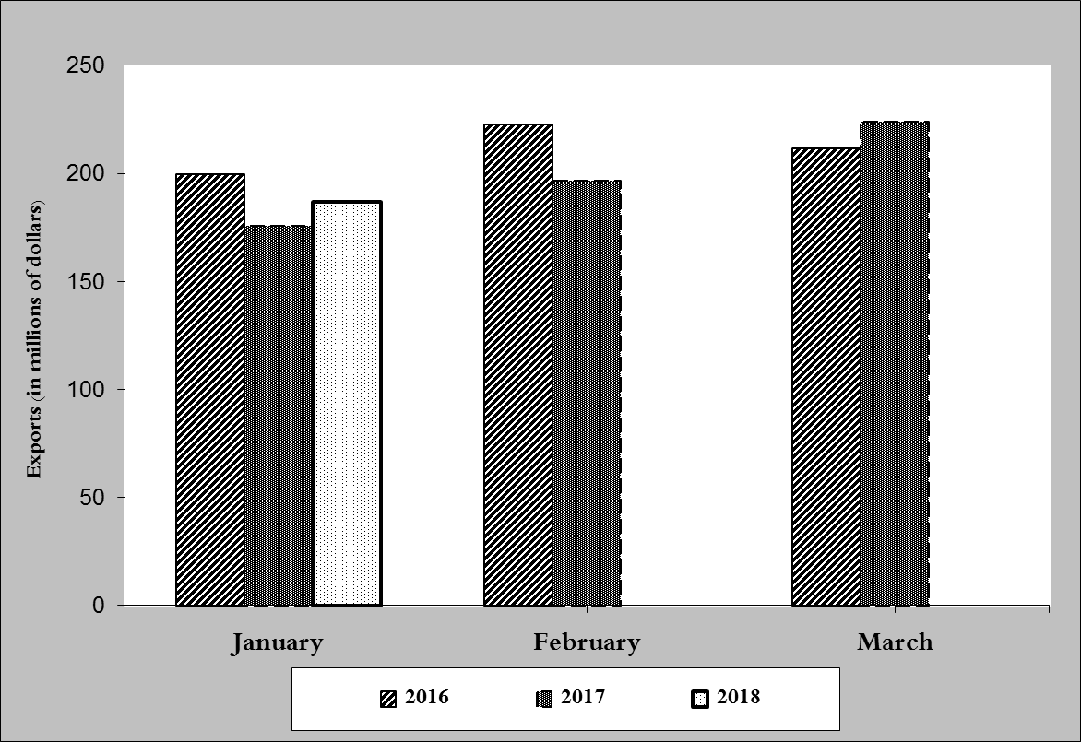
Chart 1: Industrial exports during years 2016-2017-2018
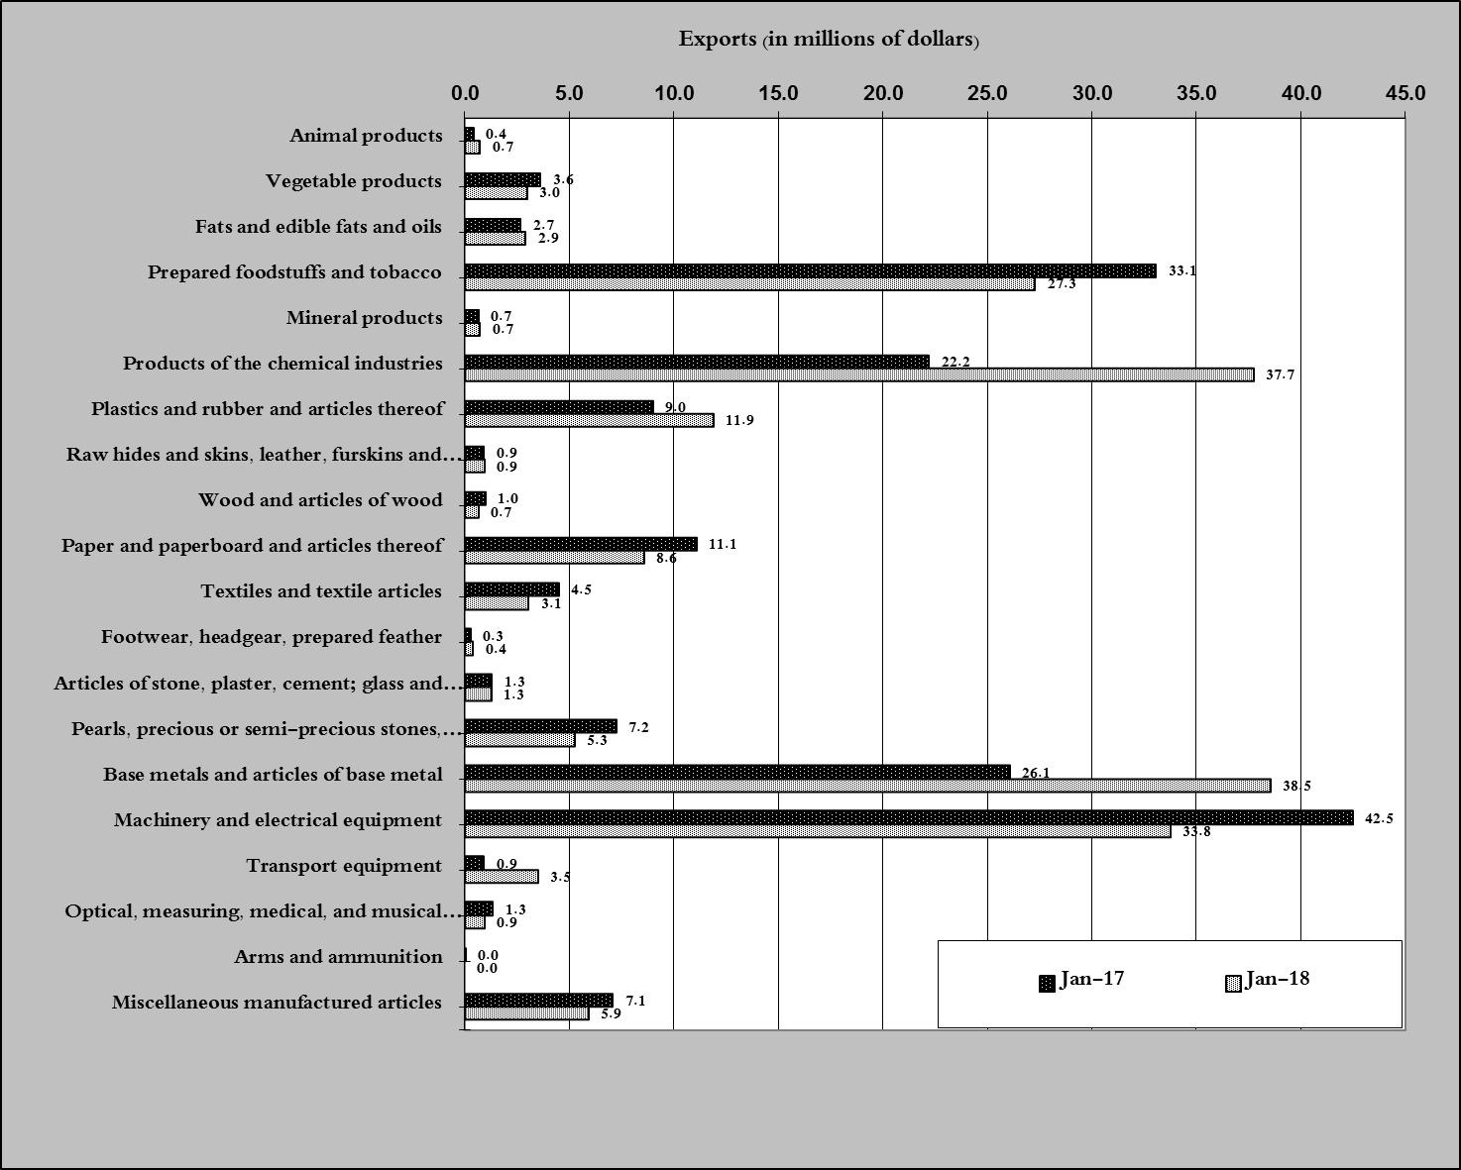
Chart 2: Comparison of industrial exports during January 2018 and January 2017

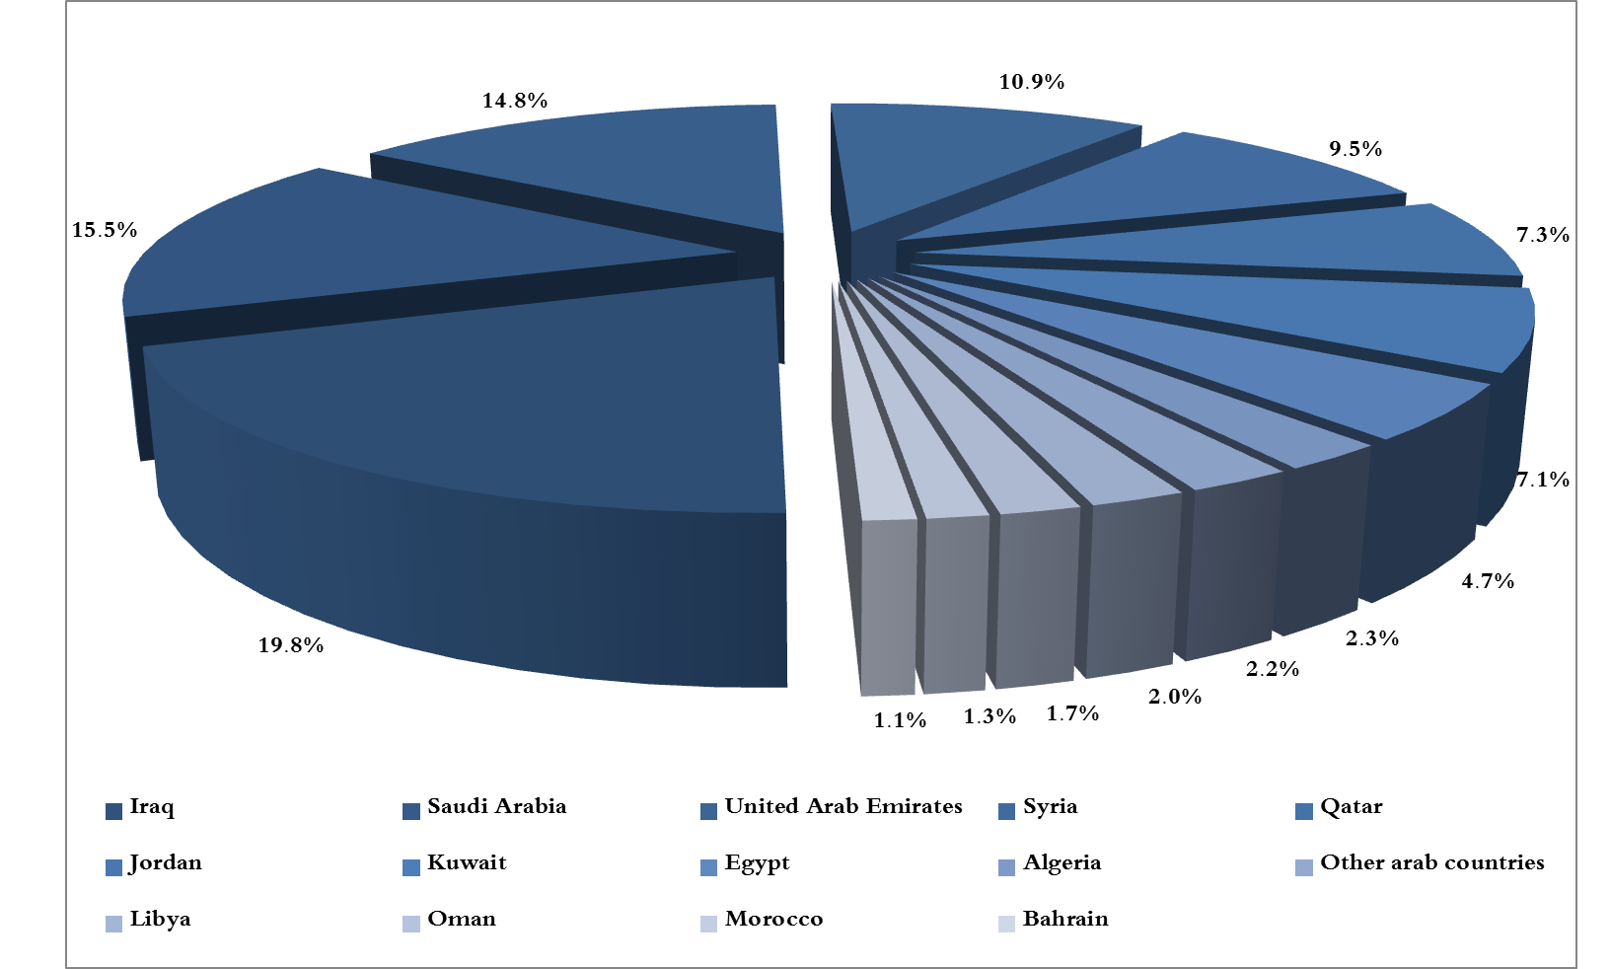
Chart 3: Distribution of industrial exports to Arab countries during January 2018

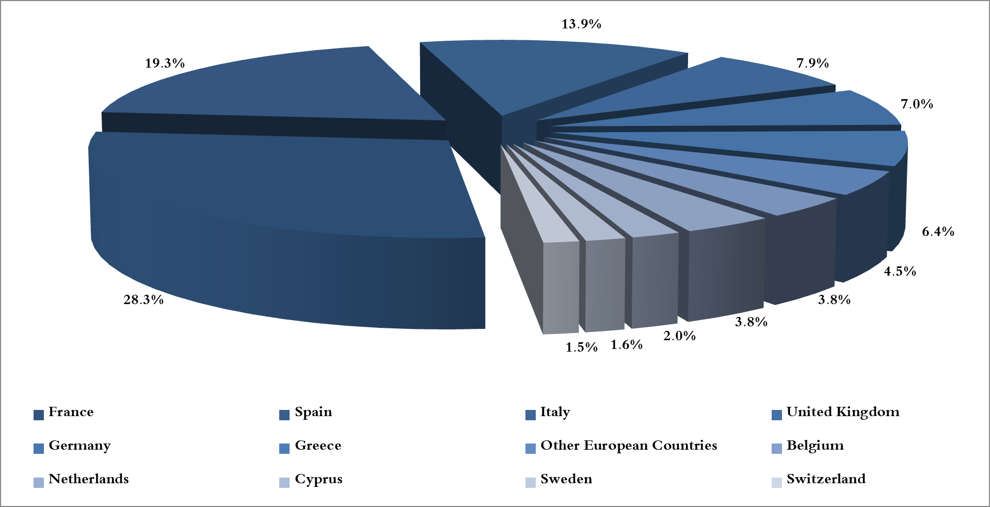
Chart 4: Distribution of industrial exports to European countries during January 2018

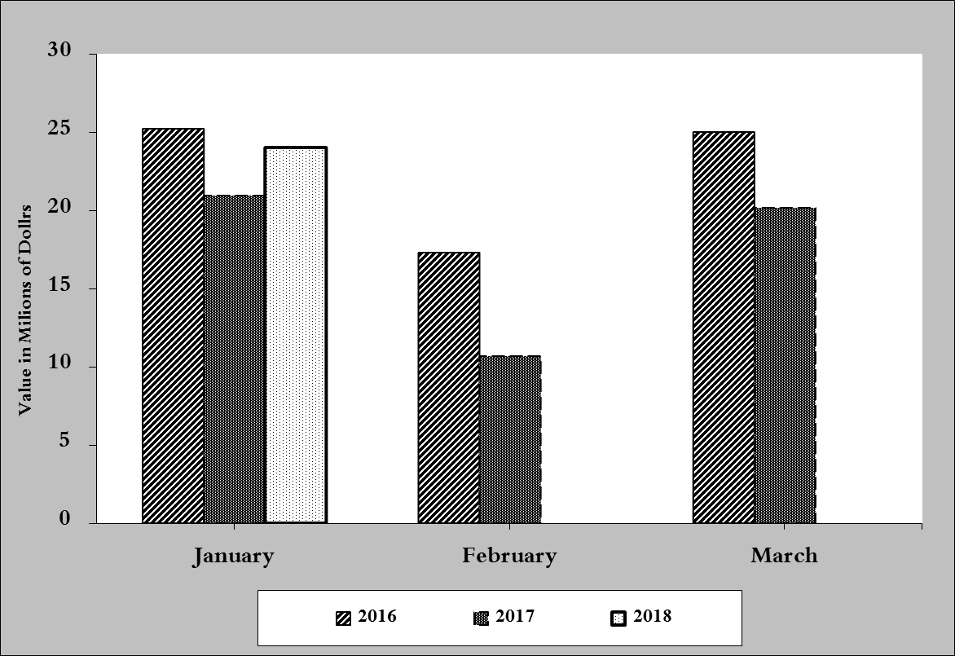
Chart 5: Imports of industrial machinery and equipment during years 2016-2017-2018
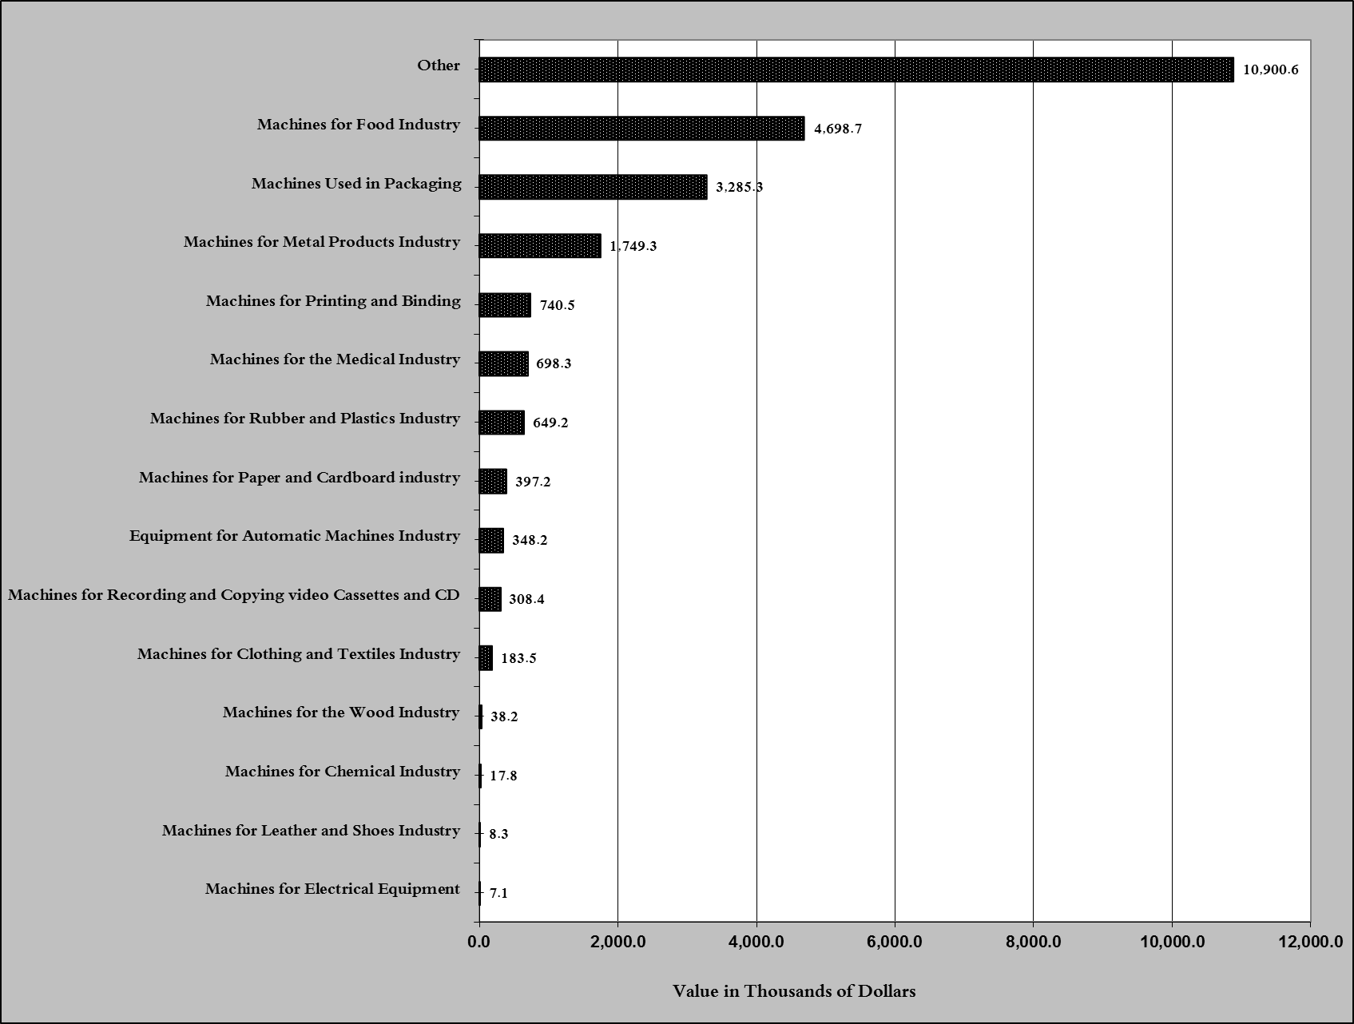
Chart 6: Imports of industrial equipment and machinery according to industrial activity during January 2018

Exports of unworked Diamonds, Silver and Gold Ingots reached this month a value of 105.4 million USD
The machineries and equipment are classified in this table according to the industrial sectors that are used in, while heading "other" includes machineries and equipment that can be used in various sectors.

