

A detailed report on industrial exports
and imports of industrial machinery and equipment in July 2018

Prepared by:
Ministry of Industry
Industrial Information Department

www.industry.gov.lb
Index

I. Introduction 3
II. Industrial exports in July 2018 4
1. Main exported products 4
2. Products with increased exports value 4
2.1. Base metals and articles of base metal 4
2.2. Pearls, precious or semi-precious stones, precious metals and articles thereof (Excluding unworked diamonds, silver and gold Ingots) 4
3. Products with decreased exports value 5
3.1. Products of the chemical industries 5
3.2. Paper and paperboard and articles thereof 5
4. Main export markets 5
4.1. Main export markets by groups of countries 5
4.2. Main export markets by country 6
III. Imports of industrial machinery and equipment 6
1. Imported industrial machinery and equipment by country of origin 6
2. Imported industrial machinery and equipment by country of origin and industrial activity 6
IV. Appendix tables 8
IV. Appendix maps 21
VI. Appendix charts 25

Introduction
The Industrial Information Department of the Ministry of Industry has prepared a detailed report on industrial exports and imports of industrial machinery and equipment for the month of July 2018.
It should be noted that the total value of industrial exports during first seven months of the year 2018 amounted about 1 billion and 464.1 million US dollars compared to 1 billion and 427.6 million US dollars during the same period of the year 2017, and 1 billion and 479.7 million US dollars during the same period of the year 2016. Therefore we notice an increase of 2.6% compared to the year 2017, and a decline of 1.1% compared to the year 2016. (Tables 1 and 11(
It should also be noted that the monthly average of the Lebanese industrial exports during the first seven months of the year 2018 amounted about 209.2 million US dollars compared to 203.9 million US dollars during the year 2017, and 211.4 million US dollars during the year 2016.
On the other hand, the total value of imports of industrial machinery and equipment during the first seven months of the year 2018 amounted about 169.2 million US dollars compared to 137.0 million US dollars during the same period of the year 2017, and 147.0 million US dollars during the same period of the year 2016. Therefore, we notice an increase of 23.5% compared to the year 2017, and an increase of 14.5% compared to the year 2016. (Table 17)

Industrial exports in July 2018
The total value of industrial exports in July 2018 amounted to nearly 198.5 million US dollars, compared to 215.7 million US dollars in July 2017, and 178.8 million US dollars in July 2016, which is equivalent to a decline of 17.2 million US dollars, with the rate of 8.0% compared to year 2017, and an increase of 19.7 million US dollars with the rate of 11.0%, compared to year 2016. (Table 1, and Map 1, and Chart 1)

Main exported products
Exports of machinery and electrical equipment came first in July 2018, with a total value of 36.4 million US dollars; Syria was on top of importers list of this product, with an import value of 5.2 million US dollars. Followed by exports of base metals and articles of base metal, with a total value of 35.9 million US dollars, Turkey was the largest importer of this product, with an import value of 11.9 million US dollars. Then prepared foodstuffs and tobacco, with a total value of 32.9 million US dollars, Saudi Arabia topped the importers list of this product, with an import value of 3.9 million US dollars, followed by products of the chemical industries, with a total value of 24.6 million US dollars. (For more details tables 2, 4, 6, 8, 10, 15, and 16 and Maps 2, 3, and 4)

Products with increased exports value
Statistics showed a significant increase in exports of the following products:

Base metals and articles of base metal
Exports of this product increased from 26.9 million US dollars in July 2017 to 35.9 million US dollars in July 2018 (Table 2 and Chart 2). The exports of this product mainly increased to Turkey and Nigeria which led to an increase in the total value of about 9 million US dollars. (Tables 3 and 4)

Pearls, precious or semi-precious stones, precious metals and articles thereof (Excluding unworked diamonds, silver and gold Ingots)
Exports of this product increased from 7.3 million US dollars in July 2017 to 11.6 million US dollars in July 2018 (Table 2 and Chart 2). The exports of this product mainly decreased to Saudi Arabia whereas it mainly increased to United Arab Emirates and Thailand which led to an increase of the total value of about 4.3 million US dollars. (Tables 5 and 6).

Products with decreased exports value
Statistics showed a significant decrease in exports of the following products:

Products of the chemical industries
Exports of this product decreased from 50.1 million US dollars in July 2017 to 24.6 million US dollars in July 2018 (Table 2 and Chart 2). The exports of this product mainly increased to Iraq whereas it mainly decreased to Bangladesh, Italy, and Spain which led to a fall of the total value of about 25.5 million US dollars. (Tables 7 and 8)

Paper and paperboard and articles thereof
Exports of this product decreased from 18.9 million US dollars in July 2017 to 11.1 million US dollars in July 2018 (Table 2 and Chart 2). The exports of this product mainly decreased to Iraq which led to a fall of the total value of about 7.8 million US dollars. (Tables 9 and 10)

Main export markets

Main export markets by groups of countries
Arab countries were the main market for Lebanese industrial exports in July 2018, with a total export value of 109.5 million US dollars, with a rate of 55.2% of the total export value. European countries were the second largest export markets with a rate of 14.6% of the total export value. Followed by, Non-arab African countries with a rate of 12.1% of the total export value, and, the Non-arab Asian countries with a rate of 12.0% of the total export value. The main products exported to Arab countries are: products of the chemical industries with the total value of 21.6 million US dollars, machinery and electrical equipment with the total value of 21.2 million US dollars, and the prepared foodstuffs and tobacco with the total value of 19.0 million US dollars. (Table 12 and Map 1)

Main export markets by country
Among countries importing Lebanese industrial products, Syria ranked first with a total value of 22.6 million US dollars, with a rate of 11.4% of the total export value. United Arab Emirates came second with a total value of 18.0 million US dollars with a rate of 9.1% of the total export value. Followed by, Iraq with a total value of 15.9 million US dollars with a rate of 8% of the total exports value. (Table 13 and Map 1)
During this month, Lebanese products were exported to 41 European countries, 39 Non-arab African countries, 27 Non-arab Asian countries, 23 American countries, 19 Arab countries, and 5 Oceanic countries. Countries that imported Lebanese goods by over 1 million US dollars are as following: 11 Arab countries, 8 European countries, 8 Non-arab African countries, 6 Non-arab Asian countries, and 2 American countries, and 1 Oceanic country. (Table 14, and Map 1, and Charts 3 and 4)

Imports of industrial machinery and equipment
The total import value of industrial machinery and equipment in July 2018 reached about 18.3 million US dollars compared to 21.8 million US dollars during the same period in 2017, and 16.8 million US dollars during the same period in 2016, a decline by 16.2% compared to year 2017, and an increase of 8.9% compared to year 2016. (Tables 17 and 18 and Chart 5)

Imported industrial machinery and equipment by country of origin
China ranked first on the list of countries exporting industrial machinery and equipment to Lebanon, with a total value amounting to about 4.6 million US dollars, followed by Italy, with a total value of 4.1 million US dollars, and Germany, with a total value of 1.7 million US dollars. (Table 18)

Imported industrial machinery and equipment by country of origin and industrial activity
In July 2018, imports of machines for food industry, ranked first, with a total value of 3.2 million US dollars, and Italy topped the list of countries exporting of this product to Lebanon with exports value of 1.4 million US dollars, followed by machines for rubber and plastics industry, with a total value of 1.6 million US dollars. China was the leading exporter of this product with an export value of 0.7 million US dollars. Followed by machines used in packaging, with a total value of 1.2 million US dollars. (Table 19, Chart 6)

Appendix tables

Table 1: Industrial exports during Years 2016 – 2017 – 2018
Month | Year  2016 | Year  2017 | Year  2018 | Variation in %  2016/2018 | Variation in %  2017/2018
January | 199.5 | 175.9 | 187.0 | -6.3% | 6.3%
February | 222.8 | 196.8 | 203.4 | -8.7% | 3.4%
March | 211.6 | 223.9 | 238.4 | 12.6% | 6.5%
April | 231.1 | 210.4 | 227.8 | -1.4% | 8.3%
May | 210.6 | 205.9 | 222.8 | 5.8% | 8.2%
June | 225.3 | 199.0 | 186.3 | -17.4% | -6.4%
July | 178.8 | 215.7 | 198.5 | 11.0% | -8.0%
August | 232.9 | 227.0
September | 184.3 | 167.6
October | 220.0 | 226.7
November | 193.7 | 205.1
December | 216.3 | 219.6
Total | 2,526.9 | 2,473.5 | 1,464.1
All above figures are in Millions of USD

Table 2: Comparison of industrial exports during July 2018 and July 2017
Section | Goods | July 2017 | July 2018 | Variation 2017/2018 | Variation in % 2017/2018
1 | Animal products | 0.49 | 0.47 | -0.02 | -3.1%
2 | Vegetable products | 3.51 | 4.24 | 0.73 | 20.9%
3 | Fats and edible fats and oils | 2.23 | 4.33 | 2.10 | 94.0%
4 | Prepared foodstuffs and tobacco | 33.95 | 32.92 | -1.03 | -3.0%
5 | Mineral products | 0.47 | 0.94 | 0.47 | 99.0%
6 | Products of the chemical industries | 50.14 | 24.64 | -25.50 | -50.9%
7 | Plastics and rubber and articles thereof | 13.43 | 16.99 | 3.56 | 26.5%
8 | Raw hides and skins, leather, furskins and articles thereof | 0.77 | 0.66 | -0.10 | -13.6%
9 | Wood and articles of wood | 0.72 | 0.50 | -0.22 | -30.9%
10 | Paper and paperboard and articles thereof | 18.90 | 11.14 | -7.76 | -41.1%
11 | Textiles and textile articles | 6.76 | 4.49 | -2.27 | -33.6%
12 | Footwear, headgear, prepared feather | 0.64 | 0.53 | -0.11 | -17.4%
13 | Articles of stone, plaster, cement; glass and glassware | 1.42 | 1.84 | 0.42 | 29.2%
14 | Pearls, precious or semi-precious stones, precious metals and articles thereof (Excluding unworked diamonds, silver and gold Ingots) | 7.32 | 11.59 | 4.27 | 58.3%
15 | Base metals and articles of base metal | 26.95 | 35.90 | 8.96 | 33.2%
16 | Machinery and electrical equipment | 38.50 | 36.43 | -2.06 | -5.4%
17 | Transport equipment | 1.39 | 2.13 | 0.74 | 53.3%
18 | Optical, measuring, medical, and musical instruments; clocks and watches | 1.38 | 0.52 | -0.86 | -62.1%
19 | Arms and ammunition
20 | Miscellaneous manufactured articles | 6.77 | 8.26 | 1.48 | 21.9%
 | Total | 215.74 | 198.52 | -17.22 | -8.0%
All above figures are in Millions of USD
Table 3: Exports of base metals and articles of base metal according to the main importing countries during July 2017
Export destination Country | Turkey | Republic of Korea | Spain | Greece | Belgium | Saudi Arabia | India | Bulgaria
Value in thousands of USD | 9,029 | 3,807 | 2,702 | 1,311 | 888 | 830 | 668 | 613

Table 4: Exports of base metals and articles of base metal according to the main importing countries during July 2018
Export destination Country | Turkey | Republic of Korea | Spain | Greece | Nigeria | Bulgaria | Italy | United Arab Emirates
Value in thousands of USD | 11,872 | 4,002 | 2,853 | 1,899 | 1,823 | 1,078 | 1,071 | 916

Table 5: Exports of pearls, precious or semi-precious stones, precious metals and articles thereof (Excluding unworked diamonds, silver and gold Ingots) according to the main importing countries during July 2017
Export destination Country | United Arab Emirates | Saudi Arabia | Jordan | Belgium | Switzerland | United States Of America | Upper Volta | Thailand
Value in thousands of USD | 4,159 | 1,216 | 652 | 452 | 305 | 205 | 141 | 96

Table 6: Exports of pearls, precious or semi-precious stones, precious metals and articles thereof (Excluding unworked diamonds, silver and gold Ingots) according to the main importing countries during July 2018
Export destination Country | United Arab Emirates | Thailand | Jordan | France | United States Of America | Italy | Switzerland | Saudi Arabia
Value in thousands of USD | 6,785 | 1,631 | 785 | 577 | 568 | 477 | 289 | 237

Table 7: Exports of products of the chemical industries according to the main importing countries during July 2017
Export destination Country | Bangladesh | Iraq | Italy | United Arab Emirates | Saudi Arabia | Spain | Jordan | Syria
Value in thousands of USD | 21,234 | 4,817 | 4,061 | 3,953 | 3,276 | 3,245 | 2,338 | 1,369

Table 8: Exports of products of the chemical industries according to the main importing countries during July 2018
Export destination Country | Iraq | United Arab Emirates | Saudi Arabia | Syria | Jordan | Qatar | Kuwait | Algeria
Value in thousands of USD | 5,766 | 4,134 | 3,764 | 2,016 | 1,875 | 1,510 | 994 | 486

Table 9: Exports of paper and paperboard and articles thereof according to the main importing countries during July 2017
Export destination Country | Iraq | Saudi Arabia | Morocco | Egypt | Syria | Algeria | Ivory Coast | Jordan
Value in thousands of USD | 6,857 | 1,517 | 1,304 | 1,303 | 1,249 | 887 | 828 | 659

Table 10: Exports of paper and paperboard and articles thereof according to the main importing countries during July 2018
Export destination Country | Saudi Arabia | Syria | Qatar | Algeria | Egypt | Libya | Jordan | United Arab Emirates
Value in thousands of USD | 1,365 | 1,096 | 841 | 762 | 706 | 690 | 544 | 538

Table 11: Industrial exports according to exported goods during year 2018

Table 12: Industrial exports according to exported goods and countries groups during July 2018
Goods | Arab Countries | European Countries | Oceanic Countries | Non-Arab Asian countries | American Countries | Non-Arab African countries | Other* | Total
Animal products | 319 |  |  |  | 71 | 80 |  | 471
Vegetable products | 2,149 | 902 | 57 | 238 | 553 | 339 | 0 | 4,239
Fats and edible fats and oils | 1,471 | 915 | 44 | 66 | 1,681 | 152 |  | 4,329
Prepared foodstuffs and tobacco | 18,988 | 6,058 | 805 | 296 | 4,023 | 2,311 | 439 | 32,921
Mineral products | 721 | 30 |  | 15 | 11 | 59 | 100 | 936
Products of the chemical industries | 21,558 | 1,202 | 76 | 229 | 387 | 831 | 355 | 24,637
Plastics and rubber and articles thereof | 12,214 | 1,599 | 20 | 949 | 306 | 1,794 | 110 | 16,992
Raw hides and skins, leather, furskins and articles thereof | 346 | 112 |  | 102 | 0 | 94 | 9 | 664
Wood and articles of wood | 201 | 7 |  | 0 | 57 | 233 |  | 498
Paper and paperboard and articles thereof | 7,712 | 780 | 5 | 240 | 165 | 2,217 | 24 | 11,143
Textiles and textile articles | 1,884 | 1,959 | 42 | 51 | 109 | 310 | 133 | 4,488
Footwear, headgear, prepared feather | 384 | 80 |  | 11 | 0 | 54 |  | 529
Articles of stone, plaster, cement; glass and glassware | 1,217 | 176 | 87 | 3 | 36 | 322 |  | 1,841
Pearls, precious or semi-precious stones, precious metals and articles thereof (Excluding unworked diamonds, silver and gold Ingots) | 7,836 | 1,403 |  | 1,778 | 568 | 2 |  | 11,587
Base metals and articles of base metal | 3,960 | 8,755 | 45 | 18,360 | 51 | 4,627 | 105 | 35,903
Machinery and electrical equipment | 21,158 | 3,611 | 131 | 1,389 | 467 | 8,796 | 883 | 36,433
Transport equipment | 1,052 | 851 | 11 | 5 | 56 | 151 |  | 2,127
Optical, measuring, medical, and musical instruments; clocks and watches | 274 | 147 | 0 |  | 49 | 53 |  | 524
Arms and ammunition
Miscellaneous manufactured articles | 6,059 | 399 | 25 | 115 | 159 | 1,502 |  | 8,258
Total | 109,503 | 28,988 | 1,347 | 23,847 | 8,750 | 23,927 | 2,158 | 198,521
All the above figures are in thousands of US dollars.
* "other" Includes exported goods to the duty free market and those that are supplied to ships and aircraft.
Table 13: Distribution of the industrial exports according to the main importing countries during July 2018
Export destination Country | Syria | United Arab Emirates | Iraq | Saudi Arabia | Turkey | Qatar | Jordan | Kuwait
Value in thousands of USD | 22,554 | 17,974 | 15,868 | 15,511 | 13,052 | 9,690 | 5,858 | 5,563

Export destination Country | Egypt | France | United States Of America | Republic of Korea | Spain | Germany | Libya | Algeria
Value in thousands of USD | 5,016 | 4,816 | 4,792 | 4,002 | 3,703 | 3,618 | 3,450 | 3,277

Export destination Country | Ivory Coast | Nigeria | Ghana | Italy | Congo | United Kingdom | Canada | Greece
Value in thousands of USD | 3,268 | 3,230 | 3,207 | 2,767 | 2,553 | 2,526 | 2,379 | 2,152

Table 14: Distribution of importing countries according to countries groups and the value of exports during July 2018
Exports Value  (in million USD) | Arab Countries | European Countries | Oceania Countries | Non-Arab Asian countries | American Countries | Non-Arab African countries | Total
]0-1[ | 8 | 33 | 4 | 21 | 21 | 31 | 118
[1-5[ | 3 | 8 | 1 | 5 | 2 | 8 | 27
[5-10[ | 4 |  |  |  |  |  | 4
[10-15[ |  |  |  | 1 |  |  | 1
More than 15 million USD | 4 |  |  |  |  |  | 4
Total | 19 | 41 | 5 | 27 | 23 | 39 | 154

Table 15: Distribution of the industrial exports according to product and to the main importing countries during July 2018

Animal products | Iraq | Qatar | United States Of America | Jordan | United Arab Emirates | Ivory Coast | Kuwait | Zambia
Value in 1000 of USD | 95 | 90 | 62 | 60 | 51 | 33 | 18 | 15

Vegetable products | United Arab Emirates | Saudi Arabia | Netherlands | United States Of America | Germany | Turkey | Syria | Algeria
Value in 1000 of USD | 550 | 475 | 376 | 344 | 242 | 230 | 211 | 205

Fats and edible fats and oils | United States Of America | Canada | Syria | Netherlands | Kuwait | United Kingdom | United Arab Emirates | Iraq
Value in 1000 of USD | 975 | 635 | 340 | 335 | 292 | 234 | 224 | 215

Prepared foodstuffs and tobacco | Saudi Arabia | Syria | Iraq | Qatar | United States Of America | United Arab Emirates | France | Germany
Value in 1000 of USD | 3,946 | 3,859 | 3,044 | 2,122 | 2,071 | 1,667 | 1,446 | 1,248

Mineral products | Syria | Other | United Kingdom | Togo | Angola | Chile | Turkey | Kuwait
Value in 1000 of USD | 713 | 95 | 29 | 26 | 12 | 11 | 9 | 8

Plastics and rubber and articles thereof | Syria | Saudi Arabia | Iraq | Qatar | Spain | Egypt | Jordan | Ivory Coast
Value in 1000 of USD | 7,666 | 1,302 | 978 | 655 | 525 | 400 | 332 | 330

Raw hides and skins, leather, furskins and articles thereof | United Arab Emirates | Qatar | Turkey | Nigeria | Syria | Portugal | Spain | Kuwait
Value in 1000 of USD | 179 | 84 | 81 | 77 | 44 | 42 | 28 | 20

Wood and articles of wood | Ivory Coast | Saudi Arabia | United States Of America | Algeria | Nigeria | United Arab Emirates | Zambia | Togo
Value in 1000 of USD | 128 | 75 | 57 | 47 | 43 | 42 | 38 | 14

Textiles and textile articles | Italy | Syria | Germany | France | Kuwait | United Arab Emirates | Egypt | Jordan
Value in 1000 of USD | 687 | 466 | 465 | 406 | 382 | 264 | 255 | 222

Table 15: (continued) Distribution of the industrial exports according to product and the main importing countries during July 2018
Footwear, headgear, prepared feather | Saudi Arabia | United Arab Emirates | Switzerland | United Kingdom | Senegal | Kuwait | Egypt | Congo
Value in 1000 of USD | 244 | 73 | 52 | 23 | 20 | 20 | 17 | 15

Articles of stone, plaster, cement; glass and glassware | Kuwait | Qatar | Congo | Belgium | Algeria | Syria | United Arab Emirates | Australia
Value in 1000 of USD | 453 | 319 | 136 | 136 | 126 | 123 | 115 | 87

Machinery and electrical equipment | Syria | Iraq | Egypt | Ghana | Libya | United Arab Emirates | France | Qatar
Value in 1000 of USD | 5,235 | 4,283 | 2,654 | 2,331 | 2,082 | 1,589 | 1,491 | 1,399

Transport equipment | Azerbaijan | Libya | Iraq | Egypt | Syria | France | Belgium | United Arab Emirates
Value in 1000 of USD | 490 | 318 | 257 | 207 | 119 | 75 | 68 | 67

Optical, measuring, medical, and musical instruments; clocks and watches | Bahrain | Syria | United Arab Emirates | United States Of America | Italy | Upper Volta | Spain | Germany
Value in 1000 of USD | 108 | 90 | 66 | 49 | 47 | 46 | 36 | 30

Miscellaneous manufactured articles | Saudi Arabia | Qatar | Algeria | United Arab Emirates | Iraq | Ivory Coast | Angola | Congo
Value in 1000 of USD | 2,032 | 1,589 | 985 | 509 | 467 | 419 | 270 | 200

Table 16: Distribution of industrial exports, according to the main exported goods and main importing countries during July 2018

Table 17: Imports of industrial machinery and equipment during years 2016-2017-2018
Month | Year  2016 | Year  2017 | Year  2018 | Variation in %  2016/2018 | Variation in %  2017/2018
January | 25.3 | 21.0 | 24.0 | -4.9% | 14.7%
February | 17.3 | 10.7 | 18.8 | 8.3% | 75.6%
March | 25.1 | 20.2 | 28.2 | 12.4% | 39.5%
April | 22.8 | 18.0 | 31.1 | 36.4% | 72.5%
May | 20.5 | 23.1 | 25.2 | 22.6% | 9.1%
June | 20.0 | 22.2 | 23.7 | 18.3% | 6.7%
July | 16.8 | 21.8 | 18.3 | 8.9% | -16.2%
August | 19.0 | 27.0
September | 16.2 | 30.1
October | 14.5 | 22.4
November | 20.0 | 17.6
December | 17.9 | 23.2
Total | 235.5 | 257.4 | 169.2
All above figures are in Millions of USD

Table 18: Imports of industrial equipment and machinery according to exporting country for the year 2018
Table 19: Imports of industrial equipment and machinery according to industrial activity and country during July 2018

Appendix maps
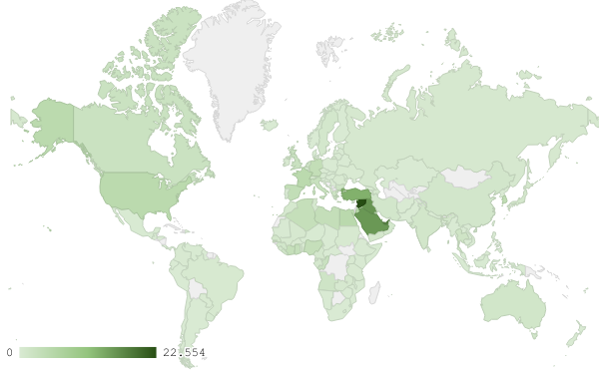
Map 1: Distribution of industrial exports during July 2018

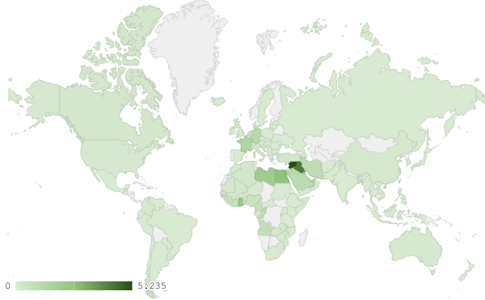
Map 2: Exports of machinery and electrical equipment during July 2018

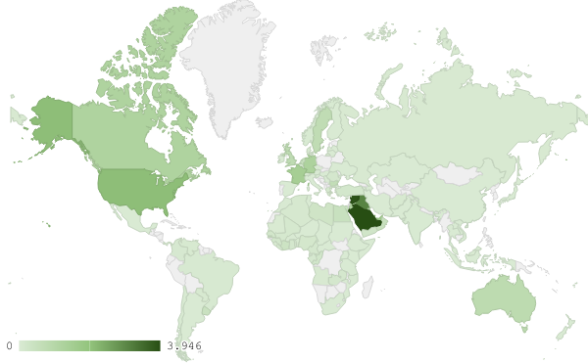
Map 3: Exports of prepared foodstuffs and tobacco during July 2018
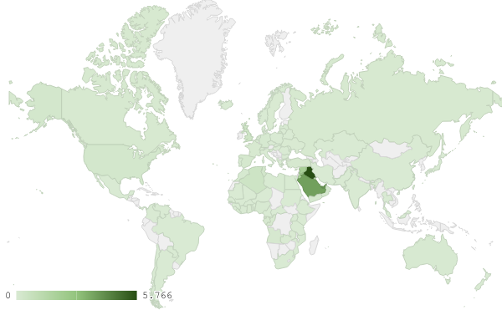
Map 4: Exports of products of the chemical industries during July 2018

Appendix charts
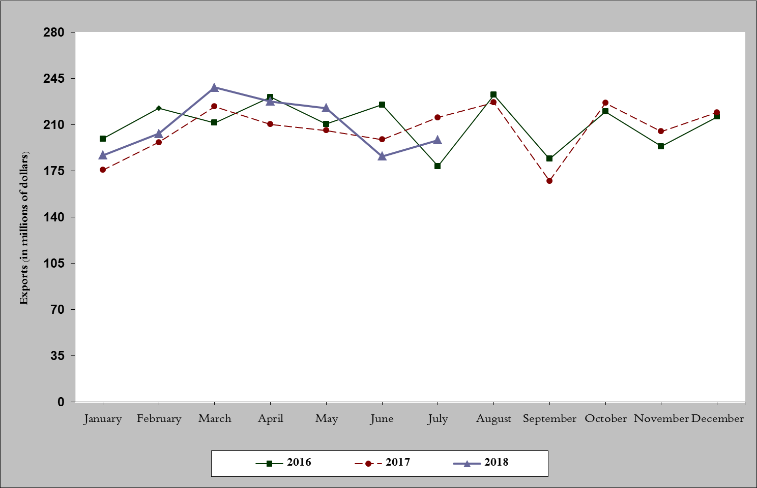
Chart 1: Industrial exports during years 2016-2017-2018
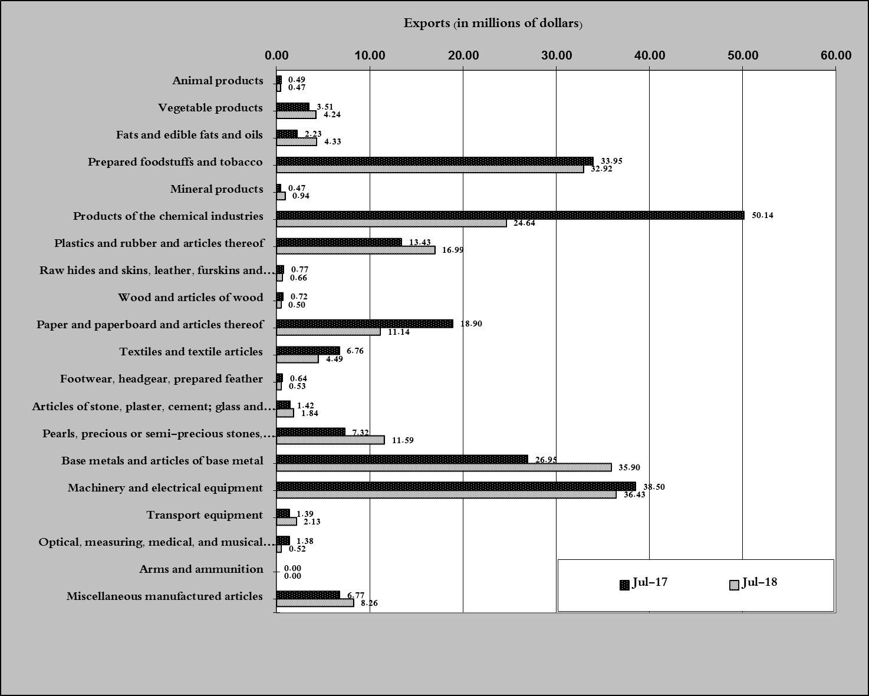
Chart 2: Comparison of industrial exports during July 2018 and July 2017
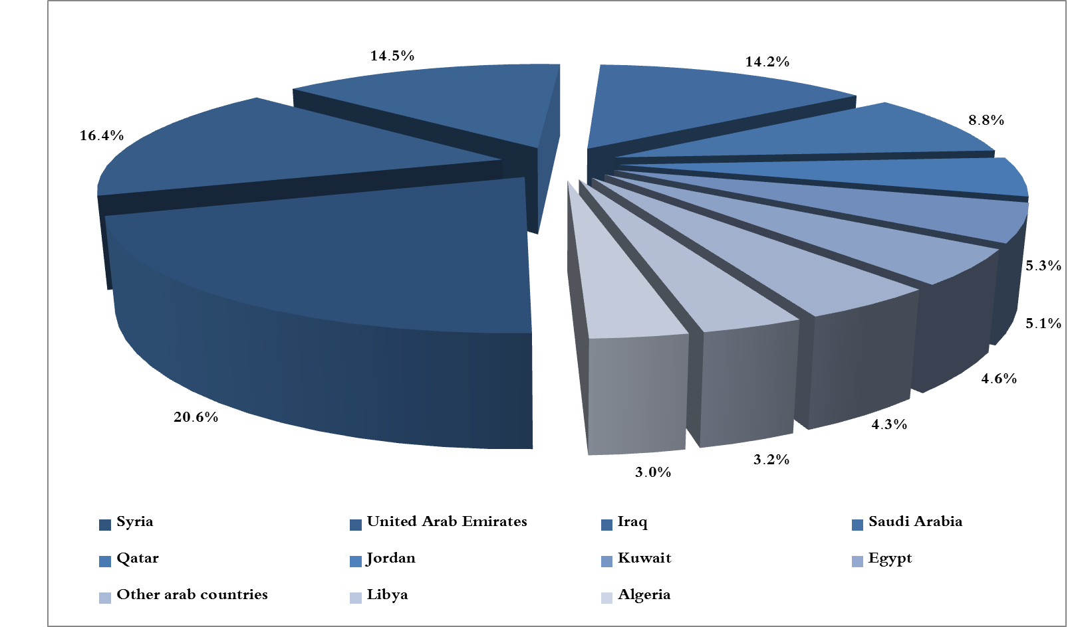
Chart 3: Distribution of industrial exports to Arab countries during July 2018

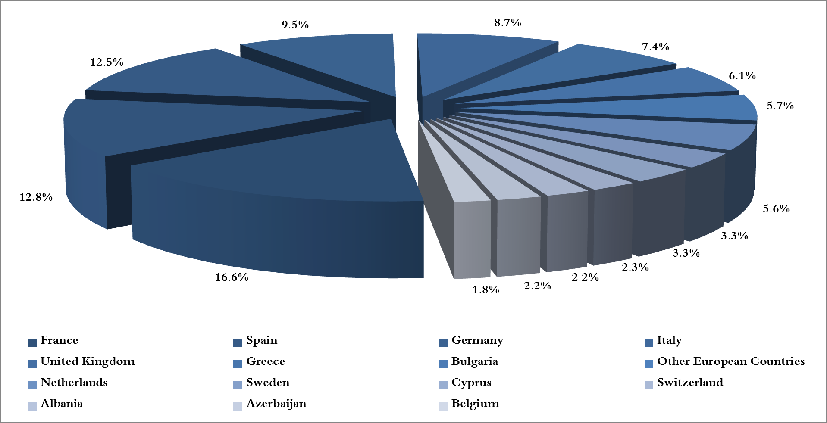
Chart 4: Distribution of industrial exports to European countries during July 2018

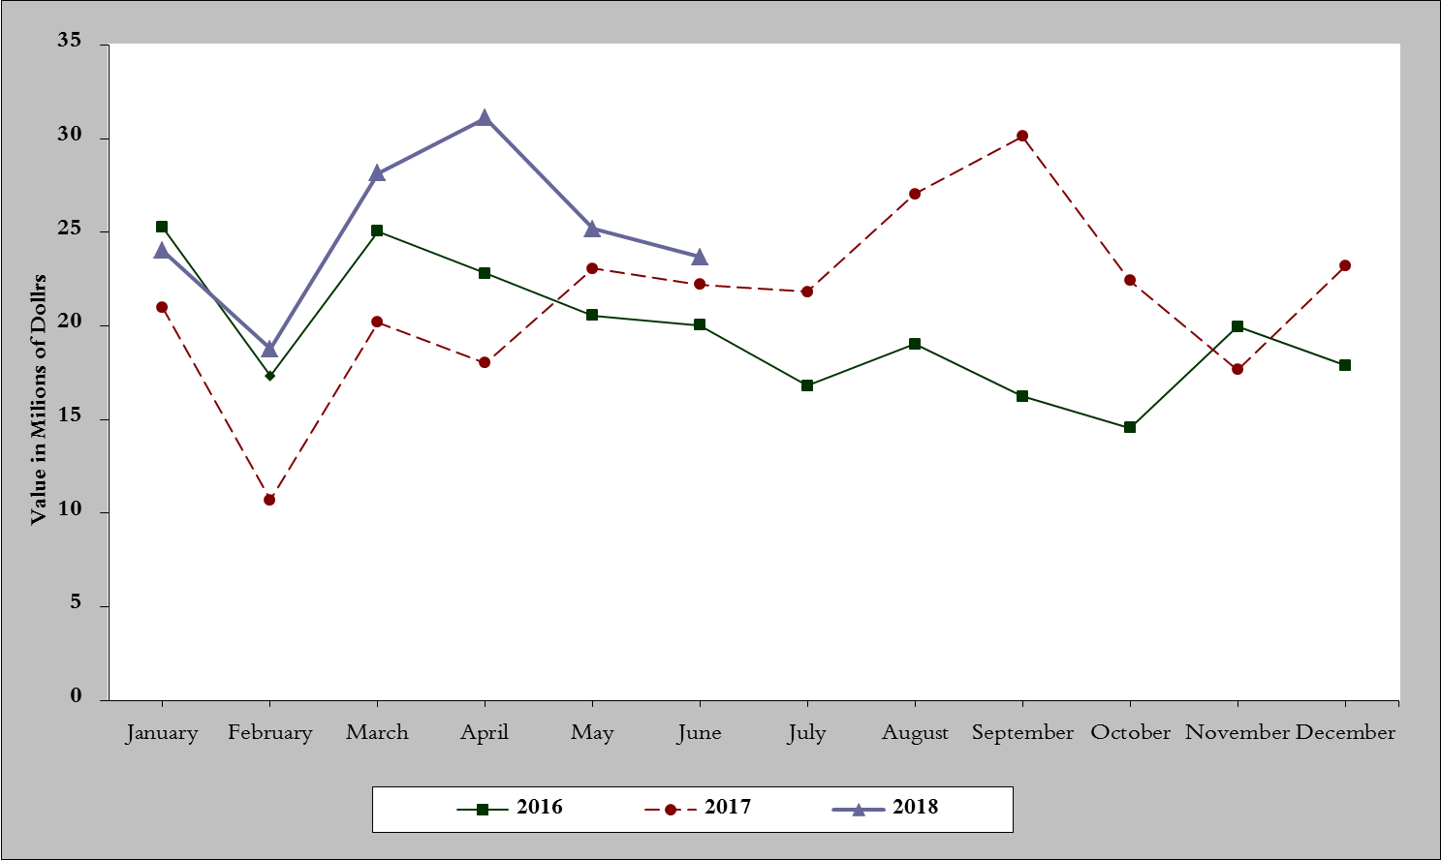
Chart 5: Imports of industrial machinery and equipment during years 2016-2017-2018

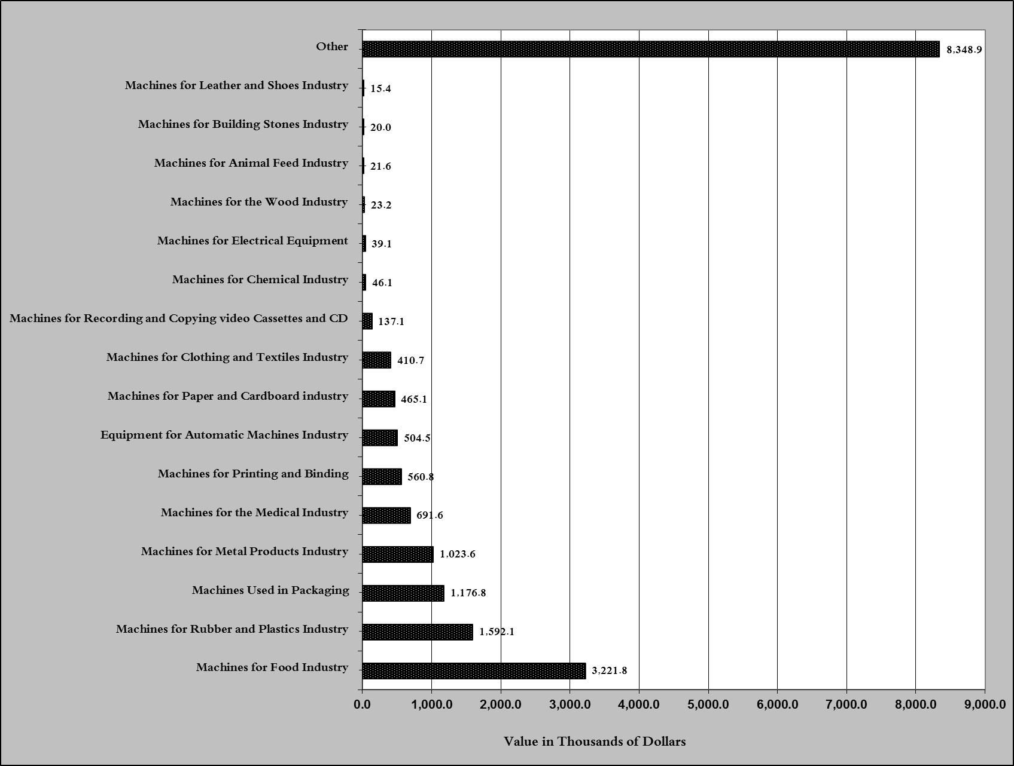
Chart 6: Imports of industrial equipment and machinery according to industrial activity during July 2018

Exports of unworked Diamonds, Silver and Gold Ingots reached this month a value of 21.3 million USD
The machineries and equipment are classified in this table according to the industrial sectors that are used in, while heading "other" includes machineries and equipment that can be used in various sectors.

