

A detailed report on industrial exports
and imports of industrial machinery and equipment in June 2018

Prepared by:
Ministry of Industry
Industrial Information Department

www.industry.gov.lb
Index

I. Introduction 3
II. Industrial exports in June 2018 4
1. Main exported products 4
2. Products with increased exports value 4
2.1. Base metals and articles of base metal 4
2.2. Pearls, precious or semi-precious stones, precious metals and articles thereof (Excluding unworked diamonds, silver and gold Ingots) 4
3. Products with decreased exports value 5
3.1. Machinery and electrical equipment 5
3.2. Prepared foodstuffs and tobacco 5
4. Main export markets 5
4.1. Main export markets by groups of countries 5
4.2. Main export markets by country 6
III. Imports of industrial machinery and equipment 6
1. Imported industrial machinery and equipment by country of origin 6
2. Imported industrial machinery and equipment by country of origin and industrial activity 6
IV. Appendix tables 8
IV. Appendix maps 21
VI. Appendix charts 25

Introduction
The Industrial Information Department of the Ministry of Industry has prepared a detailed report on industrial exports and imports of industrial machinery and equipment for the month of June 2018.
It should be noted that the total value of industrial exports during first six months of the year 2018 amounted about 1 billion and 265.5 million US dollars compared to 1 billion and 211.8 million US dollars during the same period of the year 2017, and 1 billion and 300.9 million US dollars during the same period of the year 2016. Therefore we notice an increase of 4.4% compared to the year 2017, and a decline of 2.7% compared to the year 2016. (Tables 1 and 11(
It should also be noted that the monthly average of the Lebanese industrial exports during the first six months of the year 2018 amounted about 210.9 million US dollars compared to 202.0 million US dollars during the year 2017, and 216.8 million US dollars during the year 2016.
On the other hand, the total value of imports of industrial machinery and equipment during the first six months of the year 2018 amounted about 150.9 million US dollars compared to 115.2 million US dollars during the same period of the year 2017, and 131.0 million US dollars during the same period of the year 2016. Therefore, we notice an increase of 31.1% compared to the year 2017, and an increase of 15.2% compared to the year 2016. (Table 17)

Industrial exports in June 2018
The total value of industrial exports in June 2018 amounted to nearly 186.3 million US dollars, compared to 199.0 million US dollars in June 2017, and 225.3 million US dollars in June 2016, which is equivalent to a decrease of 12.8 million US dollars, with the rate of 6.4% compared to year 2017, and a decrease of 39.1 million US dollars with the rate of 17.4%, compared to year 2016. (Table 1, and Map 1, and Chart 1)

Main exported products
Exports of base metals and articles of base metal came first in June 2018, with a total value of 31.8 million US dollars; Turkey was on top of importers list of this product, with an import value of 6.2 million US dollars. Followed by exports of machinery and electrical equipment, with a total value of 30.0 million US dollars, Egypt was the largest importer of this product, with an import value of 2.9 million US dollars. Then products of the chemical industries, with a total value of 28.0 million US dollars, United Arab Emirates topped the importers list of this product, with an import value of 5.0 million US dollars, followed by prepared foodstuffs and tobacco, with a total value of 27.3 million US dollars. (For more details tables 2, 4, 6, 8, 10, 15, and 16 and Maps 2, 3, and 4)

Products with increased exports value
Statistics showed a significant increase in exports of the following products:

Base metals and articles of base metal
Exports of this product increased from 25.1 million US dollars in June 2017 to 31.8 million US dollars in June 2018 (Table 2 and Chart 2). The exports of this product mainly increased to Spain, Greece, and Nigeria which led to an increase in the total value of about 6.7 million US dollars. (Tables 3 and 4)

Pearls, precious or semi-precious stones, precious metals and articles thereof (Excluding unworked diamonds, silver and gold Ingots)
Exports of this product increased from 12.2 million US dollars in June 2017 to 18.8 million US dollars in June 2018 (Table 2 and Chart 2). The exports of this product mainly decreased to Saudi Arabia whereas it mainly increased to United Arab Emirates and Switzerland which led to an increase of the total value of about 6.6 million US dollars. (Tables 5 and 6).

Products with decreased exports value
Statistics showed a significant decrease in exports of the following products:

Machinery and electrical equipment
Exports of this product decreased from 48.8 million US dollars in June 2017 to 30.0 million US dollars in June 2018 (Table 2 and Chart 2). The exports of this product mainly increased to Egypt whereas it mainly decreased to Iraq, Libya, Saudi Arabia, United Arab Emirates, and Kuwait which led to a fall of the total value of about 18.8 million US dollars. (Tables 7 and 8)

Prepared foodstuffs and tobacco
Exports of this product decreased from 38.0 million US dollars in June 2017 to 27.3 million US dollars in June 2018 (Table 2 and Chart 2). The exports of this product mainly decreased to Syria which led to a fall of the total value of about 10.8 million US dollars. (Tables 9 and 10)

Main export markets

Main export markets by groups of countries
Arab countries were the main market for Lebanese industrial exports in June 2018, with a total export value of 98.0 million US dollars, with a rate of 52.6% of the total export value. European countries were the second largest export markets with a rate of 19.9% of the total export value. Followed by, Non-arab African countries with a rate of 13.3% of the total export value, and, the Non-arab Asian countries with a rate of 9.9% of the total export value. The main products exported to Arab countries are: products of the chemical industries with the total value of 17.2 million US dollars, prepared foodstuffs and tobacco with the total value of 16.7 million US dollars, and the machinery and electrical equipment with the total value of 15.9 million US dollars. (Table 12 and Map 1)

Main export markets by country
Among countries importing Lebanese industrial products, United Arab Emirates ranked first with a total value of 25.5 million US dollars, with a rate of 13.7% of the total export value. Saudi Arabia came second with a total value of 13.81 million US dollars with a rate of 7.4% of the total export value. Followed by, Syria with a total value of 13.80 million US dollars with a rate of 7.4% of the total exports value. (Table 13 and Map 1)
During this month, Lebanese products were exported to 41 European countries, 38 Non-arab African countries, 25 Non-arab Asian countries, 21 American countries, 19 Arab countries, and 5 Oceanic countries. Countries that imported Lebanese goods by over 1 million US dollars are as following: 12 Arab countries, 11 European countries, 7 Non-arab African countries, 2 Non-arab Asian countries, and 3 American countries. (Table 14, and Map 1, and Charts 3 and 4)

Imports of industrial machinery and equipment
The total import value of industrial machinery and equipment in June 2018 reached about 23.7 million US dollars compared to 22.2 million US dollars during the same period in 2017, and 20.0 million US dollars during the same period in 2016, an increase by 6.7% compared to year 2017, and an increase of 18.3% compared to year 2016. (Tables 17 and 18 and Chart 5)

Imported industrial machinery and equipment by country of origin
Germany ranked first on the list of countries exporting industrial machinery and equipment to Lebanon, with a total value amounting to about 9.4 million US dollars, followed by Italy, with a total value of 5.2 million US dollars, and China, with a total value of 2.8 million US dollars. (Table 18)

Imported industrial machinery and equipment by country of origin and industrial activity
In June 2018, imports of machines used in packaging, ranked first, with a total value of 6.2 million US dollars, and Germany topped the list of countries exporting of this product to Lebanon with exports value of 4.5 million US dollars, followed by machines for food industry, with a total value of 2.6 million US dollars. Italy was the leading exporter of this product with an export value of 0.9 million US dollars. Followed by machines for paper and cardboard industry, with a total value of 1.6 million US dollars. (Table 19, Chart 6)

Appendix tables

Table 1: Industrial exports during Years 2016 – 2017 – 2018
Month | Year  2016 | Year  2017 | Year  2018 | Variation in %  2016/2018 | Variation in %  2017/2018
January | 199.5 | 175.9 | 187.0 | -6.3% | 6.3%
February | 222.8 | 196.8 | 203.4 | -8.7% | 3.4%
March | 211.6 | 223.9 | 238.4 | 12.6% | 6.5%
April | 231.1 | 210.4 | 227.8 | -1.4% | 8.3%
May | 210.6 | 205.9 | 222.8 | 5.8% | 8.2%
June | 225.3 | 199.0 | 186.3 | -17.4% | -6.4%
July | 178.8 | 215.7
August | 232.9 | 227.0
September | 184.3 | 167.6
October | 220.0 | 226.7
November | 193.7 | 205.1
December | 216.3 | 219.6
Total | 2,526.9 | 2,473.5 | 1,265.6
All above figures are in Millions of USD

Table 2: Comparison of industrial exports during June 2018 and June 2017
Section | Goods | June 2017 | June 2018 | Variation 2017/2018 | Variation in % 2017/2018
1 | Animal products | 0.43 | 0.47 | 0.03 | 7.9%
2 | Vegetable products | 3.43 | 3.82 | 0.38 | 11.2%
3 | Fats and edible fats and oils | 2.44 | 3.17 | 0.73 | 30.1%
4 | Prepared foodstuffs and tobacco | 38.04 | 27.27 | -10.77 | -28.3%
5 | Mineral products | 0.68 | 0.92 | 0.25 | 37.0%
6 | Products of the chemical industries | 25.85 | 28.03 | 2.18 | 8.4%
7 | Plastics and rubber and articles thereof | 10.80 | 14.10 | 3.31 | 30.6%
8 | Raw hides and skins, leather, furskins and articles thereof | 0.81 | 0.93 | 0.12 | 14.9%
9 | Wood and articles of wood | 0.80 | 0.65 | -0.15 | -18.8%
10 | Paper and paperboard and articles thereof | 12.15 | 10.13 | -2.02 | -16.6%
11 | Textiles and textile articles | 4.87 | 3.36 | -1.51 | -31.0%
12 | Footwear, headgear, prepared feather | 0.76 | 0.50 | -0.26 | -34.3%
13 | Articles of stone, plaster, cement; glass and glassware | 1.67 | 1.24 | -0.43 | -25.8%
14 | Pearls, precious or semi-precious stones, precious metals and articles thereof (Excluding unworked diamonds, silver and gold Ingots) | 12.19 | 18.80 | 6.61 | 54.2%
15 | Base metals and articles of base metal | 25.09 | 31.79 | 6.70 | 26.7%
16 | Machinery and electrical equipment | 48.82 | 29.98 | -18.83 | -38.6%
17 | Transport equipment | 2.25 | 2.57 | 0.32 | 14.1%
18 | Optical, measuring, medical, and musical instruments; clocks and watches | 1.07 | 1.99 | 0.92 | 86.2%
19 | Arms and ammunition | 0.07 | 0.00 | -0.06 | -93.9%
20 | Miscellaneous manufactured articles | 6.81 | 6.52 | -0.29 | -4.3%
 | Total | 199.03 | 186.25 | -12.78 | -6.4%
All above figures are in Millions of USD
Table 3: Exports of base metals and articles of base metal according to the main importing countries during June 2017
Export destination Country | Turkey | Republic of Korea | Greece | Japan | Italy | Algeria | China | Spain
Value in thousands of USD | 6,593 | 5,123 | 1,210 | 1,108 | 1,060 | 830 | 776 | 616

Table 4: Exports of base metals and articles of base metal according to the main importing countries during June 2018
Export destination Country | Turkey | Republic of Korea | Spain | Greece | Nigeria | Belgium | Italy | Congo
Value in thousands of USD | 6,213 | 4,625 | 4,243 | 3,039 | 1,621 | 1,039 | 874 | 790

Table 5: Exports of pearls, precious or semi-precious stones, precious metals and articles thereof (Excluding unworked diamonds, silver and gold Ingots) according to the main importing countries during June 2017
Export destination Country | United Arab Emirates | Saudi Arabia | United States Of America | Thailand | Switzerland | Germany | Hong Kong | Upper Volta
Value in thousands of USD | 8,214 | 1,544 | 1,200 | 332 | 239 | 167 | 106 | 104

Table 6: Exports of pearls, precious or semi-precious stones, precious metals and articles thereof (Excluding unworked diamonds, silver and gold Ingots) according to the main importing countries during June 2018
Export destination Country | United Arab Emirates | Switzerland | Italy | Hong Kong | Turkey | United States Of America | Saudi Arabia | Kuwait
Value in thousands of USD | 14,070 | 1,655 | 656 | 497 | 391 | 367 | 265 | 199

Table 7: Exports of machinery and electrical equipment according to the main importing countries during June 2017
Export destination Country | Iraq | Libya | Saudi Arabia | United Arab Emirates | Kuwait | Syria | Senegal | Sudan
Value in thousands of USD | 9,256 | 6,880 | 4,620 | 3,940 | 3,146 | 2,461 | 2,351 | 1,565

Table 8: Exports of machinery and electrical equipment according to the main importing countries during June 2018
Export destination Country | Egypt | Iraq | Syria | Congo | Kuwait | France | Algeria | Ghana
Value in thousands of USD | 2,901 | 2,658 | 2,302 | 2,054 | 1,808 | 1,685 | 1,462 | 1,366

Table 9: Exports of prepared foodstuffs and tobacco according to the main importing countries during June 2017
Export destination Country | Syria | Saudi Arabia | Iraq | United States Of America | Qatar | United Arab Emirates | Jordan | United Kingdom
Value in thousands of USD | 10,129 | 5,381 | 2,680 | 2,408 | 2,022 | 1,752 | 1,240 | 1,228

Table 10: Exports of prepared foodstuffs and tobacco according to the main importing countries during June 2018
Export destination Country | Saudi Arabia | Qatar | Syria | United Arab Emirates | Iraq | United States Of America | Kuwait | United Kingdom
Value in thousands of USD | 5,204 | 2,628 | 2,385 | 1,816 | 1,741 | 1,593 | 1,128 | 1,073

Table 11: Industrial exports according to exported goods during year 2018

Table 12: Industrial exports according to exported goods and countries groups during June 2018
Goods | Arab Countries | European Countries | Oceanic Countries | Non-Arab Asian countries | American Countries | Non-Arab African countries | Other* | Total
Animal products | 426 | 5 |  |  | 6 | 31 | 1 | 468
Vegetable products | 1,462 | 1,105 | 148 | 260 | 333 | 510 | 1 | 3,818
Fats and edible fats and oils | 868 | 871 | 83 | 35 | 1,221 | 96 |  | 3,173
Prepared foodstuffs and tobacco | 16,733 | 4,975 | 461 | 223 | 2,544 | 1,974 | 359 | 27,268
Mineral products | 478 | 272 |  | 73 |  | 54 | 48 | 925
Products of the chemical industries | 17,244 | 6,154 | 83 | 2,702 | 393 | 1,258 | 197 | 28,032
Plastics and rubber and articles thereof | 9,930 | 1,737 | 1 | 298 | 27 | 1,961 | 148 | 14,101
Raw hides and skins, leather, furskins and articles thereof | 477 | 340 |  | 41 | 0 | 74 | 1 | 933
Wood and articles of wood | 479 | 13 |  |  | 1 | 158 | 1 | 652
Paper and paperboard and articles thereof | 6,976 | 864 | 4 | 479 | 5 | 1,794 | 5 | 10,127
Textiles and textile articles | 1,880 | 767 | 32 | 132 | 111 | 269 | 172 | 3,362
Footwear, headgear, prepared feather | 361 | 32 | 2 |  |  | 58 | 45 | 497
Articles of stone, plaster, cement; glass and glassware | 483 | 124 | 0 | 6 | 91 | 536 |  | 1,240
Pearls, precious or semi-precious stones, precious metals and articles thereof (Excluding unworked diamonds, silver and gold Ingots) | 14,661 | 2,655 | 0 | 988 | 367 | 133 |  | 18,804
Base metals and articles of base metal | 4,038 | 11,237 | 57 | 12,367 | 115 | 3,927 | 46 | 31,789
Machinery and electrical equipment | 15,864 | 3,579 | 71 | 433 | 149 | 9,674 | 212 | 29,982
Transport equipment | 1,170 | 1,131 | 1 | 64 | 26 | 173 | 2 | 2,567
Optical, measuring, medical, and musical instruments; clocks and watches | 599 | 827 |  | 220 | 210 | 130 |  | 1,987
Arms and ammunition | 4 |  |  |  |  |  |  | 4
Miscellaneous manufactured articles | 3,856 | 415 | 0 | 103 | 192 | 1,947 | 7 | 6,520
Total | 97,990 | 37,103 | 942 | 18,425 | 5,790 | 24,756 | 1,245 | 186,251
All the above figures are in thousands of US dollars.
* "other" Includes exported goods to the duty free market and those that are supplied to ships and aircraft.
Table 13: Distribution of the industrial exports according to the main importing countries during June 2018
Export destination Country | United Arab Emirates | Saudi Arabia | Syria | Turkey | Qatar | Iraq | Spain | Jordan
Value in thousands of USD | 25,535 | 13,808 | 13,803 | 10,001 | 9,226 | 9,029 | 8,425 | 6,161

Export destination Country | Kuwait | Egypt | Republic of Korea | France | United States Of America | Congo | Greece | Italy
Value in thousands of USD | 5,362 | 5,059 | 4,625 | 4,613 | 4,044 | 4,007 | 3,733 | 3,713

Export destination Country | Ivory Coast | Algeria | Netherlands | United Kingdom | Nigeria | Ghana | Switzerland | Morocco
Value in thousands of USD | 3,658 | 3,243 | 3,034 | 2,879 | 2,814 | 2,277 | 1,955 | 1,852

Table 14: Distribution of importing countries according to countries groups and the value of exports during June 2018
Exports Value  (in million USD) | Arab Countries | European Countries | Oceania Countries | Non-Arab Asian countries | American Countries | Non-Arab African countries | Total
]0-1[ | 7 | 30 | 5 | 23 | 19 | 31 | 115
[1-5[ | 4 | 10 |  | 1 | 2 | 7 | 24
[5-10[ | 5 | 1 |  |  |  |  | 6
[10-15[ | 2 |  |  | 1 |  |  | 3
More than 15 million USD | 1 |  |  |  |  |  | 1
Total | 19 | 41 | 5 | 25 | 21 | 38 | 149

Table 15: Distribution of the industrial exports according to product and to the main importing countries during June 2018

Animal products | Iraq | Qatar | Saudi Arabia | Liberia | Kuwait | United Arab Emirates | Congo | United States Of America
Value in 1000 of USD | 209 | 144 | 52 | 11 | 9 | 9 | 8 | 6

Vegetable products | Netherlands | Qatar | Jordan | United States Of America | United Arab Emirates | Turkey | Sweden | Nigeria
Value in 1000 of USD | 415 | 376 | 327 | 290 | 238 | 224 | 209 | 175

Fats and edible fats and oils | United States Of America | Netherlands | Canada | Kuwait | Iraq | United Kingdom | United Arab Emirates | France
Value in 1000 of USD | 916 | 446 | 272 | 268 | 227 | 159 | 109 | 96

Mineral products | Syria | Cyprus | Egypt | China | Other | Qatar | Congo | Kuwait
Value in 1000 of USD | 350 | 272 | 83 | 73 | 39 | 35 | 29 | 10

Products of the chemical industries | United Arab Emirates | Spain | Saudi Arabia | Turkey | Iraq | Jordan | Syria | Italy
Value in 1000 of USD | 5,041 | 3,560 | 3,374 | 2,576 | 2,519 | 1,870 | 1,309 | 1,259

Plastics and rubber and articles thereof | Syria | Saudi Arabia | Qatar | Jordan | Egypt | Spain | Iraq | Ghana
Value in 1000 of USD | 5,036 | 1,071 | 899 | 667 | 595 | 584 | 392 | 357

Raw hides and skins, leather, furskins and articles thereof | United Arab Emirates | Germany | Egypt | Portugal | Estonia | Nigeria | Turkey | Syria
Value in 1000 of USD | 262 | 179 | 135 | 77 | 58 | 56 | 41 | 32

Wood and articles of wood | Qatar | United Arab Emirates | Ivory Coast | Jordan | Saudi Arabia | Guinea | Oman | Ghana
Value in 1000 of USD | 187 | 179 | 86 | 48 | 37 | 26 | 20 | 18

Paper and paperboard and articles thereof | Morocco | Syria | Saudi Arabia | Qatar | United Arab Emirates | Ivory Coast | Jordan | Algeria
Value in 1000 of USD | 1,247 | 1,123 | 926 | 897 | 718 | 548 | 444 | 378

Table 15: (continued) Distribution of the industrial exports according to product and the main importing countries during June 2018
Textiles and textile articles | United Arab Emirates | Kuwait | Qatar | Jordan | Bahrain | Syria | Egypt | Belgium
Value in 1000 of USD | 456 | 285 | 277 | 194 | 194 | 173 | 139 | 137

Footwear, headgear, prepared feather | Kuwait | United Arab Emirates | Other | Congo | Saudi Arabia | United Kingdom | Bahrain | Ivory Coast
Value in 1000 of USD | 145 | 138 | 45 | 42 | 34 | 32 | 21 | 12

Articles of stone, plaster, cement; glass and glassware | Guinea | Algeria | Congo | Qatar | Italy | United States Of America | Liberia | Syria
Value in 1000 of USD | 218 | 216 | 115 | 106 | 69 | 63 | 50 | 45

Transport equipment | United Kingdom | United Arab Emirates | France | Syria | Egypt | Iraq | Angola | Germany
Value in 1000 of USD | 537 | 510 | 396 | 315 | 196 | 118 | 90 | 86

Optical, measuring, medical, and musical instruments; clocks and watches | France | Jordan | Hong Kong | United Arab Emirates | United States Of America | Netherlands | Syria | Canada
Value in 1000 of USD | 576 | 235 | 220 | 173 | 149 | 138 | 82 | 61

Arms and ammunition | Qatar
Value in 1000 of USD | 4

Miscellaneous manufactured articles | Qatar | Saudi Arabia | Ivory Coast | Iraq | Angola | Equatorial Guinea | Jordan | United States Of America
Value in 1000 of USD | 1,389 | 1,137 | 744 | 721 | 330 | 240 | 192 | 189

Table 16: Distribution of industrial exports, according to the main exported goods and main importing countries during June 2018

Table 17: Imports of industrial machinery and equipment during years 2016-2017-2018
Month | Year  2016 | Year  2017 | Year  2018 | Variation in %  2016/2018 | Variation in %  2017/2018
January | 25.3 | 21.0 | 24.0 | -4.9% | 14.7%
February | 17.3 | 10.7 | 18.8 | 8.3% | 75.6%
March | 25.1 | 20.2 | 28.2 | 12.4% | 39.5%
April | 22.8 | 18.0 | 31.1 | 36.4% | 72.5%
May | 20.5 | 23.1 | 25.2 | 22.6% | 9.1%
June | 20.0 | 22.2 | 23.7 | 18.3% | 6.7%
July | 16.8 | 21.8
August | 19.0 | 27.0
September | 16.2 | 30.1
October | 14.5 | 22.4
November | 20.0 | 17.6
December | 17.9 | 23.2
Total | 235.5 | 257.4 | 150.9
All above figures are in Millions of USD

Table 18: Imports of industrial equipment and machinery according to exporting country for the year 2018
Table 19: Imports of industrial equipment and machinery according to industrial activity and country during June 2018

Appendix maps
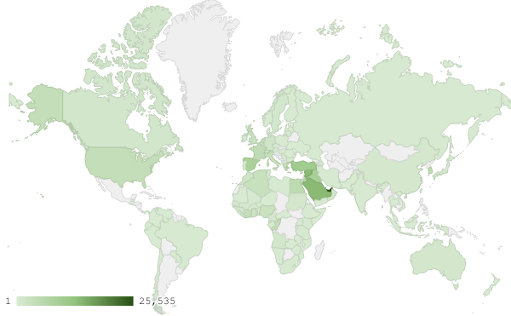
Map 1: Distribution of industrial exports during June 2018

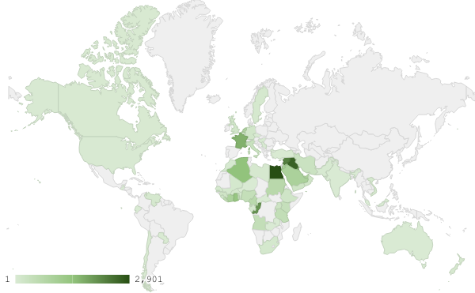
Map 2: Exports of machinery and electrical equipment during June 2018

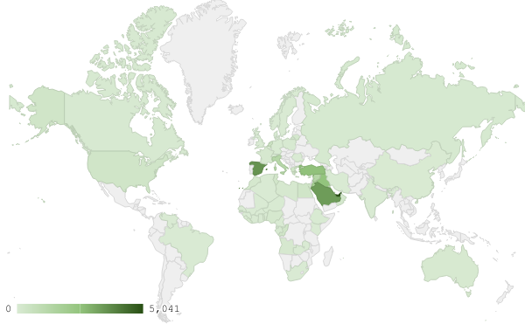
Map 3: Exports of products of the chemical industries during June 2018
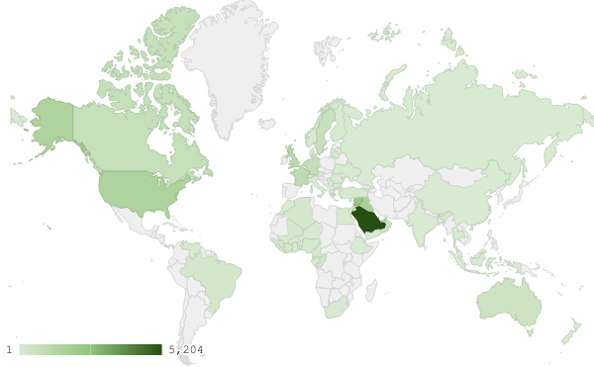
Map 4: Exports of prepared foodstuffs and tobacco during June 2018

Appendix charts
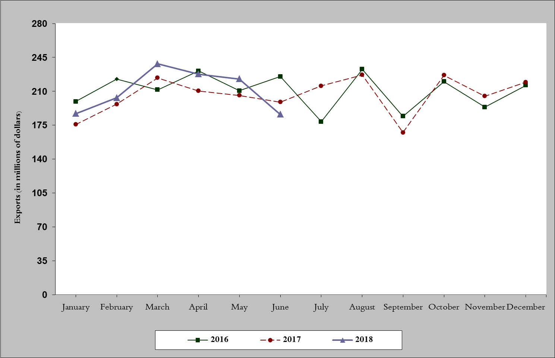
Chart 1: Industrial exports during years 2016-2017-2018
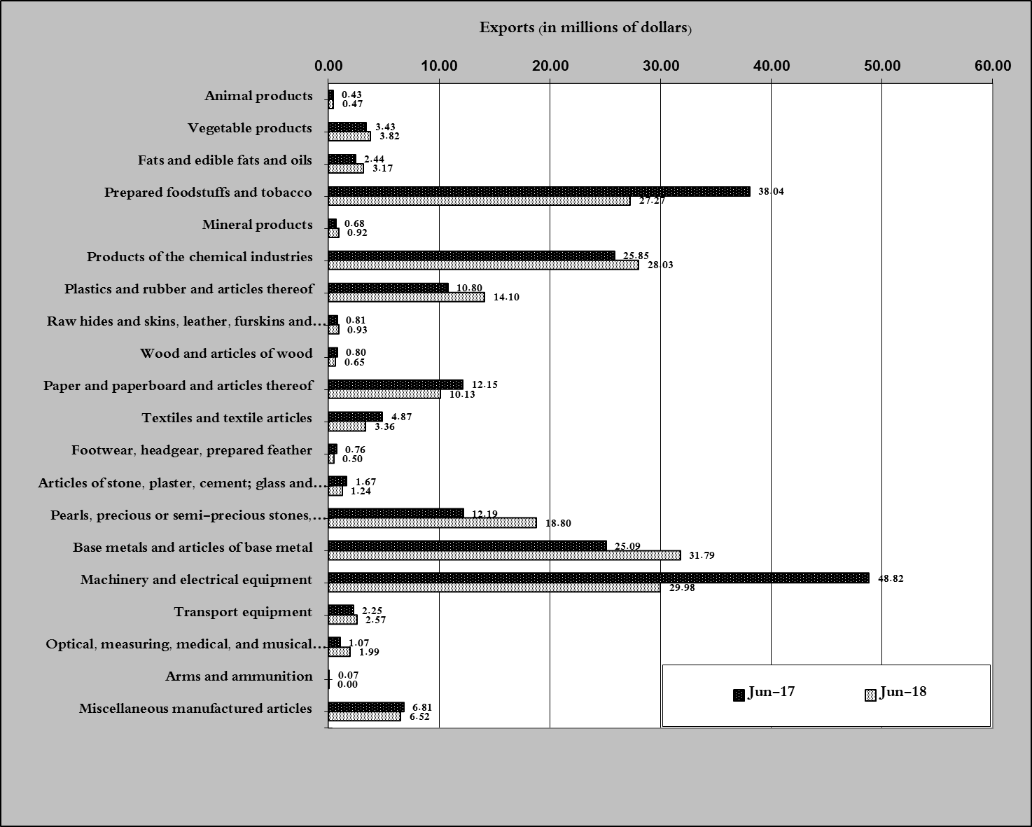
Chart 2: Comparison of industrial exports during June 2018 and June 2017

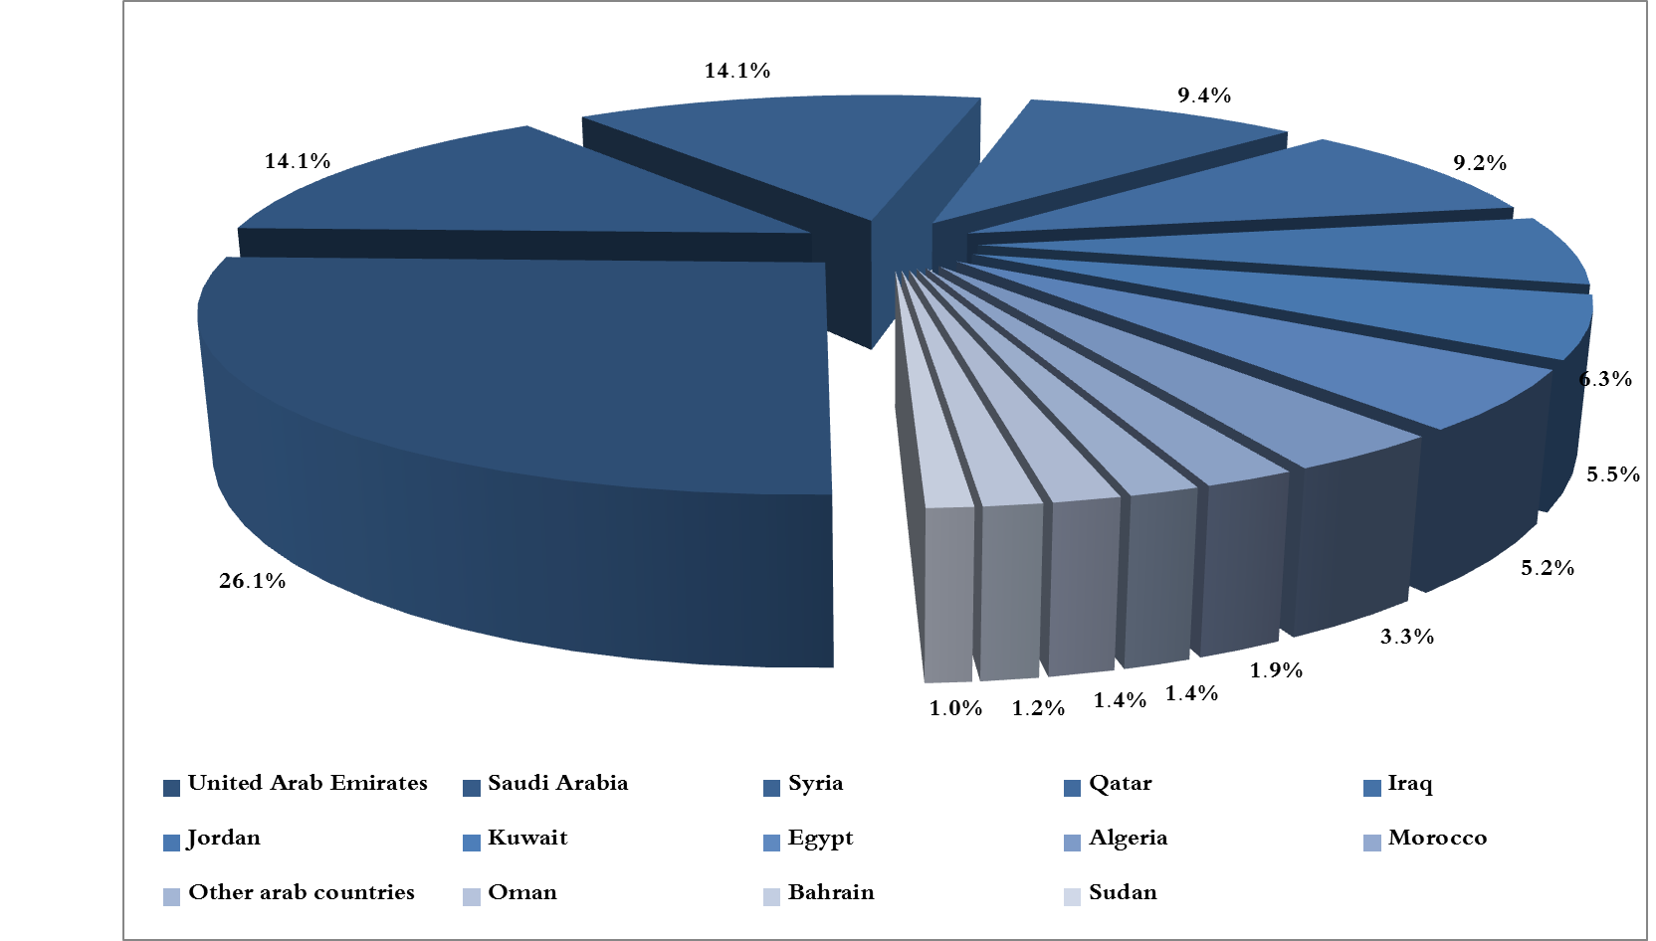
Chart 3: Distribution of industrial exports to Arab countries during June 2018

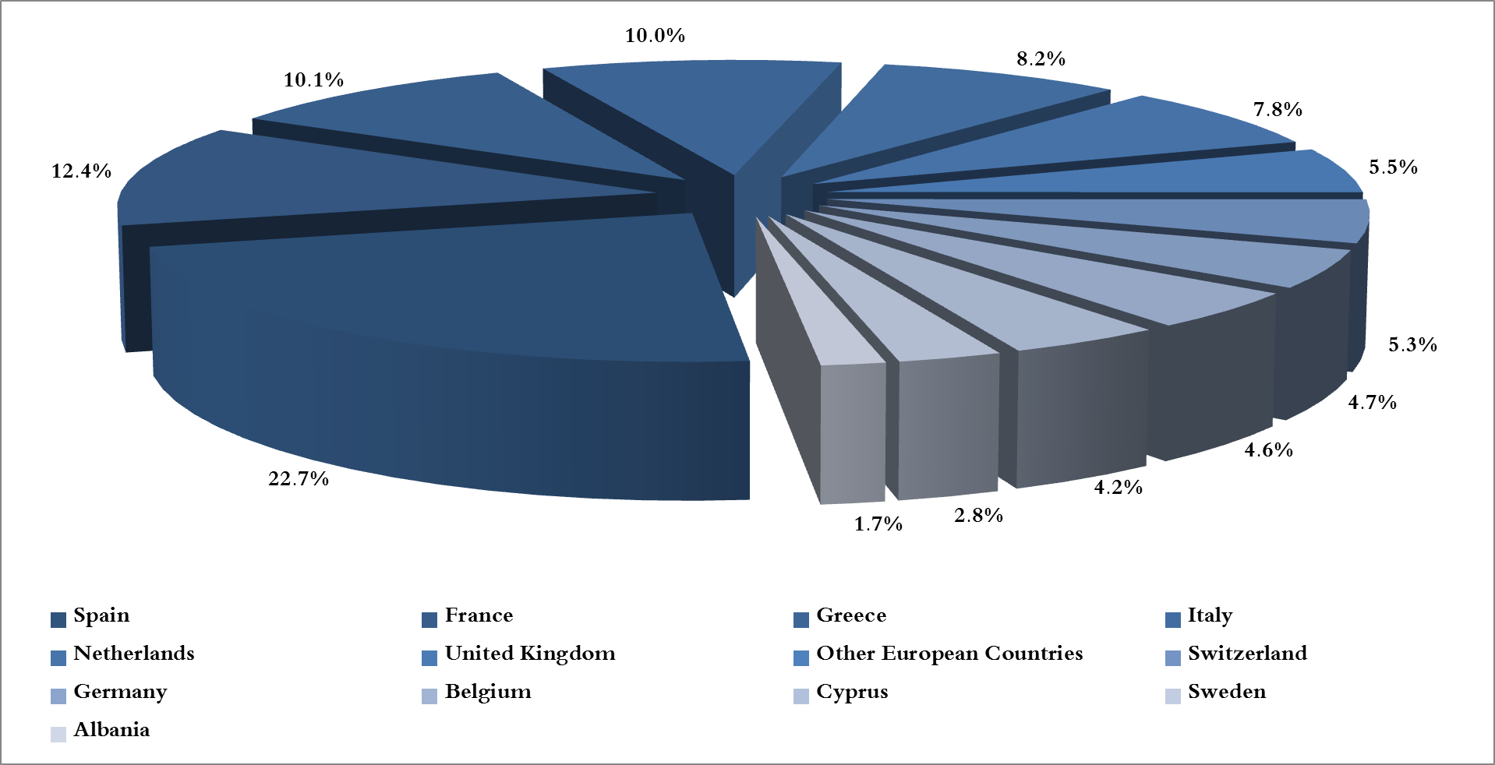
Chart 4: Distribution of industrial exports to European countries during June 2018

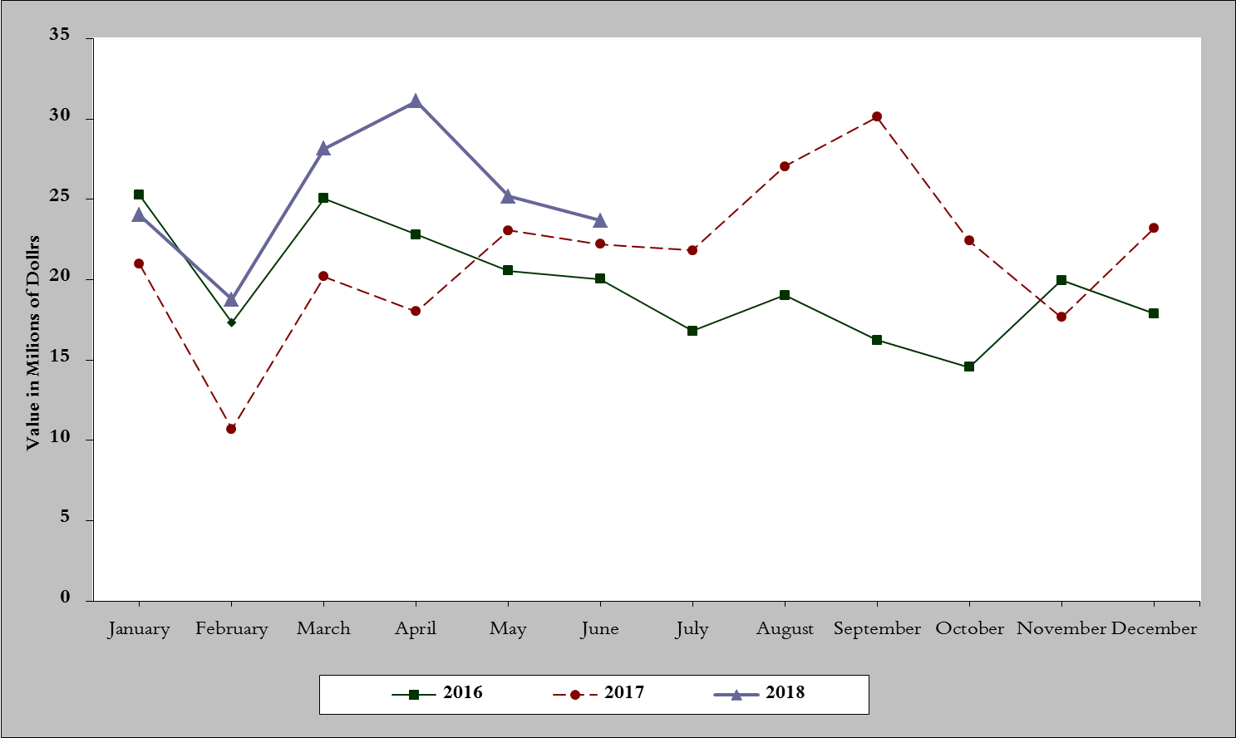
Chart 5: Imports of industrial machinery and equipment during years 2016-2017-2018

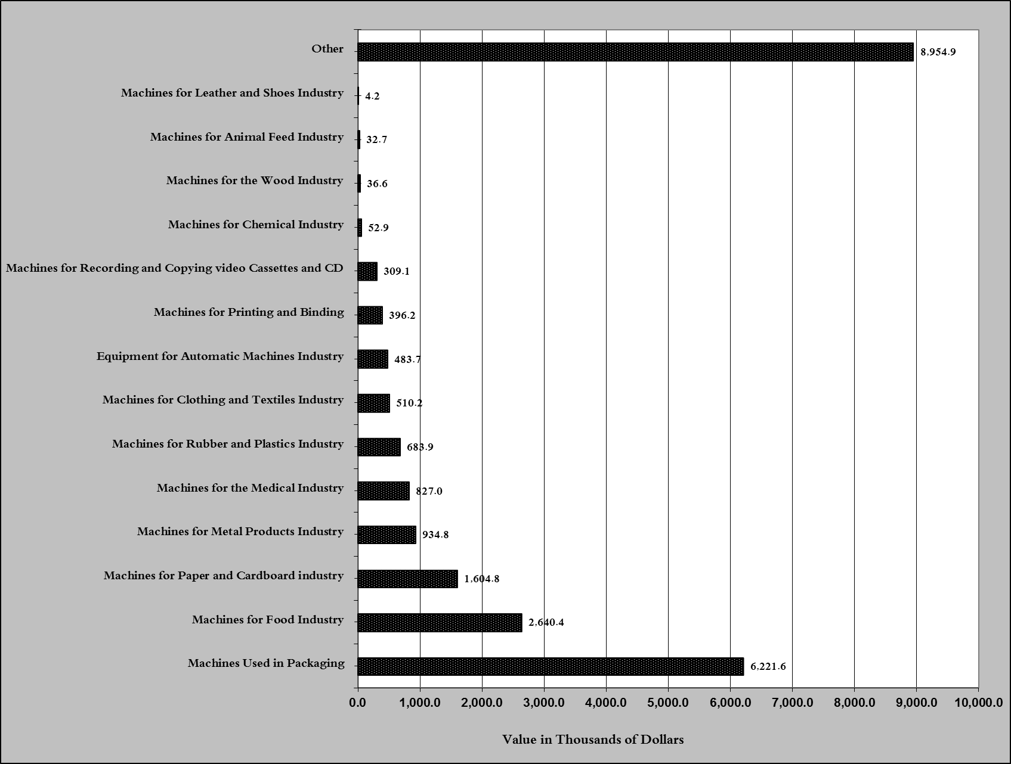
Chart 6: Imports of industrial equipment and machinery according to industrial activity during June 2018

Exports of unworked Diamonds, Silver and Gold Ingots reached this month a value of 32.6 million USD
The machineries and equipment are classified in this table according to the industrial sectors that are used in, while heading "other" includes machineries and equipment that can be used in various sectors.

