

A detailed report on industrial exports
and imports of industrial machinery and equipment in March 2018

Prepared by:
Ministry of Industry
Industrial Information Department

www.industry.gov.lb
Index

I. Introduction 3
II. Industrial exports in March 2018 4
1. Main exported products 4
2. Products with increased exports value 4
2.1. Base metals and articles of base metal 4
2.2. Products of the chemical industries 4
3. Products with decreased exports value 5
3.1. Pearls, precious or semi-precious stones, precious metals and articles thereof (Excluding unworked diamonds, silver and gold Ingots) 5
3.2. Machinery and electrical equipment 5
4. Main export markets 5
4.1. Main export markets by groups of countries 5
4.2. Main export markets by country 6
III. Imports of industrial machinery and equipment 6
1. Imported industrial machinery and equipment by country of origin 6
2. Imported industrial machinery and equipment by country of origin and industrial activity 6
IV. Appendix tables 8
IV. Appendix maps 21
VI. Appendix charts 25

Introduction
The Industrial Information Department of the Ministry of Industry has prepared a detailed report on industrial exports and imports of industrial machinery and equipment for the month of March 2018.
It should be noted that the total value of industrial exports during first three months of the year 2018 amounted about 628.8 million US dollars compared to 596.6 million US dollars during the same period of the year 2017, and 633.9 million US dollars during the same period of the year 2016. Therefore we notice an increase of 5.4% compared to the year 2017, and a decline of 0.8% compared to the year 2016. (Tables 1 and 11(
It should also be noted that the monthly average of the Lebanese industrial exports during the first three months of the year 2018 amounted about 209.6 million US dollars compared to 198.9 million US dollars during the year 2017, and 211.3 million US dollars during the year 2016.
On the other hand, the total value of imports of industrial machinery and equipment during the first three months of the year 2018 amounted about 71 million US dollars compared to 51.8 million US dollars during the same period of the year 2017, and 67.7 million US dollars during the same period of the year 2016. Therefore, we notice an increase of 36.9% compared to the year 2017, and an increase of 4.9% compared to the year 2016. (Table 17)

Industrial exports in March 2018
The total value of industrial exports in March 2018 amounted to nearly 238.4 million US dollars, compared to 223.9 million US dollars in March 2017, and 211.6 million US dollars in March 2016, which is equivalent to an increase of 14.5 million US dollars, with the rate of 6.5% compared to year 2017, and an increase of 26.7 million US dollars with the rate of 12.6%, compared to year 2016. (Table 1, and Map 1, and Chart 1)

Main exported products
Exports of prepared foodstuffs and tobacco came first in March 2018, with a total value of 45.6 million US dollars; Saudi Arabia was on top of importers list of this product, with an import value of 5.2 million US dollars. Followed by exports of base metals and articles of base metal, with a total value of 43.1 million US dollars, Turkey was the largest importer of this product, with an import value of 12.9 million US dollars. Then machinery and electrical equipment, with a total value of 40.6 million US dollars, Iraq topped the importers list of this product, with an import value of 7.6 million US dollars, followed by products of the chemical industries, with a total value of 32.4 million US dollars. (For more details tables 2, 4, 6, 8, 10, 15, and 16 and Maps 2, 3, and 4)

Products with increased exports value
Statistics showed a significant increase in exports of the following products:

Base metals and articles of base metal
Exports of this product increased from 30.5 million US dollars in March 2017 to 43.1 million US dollars in March 2018 (Table 2 and Chart 2). The exports of this product mainly increased to Spain, Greece, and Turkey which led to an increase in the total value of about 12.7 million US dollars. (Tables 3 and 4)

Products of the chemical industries
Exports of this product increased from 27.4 million US dollars in March 2017 to 32.4 million US dollars in March 2018 (Table 2 and Chart 2). The exports of this product mainly decreased to United Arab Emirates and Iraq whereas it mainly increased to Italy, Turkey, Syria, and Qatar which led to an increase of the total value of about 5 million US dollars. (Tables 5 and 6).

Products with decreased exports value
Statistics showed a significant decrease in exports of the following products:

Pearls, precious or semi-precious stones, precious metals and articles thereof (Excluding unworked diamonds, silver and gold Ingots)
Exports of this product decreased from 21.3 million US dollars in March 2017 to 12.3 million US dollars in March 2018 (Table 2 and Chart 2). The exports of this product mainly increased to Belgium whereas it mainly decreased to United Arab Emirates, United Kingdom, Saudi Arabia and Germany which led to a fall of the total value of about 9 million US dollars. (Tables 7 and 8)

Machinery and electrical equipment
Exports of this product decreased from 43.2 million US dollars in March 2017 to 40.6 million US dollars in March 2018 (Table 2 and Chart 2). The exports of this product mainly increased to Kuwait and Iraq whereas it mainly decreased to Saudi Arabia, United Arab Emirates, Ghana, and Syria which led to a fall of the total value of about 2.7 million US dollars. (Tables 9 and 10)

Main export markets

Main export markets by groups of countries
Arab countries were the main market for Lebanese industrial exports in March 2018, with a total export value of 118.9 million US dollars, with a rate of 49.9% of the total export value. European countries were the second largest export markets with a rate of 20.8% of the total export value. Followed by, Non-arab African countries with a rate of 12.6% of the total export value, and, the Non-arab Asian countries with a rate of 11.1% of the total export value. The main products exported to Arab countries are: prepared foodstuffs and tobacco with the total value of 25 million US dollars, machinery and electrical equipment with the total value of 24.7 million US dollars, and the products of the chemical industries with the total value of 20.1 million US dollars. (Table 12 and Map 1)

Main export markets by country
Among countries importing Lebanese industrial products, United Arab Emirates ranked first with a total value of 22 million US dollars, with a rate of 9.2% of the total export value. Saudi Arabia came second with a total value of 18.6 million US dollars with a rate of 7.8% of the total export value. Followed by, Iraq with a total value of 18.3 million US dollars with a rate of 7.7% of the total exports value. (Table 13 and Map 1)
During this month, Lebanese products were exported to 40 European countries, 33 Non-arab African countries, 23 Non-arab Asian countries, 19 Arab countries, 16 American countries, and 2 Oceanic countries. Countries that imported Lebanese goods by over 1 million US dollars are as following: 13 Arab countries, 12 European countries, 10 Non-arab African countries, 3 Non-arab Asian countries, and 2 American countries, and 1 Oceanic country. (Table 14, and Map 1, and Charts 3 and 4)

Imports of industrial machinery and equipment
The total import value of industrial machinery and equipment in March 2018 reached about 28.2 million US dollars compared to 20.2 million US dollars during the same period in 2017, and 25.1 million US dollars during the same period in 2016, an increase by 39.5% compared to year 2017, and an increase of 12.4% compared to year 2016. (Tables 17 and 18 and Chart 5)

Imported industrial machinery and equipment by country of origin
Italy ranked first on the list of countries exporting industrial machinery and equipment to Lebanon, with a total value amounting to about 13.1 million US dollars, followed by Germany, with a total value of 3.5 million US dollars, and China, with a total value of 3.4 million US dollars. (Table 18)

Imported industrial machinery and equipment by country of origin and industrial activity
In March 2018, imports of machines for food industry, ranked first, with a total value of 3.4 million US dollars, and Italy topped the list of countries exporting of this product to Lebanon with exports value of 1.3 million US dollars, followed by machines for rubber and plastics industry, with a total value of 2.8 million US dollars. Germany was the leading exporter of this product with an export value of 1.3 million US dollars. Followed by machines for paper and cardboard industry, with a total value of 2.2 million US dollars. (Table 19, Chart 6)

Appendix tables

Table 1: Industrial exports during Years 2016 – 2017 – 2018
Month | Year  2016 | Year  2017 | Year  2018 | Variation in %  2016/2018 | Variation in %  2017/2018
January | 199.5 | 175.9 | 187.0 | -6.3% | 6.3%
February | 222.8 | 196.8 | 203.4 | -8.7% | 3.4%
March | 211.6 | 223.9 | 238.4 | 12.6% | 6.5%
April | 231.1 | 210.4
May | 210.6 | 205.9
June | 225.3 | 199.0
July | 178.8 | 215.7
August | 232.9 | 227.0
September | 184.3 | 167.6
October | 220.0 | 226.7
November | 193.7 | 205.1
December | 216.3 | 219.6
Total | 2,526.9 | 2,473.5 | 628.8
All above figures are in Millions of USD

Table 2: Comparison of industrial exports during March 2018 and March 2017
Section | Goods | March 2017 | March 2018 | Variation 2017/2018 | Variation in % 2017/2018
1 | Animal products | 0.43 | 0.59 | 0.16 | 38.6%
2 | Vegetable products | 4.53 | 5.80 | 1.27 | 28.1%
3 | Fats and edible fats and oils | 4.03 | 4.19 | 0.16 | 3.9%
4 | Prepared foodstuffs and tobacco | 42.53 | 45.60 | 3.07 | 7.2%
5 | Mineral products | 0.57 | 0.88 | 0.32 | 55.4%
6 | Products of the chemical industries | 27.40 | 32.38 | 4.98 | 18.2%
7 | Plastics and rubber and articles thereof | 13.87 | 15.74 | 1.86 | 13.4%
8 | Raw hides and skins, leather, furskins and articles thereof | 1.47 | 0.74 | -0.73 | -49.9%
9 | Wood and articles of wood | 0.83 | 1.18 | 0.35 | 42.6%
10 | Paper and paperboard and articles thereof | 12.19 | 12.64 | 0.45 | 3.7%
11 | Textiles and textile articles | 6.52 | 6.19 | -0.33 | -5.1%
12 | Footwear, headgear, prepared feather | 1.83 | 1.39 | -0.44 | -24.2%
13 | Articles of stone, plaster, cement; glass and glassware | 2.06 | 2.60 | 0.54 | 26.1%
14 | Pearls, precious or semi-precious stones, precious metals and articles thereof (Excluding unworked diamonds, silver and gold Ingots) | 21.28 | 12.26 | -9.02 | -42.4%
15 | Base metals and articles of base metal | 30.45 | 43.12 | 12.67 | 41.6%
16 | Machinery and electrical equipment | 43.20 | 40.55 | -2.65 | -6.1%
17 | Transport equipment | 2.20 | 1.69 | -0.50 | -22.9%
18 | Optical, measuring, medical, and musical instruments; clocks and watches | 1.70 | 1.99 | 0.29 | 16.9%
19 | Arms and ammunition | 0.04 | 0.00 | -0.04 | -100.0%
20 | Miscellaneous manufactured articles | 6.79 | 8.84 | 2.05 | 30.2%
 | Total | 223.90 | 238.36 | 14.46 | 6.5%
All above figures are in Millions of USD
Table 3: Exports of base metals and articles of base metal according to the main importing countries during March 2017
Export destination Country | Turkey | Republic of Korea | Spain | China | Algeria | India | Italy | Japan
Value in thousands of USD | 10,341 | 4,901 | 2,624 | 1,052 | 965 | 934 | 864 | 771

Table 4: Exports of base metals and articles of base metal according to the main importing countries during March 2018
Export destination Country | Turkey | Spain | Republic of Korea | Greece | China | United Arab Emirates | Qatar | Bulgaria
Value in thousands of USD | 12,859 | 5,807 | 4,719 | 3,722 | 1,710 | 1,401 | 1,229 | 1,028

Table 5: Exports of products of the chemical industries according to the main importing countries during March 2017
Export destination Country | United Arab Emirates | Iraq | Saudi Arabia | Jordan | Kuwait | Italy | Syria | Qatar
Value in thousands of USD | 7,973 | 5,624 | 2,619 | 2,402 | 1,822 | 890 | 772 | 521

Table 6: Exports of products of the chemical industries according to the main importing countries during March 2018
Export destination Country | Iraq | United Arab Emirates | Italy | Turkey | Saudi Arabia | Jordan | Syria | Qatar
Value in thousands of USD | 4,832 | 4,490 | 3,998 | 2,520 | 2,337 | 2,092 | 1,690 | 1,225

Table 7: Exports of pearls, precious or semi-precious stones, precious metals and articles thereof (Excluding unworked diamonds, silver and gold Ingots) according to the main importing countries during March 2017
Export destination Country | United Arab Emirates | Germany | United Kingdom | Saudi Arabia | United States Of America | Qatar | Belgium | Upper Volta
Value in thousands of USD | 9,308 | 4,324 | 3,234 | 2,494 | 578 | 272 | 190 | 170

Table 8: Exports of pearls, precious or semi-precious stones, precious metals and articles thereof (Excluding unworked diamonds, silver and gold Ingots) according to the main importing countries during March 2018
Export destination Country | United Arab Emirates | Germany | Belgium | United States Of America | Saudi Arabia | Switzerland | Cyprus | United Kingdom
Value in thousands of USD | 4,993 | 2,789 | 2,231 | 924 | 233 | 150 | 146 | 141

Table 9: Exports of machinery and electrical equipment according to the main importing countries during March 2017
Export destination Country | Iraq | Saudi Arabia | United Arab Emirates | Syria | Ghana | Kuwait | Congo | Netherlands
Value in thousands of USD | 6,896 | 6,807 | 5,230 | 3,666 | 2,846 | 1,777 | 1,192 | 1,150

Table 10: Exports of machinery and electrical equipment according to the main importing countries during March 2018
Export destination Country | Iraq | United Arab Emirates | Syria | Kuwait | Saudi Arabia | Jordan | France | Qatar
Value in thousands of USD | 7,598 | 3,626 | 2,704 | 2,643 | 2,616 | 1,586 | 1,498 | 1,340

Table 11: Industrial exports according to exported goods during year 2018
Table 12: Industrial exports according to exported goods and countries groups during March 2018
Goods | Arab Countries | European Countries | Oceanic Countries | Non-Arab Asian countries | American Countries | Non-Arab African countries | Other* | Total
Animal products | 472 | 1 |  |  | 11 | 107 |  | 592
Vegetable products | 2,418 | 1,310 | 105 | 92 | 911 | 956 | 5 | 5,797
Fats and edible fats and oils | 2,416 | 632 | 116 | 49 | 797 | 179 |  | 4,189
Prepared foodstuffs and tobacco | 24,993 | 9,573 | 1,377 | 396 | 4,735 | 4,053 | 473 | 45,600
Mineral products | 291 | 53 |  | 103 | 2 | 246 | 189 | 884
Products of the chemical industries | 20,113 | 6,543 | 128 | 2,744 | 607 | 1,800 | 445 | 32,380
Plastics and rubber and articles thereof | 9,902 | 2,459 | 65 | 524 | 154 | 2,485 | 147 | 15,737
Raw hides and skins, leather, furskins and articles thereof | 458 | 182 |  | 50 | 5 | 43 |  | 737
Wood and articles of wood | 926 | 21 | 1 | 4 | 7 | 217 |  | 1,177
Paper and paperboard and articles thereof | 8,265 | 1,715 | 1 | 631 | 87 | 1,937 | 6 | 12,642
Textiles and textile articles | 2,980 | 2,458 | 49 | 172 | 35 | 403 | 90 | 6,186
Footwear, headgear, prepared feather | 1,132 | 45 |  | 10 | 1 | 197 | 5 | 1,389
Articles of stone, plaster, cement; glass and glassware | 1,788 | 190 | 5 | 4 | 214 | 402 |  | 2,604
Pearls, precious or semi-precious stones, precious metals and articles thereof (Excluding unworked diamonds, silver and gold Ingots) | 5,303 | 5,663 |  | 109 | 924 | 180 | 80 | 12,259
Base metals and articles of base metal | 5,640 | 12,564 | 74 | 20,675 | 623 | 3,243 | 302 | 43,120
Machinery and electrical equipment | 24,686 | 4,129 | 113 | 905 | 214 | 10,433 | 69 | 40,548
Transport equipment | 348 | 884 | 7 | 3 | 24 | 429 |  | 1,694
Optical, measuring, medical, and musical instruments; clocks and watches | 1,086 | 743 |  | 38 | 69 | 52 |  | 1,987
Arms and ammunition |  |  |  |  |  |  |  | 0
Miscellaneous manufactured articles | 5,672 | 329 | 36 | 38 | 78 | 2,663 | 20 | 8,837
Total | 118,889 | 49,495 | 2,075 | 26,545 | 9,499 | 30,026 | 1,831 | 238,361
All the above figures are in thousands of US dollars.
* "other" Includes exported goods to the duty free market and those that are supplied to ships and aircraft.
Table 13: Distribution of the industrial exports according to the main importing countries during March 2018
Export destination Country | United Arab Emirates | Saudi Arabia | Iraq | Turkey | Qatar | Syria | Kuwait | Jordan
Value in thousands of USD | 21,971 | 18,609 | 18,316 | 16,276 | 12,406 | 11,789 | 9,219 | 8,613

Export destination Country | Spain | Greece | Egypt | United States Of America | Germany | Italy | Republic of Korea | Congo
Value in thousands of USD | 7,935 | 7,495 | 6,852 | 6,426 | 5,928 | 5,677 | 4,719 | 4,655

Export destination Country | France | Ivory Coast | Algeria | United Kingdom | Netherlands | Belgium | Nigeria | Canada
Value in thousands of USD | 4,215 | 3,895 | 3,483 | 3,357 | 3,069 | 3,024 | 2,823 | 2,649

Table 14: Distribution of importing countries according to countries groups and the value of exports during March 2018
Exports Value  (in million USD) | Arab Countries | European Countries | Oceania Countries | Non-Arab Asian countries | American Countries | Non-Arab African countries | Total
]0-1[ | 6 | 28 | 1 | 20 | 14 | 23 | 92
[1-5[ | 5 | 8 | 1 | 2 | 1 | 10 | 27
[5-10[ | 3 | 4 |  |  | 1 |  | 8
[10-15[ | 2 |  |  |  |  |  | 2
More than 15 million USD | 3 |  |  | 1 |  |  | 4
Total | 19 | 40 | 2 | 23 | 16 | 33 | 133

Table 15: Distribution of the industrial exports according to product and to the main importing countries during March 2018

Animal products | Qatar | Jordan | Iraq | Kuwait | Saudi Arabia | Equatorial Guinea | Liberia | Gabon
Value in 1000 of USD | 249 | 82 | 75 | 31 | 23 | 21 | 19 | 16

Vegetable products | United States Of America | Saudi Arabia | Germany | Canada | Netherlands | United Arab Emirates | Qatar | Jordan
Value in 1000 of USD | 544 | 477 | 365 | 321 | 318 | 289 | 273 | 263

Fats and edible fats and oils | Kuwait | United States Of America | Qatar | Saudi Arabia | United Arab Emirates | Iraq | Netherlands | Canada
Value in 1000 of USD | 690 | 625 | 484 | 410 | 347 | 307 | 252 | 162

Prepared foodstuffs and tobacco | Saudi Arabia | Qatar | Egypt | United Arab Emirates | United States Of America | Greece | Iraq | Kuwait
Value in 1000 of USD | 5,211 | 4,040 | 3,749 | 2,821 | 2,700 | 2,634 | 2,587 | 2,393

Mineral products | Syria | Other | Guinea | China | Qatar | Liberia | Belgium | Italy
Value in 1000 of USD | 229 | 189 | 128 | 103 | 55 | 39 | 31 | 22

Plastics and rubber and articles thereof | Syria | Saudi Arabia | Spain | Qatar | Congo | Jordan | Algeria | Iraq
Value in 1000 of USD | 4,117 | 1,751 | 1,127 | 756 | 613 | 609 | 597 | 461

Raw hides and skins, leather, furskins and articles thereof | United Arab Emirates | Egypt | Portugal | Jordan | Turkey | Saudi Arabia | Kuwait | Nigeria
Value in 1000 of USD | 173 | 110 | 110 | 91 | 47 | 39 | 28 | 25

Wood and articles of wood | United Arab Emirates | Syria | Ivory Coast | Saudi Arabia | Jordan | Oman | Algeria | Mali
Value in 1000 of USD | 356 | 340 | 87 | 81 | 69 | 30 | 27 | 24

Paper and paperboard and articles thereof | Iraq | Saudi Arabia | Jordan | Egypt | United Arab Emirates | Syria | Cyprus | Algeria
Value in 1000 of USD | 1,204 | 1,154 | 1,042 | 1,012 | 722 | 686 | 621 | 591

Table 15: (continued) Distribution of the industrial exports according to product and the main importing countries during March 2018
Textiles and textile articles | Switzerland | United Arab Emirates | Qatar | Kuwait | Italy | France | Egypt | Syria
Value in 1000 of USD | 970 | 861 | 613 | 450 | 389 | 371 | 330 | 307

Footwear, headgear, prepared feather | Saudi Arabia | United Arab Emirates | Sierra Leone | Upper Volta | Ivory Coast | Jordan | United Kingdom | Qatar
Value in 1000 of USD | 899 | 141 | 101 | 43 | 37 | 37 | 34 | 29

Articles of stone, plaster, cement; glass and glassware | Kuwait | Algeria | Qatar | Saudi Arabia | United States Of America | Syria | Iraq | France
Value in 1000 of USD | 533 | 324 | 317 | 294 | 178 | 129 | 83 | 68

Transport equipment | Spain | Nigeria | Iraq | Armenia | Libya | France | United Arab Emirates | Ivory Coast
Value in 1000 of USD | 675 | 224 | 150 | 79 | 72 | 68 | 62 | 61

Optical, measuring, medical, and musical instruments; clocks and watches | United Arab Emirates | Switzerland | Germany | Netherlands | Cyprus | United States Of America | Japan | Oman
Value in 1000 of USD | 1,016 | 215 | 187 | 142 | 140 | 69 | 38 | 38

Miscellaneous manufactured articles | Saudi Arabia | Qatar | Congo | United Arab Emirates | Iraq | Syria | Jordan | Kuwait
Value in 1000 of USD | 2,138 | 1,216 | 1,163 | 469 | 450 | 372 | 365 | 340

Table 16: Distribution of industrial exports, according to the main exported goods and main importing countries during March 2018

Table 17: Imports of industrial machinery and equipment during years 2016-2017-2018
Month | Year  2016 | Year  2017 | Year  2018 | Variation in %  2016/2018 | Variation in %  2017/2018
January | 25.3 | 21.0 | 24.0 | -4.9% | 14.7%
February | 17.3 | 10.7 | 18.8 | 8.3% | 75.6%
March | 25.1 | 20.2 | 28.2 | 12.4% | 39.5%
April | 22.8 | 18.0
May | 20.5 | 23.1
June | 20.0 | 22.2
July | 16.8 | 21.8
August | 19.0 | 27.0
September | 16.2 | 30.1
October | 14.5 | 22.4
November | 20.0 | 17.6
December | 17.9 | 23.2
Total | 235.5 | 257.4 | 71.0
All above figures are in Millions of USD

Table 18: Imports of industrial equipment and machinery according to exporting country for the year 2018
Table 19: Imports of industrial equipment and machinery according to industrial activity and country during March 2018

Appendix maps
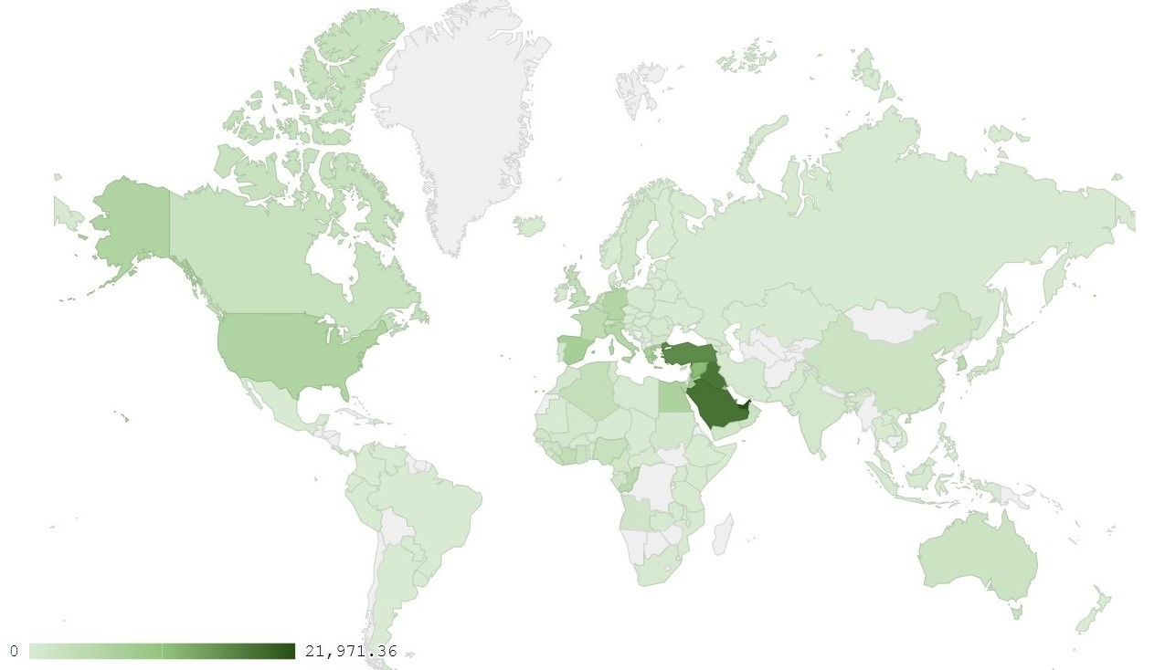
Map 1: Distribution of industrial exports during March 2018
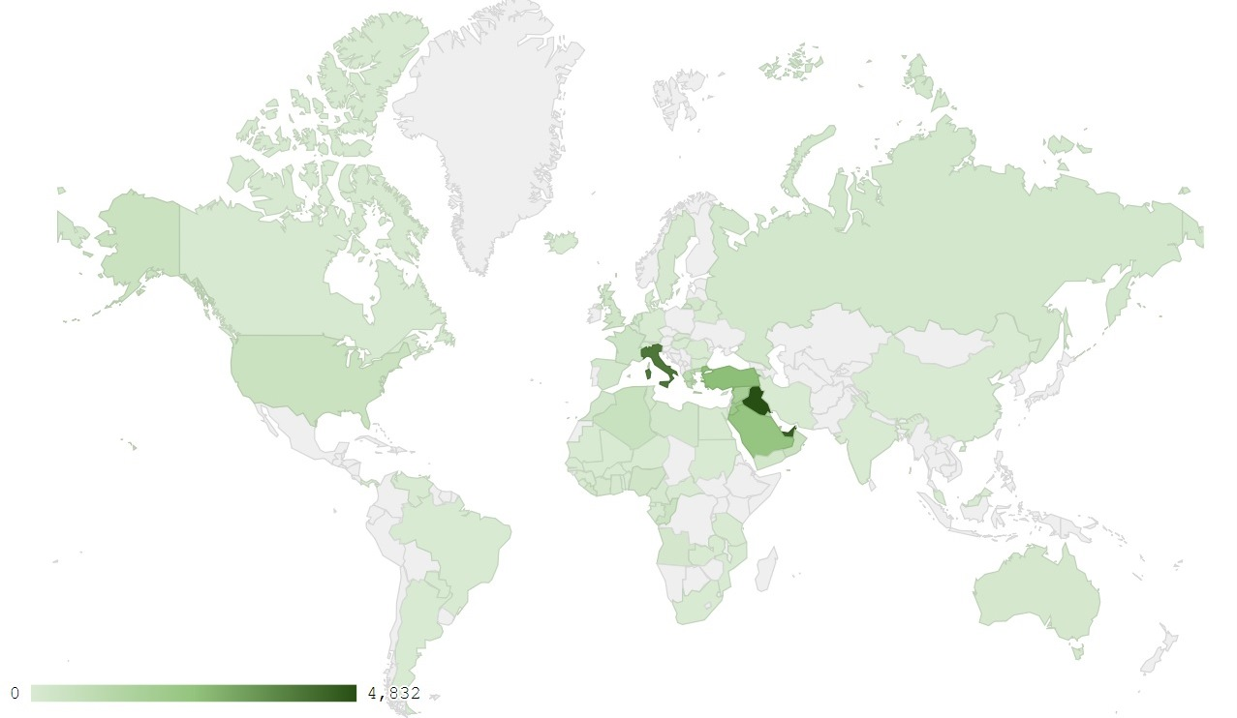
Map 2: Exports of products of the chemical industries during March 2018
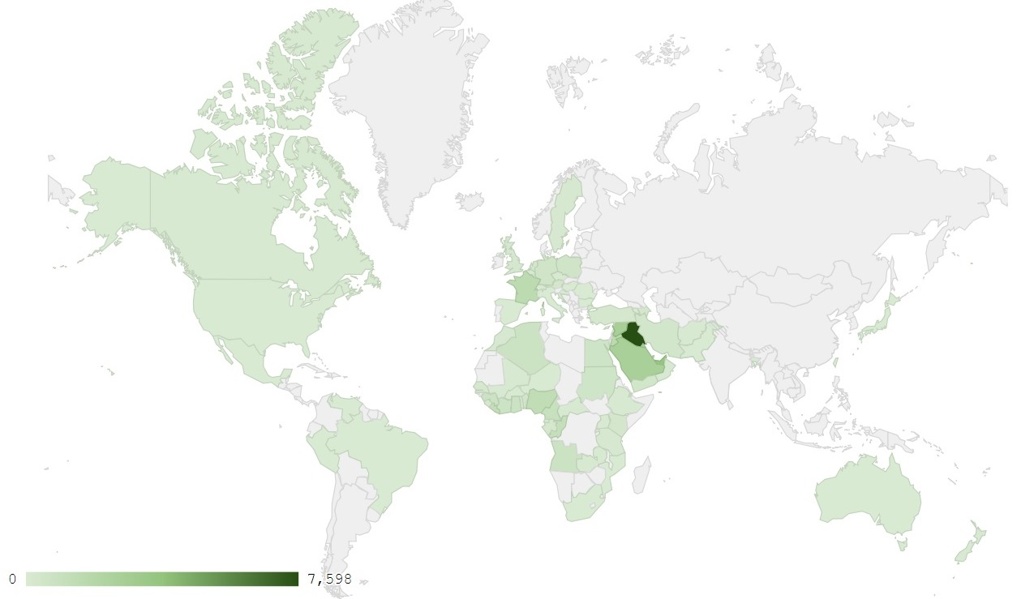
Map 3: Exports of machinery and electrical equipment during March 2018
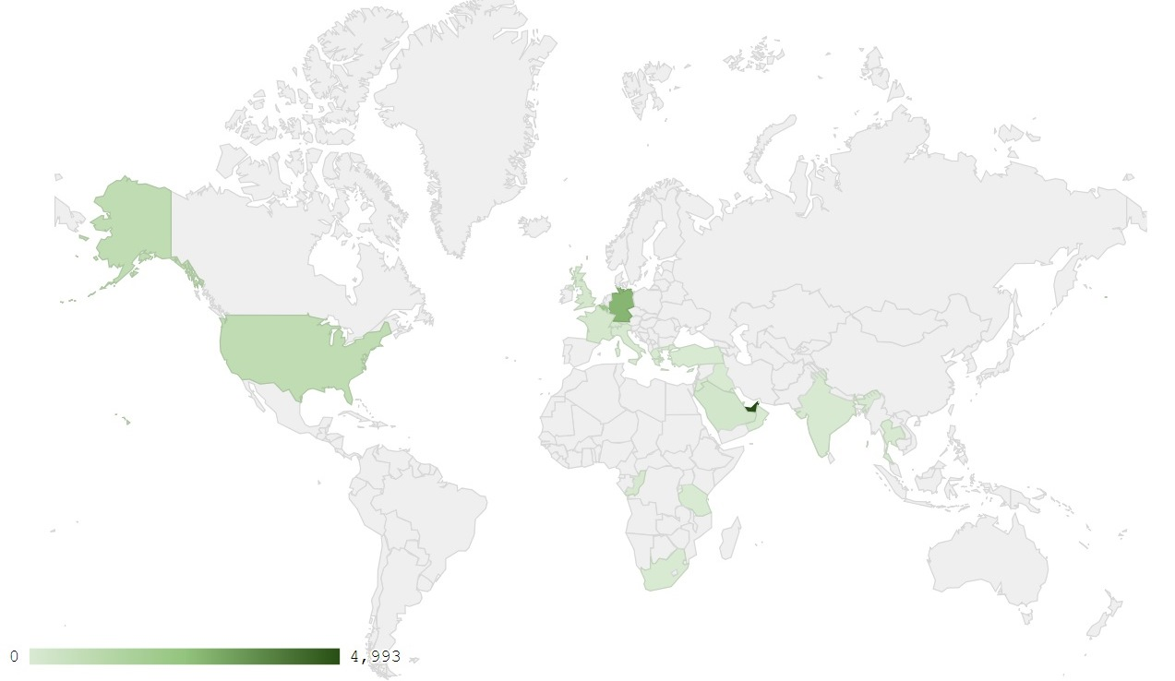
Map 4: Exports of pearls, precious or semi-precious stones, precious metals and articles thereof (Excluding unworked diamonds, silver and gold Ingots) during March 2018

Appendix charts
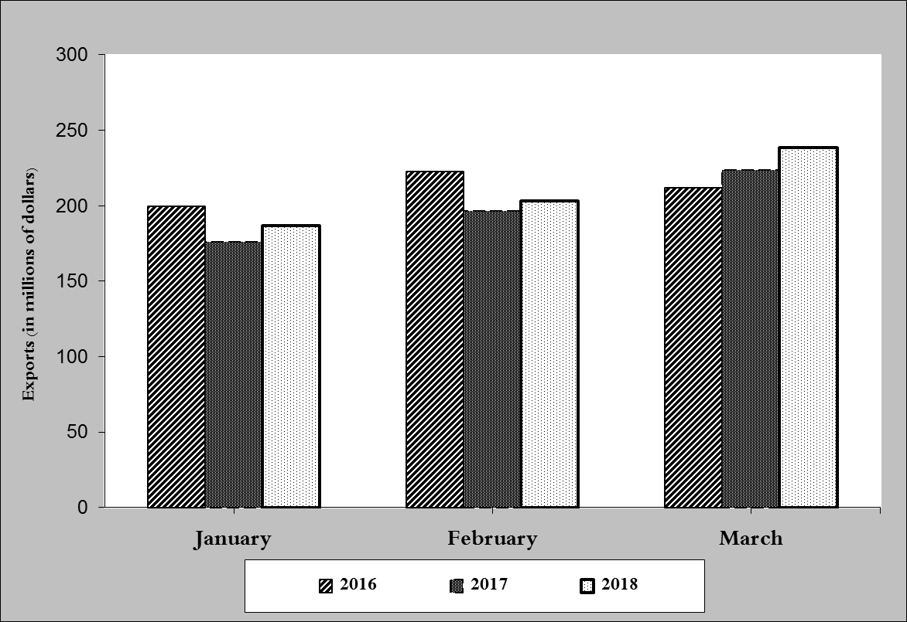
Chart 1: Industrial exports during years 2016-2017-2018
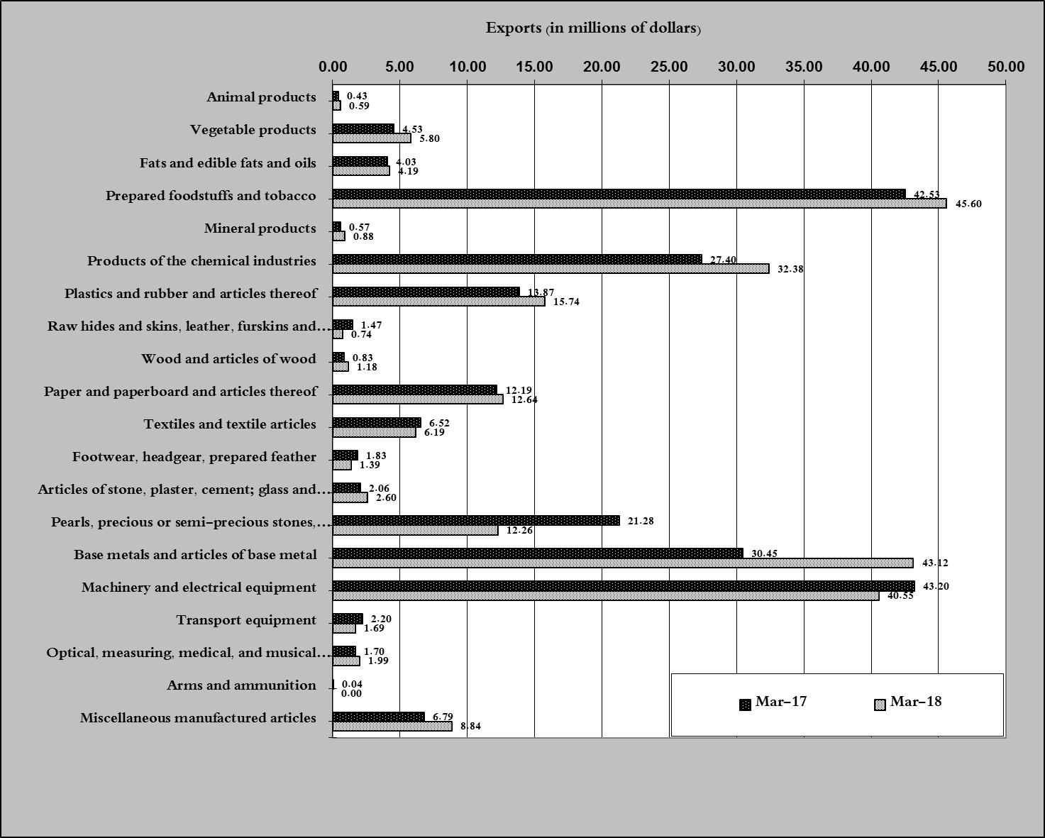
Chart 2: Comparison of industrial exports during March 2018 and March 2017

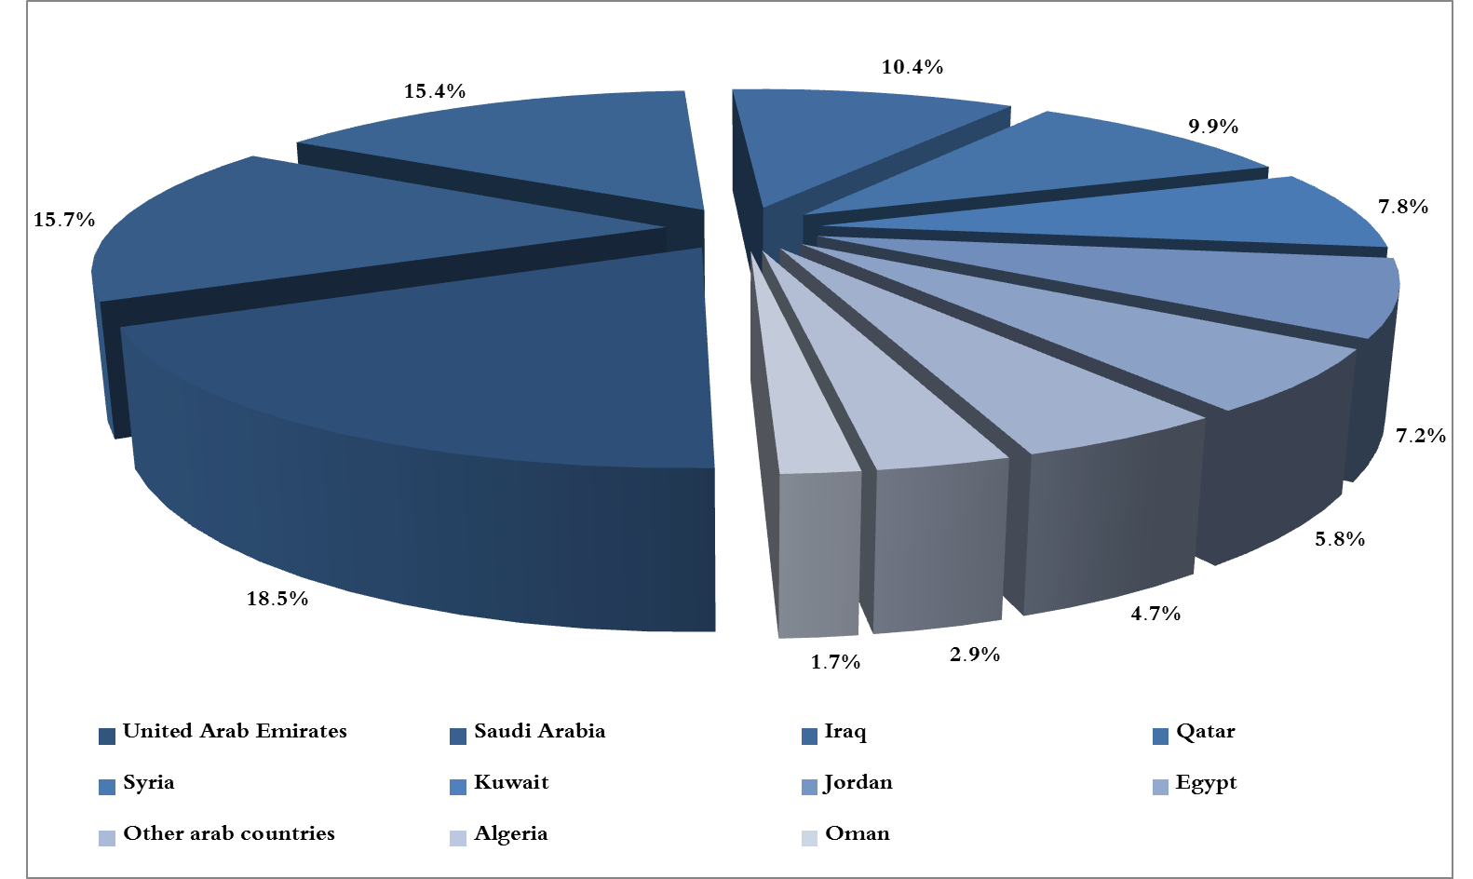
Chart 3: Distribution of industrial exports to Arab countries during March 2018

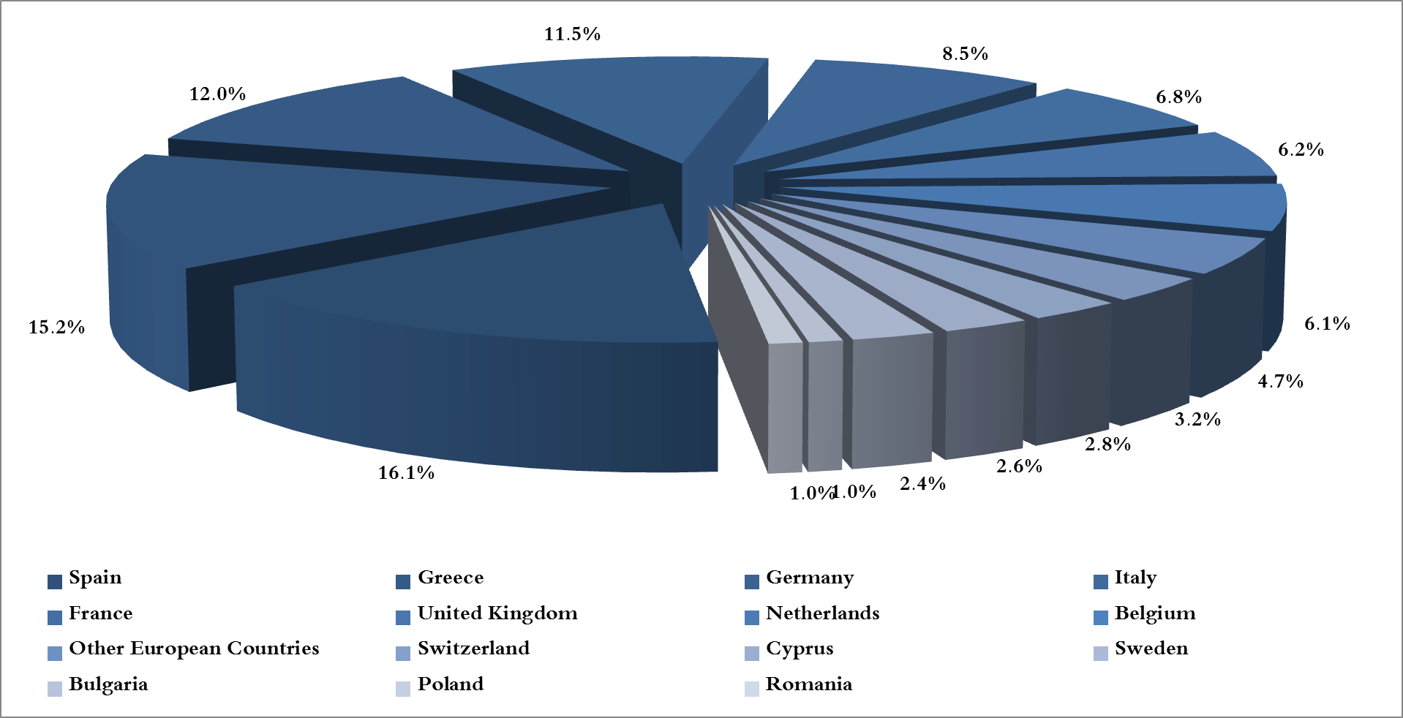
Chart 4: Distribution of industrial exports to European countries during March 2018

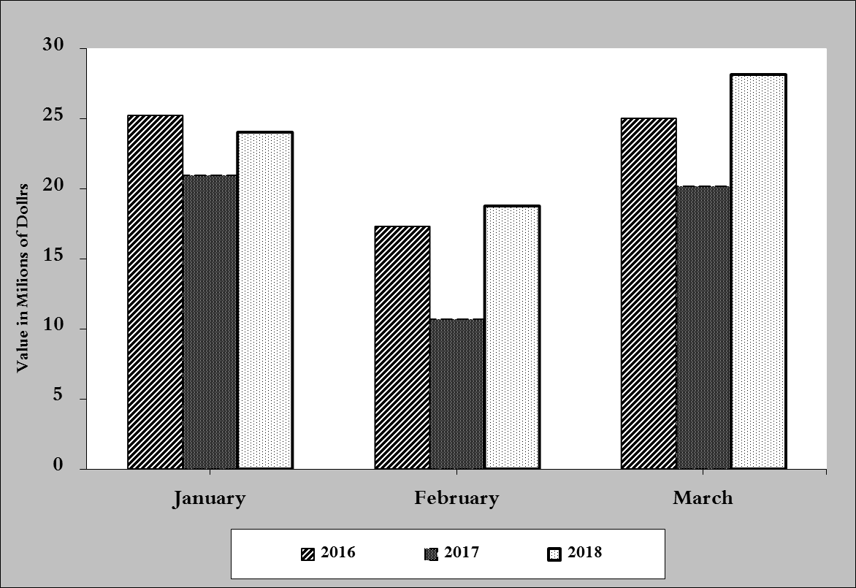
Chart 5: Imports of industrial machinery and equipment during years 2016-2017-2018
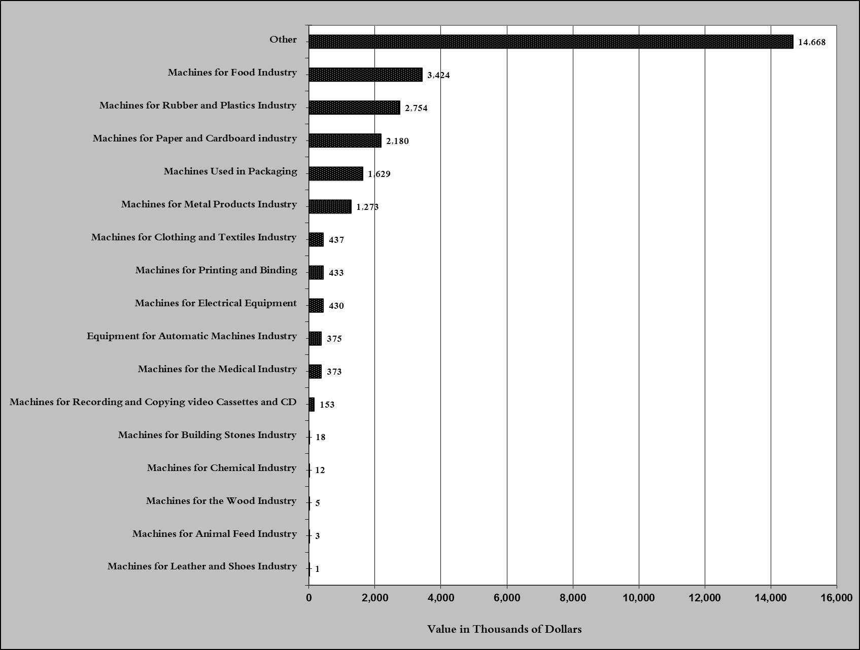
Chart 6: Imports of industrial equipment and machinery according to industrial activity during March 2018

Exports of unworked Diamonds, Silver and Gold Ingots reached this month a value of 49.8 million USD
The machineries and equipment are classified in this table according to the industrial sectors that are used in, while heading "other" includes machineries and equipment that can be used in various sectors.

