

A detailed report on industrial exports
and imports of industrial machinery and equipment in September 2018

Prepared by:
Ministry of Industry
Industrial Information Department

www.industry.gov.lb
Index

I. Introduction 3
II. Industrial exports in September 2018 4
1. Main exported products 4
2. Products with increased exports value 4
2.1. Products of the chemical industries 4
2.2. Machinery and electrical equipment 5
3. Products with decreased exports value 5
3.1. prepared foodstuffs and tobacco 5
3.2. Optical, measuring, and musical instruments; clocks and watches 5
4. Main export markets 5
4.1. Main export markets by groups of countries 5
4.2. Main export markets by country 6
III. Imports of industrial machinery and equipment 6
1. Imported industrial machinery and equipment by country of origin 6
2. Imported industrial machinery and equipment by country of origin and industrial activity 6
IV. Appendix tables 8
IV. Appendix maps 21
VI. Appendix charts 25

Introduction
The Industrial Information Department of the Ministry of Industry has prepared a detailed report on industrial exports and imports of industrial machinery and equipment for the month of September 2018.
It should be noted that the total value of industrial exports during first nine months of the year 2018 amounted about 1 billion and 882.7 million US dollars compared to 1 billion and 822.2 million US dollars during the same period of the year 2017, and 1 billion and 896.9 million US dollars during the same period of the year 2016. Therefore we notice an increase of 3.3% compared to the year 2017, and a decline of 0.7% compared to the year 2016. (Tables 1 and 11(
It should also be noted that the monthly average of the Lebanese industrial exports during the first nine months of the year 2018 amounted about 209.2 million US dollars compared to 202.5 million US dollars during the year 2017, and 210.8 million US dollars during the year 2016.
On the other hand, the total value of imports of industrial machinery and equipment during the first nine months of the year 2018 amounted about 210.3 million US dollars compared to 194.1 million US dollars during the same period of the year 2017, and 183.1 million US dollars during the same period of the year 2016. Therefore, we notice an increase of 8.3% compared to the year 2017, and an increase of 14.8% compared to the year 2016. (Table 17)

Industrial exports in September 2018
The total value of industrial exports in September 2018 amounted to nearly 206.2 million US dollars, compared to 167.6 million US dollars in September 2017, and 184.3 million US dollars in September 2016, which is equivalent to an increase of 38.6 million US dollars, with the rate of 23.0% compared to year 2017, and an increase of 21.9 million US dollars with the rate of 11.9%, compared to year 2016. (Table 1, and Map 1, and Chart 1)

Main exported products
Exports of products of the chemical industries came first in September 2018, with a total value of 50.9 million US dollars; Bangladesh was on top of importers list of this product, with an import value of 17.7 million US dollars. Followed by exports of machinery and electrical equipment, with a total value of 34.9 million US dollars, Iraq was the largest importer of this product, with an import value of 4.9 million US dollars. Then base metals and articles of base metal, with a total value of 27.5 million US dollars, Republic of korea topped the importers list of this product, with an import value of 4.8 million US dollars, followed by prepared foodstuffs and tobacco, with a total value of 24.9 million US dollars. (For more details tables 2, 4, 6, 8, 10, 15, and 16 and Maps 2, 3, and 4)

Products with increased exports value
Statistics showed a significant increase in exports of the following products:

Products of the chemical industries
Exports of this product increased from 34.8 million US dollars in September 2017 to 50.9 million US dollars in September 2018 (Table 2 and Chart 2). The exports of this product mainly decreased to Iran and Iraq whereas it mainly increased to Bangladesh, Turkey, United Arab Emirates, Spain, Syria, Saudi Arabia, and Jordan which led to an increase in the total value of about 16.2 million US dollars. (Tables 3 and 4)

Machinery and electrical equipment
Exports of this product increased from 25.6 million US dollars in September 2017 to 34.9 million US dollars in September 2018 (Table 2 and Chart 2). The exports of this product mainly increased to Egypt, Syria, Iraq, Nigeria, and United Arab Emirates which led to an increase of the total value of about 9.3 million US dollars. (Tables 5 and 6).

Products with decreased exports value
Statistics showed a significant decrease in exports of the following products:

Prepared foodstuffs and tobacco
Exports of this product decreased from 27.9 million US dollars in September 2017 to 24.9 million US dollars in September 2018 (Table 2 and Chart 2). The exports of this product mainly decreased to Egypt, Syria, and Saudi which led to a fall of the total value of about 2.9 million US dollars. (Tables 7 and 8)

Optical, measuring, medical, and musical instruments; clocks and watches
Exports of this product decreased from 2.4 million US dollars in September 2017 to 0.8 million US dollars in September 2018 (Table 2 and Chart 2). The exports of this product mainly decreased to Syria and Belgium which led to a fall of the total value of about 1.6 million US dollars. (Tables 9 and 10)

Main export markets

Main export markets by groups of countries
Arab countries were the main market for Lebanese industrial exports in September 2018, with a total export value of 107.2 million US dollars, with a rate of 52.0% of the total export value. Non-Arab Asian countries were the second largest export markets with a rate of 19.0% of the total export value. Followed by, European countries with a rate of 12.8% of the total export value, and, the Non-Arab African countries with a rate of 10.5% of the total export value. The main products exported to Arab countries are: machinery and electrical equipment with the total value of 20.7 million US dollars, products of the chemical industries with the total value of 19.6 million US dollars, and the prepared foodstuffs and tobacco with the total value of 14.0 million US dollars. (Table 12 and Map 1)

Main export markets by country
Among countries importing Lebanese industrial products, United Arab Emirates ranked first with a total value of 25.0 million US dollars, with a rate of 12.1% of the total export value. Syria came second with a total value of 19.2 million US dollars with a rate of 9.3% of the total export value. Followed by, Bangladesh with a total value of 17.7 million US dollars with a rate of 8.6% of the total exports value. (Table 13 and Map 1)
During this month, Lebanese products were exported to 43 European countries, 41 Non-Arab African countries, 29 Non-Arab Asian countries, 24 American countries, 19 Arab countries, and 5 Oceanic countries. Countries that imported Lebanese goods by over 1 million US dollars are as following: 11 Arab countries, 9 European countries, 7 Non-Arab African countries, 5 Non-Arab Asian countries, and 2 American countries, and 1 Oceanic country. (Table 14, and Map 1, and Charts 3 and 4)

Imports of industrial machinery and equipment
The total import value of industrial machinery and equipment in September 2018 reached about 13.5 million US dollars compared to 30.1 million US dollars during the same period in 2017, and 16.2 million US dollars during the same period in 2016, a decline by 55.2% compared to year 2017, and decline of 16.9% compared to year 2016. (Tables 17 and 18 and Chart 5)

Imported industrial machinery and equipment by country of origin
Italy ranked first on the list of countries exporting industrial machinery and equipment to Lebanon, with a total value amounting to about 4.1 million US dollars, followed by China, with a total value of 3.1 million US dollars, and Germany, with a total value of 1.4 million US dollars. (Table 18)

Imported industrial machinery and equipment by country of origin and industrial activity
In September 2018, imports of machines for food industry, ranked first, with a total value of 3.9 million US dollars, and Italy topped the list of countries exporting of this product to Lebanon with exports value of 2.6 million US dollars, followed by machines for rubber and plastics industry, with a total value of 1.2 million US dollars. China was the leading exporter of this product with an export value of 0.7 million US dollars. Followed by equipment for automatic machines industry, with a total value of 0.9 million US dollars. (Table 19, Chart 6)

Appendix tables

Table 1: Industrial exports during Years 2016 – 2017 – 2018
Month | Year  2016 | Year  2017 | Year  2018 | Variation in %  2016/2018 | Variation in %  2017/2018
January | 199.5 | 175.9 | 187.0 | -6.3% | 6.3%
February | 222.8 | 196.8 | 203.4 | -8.7% | 3.4%
March | 211.6 | 223.9 | 238.4 | 12.6% | 6.5%
April | 231.1 | 210.4 | 227.8 | -1.4% | 8.3%
May | 210.6 | 205.9 | 222.8 | 5.8% | 8.2%
June | 225.3 | 199.0 | 186.3 | -17.4% | -6.4%
July | 178.8 | 215.7 | 198.5 | 11.0% | -8.0%
August | 232.9 | 227.0 | 212.4 | -8.8% | -6.4%
September | 184.3 | 167.6 | 206.2 | 11.9% | 23.0%
October | 220.0 | 226.7
November | 193.7 | 205.1
December | 216.3 | 219.6
Total | 2,526.9 | 2,473.5 | 1,882.7
All above figures are in Millions of USD

Table 2: Comparison of industrial exports during September 2018 and September 2017
Section | Goods | September  2017 | September  2018 | Variation 2017/2018 | Variation in % 2017/2018
1 | Animal products | 0.56 | 0.44 | -0.12 | -22.1%
2 | Vegetable products | 2.74 | 3.84 | 1.10 | 40.0%
3 | Fats and edible fats and oils | 1.84 | 4.04 | 2.21 | 120.1%
4 | Prepared foodstuffs and tobacco | 27.87 | 24.93 | -2.94 | -10.6%
5 | Mineral products | 0.48 | 0.85 | 0.38 | 79.2%
6 | Products of the chemical industries | 34.76 | 50.92 | 16.16 | 46.5%
7 | Plastics and rubber and articles thereof | 11.64 | 14.51 | 2.87 | 24.7%
8 | Raw hides and skins, leather, furskins and articles thereof | 0.78 | 0.89 | 0.11 | 14.4%
9 | Wood and articles of wood | 0.70 | 0.64 | -0.06 | -8.1%
10 | Paper and paperboard and articles thereof | 7.60 | 11.37 | 3.77 | 49.6%
11 | Textiles and textile articles | 4.03 | 4.25 | 0.21 | 5.3%
12 | Footwear, headgear, prepared feather | 0.24 | 0.52 | 0.28 | 113.5%
13 | Articles of stone, plaster, cement; glass and glassware | 1.53 | 2.00 | 0.47 | 30.5%
14 | Pearls, precious or semi-precious stones, precious metals and articles thereof (Excluding unworked diamonds, silver and gold Ingots) | 14.90 | 15.56 | 0.66 | 4.5%
15 | Base metals and articles of base metal | 24.32 | 27.46 | 3.13 | 12.9%
16 | Machinery and electrical equipment | 25.62 | 34.95 | 9.32 | 36.4%
17 | Transport equipment | 1.54 | 1.35 | -0.19 | -12.5%
18 | Optical, measuring, medical, and musical instruments; clocks and watches | 2.44 | 0.81 | -1.64 | -66.9%
19 | Arms and ammunition
20 | Miscellaneous manufactured articles | 4.04 | 6.91 | 2.88 | 71.2%
 | Total | 167.64 | 206.24 | 38.60 | 23.0%
All above figures are in Millions of USD
Table 3: Exports of Products of the chemical industries according to the main importing countries during September 2017
Export destination Country | Iran | Iraq | Spain | United Arab Emirates | Saudi Arabia | Italy | Syria | Jordan
Value in thousands of USD | 15,274 | 4,747 | 2,758 | 2,127 | 1,552 | 1,515 | 1,419 | 1,025

Table 4: Exports of Products of the chemical industries according to the main importing countries during September 2018
Export destination Country | Bangladesh | Turkey | Spain | United Arab Emirates | Iraq | Syria | Saudi Arabia | Jordan
Value in thousands of USD | 17,687 | 5,539 | 4,963 | 4,914 | 3,186 | 3,118 | 3,056 | 2,220

Table 5: Exports of Machinery and electrical equipment according to the main importing countries during September 2017
Export destination Country | Iraq | United Arab Emirates | Kuwait | Saudi Arabia | Syria | France | Libya | Ivory Coast
Value in thousands of USD | 3,606 | 3,358 | 1,653 | 1,644 | 1,230 | 1,222 | 957 | 938

Table 6: Exports of Machinery and electrical equipment according to the main importing countries during September 2018
Export destination Country | Iraq | United Arab Emirates | Egypt | Syria | Nigeria | Saudi Arabia | France | Qatar
Value in thousands of USD | 4,880 | 4,330 | 3,851 | 3,187 | 1,916 | 1,329 | 1,094 | 953

Table 7: Exports of Prepared foodstuffs and tobacco according to the main importing countries during September 2017
Export destination Country | Saudi Arabia | Egypt | Iraq | Syria | Qatar | United Arab Emirates | United States Of America | Kuwait
Value in thousands of USD | 4,578 | 2,944 | 2,826 | 2,461 | 1,923 | 1,639 | 1,430 | 1,313

Table 8: Exports of Prepared foodstuffs and tobacco according to the main importing countries during September 2018
Export destination Country | Saudi Arabia | Iraq | Qatar | United States Of America | United Arab Emirates | Jordan | Syria | France
Value in thousands of USD | 3,574 | 2,345 | 2,172 | 1,872 | 1,718 | 1,101 | 1,083 | 1,022

Table 9: Exports of Optical, measuring, medical, and musical instruments; clocks and watches according to the main importing countries during September 2017
Export destination Country | Syria | Belgium | Libya | Switzerland | United Arab Emirates | Congo | Jordan | Greece
Value in thousands of USD | 676 | 447 | 352 | 281 | 160 | 123 | 94 | 73

Table 10: Exports of Optical, measuring, medical, and musical instruments; clocks and watches according to the main importing countries during September 2018
Export destination Country | United Arab Emirates | France | Hong Kong | United States Of America | Switzerland | Upper Volta | Germany | Iraq
Value in thousands of USD | 164 | 145 | 144 | 64 | 43 | 42 | 30 | 29

Table 11: Industrial exports according to exported goods during year 2018
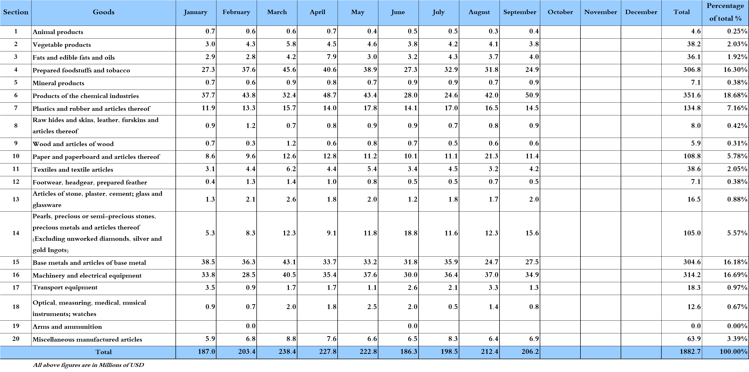

Table 12: Industrial exports according to exported goods and countries groups during September 2018
Goods | Arab Countries | European Countries | Oceanic Countries | Non-Arab Asian countries | American Countries | Non-Arab African countries | Other* | Total
Animal products | 302 | 0 |  | 2 | 6 | 128 | 0 | 439
Vegetable products | 2,223 | 609 | 12 | 221 | 382 | 388 | 1 | 3,837
Fats and edible fats and oils | 1,708 | 534 | 106 | 25 | 1,455 | 215 |  | 4,043
Prepared foodstuffs and tobacco | 13,970 | 3,841 | 854 | 416 | 2,828 | 2,216 | 804 | 24,928
Mineral products | 582 | 99 | 0 | 12 |  | 39 | 121 | 854
Products of the chemical industries | 19,596 | 6,349 | 109 | 23,278 | 388 | 910 | 294 | 50,925
Plastics and rubber and articles thereof | 11,071 | 1,131 | 51 | 504 | 49 | 1,434 | 269 | 14,510
Raw hides and skins, leather, furskins and articles thereof | 543 | 198 |  | 36 | 40 | 74 |  | 890
Wood and articles of wood | 489 | 24 | 2 | 1 | 1 | 123 |  | 640
Paper and paperboard and articles thereof | 9,078 | 630 | 1 | 393 | 47 | 1,181 | 43 | 11,373
Textiles and textile articles | 2,292 | 807 | 35 | 274 | 131 | 499 | 208 | 4,245
Footwear, headgear, prepared feather | 408 | 36 |  | 1 | 18 | 55 |  | 518
Articles of stone, plaster, cement; glass and glassware | 745 | 224 | 17 | 24 | 138 | 850 |  | 1,998
Pearls, precious or semi-precious stones, precious metals and articles thereof (Excluding unworked diamonds, silver and gold Ingots) | 12,780 | 1,672 |  | 615 | 439 | 0 | 58 | 15,565
Base metals and articles of base metal | 5,504 | 6,534 | 102 | 11,422 | 197 | 3,468 | 232 | 27,459
Machinery and electrical equipment | 20,687 | 2,492 | 549 | 1,805 | 316 | 8,381 | 718 | 34,947
Transport equipment | 505 | 345 |  | 11 | 188 | 297 |  | 1,345
Optical, measuring, medical, and musical instruments; clocks and watches | 201 | 280 |  | 144 | 92 | 83 | 8 | 808
Arms and ammunition
Miscellaneous manufactured articles | 4,523 | 509 | 98 | 63 | 395 | 1,307 | 18 | 6,915
Total | 107,207 | 26,316 | 1,935 | 39,248 | 7,111 | 21,647 | 2,775 | 206,239
All the above figures are in thousands of US dollars.
* "other" Includes exported goods to the duty free market and those that are supplied to ships and aircraft.
Table 13: Distribution of the industrial exports according to the main importing countries during September 2018
Export destination Country | United Arab Emirates | Syria | Bangladesh | Iraq | Saudi Arabia | Turkey | Spain | Qatar
Value in thousands of USD | 25,024 | 19,173 | 17,740 | 13,612 | 13,115 | 10,612 | 8,962 | 8,123

Export destination Country | Egypt | Jordan | Algeria | United States Of America | Republic of Korea | Kuwait | Nigeria | France
Value in thousands of USD | 6,458 | 6,213 | 5,119 | 4,926 | 4,860 | 4,518 | 4,180 | 4,021

Export destination Country | Italy | Ivory Coast | United Kingdom | Angola | Congo | Australia | Oman | China
Value in thousands of USD | 2,354 | 2,336 | 1,706 | 1,680 | 1,679 | 1,646 | 1,563 | 1,557

Table 14: Distribution of importing countries according to countries groups and the value of exports during September 2018
Exports Value  (in million USD) | Arab Countries | European Countries | Oceania Countries | Non-Arab Asian countries | American Countries | Non-Arab African countries | Total
]0-1[ | 8 | 34 | 4 | 24 | 22 | 34 | 126
[1-5[ | 3 | 8 | 1 | 3 | 2 | 7 | 24
[5-10[ | 4 | 1 |  |  |  |  | 5
[10-15[ | 2 |  |  | 1 |  |  | 3
More than 15 million USD | 2 |  |  | 1 |  |  | 3
Total | 19 | 43 | 5 | 29 | 24 | 41 | 161

Table 15: Distribution of the industrial exports according to product and to the main importing countries during September 2018

Animal products | Qatar | Bahrain | Saudi Arabia | United Arab Emirates | Ivory Coast | Ghana | Kuwait | Congo
Value in 1000 of USD | 127 | 65 | 45 | 43 | 39 | 25 | 20 | 15

Vegetable products | Syria | United Arab Emirates | Jordan | Saudi Arabia | United States Of America | Germany | Turkey | Tunisia
Value in 1000 of USD | 682 | 372 | 317 | 312 | 283 | 240 | 188 | 179

Fats and edible fats and oils | United States Of America | Syria | Canada | Saudi Arabia | Kuwait | Netherlands | United Arab Emirates | Iraq
Value in 1000 of USD | 997 | 668 | 351 | 327 | 302 | 287 | 171 | 104

Mineral products | Syria | Ship Supplies | France | Belgium | Kuwait | Free Zone | Congo | Kenya
Value in 1000 of USD | 548 | 107 | 59 | 35 | 26 | 14 | 13 | 11

Plastics and rubber and articles thereof | Syria | Saudi Arabia | Egypt | Iraq | Spain | Algeria | Qatar | Morocco
Value in 1000 of USD | 6,693 | 1,042 | 825 | 678 | 421 | 350 | 342 | 338

Raw hides and skins, leather, furskins and articles thereof | United Arab Emirates | Portugal | Qatar | Syria | Nigeria | Spain | United States Of America | Turkey
Value in 1000 of USD | 241 | 127 | 115 | 77 | 66 | 48 | 40 | 35

Wood and articles of wood | Syria | Oman | Qatar | Saudi Arabia | Seychelles | Ivory Coast | United Arab Emirates | Portugal
Value in 1000 of USD | 158 | 128 | 66 | 66 | 45 | 30 | 29 | 18

Paper and paperboard and articles thereof | Iraq | Syria | Saudi Arabia | Egypt | United Arab Emirates | Qatar | Algeria | Jordan
Value in 1000 of USD | 1,535 | 1,527 | 941 | 889 | 843 | 720 | 657 | 468

Textiles and textile articles | Syria | Qatar | France | Oman | Saudi Arabia | Kuwait | Turkey | Other
Value in 1000 of USD | 507 | 430 | 341 | 281 | 260 | 238 | 229 | 198
Table 15: (continued) Distribution of the industrial exports according to product and the main importing countries during September 2018
Footwear, headgear, prepared feather | Kuwait | United Arab Emirates | Egypt | Venezuela | Ivory Coast | Senegal | Morocco | Jordan
Value in 1000 of USD | 168 | 107 | 86 | 17 | 16 | 16 | 15 | 15

Articles of stone, plaster, cement; glass and glassware | Guinea | Syria | Equatorial Guinea | Belgium | Qatar | United States Of America |  | Algeria | Congo
Value in 1000 of USD | 360 | 172 | 149 | 146 | 135 | 129 | 105 |  | 94

Pearls, precious or semi-precious stones, precious metals and articles thereof (Excluding unworked diamonds, silver and gold Ingots) | United Arab Emirates | Saudi Arabia | Switzerland | Italy | Qatar | Jordan | United States Of America | Hong Kong
Value in 1000 of USD | 10,921 | 919 | 772 | 579 | 497 | 439 | 433 | 390

Base metals and articles of base metal | Republic of Korea | Turkey | Spain | Algeria | Nigeria | China | Greece | India
Value in 1000 of USD | 4,816 | 4,066 | 3,286 | 2,848 | 1,599 | 1,438 | 1,015 | 823

Transport equipment | United States Of America | United Kingdom | Iraq | Mali | United Arab Emirates | Kuwait | France | Syria
Value in 1000 of USD | 188 | 165 | 162 | 132 | 111 | 98 | 73 | 71

Miscellaneous manufactured articles | Qatar | Saudi Arabia | United Arab Emirates | Algeria | Kuwait | France | Jordan | Ivory Coast
Value in 1000 of USD | 1,187 | 906 | 572 | 566 | 320 | 296 | 278 | 278

Table 16: Distribution of industrial exports, according to the main exported goods and main importing countries during September 2018
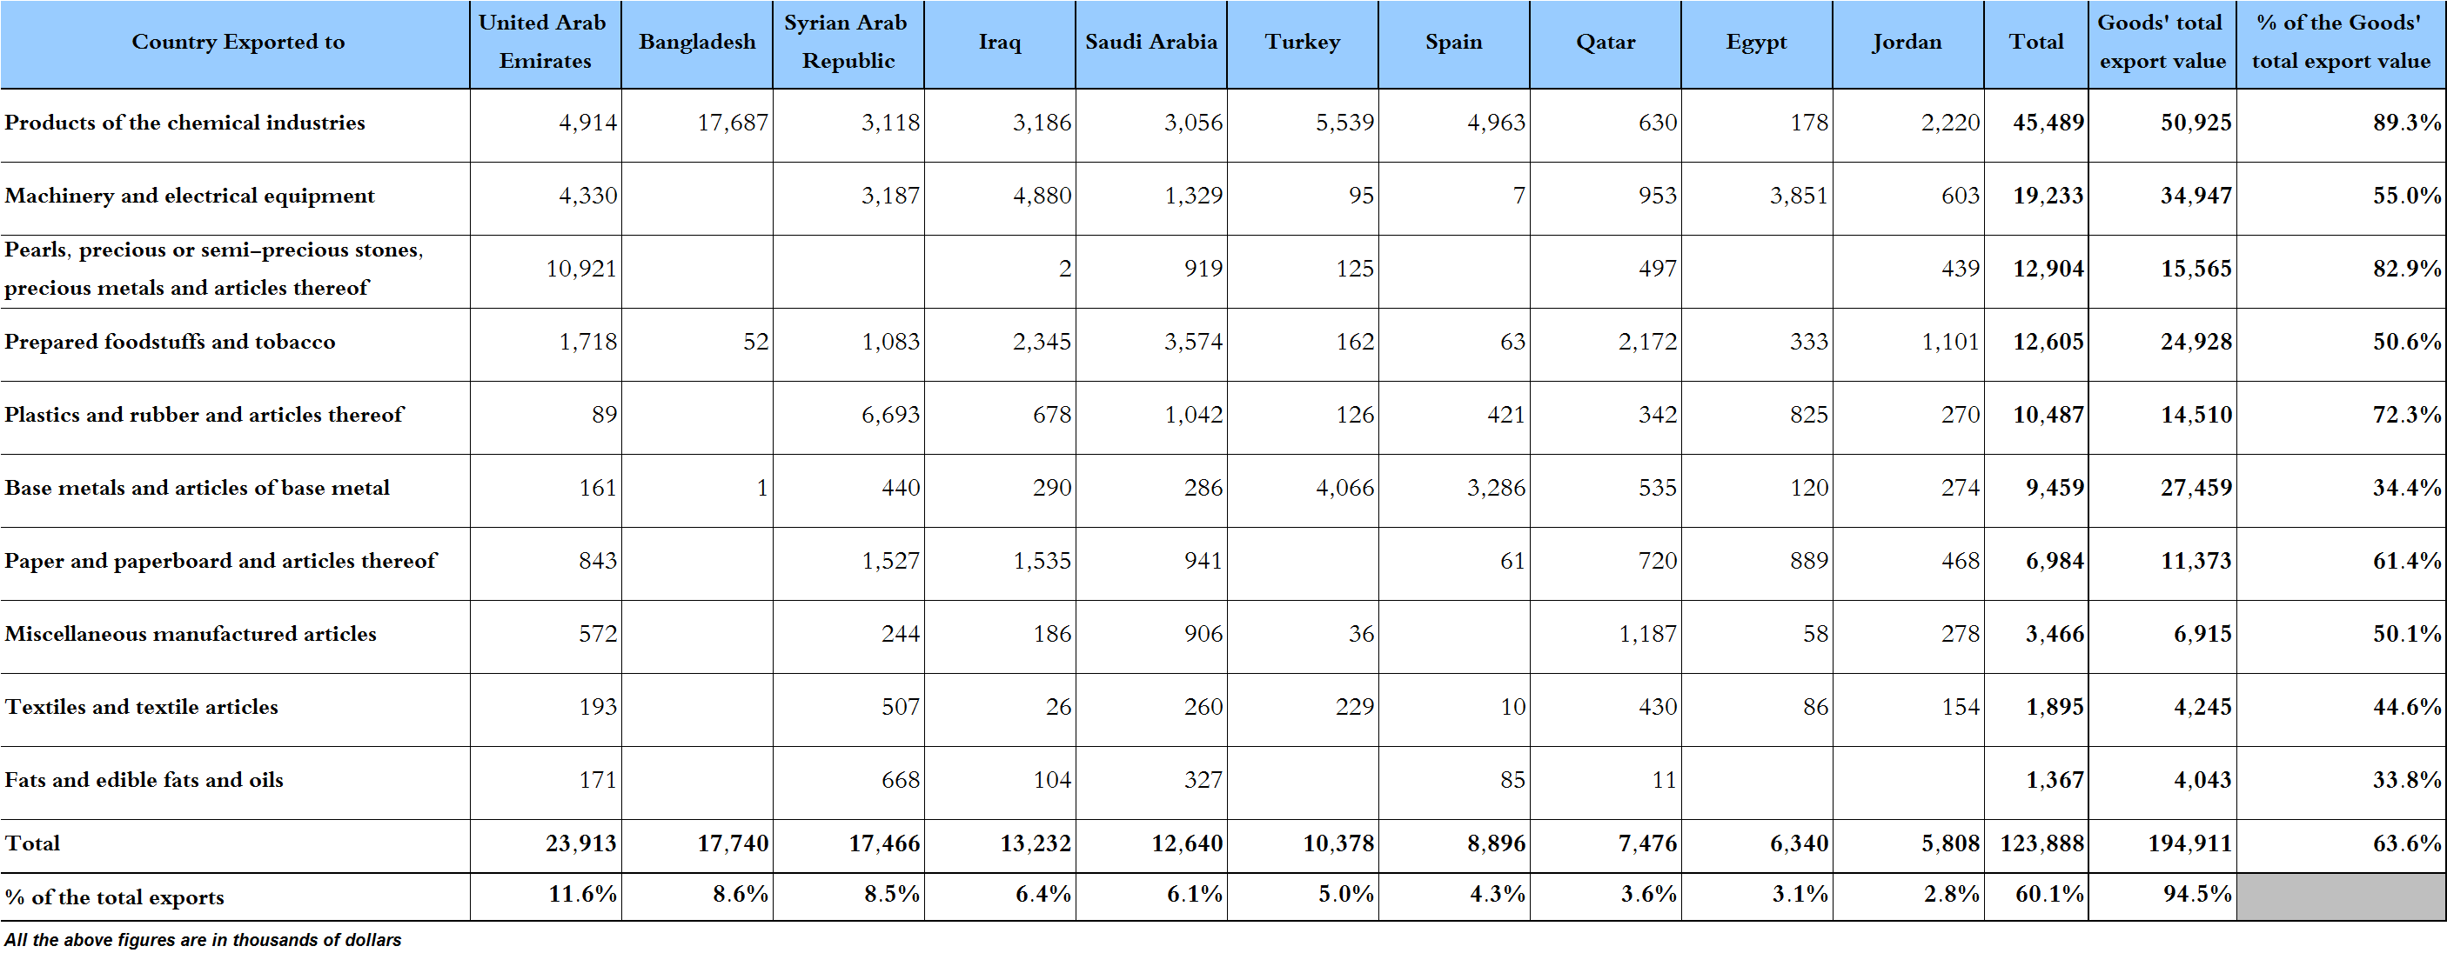

Table 17: Imports of industrial machinery and equipment during years 2016-2017-2018
Month | Year  2016 | Year  2017 | Year  2018 | Variation in %  2016/2018 | Variation in %  2017/2018
January | 25.3 | 21.0 | 24.0 | -4.9% | 14.7%
February | 17.3 | 10.7 | 18.8 | 8.3% | 75.6%
March | 25.1 | 20.2 | 28.2 | 12.4% | 39.5%
April | 22.8 | 18.0 | 31.1 | 36.4% | 72.5%
May | 20.5 | 23.1 | 25.2 | 22.6% | 9.1%
June | 20.0 | 22.2 | 23.7 | 18.3% | 6.7%
July | 16.8 | 21.8 | 18.3 | 8.9% | -16.2%
August | 19.0 | 27.0 | 27.6 | 44.9% | 2.0%
September | 16.2 | 30.1 | 13.5 | -16.9% | -55.2%
October | 14.5 | 22.4
November | 20.0 | 17.6
December | 17.9 | 23.2
Total | 235.5 | 257.4 | 210.3
All above figures are in Millions of USD

Table 18: Imports of industrial equipment and machinery according to exporting country for the year 2018
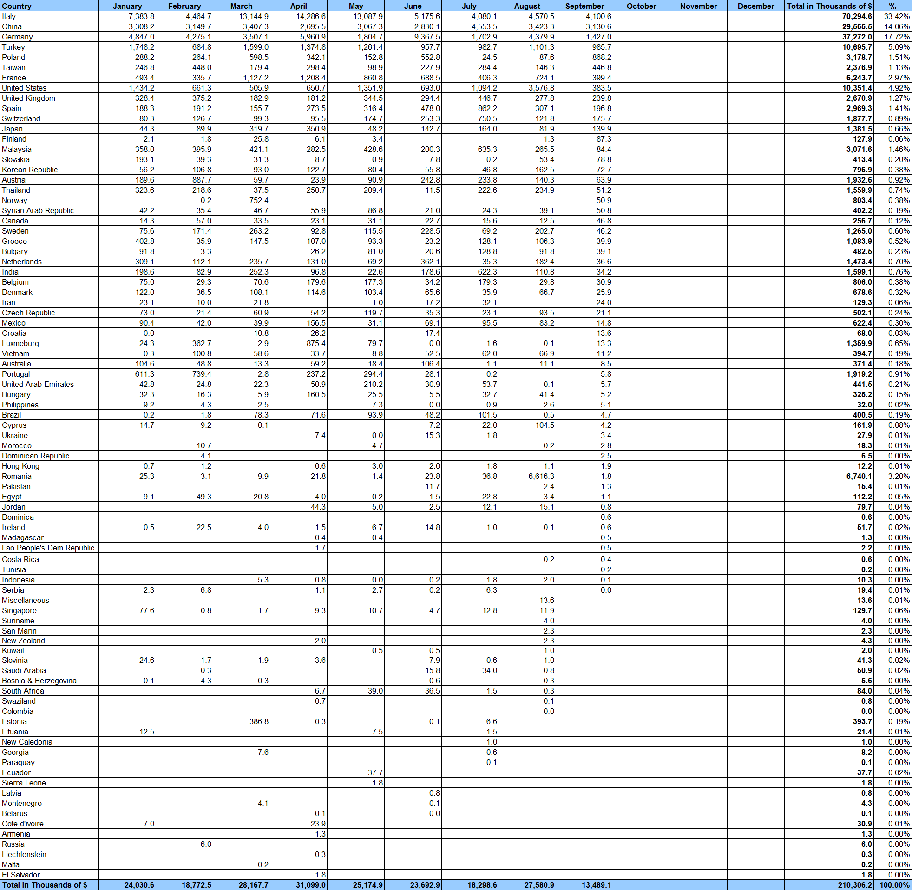
Table 19: Imports of industrial equipment and machinery according to industrial activity and country during September 2018

Appendix maps
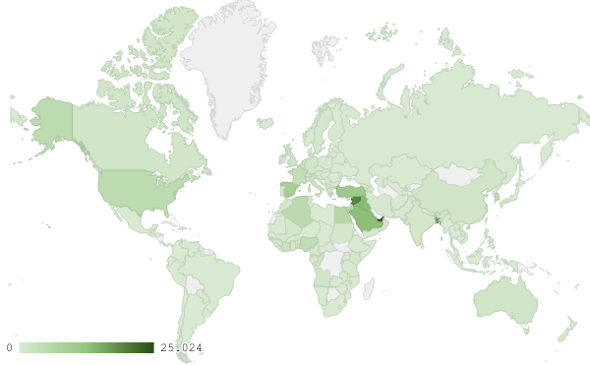
Map 1: Distribution of industrial exports during September 2018

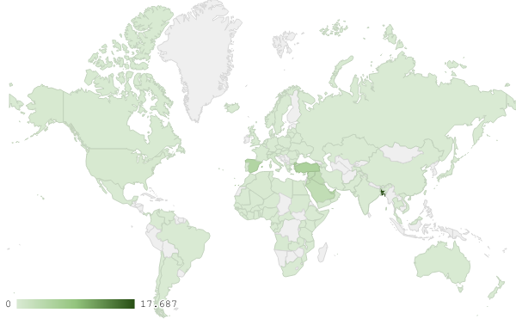
Map 2: Exports of products of the chemical industries during September 2018

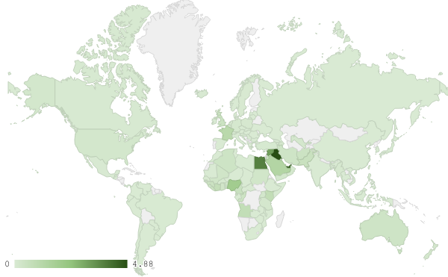
Map 3: Exports of machinery and electrical equipment during September 2018
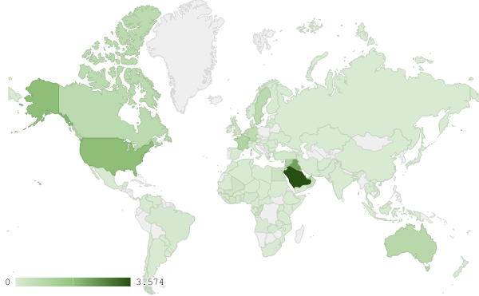
Map 4: Exports of prepared foodstuffs and tobacco during September 2018

Appendix charts
Chart 1: Industrial exports during years 2016-2017-2018
Chart 2: Comparison of industrial exports during September 2018 and September 2017
Chart 3: Distribution of industrial exports to Arab countries during September 2018

Chart 4: Distribution of industrial exports to European countries during September 2018

Chart 5: Imports of industrial machinery and equipment during years 2016-2017-2018

Chart 6: Imports of industrial equipment and machinery according to industrial activity during September 2018

Exports of unworked Diamonds, Silver and Gold Ingots reached this month a value of 21.3 million USD
The machineries and equipment are classified in this table according to the industrial sectors that are used in, while heading "other" includes machineries and equipment that can be used in various sectors.

