

A detailed report on industrial exports
and imports of industrial machinery and equipment in October 2018

Prepared by:
Ministry of Industry
Industrial Information Department

www.industry.gov.lb
Index

I. Introduction 3
II. Industrial exports in October 2018 4
1. Main exported products 4
2. Products with increased exports value 4
2.1. Products of the chemical industries 4
2.2. Machinery and electrical equipment 4
3. Products with decreased exports value 5
3.1. Prepared foodstuffs and tobacco 5
3.2. Transport equipment 5
4. Main export markets 5
4.1. Main export markets by groups of countries 5
4.2. Main export markets by country 6
III. Imports of industrial machinery and equipment 6
1. Imported industrial machinery and equipment by country of origin 6
2. Imported industrial machinery and equipment by country of origin and industrial activity 6
IV. Appendix tables 8
IV. Appendix maps 21
VI. Appendix charts 25

Introduction
The Industrial Information Department of the Ministry of Industry has prepared a detailed report on industrial exports and imports of industrial machinery and equipment for the month of October 2018.
It should be noted that the total value of industrial exports during first ten months of the year 2018 amounted about 2 billion and 122.8 million US dollars compared to 2 billion and 48.9 million US dollars during the same period of the year 2017, and 2 billion and 116.9 million US dollars during the same period of the year 2016. Therefore we notice an increase of 3.6% compared to the year 2017, and an increase of 0.3% compared to the year 2016. (Tables 1 and 11(
It should also be noted that the monthly average of the Lebanese industrial exports during the first ten months of the year 2018 amounted about 212.3 million US dollars compared to 204.9 million US dollars during the year 2017, and 211.7 million US dollars during the year 2016.
On the other hand, the total value of imports of industrial machinery and equipment during the first ten months of the year 2018 amounted about 234.8 million US dollars compared to 216.6 million US dollars during the same period of the year 2017, and 197.7 million US dollars during the same period of the year 2016. Therefore, we notice an increase of 8.4% compared to the year 2017, and an increase of 18.8% compared to the year 2016. (Table 17)

Industrial exports in October 2018
The total value of industrial exports in October 2018 amounted to nearly 240.0 million US dollars, compared to 226.7 million US dollars in October 2017, and 220.0 million US dollars in October 2016, which is equivalent to an increase of 13.4 million US dollars, with the rate of 5.9% compared to year 2017, and an increase of 20.0 million US dollars with the rate of 9.1%, compared to year 2016. (Table 1, and Map 1, and Chart 1)

Main exported products
Exports of machinery and electrical equipment came first in October 2018, with a total value of 54.5 million US dollars; Hong Kong was on top of importers list of this product, with an import value of 10.0 million US dollars. Followed by exports of products of the chemical industries, with a total value of 45.5 million US dollars, Bangladesh was the largest importer of this product, with an import value of 16.4 million US dollars. Then base metals and articles of base metal, with a total value of 33.3 million US dollars, Turkey topped the importers list of this product, with an import value of 7.3 million US dollars, followed by prepared foodstuffs and tobacco, with a total value of 30.2 million US dollars. (For more details tables 2, 4, 6, 8, 10, 15, and 16 and Maps 2, 3, and 4)

Products with increased exports value
Statistics showed a significant increase in exports of the following products:

Products of the chemical industries
Exports of this product increased from 32.1 million US dollars in October 2017 to 45.5 million US dollars in October 2018 (Table 2 and Chart 2). The exports of this product mainly decreased to Iraq and Italy whereas it mainly increased to Bangladesh and Greece which led to an increase of the total value of about 13.4 million US dollars. (Tables 3 and 4)

Machinery and electrical equipment
Exports of this product increased from 43.8 million US dollars in October 2017 to 54.5 million US dollars in October 2018 (Table 2 and Chart 2). The exports of this product mainly decreased to Iraq, Kuwait, and Saudi Arabia whereas it mainly increased to Hong Kong and Syria which led to an increase of the total value of about 10.7 million US dollars. (Tables 5 and 6).

Products with decreased exports value
Statistics showed a significant decrease in exports of the following products:

Prepared foodstuffs and tobacco
Exports of this product decreased from 46.9 million US dollars in October 2017 to 30.2 million US dollars in October 2018 (Table 2 and Chart 2). The exports of this product mainly decreased to Syria, Egypt, The United States Of America and Qatar which led to a fall of the total value of about 16.7 million US dollars. (Tables 7 and 8)

Transport equipment
Exports of this product decreased from 3.7 million US dollars in October 2017 to 1.6 million US dollars in October 2018 (Table 2 and Chart 2). The exports of this product mainly decreased to Congo which led to a fall of the total value of about 2.1 million US dollars. (Tables 9 and 10)

Main export markets

Main export markets by groups of countries
Arab countries were the main market for Lebanese industrial exports in October 2018, with a total export value of 112.9 million US dollars, with a rate of 47.0% of the total export value. Non-Arab Asian countries were the second largest export markets with a rate of 20.9% of the total export value. Followed by, European countries with a rate of 13.8% of the total export value, and, the Non-Arab African countries with a rate of 12.9% of the total export value. The main products exported to Arab countries are: machinery and electrical equipment with the total value of 23.7 million US dollars, products of the chemical industries with the total value of 19.8 million US dollars, and the prepared foodstuffs and tobacco with the total value of 16.8 million US dollars. (Table 12 and Map 1)

Main export markets by country
Among countries importing Lebanese industrial products, United Arab Emirates ranked first with a total value of 23.3 million US dollars, with a rate of 9.7% of the total export value. Syria came second with a total value of 22.9 million US dollars with a rate of 9.5% of the total export value. Followed by, Bangladesh with a total value of 16.4 million US dollars with a rate of 6.8% of the total exports value. (Table 13 and Map 1)
During this month, Lebanese products were exported to 45 European countries, 41 Non-Arab African countries, 29 Non-Arab Asian countries, 25 American countries, 19 Arab countries, and 5 Oceanic countries. Countries that imported Lebanese goods by over 1 million US dollars are as following: 13 Arab countries, 11 European countries, 8 Non-Arab African countries, 6 Non-Arab Asian countries, and 2 American countries, and 1 Oceanic country. (Table 14, and Map 1, and Charts 3 and 4)

Imports of industrial machinery and equipment
The total import value of industrial machinery and equipment in October 2018 reached about 24.5 million US dollars compared to 22.4 million US dollars during the same period in 2017, and 14.5 million US dollars during the same period in 2016, an increase by 9.0% compared to year 2017, and an increase of 68.2% compared to year 2016. (Tables 17 and 18 and Chart 5)

Imported industrial machinery and equipment by country of origin
Germany ranked first on the list of countries exporting industrial machinery and equipment to Lebanon, with a total value amounting to about 6.9 million US dollars, followed by Italy, with a total value of 5.9 million US dollars, and China, with a total value of 2.5 million US dollars. (Table 18)

Imported industrial machinery and equipment by country of origin and industrial activity
In October 2018, imports of machines used in packaging, ranked first, with a total value of 8.4 million US dollars, and Germany topped the list of countries exporting of this product to Lebanon with exports value of 4.9 million US dollars, followed by machines for food industry, with a total value of 4.1 million US dollars. Austria was the leading exporter of this product with an export value of 1.5 million US dollars. Followed by machines for metal products industry, with a total value of 1.5 million US dollars. (Table 19, Chart 6)

Appendix tables

Table 1: Industrial exports during Years 2016 – 2017 – 2018
Month | Year  2016 | Year  2017 | Year  2018 | Variation in %  2016/2018 | Variation in %  2017/2018
January | 199.5 | 175.9 | 187.0 | -6.3% | 6.3%
February | 222.8 | 196.8 | 203.4 | -8.7% | 3.4%
March | 211.6 | 223.9 | 238.4 | 12.6% | 6.5%
April | 231.1 | 210.4 | 227.8 | -1.4% | 8.3%
May | 210.6 | 205.9 | 222.8 | 5.8% | 8.2%
June | 225.3 | 199.0 | 186.3 | -17.4% | -6.4%
July | 178.8 | 215.7 | 198.5 | 11.0% | -8.0%
August | 232.9 | 227.0 | 212.4 | -8.8% | -6.4%
October | 184.3 | 167.6 | 206.2 | 11.9% | 23.0%
October | 220.0 | 226.7 | 240.0 | 9.1% | 5.9%
November | 193.7 | 205.1
December | 216.3 | 219.6
Total | 2,526.9 | 2,473.5 | 2,122.8
All above figures are in Millions of USD

Table 2: Comparison of industrial exports during October 2018 and October 2017
Section | Goods | October  2017 | October  2018 | Variation 2017/2018 | Variation in % 2017/2018
1 | Animal products | 0.43 | 0.69 | 0.26 | 59.8%
2 | Vegetable products | 4.76 | 4.39 | -0.37 | -7.8%
3 | Fats and edible fats and oils | 3.18 | 5.86 | 2.67 | 84.0%
4 | Prepared foodstuffs and tobacco | 46.86 | 30.21 | -16.66 | -35.5%
5 | Mineral products | 0.63 | 1.53 | 0.90 | 141.9%
6 | Products of the chemical industries | 32.10 | 45.54 | 13.44 | 41.9%
7 | Plastics and rubber and articles thereof | 17.27 | 17.89 | 0.62 | 3.6%
8 | Raw hides and skins, leather, furskins and articles thereof | 0.91 | 0.95 | 0.04 | 4.4%
9 | Wood and articles of wood | 1.01 | 0.97 | -0.04 | -3.9%
10 | Paper and paperboard and articles thereof | 11.45 | 11.16 | -0.29 | -2.6%
11 | Textiles and textile articles | 5.87 | 4.44 | -1.43 | -24.4%
12 | Footwear, headgear, prepared feather | 0.90 | 0.60 | -0.30 | -33.4%
13 | Articles of stone, plaster, cement; glass and glassware | 2.02 | 1.94 | -0.08 | -3.9%
14 | Pearls, precious or semi-precious stones, precious metals and articles thereof (Excluding unworked diamonds, silver and gold Ingots) | 9.08 | 15.97 | 6.89 | 75.9%
15 | Base metals and articles of base metal | 31.93 | 33.32 | 1.39 | 4.3%
16 | Machinery and electrical equipment | 43.76 | 54.48 | 10.71 | 24.5%
17 | Transport equipment | 3.72 | 1.58 | -2.14 | -57.6%
18 | Optical, measuring, medical, and musical instruments; clocks and watches | 2.22 | 1.82 | -0.40 | -18.0%
19 | Arms and ammunition
20 | Miscellaneous manufactured articles | 8.58 | 6.72 | -1.86 | -21.6%
 | Total | 226.69 | 240.04 | 13.36 | 5.9%
All above figures are in Millions of USD
Table 3: Exports of Products of the chemical industries according to the main importing countries during October 2017
Export destination Country | Iraq | United Arab Emirates | Italy | Jordan | Saudi Arabia | Syria | Kuwait | Greece
Value in thousands of USD | 7,185 | 5,492 | 4,100 | 2,734 | 2,468 | 1,518 | 1,482 | 788

Table 4: Exports of Products of the chemical industries according to the main importing countries during October 2018
Export destination Country | Bangladesh | United Arab Emirates | Iraq | Saudi Arabia | Greece | Jordan | Italy | Syria
Value in thousands of USD | 16,388 | 4,765 | 4,651 | 3,058 | 2,842 | 2,697 | 2,412 | 1,416

Table 5: Exports of Machinery and electrical equipment according to the main importing countries during October 2017
Export destination Country | Iraq | Kuwait | Saudi Arabia | Syria | United States Of America | United Arab Emirates | Qatar | Other
Value in thousands of USD | 7,115 | 3,944 | 3,022 | 2,954 | 2,155 | 2,124 | 2,063 | 2,057

Table 6: Exports of Machinery and electrical equipment according to the main importing countries during October 2018
Export destination Country | Hong Kong | Syria | Iraq | United Arab Emirates | Pakistan | Egypt | Senegal | Ivory Coast
Value in thousands of USD | 10,023 | 8,705 | 4,156 | 2,798 | 2,291 | 2,083 | 1,683 | 1,498

Table 7: Exports of Prepared foodstuffs and tobacco according to the main importing countries during October 2017
Export destination Country | Syria | Saudi Arabia | Egypt | Qatar | United States Of America | Iraq | United Arab Emirates | Germany
Value in thousands of USD | 8,585 | 5,049 | 4,452 | 3,240 | 3,116 | 2,939 | 1,813 | 1,471

Table 8: Exports of Prepared foodstuffs and tobacco according to the main importing countries during October 2018
Export destination Country | Saudi Arabia | Iraq | United Arab Emirates | Qatar | United States Of America | Germany | Kuwait | Canada
Value in thousands of USD | 5,062 | 3,155 | 2,094 | 1,919 | 1,794 | 1,371 | 1,107 | 988

Table 9: Exports of Transport equipment according to the main importing countries during October 2017
Export destination Country | Congo | United Kingdom | Ivory Coast | Syria | Iraq | United Arab Emirates | Sweden | France
Value in thousands of USD | 2,198 | 257 | 149 | 133 | 111 | 103 | 87 | 82

Table 10: Exports of Transport equipment according to the main importing countries during October 2018
Export destination Country | Iraq | Other | Libya | Ivory Coast | France | Belgium | Germany | Mauritania
Value in thousands of USD | 260 | 231 | 183 | 163 | 134 | 70 | 69 | 63

Table 11: Industrial exports according to exported goods during year 2018
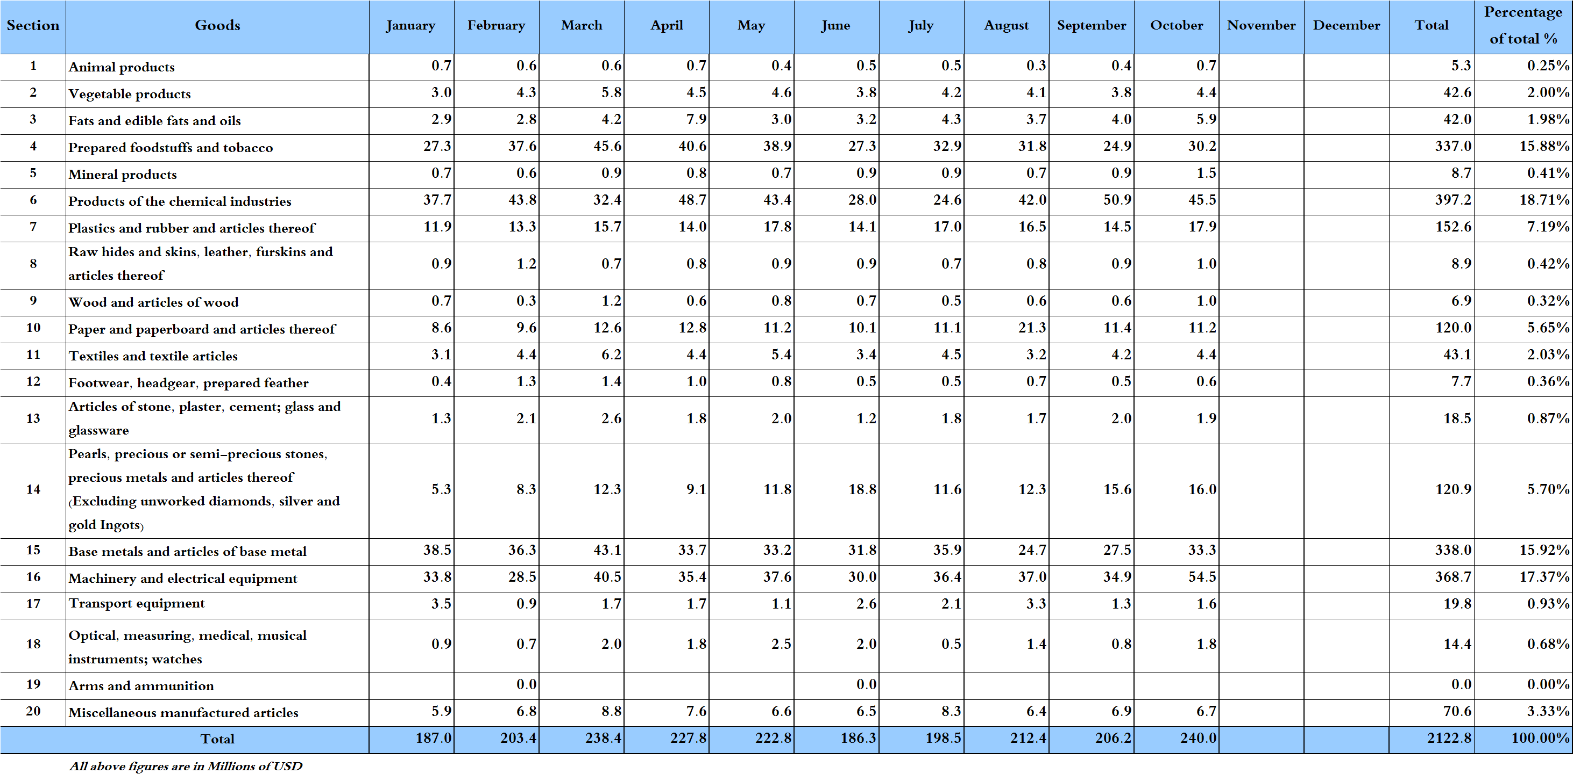

Table 12: Industrial exports according to exported goods and countries groups during October 2018
Goods | Arab Countries | European Countries | Oceanic Countries | Non-Arab Asian countries | American Countries | Non-Arab African countries | Other* | Total
Animal products | 507 |  |  | 112 | 6 | 60 | 0 | 685
Vegetable products | 2,004 | 1,045 | 139 | 293 | 272 | 633 | 0 | 4,387
Fats and edible fats and oils | 2,399 | 957 | 176 | 27 | 2,079 | 219 |  | 5,856
Prepared foodstuffs and tobacco | 16,752 | 5,449 | 693 | 701 | 3,139 | 2,951 | 521 | 30,206
Mineral products | 1,092 | 216 | 1 |  | 0 | 116 | 106 | 1,531
Products of the chemical industries | 19,807 | 6,799 | 22 | 16,731 | 499 | 1,548 | 134 | 45,540
Plastics and rubber and articles thereof | 13,866 | 1,107 | 50 | 486 | 38 | 2,183 | 161 | 17,891
Raw hides and skins, leather, furskins and articles thereof | 561 | 295 |  | 12 | 2 | 83 |  | 953
Wood and articles of wood | 564 | 3 | 1 | 0 | 49 | 351 |  | 967
Paper and paperboard and articles thereof | 6,805 | 1,394 | 13 | 275 | 97 | 2,493 | 81 | 11,157
Textiles and textile articles | 2,050 | 1,138 | 100 | 286 | 67 | 662 | 136 | 4,438
Footwear, headgear, prepared feather | 425 | 57 |  | 1 | 7 | 110 |  | 599
Articles of stone, plaster, cement; glass and glassware | 628 | 526 | 11 | 0 | 90 | 684 | 5 | 1,943
Pearls, precious or semi-precious stones, precious metals and articles thereof (Excluding unworked diamonds, silver and gold Ingots) | 11,141 | 1,935 |  | 1,768 | 1,105 | 1 | 20 | 15,971
Base metals and articles of base metal | 4,656 | 7,731 | 122 | 15,675 | 101 | 4,794 | 238 | 33,316
Machinery and electrical equipment | 23,734 | 3,443 | 381 | 13,583 | 765 | 11,940 | 630 | 54,476
Transport equipment | 651 | 358 | 2 | 16 | 50 | 273 | 231 | 1,581
Optical, measuring, medical, and musical instruments; clocks and watches | 949 | 297 | 1 | 9 | 373 | 195 |  | 1,823
Arms and ammunition |  |  |  |  |  |  |  | 0
Miscellaneous manufactured articles | 4,343 | 344 | 29 | 104 | 217 | 1,685 |  | 6,722
Total | 112,930 | 33,095 | 1,739 | 50,079 | 8,956 | 30,979 | 2,263 | 240,041
All the above figures are in thousands of US dollars.
* "other" Includes exported goods to the duty free market and those that are supplied to ships and aircraft.
Table 13: Distribution of the industrial exports according to the main importing countries during October 2018
Export destination Country | United Arab Emirates | Syria | Bangladesh | Iraq | Saudi Arabia | Hong Kong | Qatar | Turkey
Value in thousands of USD | 23,283 | 22,898 | 16,388 | 15,494 | 14,667 | 11,700 | 9,582 | 8,696

Export destination Country | Jordan | Greece | United States Of America | Egypt | Republic of Korea | Italy | Ivory Coast | Kuwait
Value in thousands of USD | 6,437 | 5,846 | 5,588 | 5,203 | 4,784 | 4,700 | 4,665 | 4,105

Export destination Country | France | Nigeria | Germany | China | Algeria | Congo | Spain | United Kingdom
Value in thousands of USD | 3,691 | 3,686 | 3,242 | 3,225 | 3,155 | 2,909 | 2,697 | 2,334

Table 14: Distribution of importing countries according to countries groups and the value of exports during October 2018
Exports Value  (in million USD) | Arab Countries | European Countries | Oceania Countries | Non-Arab Asian countries | American Countries | Non-Arab African countries | Total
]0-1[ | 6 | 34 | 4 | 23 | 23 | 33 | 123
[1-5[ | 6 | 10 | 1 | 3 | 1 | 8 | 29
[5-10[ | 3 | 1 |  | 1 | 1 |  | 6
[10-15[ | 1 |  |  | 1 |  |  | 2
More than 15 million USD | 3 |  |  | 1 |  |  | 4
Total | 19 | 45 | 5 | 29 | 25 | 41 | 164

Table 15: Distribution of the industrial exports according to product and to the main importing countries during October 2018

Animal products | Iraq | Qatar | United Arab Emirates | Turkey | Saudi Arabia | Ivory Coast | Kuwait | Liberia
Value in 1000 of USD | 185 | 121 | 115 | 111 | 63 | 22 | 16 | 11

Vegetable products | Syria | Germany | Qatar | Sweden | Turkey | Saudi Arabia | Ivory Coast | Morocco
Value in 1000 of USD | 636 | 457 | 339 | 329 | 282 | 269 | 170 | 169

Fats and edible fats and oils | United States Of America | Syria | Canada | Netherlands | Saudi Arabia | Morocco | Iraq | United Arab Emirates
Value in 1000 of USD | 1,324 | 722 | 707 | 541 | 453 | 334 | 290 | 273

Mineral products | Syria | Cyprus | Egypt | Other | Iraq | Angola | Qatar | Kuwait
Value in 1000 of USD | 826 | 216 | 110 | 106 | 54 | 47 | 47 | 37

Plastics and rubber and articles thereof | Syria | Saudi Arabia | Iraq | Egypt | Qatar | Ivory Coast | Morocco | Jordan
Value in 1000 of USD | 7,761 | 1,304 | 1,238 | 931 | 807 | 554 | 368 | 349

Raw hides and skins, leather, furskins and articles thereof | United Arab Emirates | Germany | Jordan | Nigeria | Syria | Saudi Arabia | Egypt | Portugal
Value in 1000 of USD | 208 | 183 | 90 | 76 | 68 | 61 | 58 | 36

Wood and articles of wood | Syria | Ivory Coast | Qatar | Jordan | Cameroon | United States Of America | United Arab Emirates | Gabon
Value in 1000 of USD | 295 | 186 | 123 | 78 | 57 | 49 | 29 | 26

Paper and paperboard and articles thereof | Qatar | Saudi Arabia | Syria | Egypt | Cyprus | United Arab Emirates | Jordan | Morocco
Value in 1000 of USD | 1,552 | 1,186 | 843 | 588 | 536 | 471 | 411 | 389

Textiles and textile articles | United Arab Emirates | Kuwait | Italy | Qatar | Angola | Jordan | Russian | France
Value in 1000 of USD | 480 | 430 | 340 | 312 | 251 | 238 | 237 | 211
Table 15: (continued) Distribution of the industrial exports according to product and the main importing countries during October 2018
Footwear, headgear, prepared feather | Saudi Arabia | Upper Volta | United Arab Emirates | United Kingdom | Kuwait | Ivory Coast | Qatar | Italy
Value in 1000 of USD | 310 | 71 | 63 | 39 | 19 | 19 | 15 | 10

Articles of stone, plaster, cement; glass and glassware | Belgium | Qatar | Angola | Syria | Congo | United Kingdom |  | Saudi Arabia | United States Of America
Value in 1000 of USD | 288 | 177 | 165 | 153 | 152 | 122 | 94 |  | 81

Pearls, precious or semi-precious stones, precious metals and articles thereof (Excluding unworked diamonds, silver and gold Ingots) | United Arab Emirates | Hong Kong | United States Of America | Italy | Belgium | Iraq | Switzerland | Thailand
Value in 1000 of USD | 10,480 | 1,658 | 1,105 | 943 | 585 | 385 | 293 | 107

Base metals and articles of base metal | Turkey | Republic of Korea | Greece | China | Spain | Nigeria | Algeria | Bulgaria
Value in 1000 of USD | 7,269 | 4,767 | 2,743 | 2,270 | 2,173 | 1,336 | 1,153 | 953

Optical, measuring, medical, and musical instruments; clocks and watches | Libya | United Arab Emirates | Brazil | United States Of America | Nigeria | Germany | Switzerland | Syria
Value in 1000 of USD | 563 | 288 | 255 | 118 | 110 | 86 | 67 | 58

Miscellaneous manufactured articles | Qatar | Saudi Arabia | United Arab Emirates | Nigeria | Jordan | Kuwait | Ivory Coast | Oman
Value in 1000 of USD | 1,074 | 1,023 | 516 | 505 | 473 | 325 | 264 | 210

Table 16: Distribution of industrial exports, according to the main exported goods and main importing countries during October 2018
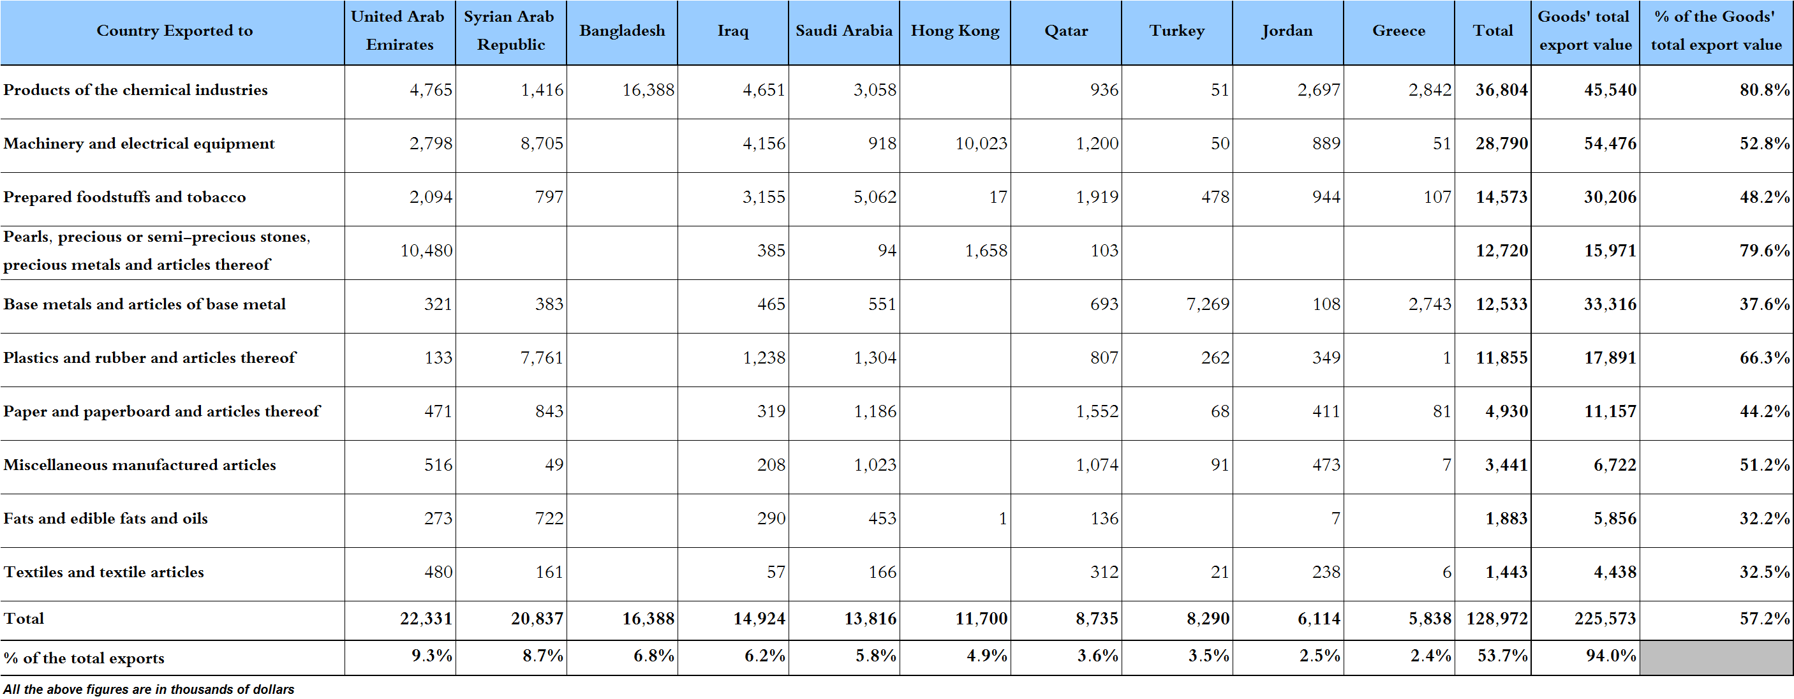

Table 17: Imports of industrial machinery and equipment during years 2016-2017-2018
Month | Year  2016 | Year  2017 | Year  2018 | Variation in %  2016/2018 | Variation in %  2017/2018
January | 25.3 | 21.0 | 24.0 | -4.9% | 14.7%
February | 17.3 | 10.7 | 18.8 | 8.3% | 75.6%
March | 25.1 | 20.2 | 28.2 | 12.4% | 39.5%
April | 22.8 | 18.0 | 31.1 | 36.4% | 72.5%
May | 20.5 | 23.1 | 25.2 | 22.6% | 9.1%
June | 20.0 | 22.2 | 23.7 | 18.3% | 6.7%
July | 16.8 | 21.8 | 18.3 | 8.9% | -16.2%
August | 19.0 | 27.0 | 27.6 | 44.9% | 2.0%
October | 16.2 | 30.1 | 13.5 | -16.9% | -55.2%
October | 14.5 | 22.4 | 24.5 | 68.2% | 9.0%
November | 20.0 | 17.6
December | 17.9 | 23.2
Total | 235.5 | 257.4 | 234.8
All above figures are in Millions of USD

Table 18: Imports of industrial equipment and machinery according to exporting country for the year 2018
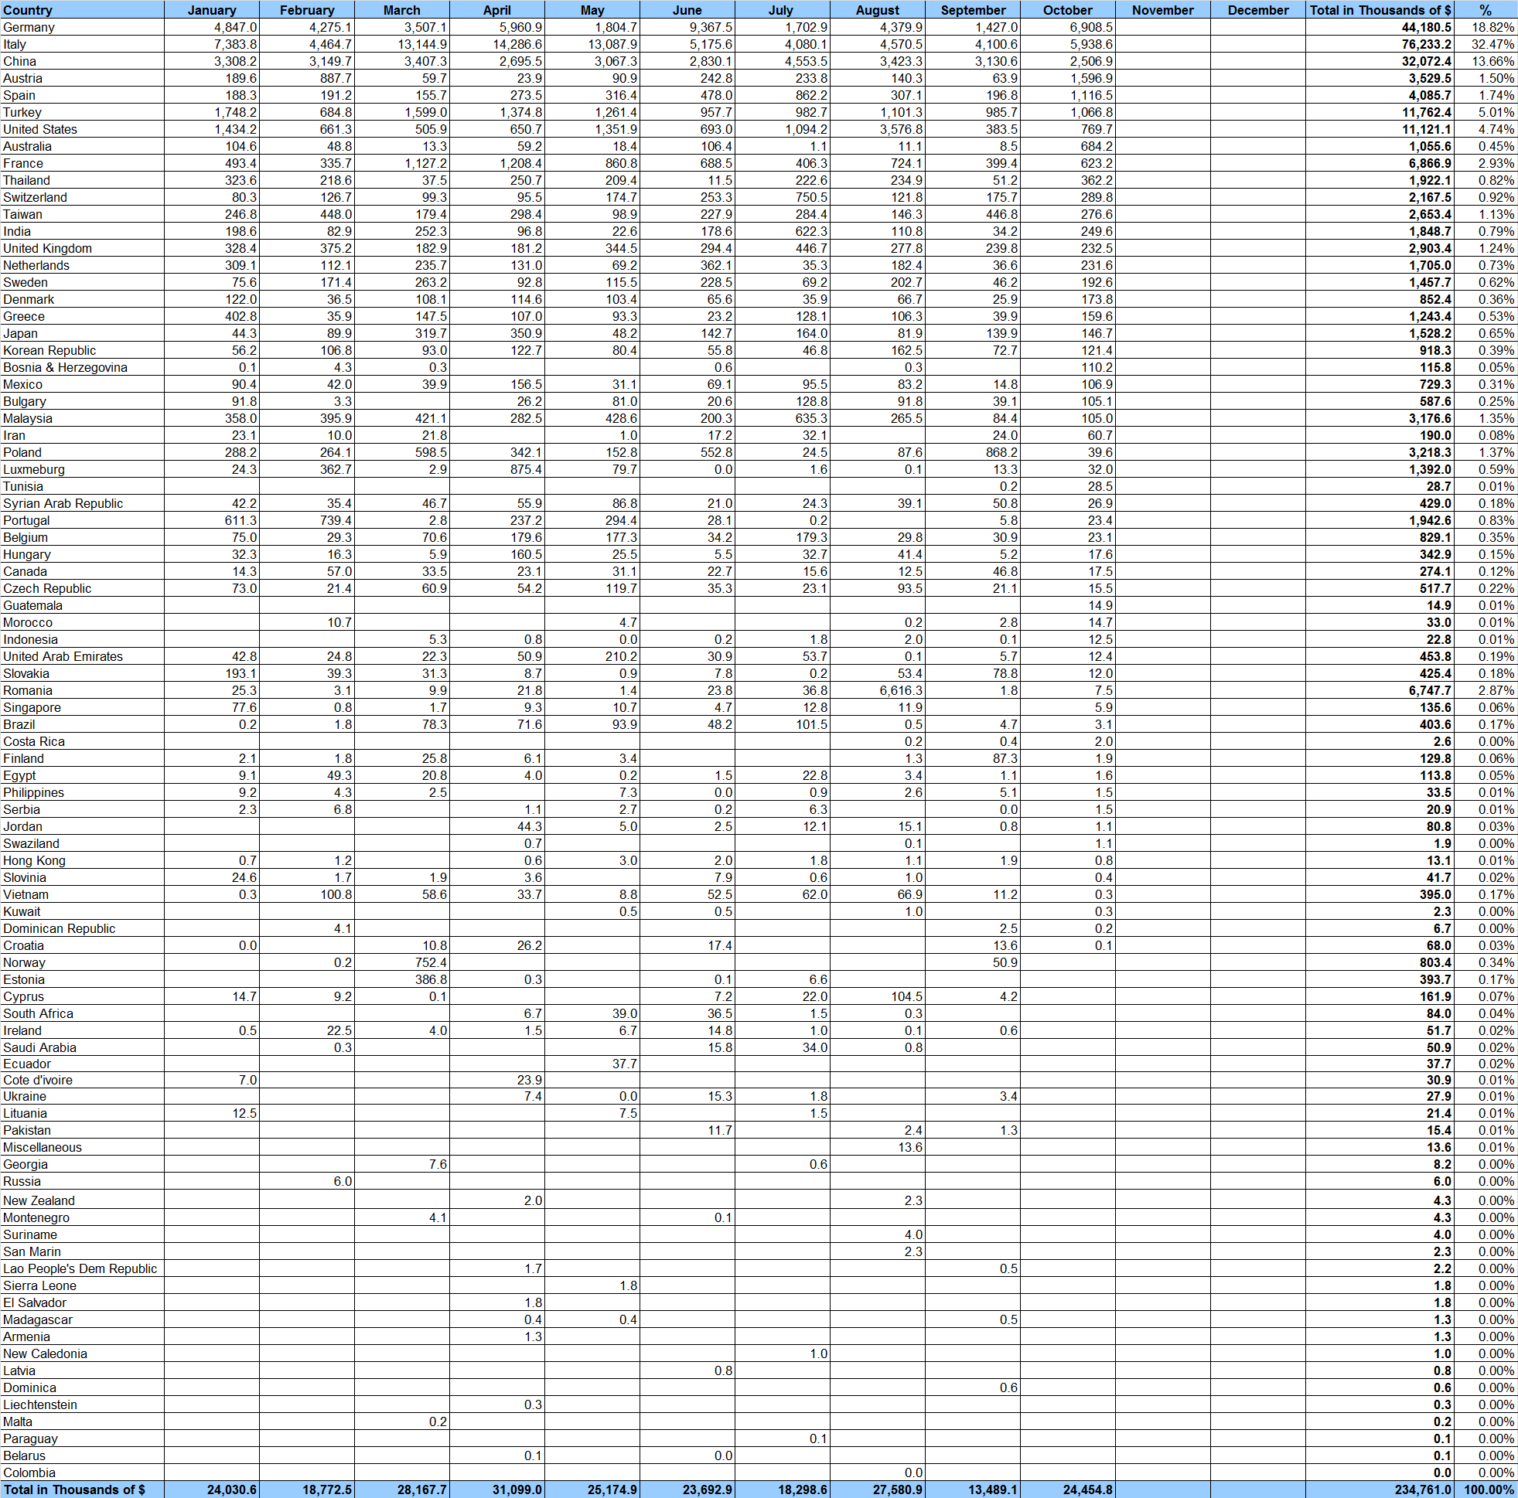
Table 19: Imports of industrial equipment and machinery according to industrial activity and country during October 2018

Appendix maps
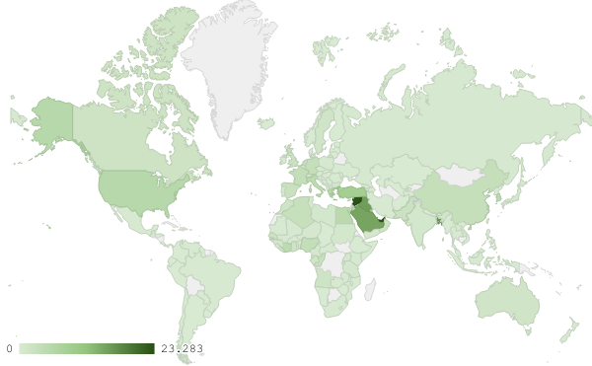
Map 1: Distribution of industrial exports during October 2018

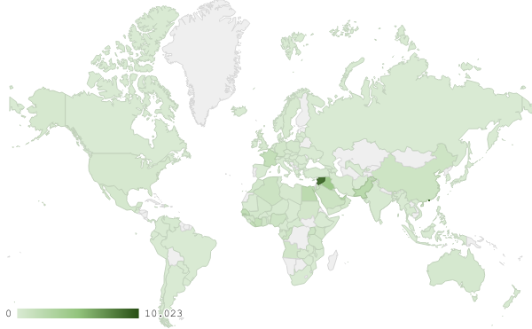
Map 2: Exports of products of machinery and electrical equipment during October 2018

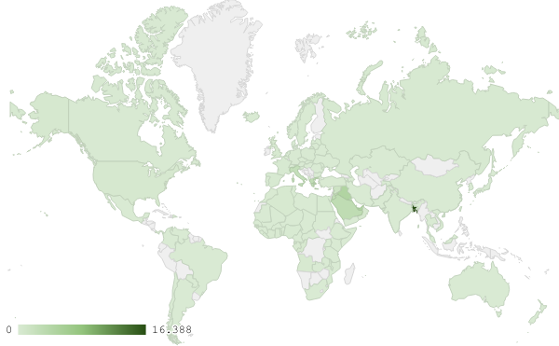
Map 3: Exports of the chemical industries during October 2018
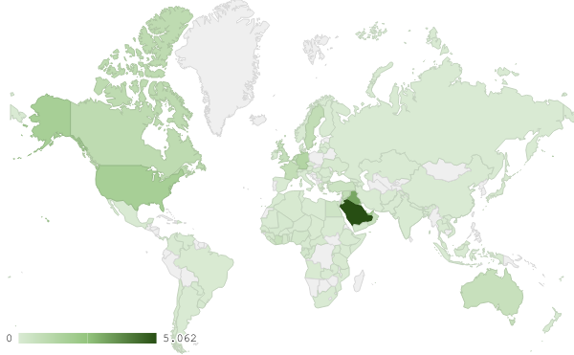
Map 4: Exports of prepared foodstuffs and tobacco during October 2018

Appendix charts
Chart 1: Industrial exports during years 2016-2017-2018
Chart 2: Comparison of industrial exports during October 2018 and October 2017
Chart 3: Distribution of industrial exports to Arab countries during October 2018

Chart 4: Distribution of industrial exports to European countries during October 2018

Chart 5: Imports of industrial machinery and equipment during years 2016-2017-2018

Chart 6: Imports of industrial equipment and machinery according to industrial activity during October 2018

Exports of unworked Diamonds, Silver and Gold Ingots reached this month a value of 31.1 million USD
The machineries and equipment are classified in this table according to the industrial sectors that are used in, while heading "other" includes machineries and equipment that can be used in various sectors.

